LendingSpace

Installation and Deployment Guide

Contents

Revision History 3

Lending Space Infrastructure Requirements 7

Lending Space Environment / Platform Standup 7

SQL Server 7

WebSphere Application Server Installation 17

WebSphere Remote Cache CELL Configuration 19

WebSphere CELL-1 Configuration - LOS 32

Keystore Creation (one time process) 46

WebSphere CELL-2 Configuration- AUS, JSQLXML,LX,UPLOAD 51

Keystore Copy 90

WebSphere CELL-3 Configuration - PORTAL 90

Keystore Copy 105

Work Engines 105

SSRS/SQLXML 110

Storage Server MQ/FTP (Non-Clustered) 130

Storage Server MQ/FTP (Clustered) 165

Proxy Server Installation 201

Proxy Upgrade (7.0 to 8.5.5) 212

Connectivity Test 218

Symantec Protection Engine Installation 218

Update and Execute Environmental Scripts 219

LS Initial Database Stand Up Procedures 219

Code Deployment to Self-Hosted Environment 230

Restoring Client Database Instructions(Rollback) 245

Reseeding Database To Existing Instances(Reseed) 248

Maintenance and Restart Activities 253

Appendices 254

Appendix A Configuration File Tool (Property File Management) 254

Appendix B Deploy Tool 258

Appendix C Smoketest 267

Appendix D Websphere Topology Screenshots 289

Appendix E Exporting IBMKeystore Private Keys 299

## Revision History

| Version | Publish Date | Description/Changes | Author(s) |
| --- | --- | --- | --- |
| 1.1 | 9/5/2014 | Split Prerequisites from install Added Revision History  Appendix Updates Smoke Test and Deploy Tool | Mike Fitzgerald  (Initial Assembly from separate documents) |
| 1.2 | 9/6/2014 | Removed history from Application Restart Tasks. Added: Temporary File Cleanup utility task information, Log file maintenance information | Derrick Yacavone |
| 1.3 | 9/11/2014 | Changed header type for SQL server section to appear in TOC, and placement within the stand up order. Added clarifications and updated WAS config table object. Added notes on profile creations. Changed J-integra instructions to reference a new installation on a new environment. Updated Work engine wording for clarity | Derrick Yacavone |
| 1.4 | 9/12/2014 | Changed headers to distinguish between installation and configuration sections | Derrick Yacavone |
| 1.5 | 9/22/2014 | Updates/clarifications after client installation | Derrick Yacavone |
| 1.6 | 9/23/2014 | Added appendix D for WAS topology pictures | Derrick Yacavone |
| 1.7 | 9/29/2014 | Added SQLCML configuration table | Derrick Yacavone |
| 1.8 | 10/1/2014 | Removed reference to tools server, change reference to proper install directory. Changed WebSphere Section to be organized by CELL | Derrick Yacavone |
| 1.9 | 10/4/2014 | Updating instructions to allow for installing by cells | Derrick Yacavone |
| 2.0 | 10/5/2014 | Updated IBM fix pack numbers | Derrick Yacavone |
| 2.1 | 10/9/2014 | Application of BFKS Template, minor edits | Michael Horniak |
| 2.2 | 10/9/2014 | Application of BFKS Template, minor edits | Michael Horniak |
| 2.3 | 10/10/2014 | Jmsadmin file name correction and screenshot removed from install, sqlxml iis configurations added dns with ip | Derrick Yacavone |
| 2.4 | 10/10/2014 | Merging 10/8 changes down into master document. Added LSAPP and LSReports roles in SQL install section | Derrick Yacavone |
| 2.5 | 10/14/2014 | Changed command to create windows service for Cell01Manager, based on Prolifics/IBM findings | Derrick Yacavone |
| 4.2.2 | 10/16/2014 | Changing revision numbers to match document numbering, updated J-integra Install troubleshooting section. Updated winzip installation to include testing command-line functions. Included how to run unsigned powershell scripts for the port-test tool. Added securing WAS cookies |  |
| 4.2.3 | 10/27/2014 | Added more troubleshooting steps and rearranged the J-Integra section. Added Aspose step after the Deployment section. Added Proxy SSL certificate renewal information and updated httpd configuration temple to include disabling SSLv3. Added Connectivity test running instructions. |  |
| 4.2.4 | 10/24/2014 | Added some notesd from SelfHosted client UAT deployment | Hari Patsa |
| 4.2.5 | 10/29/2014 | Added notes in DB instructions | Hari Patsa |
| 4.2.5 | 11/11/2014 | Added instructions to update LPS_LOS_CRDTP_LSMC service parameters | Pat Dunsford |
| 4.2.5 | 11/14/2014 | Corrected RCNODE1 command to create service | Pat Dunsford |
| 4.2.6 | 12/5/2014 | Corrected cell and server references in the Web Plugin section for each cell. Corrected Filezilla reference to Firefox in Symantec Scan engine instructions | Pat Dunsford |
| 4.2.7 | 12/5/2014 | Added domain\user account for JIntegra test | Pat Dunsford |
| 4.2.8 | 12/10/2014 | Stearns requested changes added | Pat Dunsford |
| 4.2.9 | 12/15.2014 | Updated deployment instructions with automation. | Hari Patsa |
| 4.2.10 | 1/7/2015 | Updated deployment manual instructions | Hari Patsa |
| 4.2.3 | 1/22/2015 | Updated installation documentation to reference the environment build checklist for software placement. Updated environment build checklist to reference instructions in the installation guilde. | Derrick Yacavone |
| 4.2.4 | 2/3/2015 | Updated Self- Hosted pre-deployment instructions to add more clarity of on Updating Catalog File Templates Received. | Mwaka Mahanga |
| 4.2.17 | 5/14/2015 | Updated WAS installation/configuration to record the WS_Default port for RC, AUS, and LOS servers (for the refresh function | Derrick Yacavone |
| 4.2.18 | 5/28/2015 | Added keystore creation procedures | Pat Dunsford |
| 4.2.19 | 6/18/2015 | Updated proxy install\upgrade to 8.5.5 | Pat Dunsford |
| 4.2.20 | 7/7/2015 | Added appendix for MQ on a windows Cluster, removing separate revision history | Derrick Yacavone |
| 5.0.14 | 7/14/2015 | Changed version of the document to match code versioning(first 2 numbers), merged separated out revision history back into this document, Put revision history at top of document | Derrick Yacavone |
| 5.015 | 7/15/2015 | Updated Initial DB Stand up Instructions | Patrick Dunsford |
| 5.0.16 | 7/27/15 | 1.SSL proxy updates  2. 5.0 jar file additions\removals  3. RC and AUS Cache  5. Time out additions | Pat Dunsford |
| 5.0.17 | 7/20/2015 | Added 5.0 jar file additions\removals for 2nd WAS4 nodes | Pat Dunsford |
| 5.0.18 | 7/22/2015 | Removed Appendix E, created MQ Clustered\Non Clustered instructions | Pat Dunsford |
| 5.0.19 | 7/27/2015 | Added FTP Cluster IIS Installation | Pat Dunsford |
| 5.0.20 | 7/31/2015 | Corrected Keystore information | Pat Dunsford |
| 5.0.21 | 8/7/2015 | Removed Winzip Installation, and added Portal_Only httpd.conf file for self-hosted customers that choose that option | Derrick Yacavone |
| 5.0.22 | 8/21/2015 | Increased max jvm heap size for LX from 1024 to 1536 | Derrick Yacavone |
| 5.0.23 | 8/26/2015 | Updated Portal-Only httpd.conf file to uncomment the upload section | Derrick Yacavone |
| 5.0.24 | 8/28/2015 | Changed references of IBMHTTP server v7 to v8.5 in the redundant proxy section | Derrick Yacavone |
| 5.0.25 | 9/24/2015 | Changed workengine creation script name to WRKENG_Install.bat | Pat Dunsford |
| 5.0.26 | 9/29/2015 | Moved the Keystore Creation to end of Cell1 configuration from the middle. Changes screenshots to include correct path for key file.  Added steps to copy key file to each Cell’s server from the initial creation file. Removed references to the application connectivity tool | Derrick Yacavone |
| 5.0.27 | 10/2/2015 | Corrected jvm heap sizes for UPLOAD node 2 | Derrick Yacavone |
| 5.0.28 | 10/3/2015 | Added Hung Thread configuration for Portal Server 2 that was missing, masked several client identifiers, removed creation of central directory creation for restart logs, removed BKFS proprietary ICS agent install/config section. Added password restriction for FTP user showing special characters that cannot be used. | Derrick Yacavone |
| 6.0.0 | 11/18/2015 | Changed title of document to v6.x to match code version. Added in update to HTTP Server SSL Certificate renewal section to handle issues when receiving new certificates. | Derrick Yacavone |
| 6.0.1 | 11/30/2015 | Updated the SSL Certificate Renewal process to ensure redundant proxy server process is also followed. | Derrick Yacavone |
| 6.0.2 | 12/2/2015 | Clarified the SSL Certificate Renewal process section |  |
| 6.0.3 | 1/20/2016 | Removed JIntegra, MSWord, dcomm config, SaveAsPDF | Pat Dunsford |
| 6.0.4 | 1/28/2016 | Added specific information for LOS web container | Pat Dunsford |
| 6.0.5 | 2/1/2016 | Corrected workengine portal tempview path in the httpd.conf file | Pat Dunsford |
| 6.0.6 | 2/3/2016 | Clarify remote cache web plugin for server 2 | Pat Dunsford |
| 6.0.7 | 2/5/2016 | 6.1.0.05 (Platform shared libraries), Garbage collection, 6.0.2.7 (404 Error Redirect) | Pat Dunsford |
| 6.0.8 | 2/16/2016 | Added Appendix E for exporting private keys from the IBM Keystore | Derrick Yacavone |
| 6.0.9 | 3/1/2016 | Corrections found during last PA2 deployment. Changes from 6_2 Cumulative Deployment Instructions | Pat Dunsford |
| 6.1.0 | 3/23/2016 | Blanked out logos in smoketest | Derrick Yacavone |

# Lending Space Infrastructure Requirements

For all Pre-Requisite Installation/configuration Information, Roles/Responsiblilites, Pre-Install server build checklist, Network Placement of Servers and High Availability Methods *see* ***Lending Space Requirements_vX.docx or .pdf***

# Lending Space Environment / Platform Standup

## SQL Server

#### Pre-Requisites

Prerequisite Service accounts for application after SQL installation:

* Ensure F:\Assembly exists
* Domain Based service account
* Service account needs to have the “sa” role on both instances until the entire application installation is completed.
* SQL application accounts for the different databases (<client>_databases)
* LSAPP user needs “sa” role on the online instance, and “public” on the reporting instance.
* SQL reporting account (<client>_lsreports)
* LSReports user needs “sa” role on the reporting instance, and “public” on the online instance
* If you are running the application and reporting database server instances on the same machine, 2 different TCP ports are needed

#### Instance 1 Installation

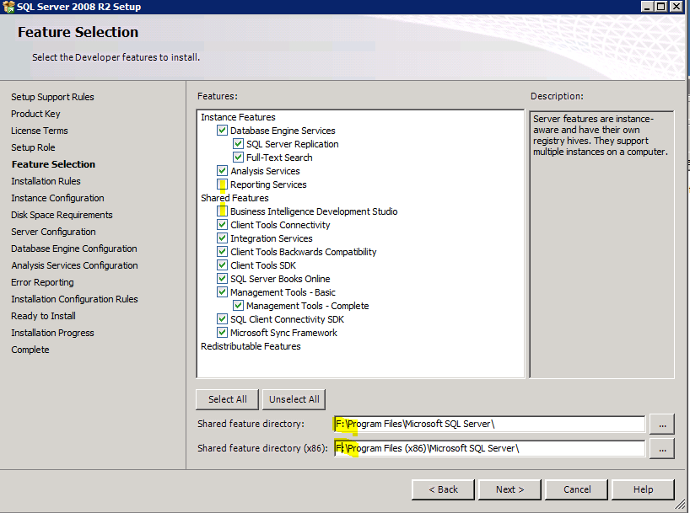

1. Mount or have mounted the SQL ISO file or DVD and begin by using setup.exe
2. Choose Installation type: New installation
   * Do **NOT** install Reporting Services or BIDS. Shared Featured directories go on F:
   * MS-SQL Server Instances: First instance is <servername>101, second is 102 (ex. VMLSSB4SQL101, VMLSSB4SQL102) INSTANCE ROOT Directory= F:\Program Files\Microsoft SQL Server\

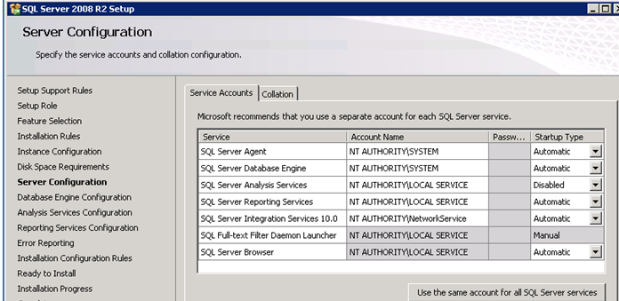

1. Set the service accounts and startup type to match above

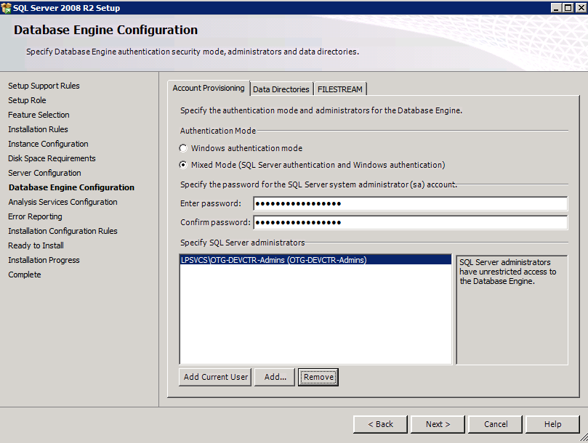

1. Add your administrative AD group to the account provisioning and ensure you are on Mixed mode (depending on who manages the server).
2. Click the Data Directories Tab!

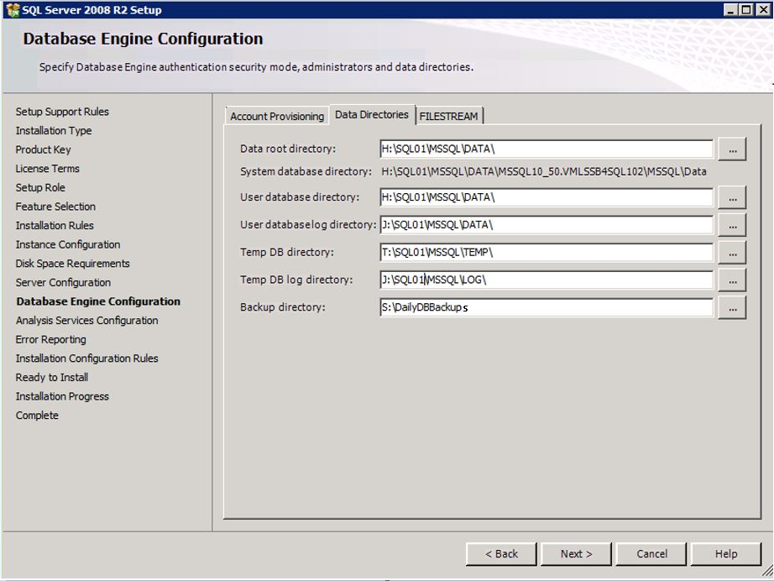

1. Change the data directories to match the path, then click the FILESTREAM tab and ensure to not enable Filestream.
2. On the Analysis Services configuration, add the adminitrative AD group you plan on using for server adminsitration.
3. Click the DATA Directories

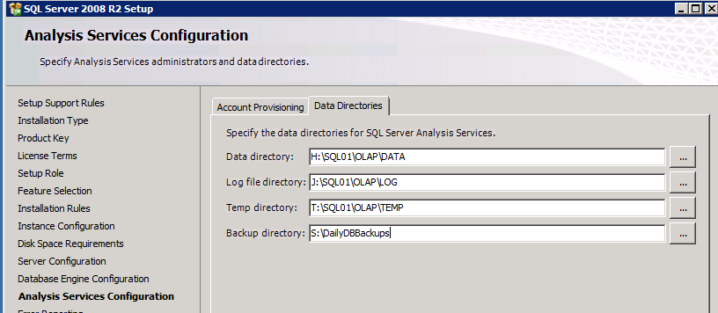

1. Click thru the “next’s and install”, and when that instance is complete-click close. Click New installation again in the SQL Server Installation Center

#### Instance 2 Installation

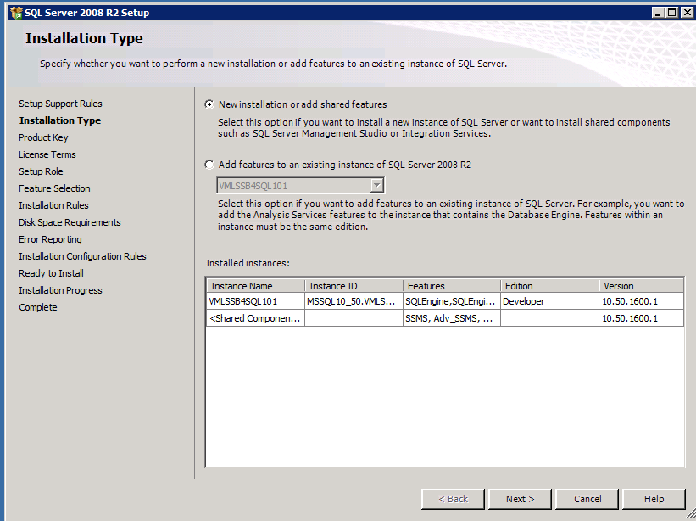

1. Mount or have mounted the SQL ISO file or DVD and begin by using setup.exe
2. Choose Installation type: New installation
   * Do **NOT** install Reporting Services or BIDS. Shared Featured directories go on F:
   * MS-SQL Server Instances: First instance is <servername>101, second is 102 (ex. VMLSSB4SQL101, VMLSSB4SQL102)

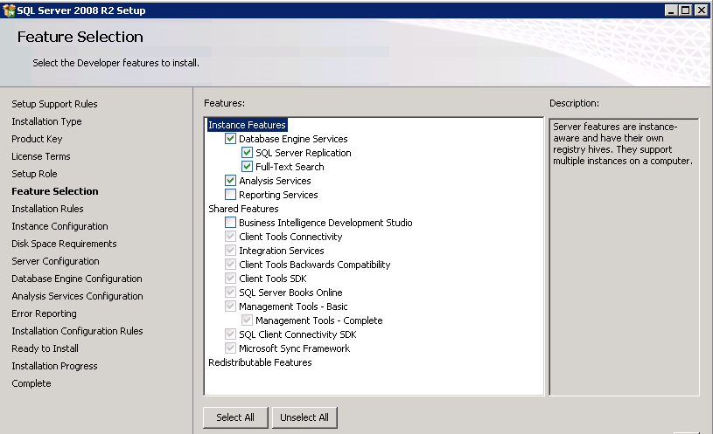

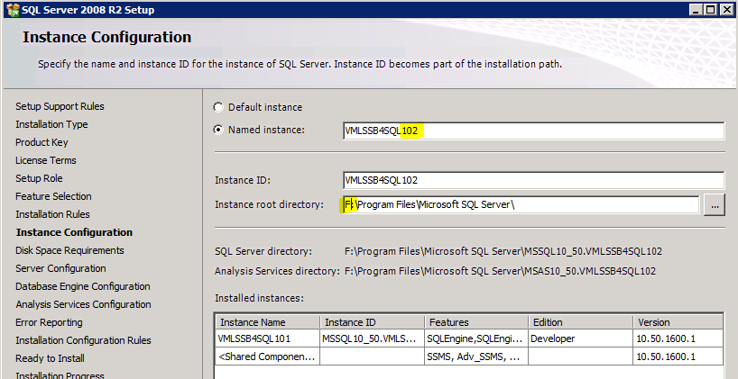

1. Put in the servername, Change the instance root, but make the second instance a “102” in the name and click Next.



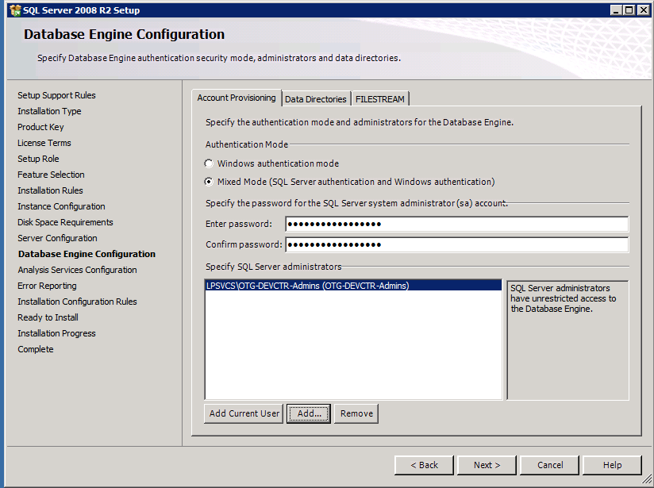

1. Add your admin group above, and go to the data directory tab and input the proper data directories. On the FILESTREAM, ensure you do not have that option selected.

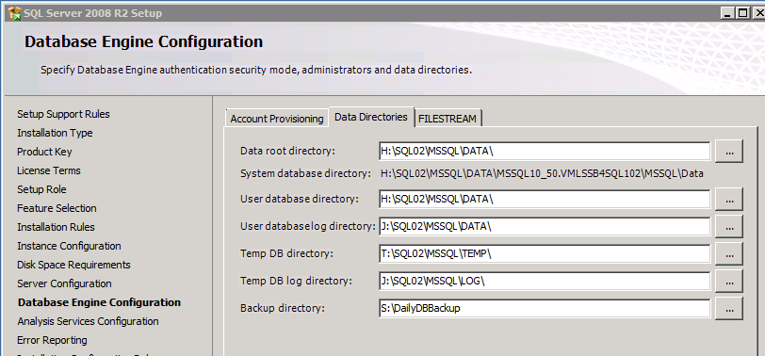

1. On the Analysis Services configuration, add the adminitrative AD group you plan on using for server adminsitration.
2. Click the DATA Directories and ensure the proper directories are input:

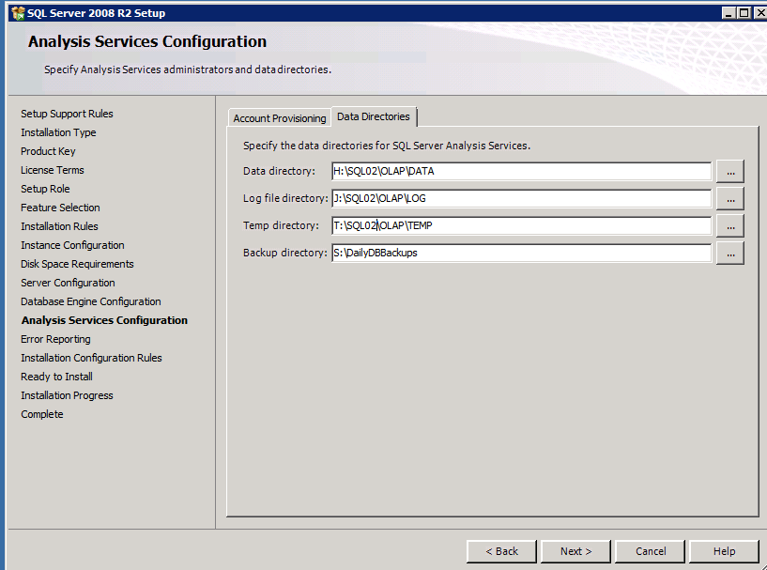

1. Click next, next, next and Install

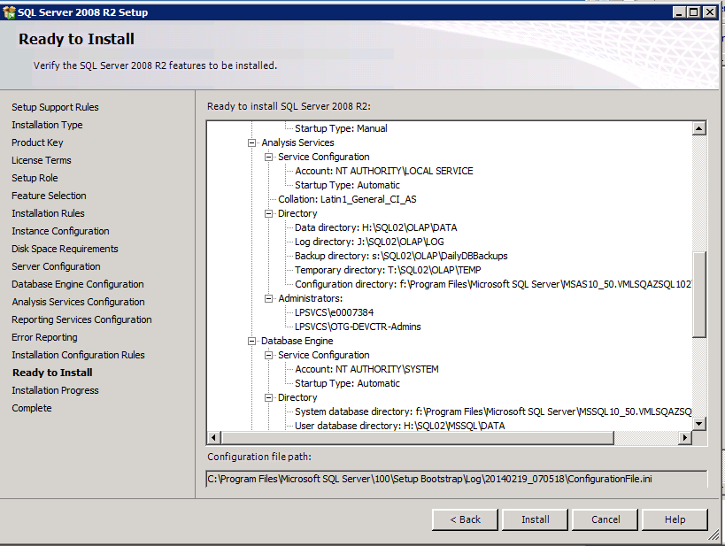

1. Configure listening ports (the ports can be changed to your standards)
2. Open SQL Server Configuration Manager.
3. For each Instance, enable TCP/IP

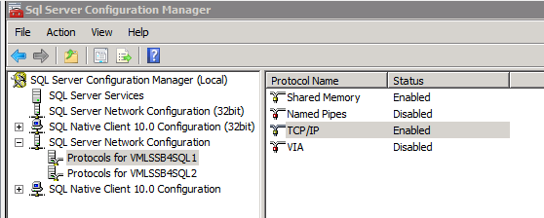

1. Open the properties, and on the IP Addresses scroll to the bottom and blank out the Dynamic ports, and enter the correct port for each instance:

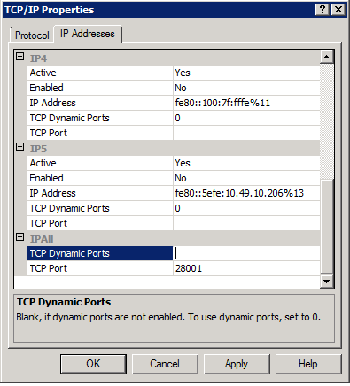

* LPSSQL101=1433
* LPSSQL102=28001
* Start SQL services.

1. From Services.msc – disable both of the SQL Full-Test Filter Daemon Lanucher and SQL Server Analysis Services on the startup type of the service.
2. When complete, shut down all SQL services , close all SQL windows, and install MSSQL2K8R2 SP2. Reboot.

#### SSDT Installation to support DAC pack installation files (not applicable for SQL 2014 Installations)

1. Execute F:\installs\SQL-and-RPT\SSDTNetworkInstall\SSDT2010NetworkInstall\SSDTSetup.exe
2. Click “I agree” on the License Terms, and Install

#### Seed the LendingSpace Starter Databases

1. Copy the databases to the SQL Server F:\DeploymentCode\<version#> directory and the instructions will guide you through the restore process *See the DB Execution section below for full instructions*
2. Change the LSAPP and LSReports account passwords to your company standards. Do not use a password that contains an ampersand. Record the passwords!
3. The Service account needs to be SA equivalent until the Environment is completely operational. The LSAPP needs to be SA on the online instance, while the Lsreports user needs to be SA on the reporting instance.

## WebSphere Application Server Installation

Overview of a typical WAS naming convention setup for Lending Space:

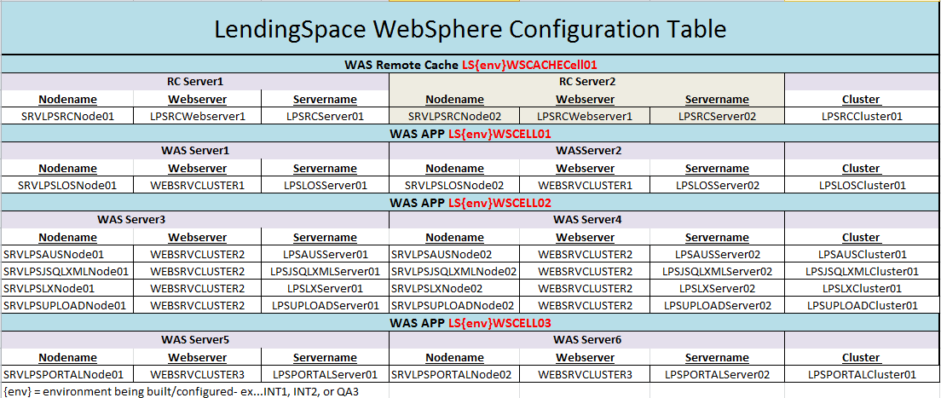

Prerequisites:

* Login and install all software as the Service Account created from the server build checklist

### IBM WebSphere Installation - WAS1,WAS2,WAS3,WAS4,WAS5,WAS6,Remote CACHE1, Remote CACHE2

1. Execute Install.exe from F:\Installs\WAS\WAS7.0-win64\WAS7.0\WAS
2. Click Next to begin the installation
3. Accept license agreement and click Next
4. Click Next from the System Prerequisites Check

* If System Prerequisites Check produces a warning, still continue by clicking Next

1. Do not select anything on the Install options, click Next
2. Select installation Directory as “F:\Data\IBM\WebSphere\AppServer” and click Next

* If you receive a Warning about symbolic links, click OK on the path Warning

1. Select None on WAS Environments and Click Next
2. Click Yes on proceeding without creating a profile.
3. Do not select “Create a repository for Centralized Installation Managers” and click Next
4. Click Next on Installation Summary, then click Finish

### IBM HTTP (IHS) Installation - WAS1,WAS2,WAS3,WAS4,WAS5,WAS6,Remote CACHE1, Remote CACHE2

1. Execute Install.exe from F:\Installs\WAS\WAS7.0-win64\IHS\IHS
2. Click Next to begin the installation
3. Accept license agreement and click Next
4. Click Next from the System Prerequisites Check

* If System Prerequisites Check produces a warning, still continue by clicking Next

1. Select installation Directory as “F:\Data\IBM\HTTPServer” and click Next

* If you receive the a pop-up warning about symbolic links, click OK to continue

1. Use the default ports (80 for HTTP, 8008 for Admin) and click Next
2. Select both to run as Windows Services and local system account (will change later in the documentation), and click Next
3. Provide Authentication information for accessing the IBM HTTP admin server, Enter admin as user name and password.

* UserID: admin (examples only, make sure you document the values you use for your environment)
* Password: admin

1. Click Next to continue
2. Deselect Installation of the HTTP Server plugin for WAS, and click Next
3. Click Next from the Installation Summary window
4. Click Finish button to exit the wizard.

### IBM “Update Installer” Installation - WAS1,WAS2,WAS3,WAS4,WAS5,WAS6,Remote CACHE1, Remote CACHE2

1. Execute Install.exe from F:\Installs\WAS\WAS7.0-win64\WAS7.0\UpdateInstaller
2. Click Next to begin the installation
3. Accept the terms and conditions agreement and click next
4. In the following step fix pack checks the compatibility and requirements of the system. If the test is passed click next

* If System Prerequisites Check produces a warning, still continue by clicking Next

1. Select installation Directory as “F:\Data\IBM\WebSphere\UpdateInstaller” and Next

* Click OK if a warning is received about symbolic links

1. Click Next at the Installation Summary window
2. Deselect Launch IBM check box and click Finish

### Fix Pack Installation For WAS/IHS - WAS1,WAS2,WAS3,WAS4,WAS5,WAS6,Remote CACHE1, Remote CACHE2

1. Prior to applying the fix packs, stop any services or processes that are java related
2. Copy all 3 fix packs from F:\Installs\WAS\FIX PACKS and paste to F:\DATA\IBM\WebSphere\UpdateInstaller\Maintenance

* There are 2 fix pack files for WAS, and one for HIS-HTTP

1. Open the Updater from the Windows Start menu
2. Click Next in the IBMUpdate Installer Window
3. Verify the directory path is “F:\Data\IBM\WebSphere\AppServer” and click Next
4. Select install maintenance package and click next.
5. Ensure the directory path is F:\DATA\IBM\WebSphere\UpdateInstaller\maintenance and click Next
6. Click next from the Installation Summary window
7. When you receive the installation complete, click Relaunch To apply IBM HTTP Hotfix

### Fix Pack Installation for IHS

1. Click the down arrow by the Directory Path, select F:\Data\IBM\HTTPServer and click Next

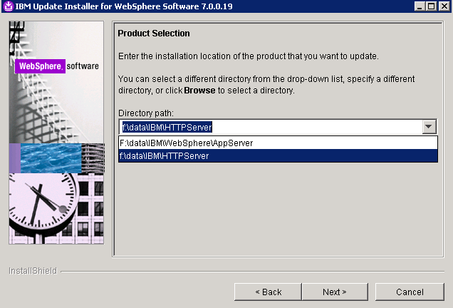

1. Select Install maintenance package and click Next
2. Ensure the directory path is F:\DATA\IBM\WebSphere\UpdateInstaller\Maintenance and click Next
3. Click Next from the Installation Summary window
4. Installation Complete, click Finish

Complete Websphere and IHS installations on ALL cache and ALL WAS APP servers before proceeding with any configurations

## WebSphere Remote Cache CELL Configuration

### WebSphere Deployment Manager Creation: Remote Cache Server 1

1. Execute PMT.bat from “F:\Data\IBM\WebSphere\AppServer\bin\ProfileManagement”
2. Click the “Create” button to start the profile creation process.
3. In the “Environment Selection” window select the “Management” option and click the “Next” button.
4. In the Server Type Selection screen, select “Deployment manager” option and click “Next”.
5. In the “profile Creation Options” screen select the “Advanced profile creation” option and click “Next”.
6. In the “Optional Application Deployment” screen leave the “Deploy the administrative console” option “checked” and click “Next”. This option will enable web based administration for the created profile.
7. In the “Profile Name and Location” screen change the profile name and directory.

* Profile Name: cell01_dmgr
* Directory: F:\Data\IBM\WebSphere\AppServer\profiles\cell01_dmgr

1. Click “Next”
2. In the “Node, Host, and Cell Names” screen change the Node name, host name and cell name.

* Node Name: Cellmanager01
* Host Name: full DNS name for that server
* Cell Name: dmgrCell01

1. Click “Next”
2. In the “Administrative Security Screen” make sure the “Enable administrative security” is checked and provide the username and password click “Next”.

* (Make sure you document the credential values you use for your environment)

1. In the “Security Certificate (Part 1)” screen leave the default options as-is and click “Next”.
2. In the “Security Certificate (Part 2)” screen leave all of the default values and click “Next”.
3. In the “Port Values Assignment” screen leave the port values as-is and click “Next”.

* Note: if you have more than one profile, make sure the port values are unique.

1. In the “Windows Service Definition” screen, make sure “Run the deployment manager process as a Windows service” is “Checked” and the “Log on as a local system account” is “selected”. Leave the “Startup type” as “automatic” and click “Next”.
2. In the “Profile Creation Summary” screen verify the summary details and click the “Create” button.
3. Once the profile is created successfully, in the “profile Creation Complete” screen “check” the “Launch the First step console” and Click the “Finish” button.
4. In the “First steps” window click the “Installation verification” look. This will verify the profile installation is done correctly and also start the Deployment Manager. Installation Verification is required to start the deployment manager prior to creating individual profiles.
5. Verify for the “The Installation verification is complete” in the First Steps Output screen.
6. Verify the service was created in the windows services listing (services.msc) (Looking for IBM WAS Server v7 –CellManager01)
7. WebSphere Profile & Node Creation: Remote Cache Server 1
8. Execute PMT.bat from “F:\Data\IBM\WebSphere\AppServer\bin\ProfileManagement” if the tool is not still running.
9. From the “Profile Management Tool” click the “Create” button
10. Select the “Custom Profile” option and click the “Next” button.
11. In the “profile Creation Options” screen select the “Advanced profile creation” option and click “Next”.

* Profile Name: SRVLPSRCNode01
* Profile Directory: F:\DATA\IBM\WebSphere\AppServer\profiles\SRVLPSRCNode01

1. Click “Next”
2. In the “node and host names” screen

* Node name: SRVLPSRCNode01
* Host name: <actual servername.domain.com>

1. Click “Next”
2. In the Federation Screen

* Deployment manager host name: <actual servername.domain.com>
* Deployment manager SOAP port number: 8879
* Deployment manager authentication
* Enter a username and password – RECORD this information

1. Leave the Federate this Node Later option unchecked, and click “Next”
2. In the Security Certificate (Part 1) screen, just click Next button.
3. In the Security Certificate (Part 2) screen, just click the Next button.
4. In the Port Values Assignment screen, Normally, you can just click Next. If there is a port conflict, make sure to change the value based on the Recommended Port Values. Click Next button.
5. On the Profile Creation Summary screen, click “Create” button to create the profile.
6. After the successful creation, click Finish button to launch the First Steps Console. The profile(s) should be seen from the Profile Management Tool. Click Exit and also close the PMT.
7. Execute Firststeps.bat from F:\DATA\IBM\WebSphere\AppServer\profiles\cell01_dmgr\firststeps directory.
8. Click the “Administrative console” and login to WAS console with the userid and passwords created for the profile from steps above.
9. (If you have any browser issues running the console, select Tools from the Menu bar, Compatibility View Settings and add localhost(or run all in compatibility mode) , close and try to run the Admin Console)
10. From the Websphere Admin Console select System administration 🡪 Nodes look to verify the nodes. In the right frame, you should see Nodes listed along with the Deployment Cell Manager.

### WebSphere Profile & Node Creation: Remote Cache Server 2

In development environments there is not always a second Cache Server. Skip past this section if applicable.

1. USE PMT (Profile Management tool) from F:\Data\IBM\WebSphere\AppServer\firststeps\firststeps.bat
2. From the “Profile Management Tool” click the “Create” button
3. Select the “Custom Profile” option and click the “Next” button.
4. In the “profile Creation Options” screen select the “Advanced profile creation” option and click “Next”.

* Profile Name: SRVLPSRCNode02
* Profile Directory: F:\DATA\IBM\WebSphere\AppServer\profiles\SRVLPSRCNode02

1. Click “Next”
2. In the “node and host names” screen

* Node name: SRVLPSRCNode02
* Host name: <actual servername.domain.com> (in your environment)

1. Click “Next”
2. In the Federation Screen

* Deployment manager host name: <FIRST CACHE SERVERNAME.domain.com>
* Deployment manager SOAP port number: 8879
* Deployment manager authentication
* Enter a username and password – RECORD this information

1. Leave the Federate this Node Later option unchecked, and click “Next”
2. In the Security Certificate (Part 1) screen, just click Next button.
3. In the Security Certificate (Part 2) screen, just click the Next button.
4. In the Port Values Assignment screen, Normally, you can just click Next. If there is a port conflict, make sure to change the value based on the Recommended Port Values. Click Next button.
5. On the Profile Creation Summary screen, click “Create” button to create the profile.
6. After the successful creation, click Finish button to launch the First Steps Console. The profile(s) should be seen from the Profile Management Tool. Click Exit and also close the PMT.
7. FROM Remote Cache Server 1:

* Execute Firststeps.bat from F:\DATA\IBM\WebSphere\AppServer\profiles\cell01_dmgr\firststeps directory.
* Click the “Administrative console” and login to WAS console.

1. From the Websphere Admin Console select System administration 🡪 Nodes look to verify the nodes. In the right frame, you should see Nodes listed along with the Deployment Cell Manager.

### WebSphere Server Creation: Remote Cache Server 1

1. From the Administrative Console - (F:\Data\IBM\WebSphere\AppServer\profiles\cell01_dmgr\firststeps\firststeps.bat)
2. Use the account and password supplied during profile creation.
3. From Servers 🡪 Server Types 🡪 Websphere application servers and click New button in the right frame.
4. Select the first Node – “SRVLPSRCNode01” from the dropdown and add “LPSRCServer01”
5. In Server template screen– select the default option and click the Next button.
6. In the Server Specific Properties screen (shown above) – leave the “Generate Unique Ports” option checked and click Next button.
7. Click the Finish button in Confirm new server screen (shown above) to create the server.
8. The Application Server is now listed. Now click the Save link in the messages block for the changes to be reflected in the Master Configuration file.
9. Select the Application Server – “LPSRCServer01” link and in the Configuration screen change the following

* Check Parallel Start option
* Check Start components as needed option
* Change the Class loader Policy as Multiple

1. Click Apply button and Save link to reflect the changes into the Master Configuration file.
2. Click the Application Server , Communications 🡪click the link to Ports. DOCUMENT the WC_defaulthost port.
3. Click the Application Server , Server Infrastructure 🡪 Java and Process Management 🡪 Process definition, Java Virtual Machine
4. Check the Verbose Garbage Collection box
5. Change the Classpath (Remote Cache Servers do not contain a classpath)
6. Change the Initial Heap size : 4096
7. Change the Maximum Heap size: 8192
8. Generic JVM Arguments: -Dsun.io.useCanonCaches=false -XX:MaxPermSize=128m -XX:NewSize=32m -XX:PermSize=32m -XX:+UseConcMarkSweepGC -XX:+UseParNewGC
9. Click Apply button and Save link to reflect the changes into the Master Configuration file.

#### WebSphere Application Servers -LOG File Size/Retention

1. From within the application server profile navigate to: Server Infrastructure > Java and Process Management > Process Definition > Logging and Tracing (under Additional Properties) > JVM Logs, and adjust the settings on the Configuration tab as follows:
2. System.out

* Log File Rotation: File Size: 5MB Maximum size. Maximum # of historical log files: 30

1. System.err

* Log File Rotation: File Size: 5MB Maximum size. Maximum # of historical log files: 30

1. Click OK, then click Save (directly to the master configuration):
2. Select the Application Server, Server Infrastructure, Java and Process Management, Monitoring policy:
3. Change the node restart state to RUNNING
4. Click Apply button and Save link to reflect the changes into the Master Configuration file.

Note: Do not create server for the second node, they are created when creating the clusters.

### WebSphere Cluster Creation: Remote Cache

1. Go to Servers 🡪 Clusters 🡪 WebSphere application server clusters link in the console. Then click the “New” button in the right frame.
2. Enter the Cluster name “LPSRCCluster01” Leave the Prefer Local option checked and configure HTTP session memory-to-memory replication option unchecked. Click the Next button.
3. In the Create First Cluster Member screen , Select the third option – Create the member by converting an existing application server - LPSRCServer01 from the list, and take the default first node. Leave the Weight field value as 2. Click the Next button.
4. NOTE: For a Single Node Cell(non-HA), do not put a membername below, just click Next !
5. In the Create Additional Cluster Members screen, provide a Member Name LPSRCServer02and Select Node 2 – SRVLPSRCNode02. Refer to the chart for naming conventions. Leave the Weight field value as 2 and Generate unique HTTP ports option checked. Now click the Add Member button. The member will get added to the list at the bottom (as shown above). Click the Next button.
6. Click the Finish button to create the cluster.
7. Click the Save link to reflect the changes to the Master Configuration.
8. *Do not execute below for single node clusters (non-HA)*
9. Log into Remote Cache Server 2 (if in an HA configuration)
10. Start Node 2
11. From a command prompt Execute startNode.bat batch file from:
12. “F:\Data\IBM\WebSphere\AppServer\profiles\SRVLPSRCNode02\bin”
13. Watch the output on the window, and wait for the “open for e-business” entry.
14. Verfiy the nodes are started, and in a synchronized status with the deployment manager using System Administration 🡪 Nodes in the Admin Console.
15. Start the Cluster server using Servers 🡪 Clusters 🡪 Web application server clusters link. Select the newly created cluster and click the Start button. This will start the cluster and in turn will start the application servers.
16. WebSphere Server Modification: Remote Cache Server 2
17. From the Administrative Console - (F:\Data\IBM\WebSphere\AppServer\profiles\cell01_dmgr\firststeps\firststeps.bat)
18. Use the account and password supplied during profile creation.
19. From Servers 🡪 Server Types 🡪 Websphere application servers and Select the second Remote Cache server “LPSRCServer02”
20. Check Parallel Start option
21. Check Start components as needed option
22. Change the Class loader Policy as Multiple
23. Click Apply button and Save link to reflect the changes into the Master Configuration file.
24. Click the Application Server , Communications 🡪click the link to Ports. DOCUMENT the WC_defaulthost port.
25. Click the Application Server , Server Infrastructure 🡪 Java and Process Management 🡪 Process definition, Java Virtual Machine
26. Change the Classpath (Remote Cache Servers do not contain a classpath)
27. Check the Verbose Garbage Collection box
28. Change the Initial Heap size : 4096
29. Change the Maximum Heap size: 8192
30. Generic JVM Arguments: -Dsun.io.useCanonCaches=false -XX:MaxPermSize=128m -XX:NewSize=32m -XX:PermSize=32m -XX:+UseConcMarkSweepGC -XX:+UseParNewGC
31. Click Apply button and Save link to reflect the changes into the Master Configuration file.
32. WebSphere Application Servers -LOG File Size/Retention
33. From within the application server profile navigate to: Server Infrastructure > Java and Process Management > Process Definition > Logging and Tracing (under Additional Properties) > JVM Logs, and adjust the settings on the Configuration tab as follows:
34. System.out
35. Log File Rotation: File Size: 5MB Maximum size. Maximum # of historical log files: 30
36. System.err
37. Log File Rotation: File Size: 5MB Maximum size. Maximum # of historical log files: 30
38. Click OK, then click Save (directly to the master configuration):
39. Select the Application Server, Server Infrastructure, Java and Process Management, Monitoring policy:
40. Change the node restart state to RUNNING
41. Click Apply button and Save link to reflect the changes into the Master Configuration file.

### Cache Refresh

1. Login to the admin console on RC Node 01

2. Navigate to Servers 🡪 Server Types 🡪 WebSphere application servers

3. Select the RC 01 server

4. Under Communications, select Ports

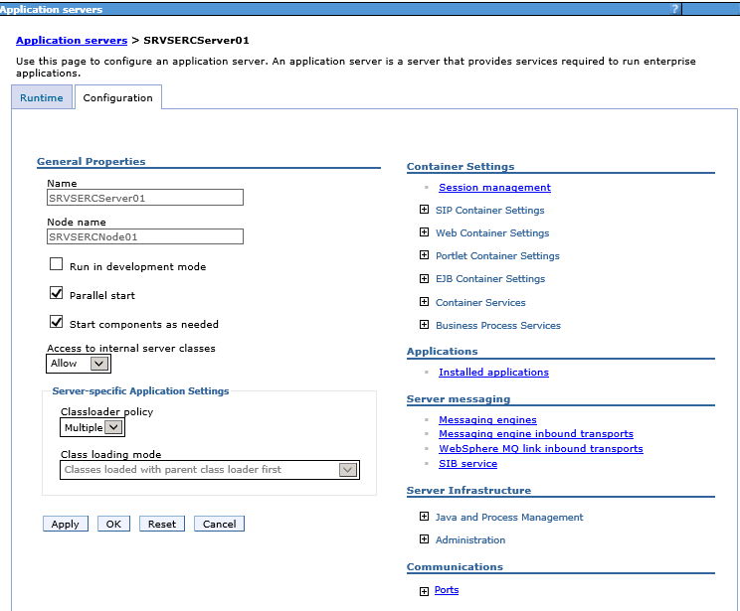

5. Record the **Port** for **WC_defaulthost** . This is the port number used for adding the default host.

### WebSphere - Add Virtual Host RC Alias

6. Select **Environment** 🡪 **Virtual hosts** 🡪 **default_host**

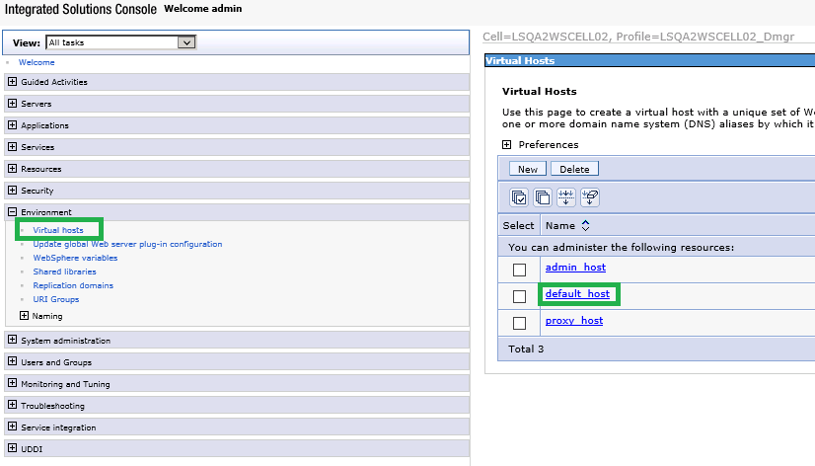

7. Select **Host Aliases**

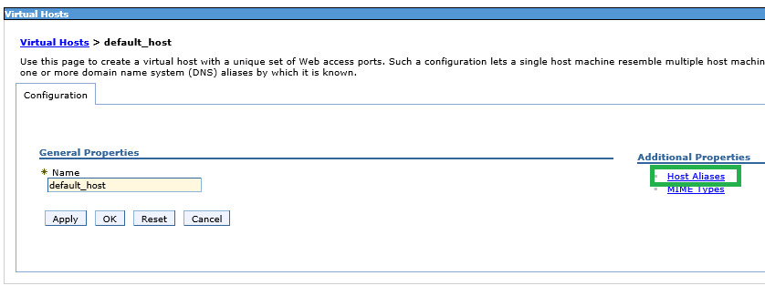

8. Select **New** to create a new host alias. ***Note: steps 4 – 7 will need to be done for Host Name * and the DNS name of the secondary server. Both will have the same Port.***

9. Enter * for Host Name and under Port enter the value from step 5 above.

10. Click **Apply** to apply the changes.

11. Click **Save** to save the changes.

12. Select **New** to create a new host alias.

13. Enter the RC 01 server DNS name for Host Name and under Port enter the value from step 5 above.

14. Click **Apply** to apply the changes.

15. Click **Save** to save the changes.

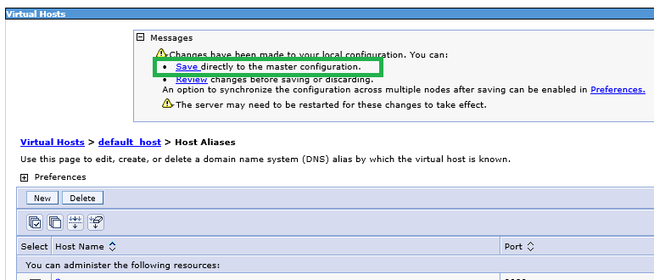

16. Perform the same steps for RC 02 server.

#### Deploy the application template WAR file - RemoteCache

1. From the Admin console of the Remote Cache Server 1: select Applications 🡪 Application Types 🡪 WebSphere enterprise applications. On the right frame, click Install button.
2. Select the sample WAR file for the application you are installing from - F:\Installs\WAS\WAR Files\SRVLPSRC.war, click Next
3. Select the Fast Path option and click the Next button.
4. Step 1:installation options - provide the Application Name SRVLPSRC, (remove the _war) Highlight all the 3 File Permissions as shown below are click “Next” button.
5. Step2: map modules to servers - select the associated cell\node\cluster and click Apply. The Server field will update with the new information,
6. Select the module, and Click “Next” button
7. Step 3: map virtual hosts for web modules - map the virtual host ar “default_host” for the selected Web Module and click the “Next” button
8. Step 4: map context roots for web modules - change the “Contect Root” as /SRVLPSRC and click “Next”.
9. Step 5: summary - click “Finish” button to install the application onto all the nodes in the cluster.
10. The Screen would show the message “Application installed successfully”. Click the Save link to reflect the changes to the master configuration file.
11. Start the installed application

### Copy “Magic” 5 files – RemoteCache Server 1

1. Copy the files from “F:\Installs\WAS\Magic 5 files (.xml and .wsdd)\RC\Deploy Mgr config-cells” directory To:

“F:\Data\IBM\WebSphere\AppServer\profiles\cell01_dmgr\config\cells\dmgrcell01\applications\SRVLPSRC.ear\deployments\SRVLPSRC\SRVLPSRC.war\WEB-INF” directory and OVERWRITE any files that exist

1. Copy the files from “F:\Installs\WAS\Magic 5 files (.xml and .wsdd)\RC\Node 01 config-cells” directory To:

“F:\Data\IBM\WebSphere\AppServer\profiles\SRVLPSRCNode01\config\cells\dmgrcell01\applications\SRVLPSRC.ear\deployments\SRVLPSRC\SRVLPSRC.war\WEB-INF” directory and OVERWRITE any files that exist

1. Copy the files from “F:\Installs\WAS\Magic 5 files (.xml and .wsdd)\RC\Node 01 installed apps” directory To:

“F:\Data\IBM\WebSphere\AppServer\profiles\SRVLPSRCNode01\installedApps\dmgrcell01\SRVLPSRC.ear\SRVLPSRC.war\WEB-INF” directory and OVERWRITE any files that exist

### Copy “Magic” 5 files – RemoteCache Server 2 (if applicable)

1. Copy the files from “F:\Installs\WAS\Magic 5 files (.xml and .wsdd)\RC\Node 02 config-cells” directory To:

“F:\Data\IBM\WebSphere\AppServer\profiles\SRVLPSRCNode02\config\cells\dmgrcell01\applications\SRVLPSRC.ear\deployments\SRVLPSRC\SRVLPSRC.war\WEB-INF” directory and OVERWRITE any files that exist

1. Copy the files from “F:\Installs\WAS\Magic 5 files (.xml and .wsdd)\RC\Node 02 installed apps” directory To:

“F:\Data\IBM\WebSphere\AppServer\profiles\SRVLPSRCNode02\installedApps\dmgrcell01\SRVLPSRC.ear\SRVLPSRC.war\WEB-INF” directory and OVERWRITE any files that exist

### WebSphere Web Server Creation: Remote Cache1 Server

1. From the Admin console for each deployment manager, go to the Servers 🡪 Server Types 🡪 Web Servers link Click the New button.
2. In Step 1: Select the first Node and provide the web server name LPSRCWebserver1. Select the Type as IBM HTTP Server and click the Next button.
3. In Step 2: Click Next button on the screen.
4. In Step 3: leave the port as 80. Change the web server installation location F:\Data\IBM\HTTPServer , leave the Service name as the default, and change the Plug-in installation location to F:\Data\IBM\HTTPServer\Plugins
5. In Step 4: confirmation screen click the Finish button. Click Save link in the next screen to save changes to master configuration.

### WebSphere Web Server Plug-in Generation: Remote Cache Server 1

After all application templates are installed within each cell

*Note1: Make a backup of the original plugin if one exists. Located:*

F:\Data\IBM\HTTPServer\Plugins\config\LPSRCWebserver1\plugin-cfg.xml

From the cell-manager Admin console on RemoteCache server 1:

Servers 🡪 Servertypes🡪 Web Servers, Select the Web server check block and click generate plug-in

### Disabling Automatic Webserver Plugin Generation: Remote Cache Server 1

1. Select the webserver (click the name) and from the Additional Properties section, click Plug –in properties
2. Deselect Automatically generate the plug-in configuration file and Automatically propagate plug-in configuration file
3. Click Apply and save to the master configuration

### WebSphere Web Server Plug-in Propagation: Remote Cache Server 1

Select web server and Click Propagate plug-in

### HTTP-Plugin BIN folder copy for Remote Cache Server 1

Copy F:\Installs\WAS\Bin folder for HTTP server plugins\bin directory to F:\Data\IBM\HTTPServer\Plugins on Remote Cache Server 1

### HTTP-Plugin BIN folder copy for Remote Cache Server 2

Copy F:\DATA\IBM\HTTPServer\Plugins directory from Remote Cache Server 1 to F:\DATA\IBM\HTTPServer on the Remote Cache Server 2

### HTTP server final configuration: Remote Cache Server 1 and 2

1. Copy the httpd.conf file from

* “F:\Installs\WAS\HTTP Conf files\Cell RC” to F:\DATA\IBM\HTTPServer\conf

1. Edit the following areas in each HTTPD.conf

* Listen and ServerName attributes
* IPv4 support, modify: Listen 0.0.0.0:80 – change 0.0.0.0 to the servers Name

1. Modify the Servername directive:

* ServerName servername:80 – enter Servers FQDN ex. myserver.domain.com
* Alias section:
* Any location referring to <StorageServerVIP> - change to the storage server VIP or IP address. Not all servers contain this alias.
* WebSpherePlugConfig section
* Look for the line:  
  WebSpherePluginConfig "F:\Data\IBM\HTTPServer\Plugins\config\LPSRCWebserver1\plugin-cfg.xml - ensure the correct WEBSRVCLUSTER for the cell being configured

1. Change the Timeout value from 300 to 600
2. Restart HTTP services

### Transaction Timeout – Cache1 and Cache2 Servers

1. Login to the admin console

2. Navigate to Servers… Server Types… WebSphere application servers.

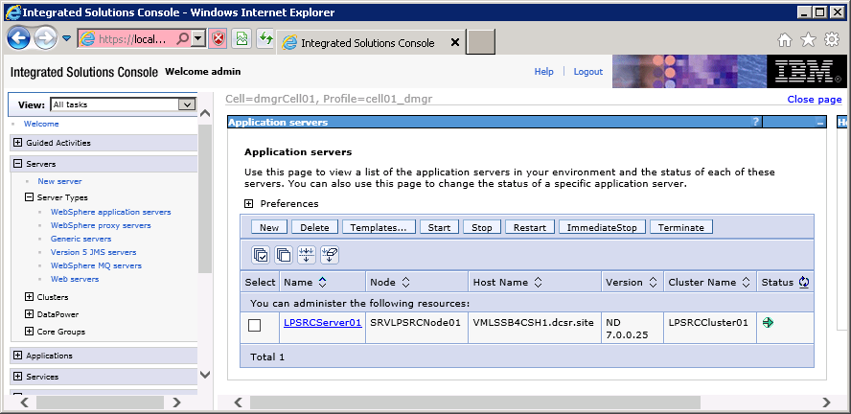

3. Click on the primary server in the cluster. LPSRCServer01 in the example.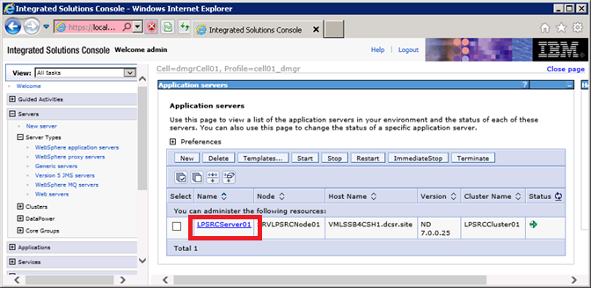

4. Click on **Container Services**.

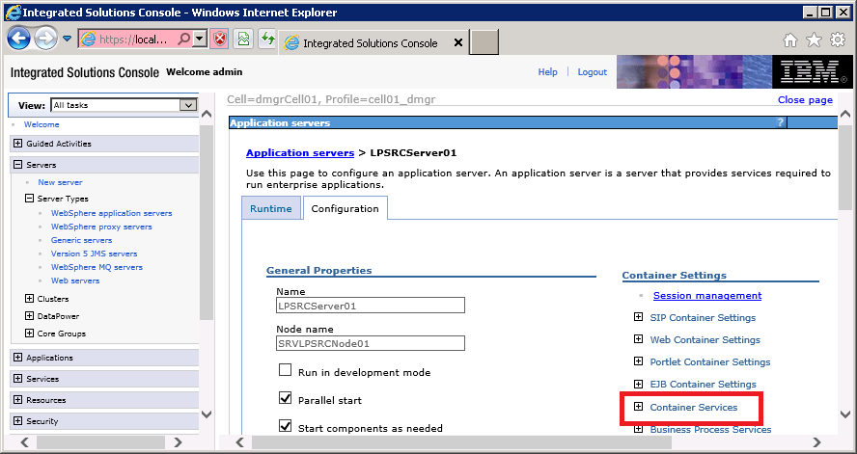

5. Click on **Transaction Service**.

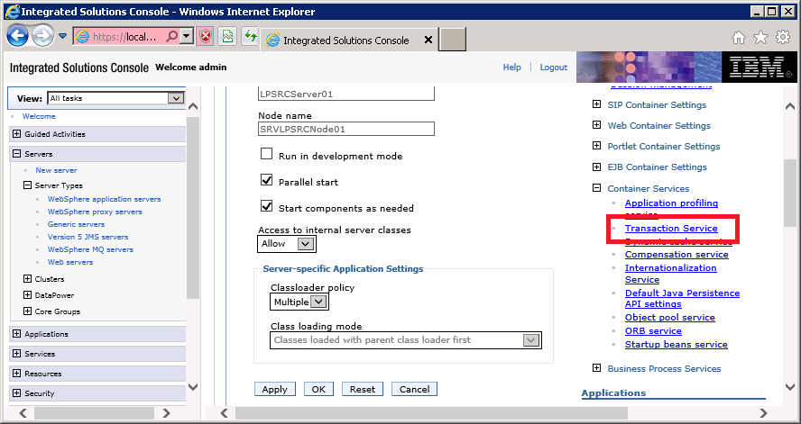

6. Change both the **Total transaction lifetime timeout** and **Maximum transaction timeout** values to **600**.

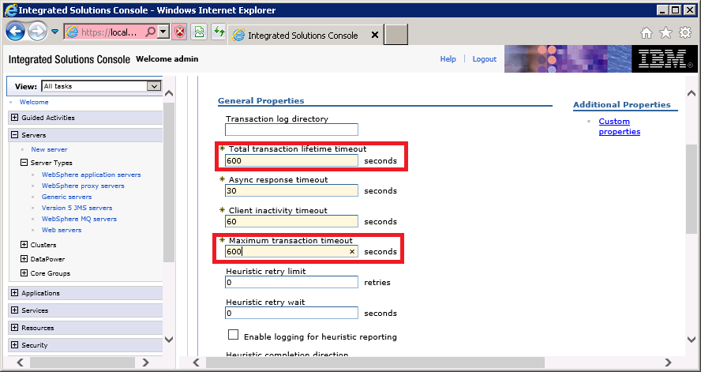

7. Click on OK, and then Save to the master configuration.

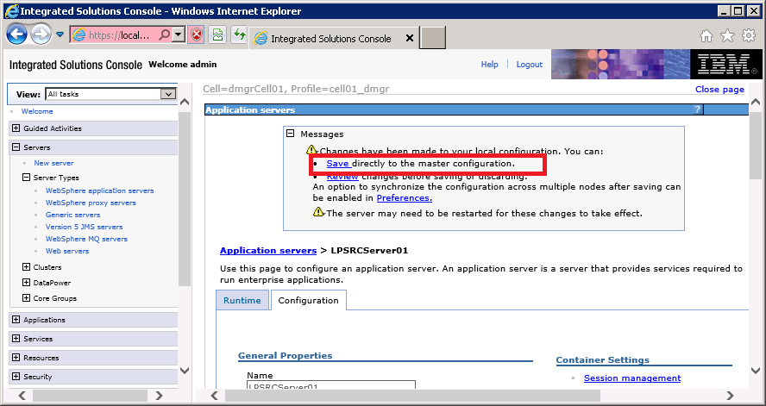

8. If multiple Remote Cache servers exist on the cluster, then repeat steps 3 through 7 for the secondary server.

### WebSphere Windows Services Creation: Remote Cache Server1

1. Open an administrative command prompt and navigate to F:\Data\IBM\Websphere\AppServer\bin
2. Run the following commands:

* “WASService -add SRVLPSRCNode01_nodeagent -serverName nodeagent -profilePath F:\Data\IBM\WebSphere\AppServer\profiles\SRVLPSRCNode01 -wasHome F:\Data\IBM\WebSphere\AppServer -logRoot F:\Data\IBM\WebSphere\AppServer\profiles\SRVLPSRCNode01\logs\nodeagent -logFile F:\Data\IBM\WebSphere\AppServer\profiles\SRVLPSRCNode01\logs\nodeagent\startServer.log"

1. Open services from Administrative Tools, manually change the startup mode for the services from manual to automatic.
2. Change the services credentials to the environment service account for the websphere services as well as the IBM HTTP Server 7.0 service.

### WebSphere Windows Services Creation: Remote Cache Server2

1. Open an administrative command prompt and navigate to F:\Data\IBM\Websphere\AppServer\bin
2. Run the following command:

* "WASService -add SRVLPSRCNode02_nodeagent -serverName nodeagent -profilePath F:\Data\IBM\WebSphere\AppServer\profiles\SRVLPSRCNode02 -wasHome F:\Data\IBM\WebSphere\AppServer -logRoot F:\Data\IBM\WebSphere\AppServer\profiles\SRVLPSRCNode02\logs\nodeagent -logFile F:\Data\IBM\WebSphere\AppServer\profiles\SRVLPSRCNode02\logs\nodeagent\startServer.log"

1. Open services from Administrative Tools, manually change the startup mode for the services from manual to automatic.
2. Change the services credentials to the environment service account for the websphere services as well as the IBM HTTP Server 7.0 service.

## WebSphere CELL-1 Configuration - LOS

### WebSphere Deployment Manager Creation: WAS1 Server

1. Execute PMT.bat from “F:\Data\IBM\WebSphere\AppServer\bin\ProfileManagement”
2. Click the “Create” button to start the profile creation process.
3. In the “Environment Selection” window select the “Management” option and click the “Next” button.
4. In the Server Type Selection screen, select “Deployment manager” option and click “Next”.
5. In the “profile Creation Options” screen select the “Advanced profile creation” option and click “Next”.
6. In the “Optional Application Deployment” screen leave the “Deploy the administrative console” option “checked” and click “Next”. This option will enable web based administration for the created profile.
7. In the “Profile Name and Location” screen change the profile name and directory.

* Profile Name: cell01_dmgr
* Directory: F:\Data\IBM\WebSphere\AppServer\profiles\cell01_dmgr

1. Click “Next”
2. In the “Node, Host, and Cell Names” screen change the Node name, host name and cell name.

* Node Name: Cellmanager01
* Host Name: full DNS name for that server
* Cell Name: dmgrCell01

1. Click “Next”
2. In the “Administrative Security Screen” make sure the “Enable administrative security” is checked and provide the username and password click “Next”.

* (Make sure you document the credential values you use for your environment)

1. In the “Security Certificate (Part 1)” screen leave the default options as-is and click “Next”.
2. In the “Security Certificate (Part 2)” screen leave all of the default values and click “Next”.
3. In the “Port Values Assignment” screen leave the port values as-is and click “Next”.

* Note: if you have more than one profile, make sure the port values are unique.

1. In the “Windows Service Definition” screen, make sure “Run the deployment manager process as a Windows service” is “Checked” and the “Log on as a local system account” is “selected”. Leave the “Startup type” as “automatic” and click “Next”.
2. In the “Profile Creation Summary” screen verify the summary details and click the “Create” button.
3. Once the profile is created successfully, in the “profile Creation Complete” screen “check” the “Launch the Frist step console” and Click the “Finish” button.
4. In the “First steps” window click the “Installation verification” look. This will verify the profile installation is done correctly and also start the Deployment Manager. Installation Verification is required to start the deployment manager prior to creating individual profiles.
5. Verify for the “The Installation verification is complete” in the First Steps Output screen.
6. Verify the service was created in the windows services listing (services.msc) (Looking for IBM WAS Server v7 –CellManager01)

### WebSphere Profile & Node Creation: WAS1 Server -LOS

1. Execute PMT.bat from “F:\Data\IBM\WebSphere\AppServer\bin\ProfileManagement” if the tool is not still running.
2. From the “Profile Management Tool” click the “Create” button
3. Select the “Custom Profile” option and click the “Next” button.
4. In the “profile Creation Options” screen select the “Advanced profile creation” option and click “Next”.

* Profile Name: SRVLPSLOSNode01
* Profile Directory: F:\DATA\IBM\WebSphere\AppServer\profiles\SRVLPSLOSNode01

1. Click “Next”
2. In the “node and host names” screen

* Node name: SRVLPSLOSNode01
* Host name: <actual servername.domain.com>

1. Click “Next”
2. In the Federation Screen

* Deployment manager host name: <actual servername.domain.com>
* Deployment manager SOAP port number: 8879
* Deployment manager authentication
* Enter a username and password – RECORD this information

1. Leave the Federate this Node Later option unchecked, and click “Next”
2. In the Security Certificate (Part 1) screen, just click Next button.
3. In the Security Certificate (Part 2) screen, just click the Next button.
4. In the Port Values Assignment screen, Normally, you can just click Next. If there is a port conflict, make sure to change the value based on the Recommended Port Values. Click Next button.
5. On the Profile Creation Summary screen, click “Create” button to create the profile.
6. After the successful creation, click Finish and do not launch the First Steps Console. The profile(s) should be seen from the Profile Management Tool. Click Exit and also close the PMT.

### WebSphere Profile & Node Creation: WAS2 Server -LOS

1. USE PMT (Profile Management tool) from F:\Data\IBM\WebSphere\AppServer\firststeps\firststeps.bat
2. From the “Profile Management Tool” click the “Create” button
3. Select the “Custom Profile” option and click the “Next” button.
4. In the “profile Creation Options” screen select the “Advanced profile creation” option and click “Next”.

* Profile Name: SRVLPSLOSNode02
* Profile Directory: F:\DATA\IBM\WebSphere\AppServer\profiles\SRVLPSLOSNode02

1. Click “Next”
2. In the “node and host names” screen

* Node name: SRVLPSLOSNode02
* Host name: <actual servername.domain.com>

1. Click “Next”
2. In the Federation Screen

* Deployment manager host name: < WAS1 SERVERNAME.domain.com> (in your environment)
* Deployment manager SOAP port number: 8879
* Deployment manager authentication
* Enter a username and password – RECORD this information

1. Leave the Federate this Node Later option unchecked, and click “Next”
2. In the Security Certificate (Part 1) screen, just click Next button.
3. In the Security Certificate (Part 2) screen, just click the Next button.
4. In the Port Values Assignment screen, Normally, you can just click Next. If there is a port conflict, make sure to change the value based on the Recommended Port Values. Click Next button.
5. On the Profile Creation Summary screen, click “Create” button to create the profile.
6. After the successful creation, click Finish button to launch the First Steps Console. The profile(s) should be seen from the Profile Management Tool. Click Exit and also close the PMT.

#### FROM WAS1 Server:

1. Execute Firststeps.bat from F:\DATA\IBM\WebSphere\AppServer\profiles\cell01_dmgr\firststeps directory.
2. Click the “Administrative console” and login to WAS console.
3. From the Websphere Admin Console select System administration 🡪 Nodes look to verify the nodes. In the right frame, you should see Nodes listed along with the Deployment Cell Manager.

### WebSphere Server Creation: WAS 1 Server -LOS

1. From the Administrative Console - (F:\Data\IBM\WebSphere\AppServer\profiles\cell01_dmgr\firststeps\firststeps.bat) Use the account and password supplied during profile creation.
2. From Servers 🡪 Server Types 🡪 Websphere application servers and click New button in the right frame.
3. Select the first Node – “SRVLPSLOSNode01” from the dropdown and add “LPSLOSServer01”
4. In Server template screen– select the default option and click the Next button.
5. In the Server Specific Properties screen (shown above) – leave the “Generate Unique Ports” option checked and click Next button.
6. Click the Finish button in Confirm new server screen (shown above) to create the server.
7. The Application Server is now listed. Now click the Save link in the messages block for the changes to be reflected in the Master Configuration file.
8. Select the Application Server – “LPSLOSServer01” link and in the Configuration screen change the following

* Check Parallel Start option
* Check Start components as needed option
* Change the Class loader Policy as Multiple

1. Click Apply button and then subsequently Save link to reflect the changes in the Master Configuration file.
2. Click the Application Server , Communications 🡪click the link to Ports. DOCUMENT the WC_defaulthost port.
3. Click the Application Server , Server Infrastructure 🡪 Java and Process Management 🡪 Process definition, Java Virtual Machine
4. Change the Classpath   
   "F:\Data\IBM\WebSphere\AppServer\profiles\SRVLPSLOSNode01; F:\data\IBM\WebSphere\AppServer\profiles\SRVLPSLOSNode01\classes;" (LOS requires both lines)
5. Check the Verbose Garbage Collection box
6. Change the Initial Heap size : 2048
7. Change the Maximum Heap size: 5120
8. Generic JVM Arguments: -Dsun.io.useCanonCaches=false -XX:MaxPermSize=1024m -XX:NewSize=640m -XX:PermSize=640m -XX:+UseConcMarkSweepGC -XX:+UseParNewGC
9. Click Apply button and Save link to reflect the changes into the Master Configuration file.

#### WebSphere Application Servers -LOG File Size/Retention

1. From within the application server profile, navigate to: Server Infrastructure > Java and Process Management > Process Definition > Logging and Tracing (under Additional Properties) > JVM Logs, and adjust the settings on the Configuration tab as follows:
2. System.out

* Log File Rotation: File Size: 5MB Maximum size. Maximum # of historical log files: 30

1. System.err

* Log File Rotation: File Size: 5MB Maximum size. Maximum # of historical log files: 30

1. Click OK, then click Save (directly to the master configuration):
2. Select the Application Server, Server Infrastructure, Java and Process Management, Monitoring policy:
3. Change the node restart state to RUNNING
4. Click Apply button and Save link to reflect the changes into the Master Configuration file.
5. From Servers 🡪 Server Types 🡪 Websphere application servers, select Web Server plug-in properties change the following
6. Use connection timeout to 0
7. Read/Write timeout to 0
8. Click Apply button and Save link to reflect the changes into the Master Configuration file.

NOTE: Do not create server for the second node, they are created when creating the clusters.

#### Hung Thread Issue Fix – for Portal\LOS Server Configuration Instructions

This must be done for both nodes, and entails the creation of a custom property in the Websphere application server to avoid HUNG Thread issue.

1. Select Websphere Application Servers > Application Server > Click Administation and Custom Properties

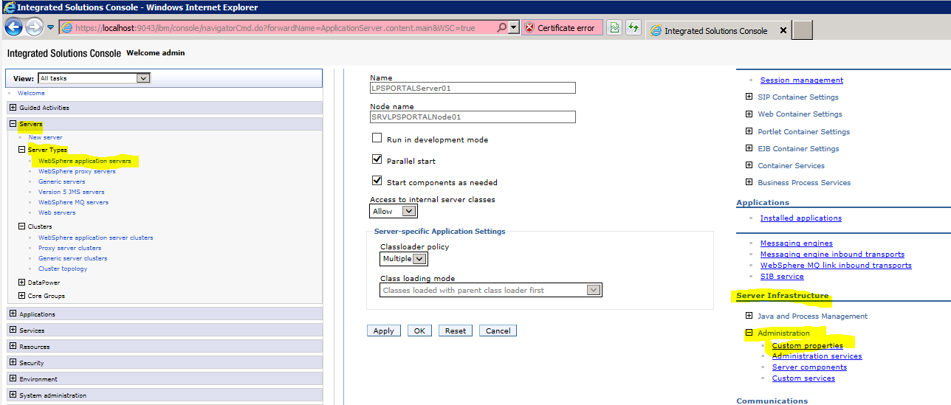

1. Click New
2. Add the following properties (suggestion – copy below and paste into given fields)
3. Property1:

* Name: com.ibm.websphere.threadmonitor.interval
* Value: 360
* Description: The frequency (in seconds) at which managed threads in the selected application server will be interrogated.
  + Click Apply and click OK
  + Save the changes.

1. Property2:

* Name: com.ibm.websphere.threadmonitor.threshold
* Value: 2100
* Description: The length of time (in seconds) in which a thread can be active before it is considered hung. Any thread that is detected as active for longer than this length of time is reported as hung.
  + Click Apply and click OK
  + Save the changes.

1. Property3:

* Name: com.ibm.websphere.threadmonitor.false.alarm.threshold
* Value: 100
* Description: The number of times (T) that false alarms can occur before automatically increasing the threshold. It is possible that a thread that is reported as hung eventually completes its work, resulting in a false alarm. A large number of these events indicates that the threshhold value is too small. The hang detection facility can automatically respond to this situation: For every T false alarms, the threshold T is increased by a factor of 1.5. Set the value to zero (or less) to disable the automatic adjustment.
  + Click Apply and click OK
  + Save the changes.

1. Property4:

* Name: com.ibm.websphere.threadmonitor.dump.java
* Value: False
* Description: Set to true to cause a javacore to be created when a hung thread is detected and a WSVR0605W message is printed. The threads section of the javacore can be analyzed to determine what the reported thread and other related threads are doing.
  + Click Apply and click OK
  + Save the changes.

### WebSphere Cluster Creation: -LOS

1. Go to Servers 🡪 Clusters 🡪 WebSphere application server clusters link in the console. Then click the “New” button in the right frame.
2. Enter the Cluster name “LPSLOSCluster01” Leave the Prefer Local option checked and configure HTTP session memory-to-memory replication option unchecked. Click the Next button.
3. In the Create First Cluster Member screen , Select the third option – Create the member by converting an existing application server - LPSLOSServer01 from the list, and take the default first node. Leave the Weight field value as 2. Click the Next button.
4. In the Create Additional Cluster Members screen, provide a Member Name
5. LPSLOSServer02
6. and Select Node 2 – SRVLPSLOSNode02. Refer to the chart for naming conventions. Leave the Weight field value as 2 and Generate unique HTTP ports option checked. Now click the Add Member button. The member will get added to the list at the bottom (as shown above). Click the Next button.
7. Click the Finish button to create the cluster.
8. Click the Save link to reflect the changes to the Master Configuration.
9. Log into WAS Server 2
10. Start Node 2
11. From a command prompt Execute startNode.bat batch file from:

“F:\Data\IBM\WebSphere\AppServer\profiles\SRVLPSLOSNode02\bin”

1. Watch the output on the window, and wait for the “open for e-business” entry.
2. Verfiy the nodes are started, and in a synchronized status with the deployment manager using System Administration 🡪 Nodes in the Admin Console.
3. Start the Cluster server using Servers 🡪 Clusters 🡪 Web application server clusters link. Select the newly created cluster and click the Start button. This will start the cluster and in turn will start the application servers.

### WebSphere Server Modification: WAS2 Server -LOS

1. From the Administrative Console - (F:\Data\IBM\WebSphere\AppServer\profiles\cell01_dmgr\firststeps\firststeps.bat)
2. Use the account and password supplied during profile creation.
3. From Servers 🡪 Server Types 🡪 Websphere application servers and Select the second LOS server “LPSLOSServer02”
4. Check Parallel Start option
5. Check Start components as needed option
6. Change the Class loader Policy as Multiple
7. Click Apply button and Save link to reflect the changes into the Master Configuration file.
8. Click the Application Server , Communications 🡪click the link to Ports. DOCUMENT the WC_defaulthost port.
9. Click the Application Server , Server Infrastructure 🡪 Java and Process Management 🡪 Process definition, Java Virtual Machine
10. Change the Classpath

F:\Data\IBM\WebSphere\AppServer\profiles\SRVLPSLOSNode02;

F:\Data\IBM\WebSphere\AppServer\profiles\SRVLPSLOSNode02\classes;

1. Check the Verbose Garbage Collection box
2. Change the Initial Heap size : 2048
3. Change the Maximum Heap size: 5120
4. Generic JVM Arguments:

-Dsun.io.useCanonCaches=false -XX:MaxPermSize=1024m -XX:NewSize=640m -XX:PermSize=640m -XX:+UseConcMarkSweepGC -XX:+UseParNewGC

1. Click Apply button and Save link to reflect the changes into the Master Configuration file.

#### WebSphere Application Servers -LOG File Size/Retention

1. From within the application server profile navigate to: Server Infrastructure > Java and Process Management > Process Definition > Logging and Tracing (under Additional Properties) > JVM Logs, and adjust the settings on the Configuration tab as follows:
2. System.out

* Log File Rotation: File Size: 5MB Maximum size. Maximum # of historical log files: 30

1. System.err

* Log File Rotation: File Size: 5MB Maximum size. Maximum # of historical log files: 30

1. Click OK, then click Save (directly to the master configuration):
2. Select the Application Server, Server Infrastructure, Java and Process Management, Monitoring policy:
3. Change the node restart state to RUNNING
4. Click Apply button and Save link to reflect the changes into the Master Configuration file.

#### Hung Thread Issue Fix – for Portal\LOS Server Configuration Instructions

This must be done for both nodes, and entails the creation of a custom property in the Websphere application server to avoid HUNG Thread issue.

1. Select Websphere Application Servers > Application Server > Click Administation and Custom Properties



1. Click New
2. Add the following properties (suggestion – copy below and paste into given fields)
3. Property1:

* Name: com.ibm.websphere.threadmonitor.interval
* Value: 360
* Description: The frequency (in seconds) at which managed threads in the selected application server will be interrogated.
  + Click Apply and click OK
  + Save the changes.

1. Property2:

* Name: com.ibm.websphere.threadmonitor.threshold
* Value: 2100
* Description: The length of time (in seconds) in which a thread can be active before it is considered hung. Any thread that is detected as active for longer than this length of time is reported as hung.
  + Click Apply and click OK
  + Save the changes.

1. Property3:

* Name: com.ibm.websphere.threadmonitor.false.alarm.threshold
* Value: 100
* Description: The number of times (T) that false alarms can occur before automatically increasing the threshold. It is possible that a thread that is reported as hung eventually completes its work, resulting in a false alarm. A large number of these events indicates that the threshhold value is too small. The hang detection facility can automatically respond to this situation: For every T false alarms, the threshold T is increased by a factor of 1.5. Set the value to zero (or less) to disable the automatic adjustment.
  + Click Apply and click OK
  + Save the changes.

1. Property4:

* Name: com.ibm.websphere.threadmonitor.dump.java
* Value: False
* Description: Set to true to cause a javacore to be created when a hung thread is detected and a WSVR0605W message is printed. The threads section of the javacore can be analyzed to determine what the reported thread and other related threads are doing.
  + Click Apply and click OK
  + Save the changes.

### Deploy the application template WAR file - LOS

1. From the Admin console of the WAS1: select Applications 🡪 Application Types 🡪 WebSphere enterprise applications. On the right frame, click Install button.
2. Select the sample WAR file for the application you are installing from - F:\Installs\WAS\WAR Files\SRVLPSLOS.war, click Next
3. Select the Fast Path option and click the Next button.
4. Step 1:installation options - provide the Application Name SRVLPSLOS, (remove the _war) Highlight all the 3 File Permissions as shown below are click “Next” button.
5. Step2: map modules to servers - select the associated cell\node\cluster and click Apply. The Server field will update with the new information,
6. Select the module, and Click “Next” button
7. Step 3: map virtual hosts for web modules - map the virtual host ar “default_host” for the selected Web Module and click the “Next” button
8. Step 4: map context roots for web modules - change the “Contect Root” as /SRVLPSLOS and click “Next”.
9. Step 5: summary - click “Finish” button to install the application onto all the nodes in the cluster.
10. The Screen would show the message “Application installed successfully”. Click the Save link to reflect the changes to the master configuration file.
11. Start the installed application

### Shared Libraries: WAS1 Server –LOS

1. Copy F:\Installs\WAS WEBSPHERE_SHARED_LIBRARIES to the root of F:\
2. Delete all libraries within the folder except LOS and was_generated_keystore.jks
3. Verify Disruptor-3.3.0.jar, Log4j-api-2.1.jar and Log4j-core-2.1.jar are located within the LOS_Library
4. Verify xercesImpl.jar and xercesImpl-1.5.jar are removed from the LOS_Library
5. From the WebSphere admin console – Select: Environment 🡪 Shared libraries
6. Select the appropriate app,node and server from the dropdown list

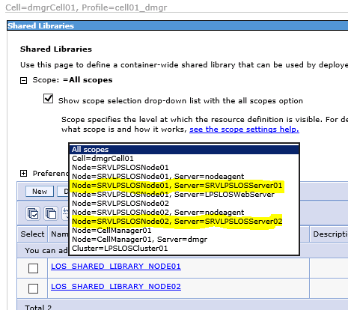

1. Select New
2. Enter the following:
   1. Name = LOS_SHARED_LIBRARY_NODE01
   2. Classpath = F:\WEBSPHERE_SHARED_LIBRARIES\LOS_LIBRARY
3. Click Apply and Save
4. Select New
5. Enter the following:
   1. Name = LOS_PLATFORM_SERVICES_LIBRARY_NODE01
   2. Classpath = F:\WEBSPHERE_SHARED_LIBRARIES\PLATFORM_SERVICES_LIBRARY
6. Click Apply and Save
7. Select Severs 🡪 Server Types🡪WebSphere application servers
8. Select LPSLOSServer01🡪Server Infrastructure 🡪 Java and Process Management 🡪Class loader
9. New
10. Verify Class loader order has “Classes loaded with parent class loader first” and choose ok
11. Click on the actual Classloader
12. Select “shared library referenece”
13. Add
14. Select corresponding library name LOS_SHARED_LIBRARY_NODE01
15. Apply and Save
16. Take note of the existing Class Loader(s) and click New
17. Click on the actual Classloader
18. Select “shared library referenece”
19. Add
20. Select corresponding library name LOS_PLATFORM_SERVICES_LIBRARY_NODE01
21. Apply and Save

### Shared Libraries: WAS2 Server –LOS

1. Copy F:\Installs\WAS WEBSPHERE_SHARED_LIBRARIES to the root of F:\
2. Delete all libraries within the folder except LOS and was_generated_keystore.jks
3. Verify Disruptor-3.3.0.jar, Log4j-api-2.1.jar and Log4j-core-2.1.jar are located within the LOS_Library
4. Verify xercesImpl.jar and xercesImpl-1.5.jar are removed from the LOS_Library
5. From the WebSphere admin console – Select: Environment 🡪 Shared libraries
6. Select the appropriate app, node and server from the dropdown list



1. Select New
2. Enter the following:
   1. Name = LOS_SHARED_LIBRARY_NODE02
   2. Classpath = F:\WEBSPHERE_SHARED_LIBRARIES\LOS_LIBRARY
3. Click Apply and Save
4. New
5. Verify Class loader order has “Classes loaded with parent class loader first” and choose ok
6. Click on the actual Classloader
7. Select “shared library referenece”
8. Add
9. Select corresponding library name LOS_SHARED_LIBRARY_NODE02
10. Apply and Save
11. Take note of the existing Class Loader(s) and click New
12. Click on the actual Classloader
13. Select “shared library referenece”
14. Add
15. Select corresponding library name LOS_PLATFORM_SERVICES_LIBRARY_NODE02
16. Apply and Save

### Copy “Magic” 5 files – WAS1 Server

1. Copy the files from “F:\Installs\WAS\Magic 5 files (.xml and .wsdd)\LOS\Deploy Mgr config-cells” directory To:

“F:\Data\IBM\WebSphere\AppServer\profiles\cell01_dmgr\config\cells\dmgrCell01\applications\SRVLPSLOS.ear\deployments\SRVLPSLOS\SRVLPSLOS.war\WEB-INF” directory and OVERWRITE any files that exist

1. Copy the files from “F:\Installs\WAS\Magic 5 files (.xml and .wsdd)\LOS\Node 01 config-cells” directory To:

“F:\Data\IBM\WebSphere\AppServer\profiles\SRVLPSLOSNode01\config\cells\dmgrCell01\applications\SRVLPSLOS.ear\deployments\SRVLPSLOS\SRVLPSLOS.war\WEB-INF” directory and OVERWRITE any files that exist

1. Copy the files from “F:\Installs\WAS\Magic 5 files (.xml and .wsdd)\LOS\Node 01 installed apps” directory To:

“F:\Data\IBM\WebSphere\AppServer\profiles\SRVLPSLOSNode01\installedApps\dmgrCell01\SRVLPSLOS.ear\SRVLPSLOS.war\WEB-INF” directory and OVERWRITE any files that exist

### Copy “Magic” 5 files – WAS2 Server

1. Copy the files from “F:\Installs\WAS\Magic 5 files (.xml and .wsdd)\LOS\Node 02 config-cells” directory To:

“F:\Data\IBM\WebSphere\AppServer\profiles\SRVLPSLOSNode02\config\cells\dmgrCell01\applications\SRVLPSLOS.ear\deployments\SRVLPSLOS\SRVLPSLOS.war\WEB-INF” directory and OVERWRITE any files that exist

1. Copy the files from “F:\Installs\WAS\Magic 5 files (.xml and .wsdd)\LOS\Node 02 installed apps” directory To:

“F:\Data\IBM\WebSphere\AppServer\profiles\SRVLPSLOSNode02\installedApps\dmgrCell01\SRVLPSLOS.ear\SRVLPSLOS.war\WEB-INF” directory and OVERWRITE any files that exist

### WebSphere Web Server Creation: WAS1

1. From the Admin console for each deployment manager, go to the Servers 🡪 Server Types 🡪 Web Servers link Click the New button.
2. In Step 1: Select the first Node and provide the web server name WEBSRVCLUSTER1. Select the Type as IBM HTTP Server and click the Next button.
3. In Step 2: Click Next button on the screen.
4. In Step 3: leave the port as 80. Change the web server installation location F:\Data\IBM\HTTPServer , leave the Service name as the default, and change the Plug-in installation location to F:\Data\IBM\HTTPServer\Plugins
5. In Step 4: confirmation screen click the Finish button. Click Save link in the next screen to save changes to master configuration.

### WebSphere Web Server Plug-in Generation - WAS1 Server

After all application templates are installed within each cell

Note: Make a backup of the original plugin if one exists. Located:

F:\Data\IBM\HTTPServer\Plugins\config\WEBSRVCLUSTER1\plugin-cfg.xml

From the cell-manager Admin console on WAS1 Server:

Servers 🡪 Servertypes🡪 Web Servers, Select the Web server check block and click generate plug-in

Note the plug-in config file location (the path will be used during cell 1 configuration to over write) and copy that file location and paste it into notepad for propagation step:

F:\data\IBM\WebSphere\AppServer\profiles\cell01_dmgr\config\cells\dmgrCell01\nodes\SRVLPS<APP>Node01\servers\WEBSRVCLUSTERx

### Disabling Automatic Webserver Plugin Generation: WAS1 Server

1. Select the webserver (click the name) and from the Additional Properties section, click Plug –in properties.
2. Deselect Automatically generate the plug-in configuration file and Automatically propagate plug-in configuration file.
3. Click Apply and save to the master configuration.

If encountering an error in Cell 1, copy the plugin-key.kdb and plugin.key.sth from F:\Installs\Temp plugin to the path specified when originally generating the plugin-cfg. Once copied perfom the steps to disable the auto generation and propagation. Delete the temporary plugin files.

### WebSphere Web Server Plug-in Propagation: WAS1 Server

1. From the console main column tree – select Environment 🡪 Select “Update global Web server plug-in configuration.

The plugin is generated at :

F:\Data\IBM\WebSphere\AppServer\profiles\cell01_dmgr\config\cells\plugin-cfg.xml

1. Copy that file into the location you recorded from previous step:

F:\data\IBM\WebSphere\AppServer\profiles\cell01_dmgr\config\cells\dmgrCell01\nodes\SRVLPS<APP>Node01\servers\WEBSRVCLUSTERx

1. Return to Web servers, select the web server and propagate plug-in

### HTTP-Plugin BIN folder copy for WAS1

Copy F:\Installs\WAS\Bin folder for HTTP server plugins\bin directory to F:\Data\IBM\HTTPServer\Plugins on WAS Server 1

### HTTP-Plugin BIN folder copy for WAS2

Copy F:\DATA\IBM\HTTPServer\Plugins directory from WAS Server 1 to F:\DATA\IBM\HTTPServer on the WAS Server 2

### HTTP server final configuration: WAS1 and WAS2

1. Copy the httpd.conf file from
2. “F:\Installs\WAS\HTTP Conf files\Cell 01” to F:\DATA\IBM\HTTPServer\conf
3. Edit the following areas in each HTTPD.conf
4. Listen and ServerName attributes

* IPv4 support, modify: Listen 0.0.0.0:80 – change 0.0.0.0 to the servername  
  May be load balancer type dependent, it might need to stay as it exists

1. Modify the Servername directive:
2. ServerName servername:80 – enter Servers FQDN ex. myserver.domain.com
3. Alias section

* Any location referring to <StorageServerFQDN> - change to the storage server fully qualified domain name (no ip addresses). Not all servers contain this alias.

1. ServerSignature

* Ensure the value is set to off.

1. WebSpherePlugConfig section

* Look for the line:  
  WebSpherePluginConfig "F:\Data\IBM\HTTPServer\Plugins\config\ WEBSRVCLUSTER1\plugin-cfg.xml – ensure the correct WEBSRVCLUSTER for the cell being configured

1. Restart HTTP services

### WebSphere Secure Cookies – WAS1 and WAS2 Servers

**Set HTTP Only on cookes in WAS 7.0 (not Cache Servers)**

1.       Open the WebSphere Administration Console.

2.       Select Servers, Server Types, WebSphere application Servers

3.       Select "your server".

**4.       Select "Web Container Settings" -> “Web container “**

5.       Select "Custom properties"

6.       Press the "new" button.

**7.       Enter com.ibm.ws.webcontainer.httpOnlyCookies in the "Name" field.**

8.       Enter * in the Value field.

9.       Enter "Secure Cookies" in the "Description" field.

10.   Press the "Apply" button.

11.   Press the "OK button.

12.   You will be navigated back to the custom properties field.

**Set the Secure Flag on JSESSIONID Cookie.**

1. Select Web Container
2. Session Management
3. Check "Enable Cookies" checkbox in the "General Properties" section.
4. The text "Enable Cookies" is a hyperlink. Click on it.
5. Under general properties, check that JSESSIONID is entered in the "Cookie name" field.
6. Check the check-box named "Restrict cookies to HTTPS sessions"
7. Press the "Apply" button.
8. Press the "OK" button.
9. Restart the previously selected "server name".

### WebSphere Windows Services Creation: WAS1 Server

1. Open an administrative command prompt and navigate to F:\Data\IBM\Websphere\AppServer\bin
2. Run the following commands:
3. "F:\Data\IBM\WebSphere\AppServer\bin\WASService -add CellManager01 -serverName dmgr -profilePath F:\Data\IBM\WebSphere\AppServer\profiles\cell01_dmgr -wasHome F:\Data\IBM\WebSphere\AppServer\ -logRoot F:\Data\IBM\WebSphere\AppServer\profiles\cell01_dmgr\logs\dmgr -logFile MS_Windows_service_ISC.log”
4. "WASService -add SRVLPSLOSNode01_nodeagent -serverName nodeagent -profilePath F:\Data\IBM\WebSphere\AppServer\profiles\SRVLPSLOSNode01 -wasHome F:\Data\IBM\WebSphere\AppServer -logRoot F:\Data\IBM\WebSphere\AppServer\profiles\SRVLPSLOSNode01\logs\nodeagent -logFile F:\Data\IBM\WebSphere\AppServer\profiles\SRVLPSLOSNode01\logs\nodeagent\startServer.log"
5. Open services from Administrative Tools, manually change the startup mode for the newly created service from manual to automatic.
6. Change the services credentials to the environment service account for the websphere services as well as the IBM HTTP Server 7.0 service.

### WebSphere Windows Services Creation: WAS2 Server

1. Open an administrative command prompt and navigate to F:\Data\IBM\Websphere\AppServer\bin
2. Run the following command:
3. "WASService -add SRVLPSLOSNode02_nodeagent -serverName nodeagent -profilePath F:\Data\IBM\WebSphere\AppServer\profiles\SRVLPSLOSNode02 -wasHome F:\Data\IBM\WebSphere\AppServer -logRoot F:\Data\IBM\WebSphere\AppServer\profiles\SRVLPSLOSNode02\logs\nodeagent -logFile F:\Data\IBM\WebSphere\AppServer\profiles\SRVLPSLOSNode02\logs\nodeagent\startServer.log"
4. Open services from Administrative Tools, manually change the startup mode for the newly created service from manual to automatic.
5. Change the services credentials to the environment service account for the websphere services as well as the IBM HTTP Server 7.0 service.

## Keystore Creation (one time process)

The keystore for LendingSpace password encryption will be used only by the LOS, AUS, and PORAL web applications. As such, we must use the IBM JCE (Java Cryptography Extension) supplied with the IBM JDK 1.6 supplied with WebSphere Application Server v.7.x.

IBM provides a graphical tool for generating the keystore file. The steps illustrated below will step the user through the creation of the keystore. It is worthy of note that the keystore is created once, and kept as a permanent component of the environment.

### Database Prerequisite

The key value to be added to the keystore should match the OrgCd from the following query:

SELECT [OrgId] ,[OrgCd]

FROM [MasterAuthentication].[dbo].[Company];

|  |  |
| --- | --- |
| Figure 1. The OrgCd value for the client is usually a 4 character field. The value should be entered in the keystore as key. | Figure 2. A complete keystore example. Secret keys are stored in lowercase. |

*Precondition-The administrator is logged on to one of the WebSphere services with the appropriate service account.*

1. Login to WebSphere Cell 01 Node 01 as the service account.
2. Navigates to the following directory’ – F:\Data\IBM\Websphere\AppServer\Java\jre\bin

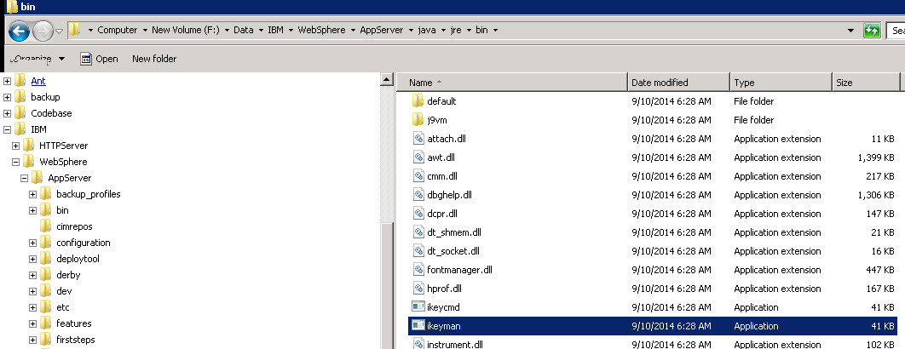

1. Double-Click on the ***ikeyman*** application.

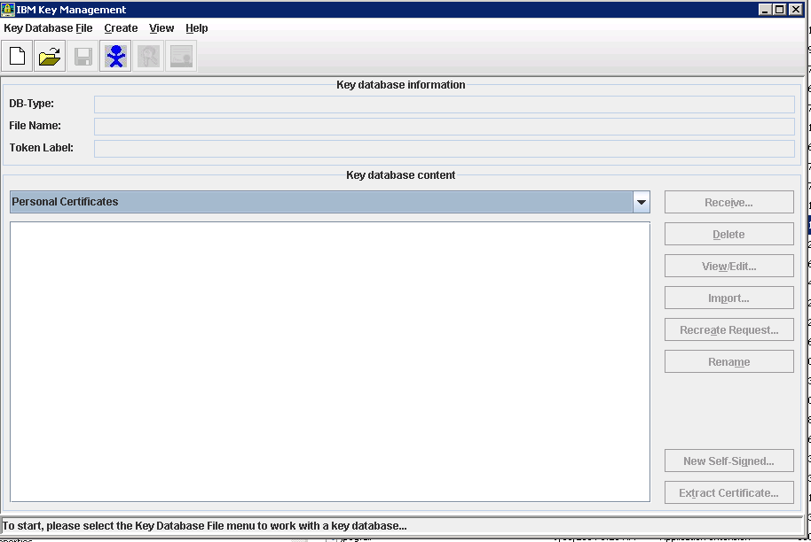

1. Click on the New File control as indicated by the red arrow to bring up the “New” dialog.

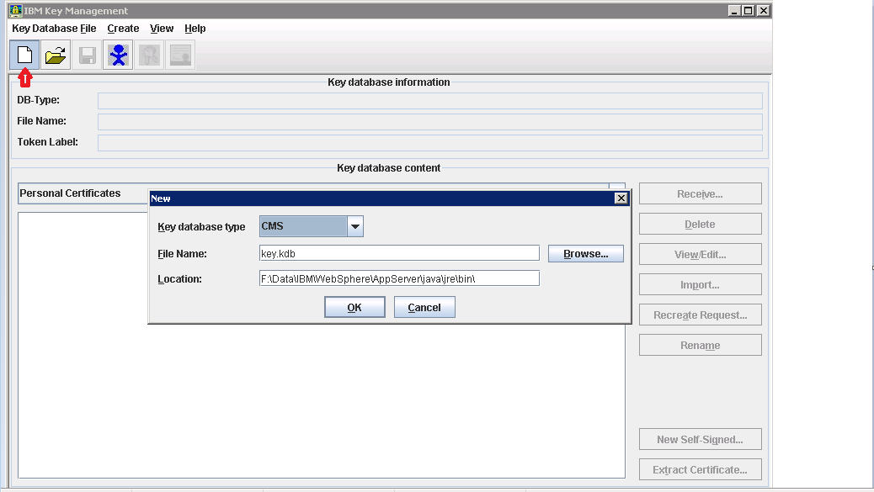

1. Select JCEKS as the Key database type. Enter **was_generated_keystore.jks** as the File name. Enter **F:\WEBSPHERE_SHARED_LIBRARIES** as the Location.

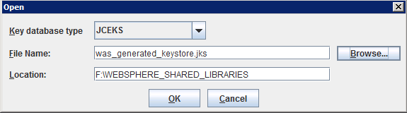

1. Press the **O**K button. Enter a password and confirm the password**. Press OK, NOTE! THIS PASSWORD CANNOT BE CHANGED ONCE CREATED. IT MUST BE ENTERED INTO THE LENDING SPACE CATALOG FILE.**

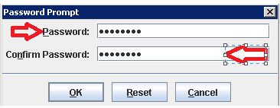

1. Select Secret Keys from the Key Database Content drop-down. Press **New,**

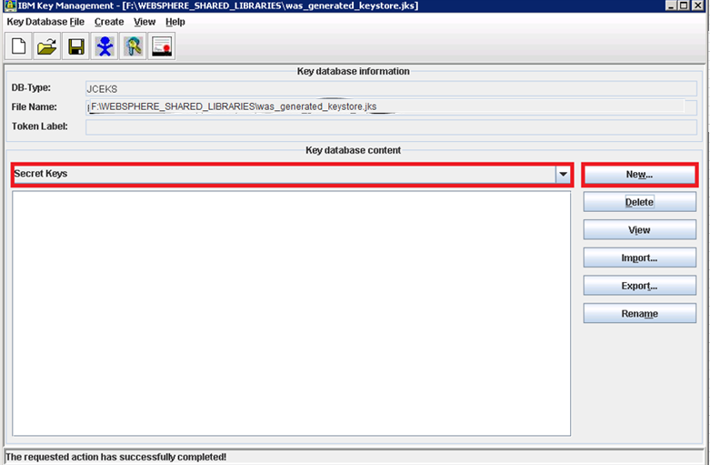

1. Enter the following values and determine what your implementation should use for the Alias.

Press **Ok when complete.**

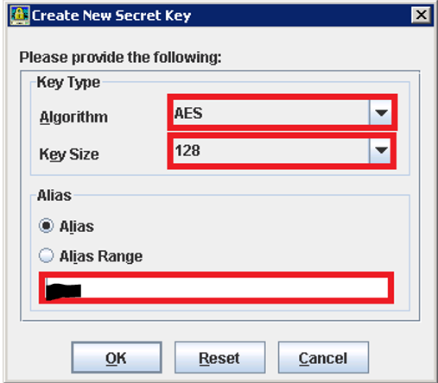

Figure 3. Enter the OrgCd that was found in the MasterAuthentication.dbo.Company table. See Database Prerequisite at top.

1. Click save and exit the tool.
2. Open a command prompt and navigate to the following directory and validate that the keystore exists.

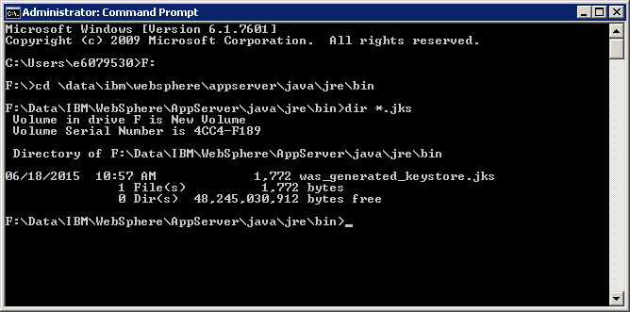

1. Execute the following command

keytool -list -storetype JCEKS -keystore was_generated_keystore.jks -storepass password Where “password” is the password you used earlier to create the store.

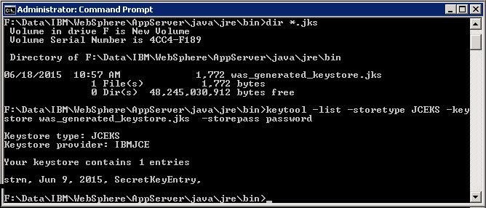

Figure 4. Self-hosted clients should only have a single entry in the keystore.

This validates that the store type is JCEKS, the provider is the IBMJCE, and all of your secret keys exist.

1. At this point, the keystore file should be removed from the directory and placed into your appropriate secure storage area. Keystores may not exist in the same repository as source code.

Deployment of the Keystore

The Keystore file will **only** be deployed to the LOS, AUS, and PORTAL servers in the following location:

F:\WEBSPHERE_SHARED_LIBRARIES

The file must be deployed to each WebSphere Application Server Node hosting the above web applications.

*Copy the keystore file to the F:* WEBSPHERE_SHARED_LIBRARIES directory on WebSphere Server 2 from the WebSphere Server 1

**Recommended: Save generated keystore file for each environment in a secure location in the event of a server rebuild or restore. The same file will need to be re-applied to the environment. Generating a new keystore will cause all existing passwords to be reset.**

## WebSphere CELL-2 Configuration- AUS, JSQLXML,LX,UPLOAD

### WebSphere Deployment Manager Creation: WAS3 Server

1. Execute PMT.bat from “F:\Data\IBM\WebSphere\AppServer\bin\ProfileManagement”
2. Click the “Create” button to start the profile creation process.
3. In the “Environment Selection” window select the “Management” option and click the “Next” button.
4. In the Server Type Selection screen, select “Deployment manager” option and click “Next”.
5. In the “profile Creation Options” screen select the “Advanced profile creation” option and click “Next”.
6. In the “Optional Application Deployment” screen leave the “Deploy the administrative console” option “checked” and click “Next”. This option will enable web based administration for the created profile.
7. In the “Profile Name and Location” screen change the profile name and directory.
8. Profile Name: cell01_dmgr
9. Directory: F:\Data\IBM\WebSphere\AppServer\profiles\cell01_dmgr
10. Click “Next”
11. In the “Node, Host, and Cell Names” screen change the Node name, host name and cell name.
12. Node Name: Cellmanager01
13. Host Name: full DNS name for that server
14. Cell Name: dmgrCell01
15. Click “Next”
16. In the “Administrative Security Screen” make sure the “Enable administrative security” is checked and provide the username and password click “Next”. (Make sure you document the credential values you use for your environment)
17. In the “Security Certificate (Part 1)” screen leave the default options as-is and click “Next”.
18. In the “Security Certificate (Part 2)” screen leave all of the default values and click “Next”.
19. In the “Port Values Assignment” screen leave the port values as-is and click “Next”.

Note: if you have more than one profile, make sure the port values are unique.

1. In the “Windows Service Definition” screen, make sure “Run the deployment manager process as a Windows service” is “Checked” and the “Log on as a local system account” is “selected”. Leave the “Startup type” as “automatic” and click “Next”.
2. In the “Profile Creation Summary” screen verify the summary details and click the “Create” button.
3. Once the profile is created successfully, in the “profile Creation Complete” screen “uncheck” the “Launch the First steps console” and Click Create to do the next Profile

### WebSphere Profile & Node Creation: WAS3 Server -AUS

1. Execute PMT.bat from “F:\Data\IBM\WebSphere\AppServer\bin\ProfileManagement” if the tool is not still running.
2. From the “Profile Management Tool” click the “Create” button
3. Select the “Custom Profile” option and click the “Next” button.
4. In the “profile Creation Options” screen select the “Advanced profile creation” option and click “Next”.
5. Profile Name: SRVLPSAUSNode01
6. Profile Directory: F:\DATA\IBM\WebSphere\AppServer\profiles\SRVLPSAUSNode01
7. Click “Next”
8. In the “node and host names” screen
9. Node name: SRVLPSAUSNode01
10. Host name: <actual servername.domain.com>
11. Click “Next”
12. In the Federation Screen
13. Deployment manager host name: <actual servername.domain.com>
14. Deployment manager SOAP port number: 8879
15. Deployment manager authentication

* Enter a username and password – RECORD this information

1. Leave the Federate this Node Later option unchecked, and click “Next”
2. In the Security Certificate (Part 1) screen, just click Next button.
3. In the Security Certificate (Part 2) screen, just click the Next button.
4. In the Port Values Assignment screen, Normally, you can just click Next. If there is a port conflict, make sure to change the value based on the Recommended Port Values. Click Next button.
5. On the Profile Creation Summary screen, click “Create” button to create the profile.
6. Uncheck the “Launch the First steps console” and Click Finish. Then go back to the Profile management tool, and finish creating the additional profiles ahead.

### WebSphere Profile & Node Creation: WAS3 Server -JSQLXML

1. Execute PMT.bat from “F:\Data\IBM\WebSphere\AppServer\bin\ProfileManagement” if the tool is not still running.
2. From the “Profile Management Tool” click the “Create” button
3. Select the “Custom Profile” option and click the “Next” button.
4. In the “profile Creation Options” screen select the “Advanced profile creation” option and click “Next”.
5. Profile Name: SRVLPSJSQLXMLNode01
6. Profile Directory: F:\DATA\IBM\WebSphere\AppServer\profiles\SRVLPSJSQLXMLNode01
7. Click “Next”
8. In the “node and host names” screen
9. Node name: SRVLPSJSQLXMLNode01
10. Host name: <actual servername.domain.com>
11. Click “Next”
12. In the Federation Screen
13. Deployment manager host name: <actual servername.domain.com>
14. Deployment manager SOAP port number: 8879
15. Deployment manager authentication

* Enter a username and password – RECORD this information

1. Leave the Federate this Node Later option unchecked, and click “Next”
2. In the Security Certificate (Part 1) screen, just click Next button.
3. In the Security Certificate (Part 2) screen, just click the Next button.
4. In the Port Values Assignment screen, Normally, you can just click Next. If there is a port conflict, make sure to change the value based on the Recommended Port Values. Click Next button.
5. On the Profile Creation Summary screen, click “Create” button to create the profile.
6. Uncheck the “Launch the First steps console” and Click Finish. Then go back to the Profile management tool, and finish creating the additional profiles ahead.

### WebSphere Profile & Node Creation: WAS3 Server -LX

1. Execute PMT.bat from “F:\Data\IBM\WebSphere\AppServer\bin\ProfileManagement” if the tool is not still running.
2. From the “Profile Management Tool” click the “Create” button
3. Select the “Custom Profile” option and click the “Next” button.
4. In the “profile Creation Options” screen select the “Advanced profile creation” option and click “Next”.
5. Profile Name: SRVLPSLXNode01
6. Profile Directory: F:\DATA\IBM\WebSphere\AppServer\profiles\SRVLPSLXNode01
7. Click “Next”
8. In the “node and host names” screen
9. Node name: SRVLPSLXNode01
10. Host name: <actual servername.domain.com>
11. Click “Next”
12. In the Federation Screen
13. Deployment manager host name: <actual servername.domain.com>
14. Deployment manager SOAP port number: 8879
15. Deployment manager authentication

* Enter a username and password – RECORD this information

1. Leave the Federate this Node Later option unchecked, and click “Next”
2. In the Security Certificate (Part 1) screen, just click Next button.
3. In the Security Certificate (Part 2) screen, just click the Next button.
4. In the Port Values Assignment screen, Normally, you can just click Next. If there is a port conflict, make sure to change the value based on the Recommended Port Values. Click Next button.
5. On the Profile Creation Summary screen, click “Create” button to create the profile.
6. Uncheck the “Launch the First steps console” and Click Finish. Then go back to the Profile management tool, and finish creating the additional profiles ahead.

### WebSphere Profile & Node Creation: WAS3 Server -UPLOAD

1. Execute PMT.bat from “F:\Data\IBM\WebSphere\AppServer\bin\ProfileManagement” if the tool is not still running.
2. From the “Profile Management Tool” click the “Create” button
3. Select the “Custom Profile” option and click the “Next” button.
4. In the “profile Creation Options” screen select the “Advanced profile creation” option and click “Next”.
5. Profile Name: SRVLPSUPLOADNode01
6. Profile Directory: F:\DATA\IBM\WebSphere\AppServer\profiles\SRVLPSUPLOADNode01
7. Click “Next”
8. In the “node and host names” screen
9. Node name: SRVLPSUPLOADNode01
10. Host name: <actual servername.domain.com>
11. Click “Next”
12. In the Federation Screen
13. Deployment manager host name: <actual servername.domain.com>
14. Deployment manager SOAP port number: 8879
15. Deployment manager authentication

* Enter a username and password – RECORD this information

1. Leave the Federate this Node Later option unchecked, and click “Next”
2. In the Security Certificate (Part 1) screen, just click Next button.
3. In the Security Certificate (Part 2) screen, just click the Next button.
4. In the Port Values Assignment screen, Normally, you can just click Next. If there is a port conflict, make sure to change the value based on the Recommended Port Values. Click Next button.
5. On the Profile Creation Summary screen, click “Create” button to create the profile.
6. Click Finish, and load the First Steps program.
7. Click the “Administrative console” and login to WAS console.
8. From the Websphere Admin Console select System administration 🡪 Nodes look to verify the nodes. In the right frame, you should see Nodes listed along with the Deployment Cell Manager.
9. Move to the WAS4 server now.

### WebSphere Profile & Node Creation: WAS4 Server -AUS

1. USE PMT (Profile Management tool) from F:\Data\IBM\WebSphere\AppServer\firststeps\firststeps.bat
2. From the “Profile Management Tool” click the “Create” button
3. Select the “Custom Profile” option and click the “Next” button.
4. In the “profile Creation Options” screen select the “Advanced profile creation” option and click “Next”.
5. Profile Name: SRVLPSAUSNode02
6. Profile Directory: F:\DATA\IBM\WebSphere\AppServer\profiles\SRVLPSAUSNode02
7. Click “Next”
8. In the “node and host names” screen
9. Node name: SRVLPSAUSNode02
10. Host name: <actual servername.domain.com>
11. Click “Next”
12. In the Federation Screen
13. Deployment manager host name: < WAS3 SERVERNAME.domain.com> (in your environment)
14. Deployment manager SOAP port number: 8879
15. Deployment manager authentication

* Enter a username and password – RECORD this information

1. Leave the Federate this Node Later option unchecked, and click “Next”
2. In the Security Certificate (Part 1) screen, just click Next button.
3. In the Security Certificate (Part 2) screen, just click the Next button.
4. In the Port Values Assignment screen, Normally, you can just click Next. If there is a port conflict, make sure to change the value based on the Recommended Port Values. Click Next button.
5. On the Profile Creation Summary screen, click “Create” button to create the profile.
6. Uncheck the “Launch the First steps console” and Click Finish. Then go back to the Profile management tool, and finish creating the additional profiles ahead.

### WebSphere Profile & Node Creation: WAS4 Server -JSQLXML

In development environments there is not always a second Cache Server. Skip past this section if applicable.

1. USE PMT (Profile Management tool) from F:\Data\IBM\WebSphere\AppServer\firststeps\firststeps.bat
2. From the “Profile Management Tool” click the “Create” button
3. Select the “Custom Profile” option and click the “Next” button.
4. In the “profile Creation Options” screen select the “Advanced profile creation” option and click “Next”.
5. Profile Name: SRVLPSJSQLXMLNode02
6. Profile Directory: F:\DATA\IBM\WebSphere\AppServer\profiles\SRVLPSJSQLXMLNode02
7. Click “Next”
8. In the “node and host names” screen
9. Node name: SRVLPSJSQLXMLNode02
10. Host name: <actual servername.domain.com>
11. Click “Next”
12. In the Federation Screen
13. Deployment manager host name: < WAS3 SERVERNAME.domain.com> (in your environment)
14. Deployment manager SOAP port number: 8879
15. Deployment manager authentication

* Enter a username and password – RECORD this information

1. Leave the Federate this Node Later option unchecked, and click “Next”
2. In the Security Certificate (Part 1) screen, just click Next button.
3. In the Security Certificate (Part 2) screen, just click the Next button.
4. In the Port Values Assignment screen, Normally, you can just click Next. If there is a port conflict, make sure to change the value based on the Recommended Port Values. Click Next button.
5. On the Profile Creation Summary screen, click “Create” button to create the profile.
6. Uncheck the “Launch the First steps console” and Click Finish. Then go back to the Profile management tool, and finish creating the additional profiles ahead.

### WebSphere Profile & Node Creation: WAS4 Server -LX

In development environments there is not always a second Cache Server. Skip past this section if applicable.

1. USE PMT (Profile Management tool) from F:\Data\IBM\WebSphere\AppServer\firststeps\firststeps.bat
2. From the “Profile Management Tool” click the “Create” button
3. Select the “Custom Profile” option and click the “Next” button.
4. In the “profile Creation Options” screen select the “Advanced profile creation” option and click “Next”.
5. Profile Name: SRVLPSLXNode02
6. Profile Directory: F:\DATA\IBM\WebSphere\AppServer\profiles\SRVLPSLXNode02
7. Click “Next”
8. In the “node and host names” screen
9. Node name: SRVLPSLXNode02
10. Host name: <actual servername.domain.com>
11. Click “Next”
12. In the Federation Screen
13. Deployment manager host name: < WAS3 SERVERNAME.domain.com> (in your environment)
14. Deployment manager SOAP port number: 8879
15. Deployment manager authentication

* Enter a username and password – RECORD this information

1. Leave the Federate this Node Later option unchecked, and click “Next”
2. In the Security Certificate (Part 1) screen, just click Next button.
3. In the Security Certificate (Part 2) screen, just click the Next button.
4. In the Port Values Assignment screen, Normally, you can just click Next. If there is a port conflict, make sure to change the value based on the Recommended Port Values. Click Next button.
5. On the Profile Creation Summary screen, click “Create” button to create the profile.
6. Uncheck the “Launch the First steps console” and Click Finish. Then go back to the Profile management tool, and finish creating the additional profiles ahead.

### WebSphere Profile & Node Creation: WAS4 Server -UPLOAD

1. USE PMT (Profile Management tool) from F:\Data\IBM\WebSphere\AppServer\firststeps\firststeps.bat
2. From the “Profile Management Tool” click the “Create” button
3. Select the “Custom Profile” option and click the “Next” button.
4. In the “profile Creation Options” screen select the “Advanced profile creation” option and click “Next”.
5. Profile Name: SRVLPSUPLOADNode02
6. Profile Directory: F:\DATA\IBM\WebSphere\AppServer\profiles\SRVLPSUPLOADNode02
7. Click “Next”
8. In the “node and host names” screen
9. Node name: SRVLPSUPLOADNode02
10. Host name: <actual servername.domain.com>
11. Click “Next”
12. In the Federation Screen
13. Deployment manager host name: < WAS3 SERVERNAME.domain.com> (in your environment)
14. Deployment manager SOAP port number: 8879
15. Deployment manager authentication

* Enter a username and password – RECORD this information

1. Leave the Federate this Node Later option unchecked, and click “Next”
2. In the Security Certificate (Part 1) screen, just click Next button.
3. In the Security Certificate (Part 2) screen, just click the Next button.
4. In the Port Values Assignment screen, Normally, you can just click Next. If there is a port conflict, make sure to change the value based on the Recommended Port Values. Click Next button.
5. On the Profile Creation Summary screen, click “Create” button to create the profile.
6. Click Finish. Then go back to the Profile management tool, and close it out.

#### FROM WAS3 Server:

1. Execute Firststeps.bat from F:\DATA\IBM\WebSphere\AppServer\profiles\cell01_dmgr\firststeps directory.
2. Click the “Administrative console” and login to WAS console.
3. From the Websphere Admin Console select System administration 🡪 Nodes look to verify the nodes. In the right frame, you should see Nodes listed along with the Deployment Cell Manager.

### WebSphere Server Creation: WAS3 Server -AUS

1. From the Administrative Console - (F:\Data\IBM\WebSphere\AppServer\profiles\cell01_dmgr\firststeps\firststeps.bat), use the account and password supplied during profile creation.
2. From Servers 🡪 Server Types 🡪 Websphere application servers and click New button in the right frame.
3. Select the first Node – “SRVLPSAUSNode01” from the dropdown and add “LPSAUSServer01”
4. In Server template screen– select the default option and click the Next button.
5. In the Server Specific Properties screen (shown above) – leave the “Generate Unique Ports” option checked and click Next button.
6. Click the Finish button in Confirm new server screen (shown above) to create the server.
7. The Application Server is now listed. Now click the Save link in the messages block for the changes to be reflected in the Master Configuration file.
8. Select the Application Server – “LPSAUSServer01” link and in the Configuration screen change the following
9. Check Parallel Start option
10. Check Start components as needed option
11. Change the Class loader Policy as Multiple
12. Click Apply button and then subsequently Save link to reflect the changes in the Master Configuration file.
13. Click the Application Server , Communications 🡪click the link to Ports. DOCUMENT the WC_defaulthost port.
14. Click the Application Server , Server Infrastructure 🡪 Java and Process Management 🡪 Process definition, Java Virtual Machine
15. Change the Classpath - F:\Data\Codebase\SRVLPSAUS\conf
16. Check the Verbose Garbage Collection box
17. Change the Initial Heap size : 1024
18. Change the Maximum Heap size: 2048
19. Generic JVM Arguments:

* -Dsun.io.useCanonCaches=false -XX:MaxPermSize=32m -XX:NewSize=16m -XX:PermSize=16m -XX:+UseConcMarkSweepGC -Daus.home=F:/Data/CodeBase/SRVLPSAUS

1. Click Apply button and Save link to reflect the changes into the Master Configuration file.

#### WebSphere Application Servers -LOG File Size/Retention

1. From within the application server profile, navigate to: Server Infrastructure > Java and Process Management > Process Definition > Logging and Tracing (under Additional Properties) > JVM Logs, and adjust the settings on the Configuration tab as follows:
2. System.out

* Log File Rotation: File Size: 5MB Maximum size. Maximum # of historical log files: 30

1. System.err

* Log File Rotation: File Size: 5MB Maximum size. Maximum # of historical log files: 30

1. Click OK, then click Save (directly to the master configuration):
2. Select the Application Server, Server Infrastructure, Java and Process Management, Monitoring policy:
3. Change the node restart state to RUNNING
4. Click Apply button and Save link to reflect the changes into the Master Configuration file.
5. From Servers 🡪 Server Types 🡪 Websphere application servers, select Web Server plug-in properties change the following
6. Use connection timeout to 0
7. Read/Write timeout to 0
8. Click Apply button and Save link to reflect the changes into the Master Configuration file.

NOTE: Do not create server for the second node, they are created when creating the clusters.

### Shared Libraries: WAS3 Server –AUS

1. Copy F:\Installs\WAS WEBSPHERE_SHARED_LIBRARIES to the root of F:\
2. Delete all libraries except AUS, JSQXLM, LX, UPLOAD and was_generated_keystrore.jks
3. Verify Disruptor-3.3.0.jar, Log4j-api-2.1.jar and Log4j-core-2.1.jar are located within the AUS_Library
4. Verify xercesImpl.jar is removed from the AUS_Library
5. From the WebSphere admin console – Select: Environment 🡪 Shared libraries
6. Select the appropriate app, node and server from the dropdown list

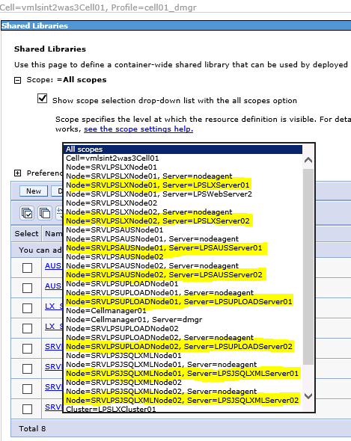

1. Select New
2. Enter the following:
   1. Name = AUS_SHARED_LIBRARY_NODE01
   2. Classpath = F:\WEBSPHERE_SHARED_LIBRARIES\AUS_LIBRARY
3. Click Apply and Save
4. Select Severs 🡪 Server Types🡪WebSphere application servers
5. Select LPSAUSServer01🡪Server Infrastructure 🡪 Java and Process Management 🡪Class loader
6. New
7. Verify Class loader order has “Classes loaded with parent class loader first” and choose ok
8. Click on the actual Classloader
9. Select “shared library referenece”
10. Add
11. Select corresponding library name that matches the server in the drop down and choose ok
12. Apply and Save

### WebSphere Server Creation: WAS3 Server -JSQLXML

1. From the Administrative Console - (F:\Data\IBM\WebSphere\AppServer\profiles\cell01_dmgr\firststeps\firststeps.bat), use the account and password supplied during profile creation.
2. From Servers 🡪 Server Types 🡪 Websphere application servers and click New button in the right frame.
3. Select the first Node – “SRVLPSJSQLXMLNode01” from the dropdown and add “LPSJSQLXMLServer01”
4. In Server template screen– select the default option and click the Next button.
5. In the Server Specific Properties screen (shown above) – leave the “Generate Unique Ports” option checked and click Next button.
6. Click the Finish button in Confirm new server screen (shown above) to create the server.
7. The Application Server is now listed. Now click the Save link in the messages block for the changes to be reflected in the Master Configuration file.
8. Select the Application Server – “LPSJSQLXMLServer01” link and in the Configuration screen change the following
9. Check Parallel Start option
10. Check Start components as needed option
11. Change the Class loader Policy as Multiple
12. Click Apply button and then subsequently Save link to reflect the changes in the Master Configuration file.
13. Click the Application Server , Server Infrastructure 🡪 Java and Process Management 🡪 Process definition, Java Virtual Machine
14. Change the Classpath
15. F:\Data\Codebase\SRVLPSJSQLXML\config
16. Change the Initial Heap size : 768
17. Change the Maximum Heap size: 1024
18. Generic JVM Arguments: -Dsun.io.useCanonCaches=false -XX:MaxPermSize=128m -XX:NewSize=32m -XX:PermSize=32m -XX:+UseConcMarkSweepGC
19. Click Apply button and Save link to reflect the changes into the Master Configuration file.

Apply and Save

#### WebSphere Application Servers -LOG File Size/Retention

1. From within the application server profile, navigate to: Server Infrastructure > Java and Process Management > Process Definition > Logging and Tracing (under Additional Properties) > JVM Logs, and adjust the settings on the Configuration tab as follows:
2. System.out

* Log File Rotation: File Size: 5MB Maximum size. Maximum # of historical log files: 30

1. System.err

* Log File Rotation: File Size: 5MB Maximum size. Maximum # of historical log files: 30

1. Click OK, then click Save (directly to the master configuration):
2. Select the Application Server, Server Infrastructure, Java and Process Management, Monitoring policy:
3. Change the node restart state to RUNNING
4. Click Apply button and Save link to reflect the changes into the Master Configuration file.
5. From Servers 🡪 Server Types 🡪 Websphere application servers, select Web Server plug-in properties change the following
6. Use connection timeout to 0
7. Read/Write timeout to 0
8. Click Apply button and Save link to reflect the changes into the Master Configuration file.

NOTE: Do not create server for the second node, they are created when creating the clusters.

### Shared Libraries: WAS3 Server –JSQLXML

1. Copy F:\Installs\WAS WEBSPHERE_SHARED_LIBRARIES to the root of F:\
2. Delete all libraries except AUS, JSQXLM, LX, UPLOAD and was_generated_keystrore.jks
3. Verify Disruptor-3.3.0.jar, Log4j-api-2.1.jar and Log4j-core-2.1.jar are located within the JSQLXML_Library
4. Verify xercesImpl.jar is removed from the AUS_Library
5. From the WebSphere admin console – Select: Environment 🡪 Shared libraries
6. Select the appropriate app, node and server from the dropdown list



1. Select New
2. Enter the following:
   1. Name = JSQLXML_SHARED_LIBRARY_NODE01
   2. Classpath = F:\WEBSPHERE_SHARED_LIBRARIES\JSQLXML_LIBRARY
3. Click Apply and Save
4. Select Severs 🡪 Server Types🡪WebSphere application servers
5. Select LPSJSQLXMLServer01🡪Server Infrastructure 🡪 Java and Process Management 🡪Class loader
6. New
7. Verify Class loader order has “Classes loaded with parent class loader first” and choose ok
8. Click on the actual Classloader
9. Select “shared library referenece”
10. Add
11. Select corresponding library name that matches the server in the drop down and choose ok

### WebSphere Server Creation: WAS3 Server -LX

1. From the Administrative Console - (F:\Data\IBM\WebSphere\AppServer\profiles\cell01_dmgr\firststeps\firststeps.bat)
2. Use the account and password supplied during profile creation.
3. From Servers 🡪 Server Types 🡪 Websphere application servers and click New button in the right frame.
4. Select the first Node – “SRVLPSLXNode01” from the dropdown and add “LPSLXServer01”
5. In Server template screen– select the default option and click the Next button.
6. In the Server Specific Properties screen (shown above) – leave the “Generate Unique Ports” option checked and click Next button.
7. Click the Finish button in Confirm new server screen (shown above) to create the server.
8. The Application Server is now listed. Now click the Save link in the messages block for the changes to be reflected in the Master Configuration file.
9. Select the Application Server – “LPSLXServer01” link and in the Configuration screen change the following
10. Check Parallel Start option
11. Check Start components as needed option
12. Change the Class loader Policy as Multiple
13. Click Apply button and then subsequently Save link to reflect the changes in the Master Configuration file.
14. Click the Application Server , Server Infrastructure 🡪 Java and Process Management 🡪 Process definition, Java Virtual Machine
15. Change the Classpath

* F:\Data\IBM\WebSphere\AppServer\profiles\SRVLPSLXNode01

1. Change the Initial Heap size : 768
2. Change the Maximum Heap size: 1536
3. Generic JVM Arguments: -Dsun.io.useCanonCaches=false -XX:MaxPermSize=128m -XX:NewSize=32m -XX:PermSize=32m -XX:+UseConcMarkSweepGC
4. Click Apply button and Save link to reflect the changes into the Master Configuration file.

#### WebSphere Application Servers -LOG File Size/Retention

1. From within the application server profile, navigate to: Server Infrastructure > Java and Process Management > Process Definition > Logging and Tracing (under Additional Properties) > JVM Logs, and adjust the settings on the Configuration tab as follows:
2. System.out

* Log File Rotation: File Size: 5MB Maximum size. Maximum # of historical log files: 30

1. System.err

* Log File Rotation: File Size: 5MB Maximum size. Maximum # of historical log files: 30

1. Click OK, then click Save (directly to the master configuration):
2. Select the Application Server, Server Infrastructure, Java and Process Management, Monitoring policy:
3. Change the node restart state to RUNNING
4. Click Apply button and Save link to reflect the changes into the Master Configuration file.
5. From Servers 🡪 Server Types 🡪 Websphere application servers, select Web Server plug-in properties change the following
6. Use connection timeout to 0
7. Read/Write timeout to 0
8. Click Apply button and Save link to reflect the changes into the Master Configuration file.

NOTE: Do not create server for the second node, they are created when creating the clusters.

### Shared Libraries: WAS3 Server – LX

1. Copy F:\Installs\WAS WEBSPHERE_SHARED_LIBRARIES to the root of F:\
2. Delete the PORTAL and LOS libraries
3. Verify Disruptor-3.3.0.jar, Log4j-api-2.1.jar and Log4j-core-2.1.jar are located within the LX_Library
4. From the WebSphere admin console – Select: Environment 🡪 Shared libraries
5. Select the appropriate app, node and server from the dropdown list



1. Select New
2. Enter the following:
   1. Name = LX_SHARED_LIBRARY_NODE01
   2. Classpath = F:\WEBSPHERE_SHARED_LIBRARIES\LX_LIBRARY
3. Click Apply and Save
4. Select Severs 🡪 Server Types🡪WebSphere application servers
5. Select LPSLXServer01🡪Server Infrastructure 🡪 Java and Process Management 🡪Class loader
6. New
7. Verify Class loader order has “Classes loaded with parent class loader first” and choose ok
8. Click on the actual Classloader
9. Select “shared library referenece”
10. Add
11. Select corresponding library name that matches the server in the drop down and choose ok

### WebSphere Server Creation: WAS3 Server -UPLOAD

1. From the Administrative Console - (F:\Data\IBM\WebSphere\AppServer\profiles\cell01_dmgr\firststeps\firststeps.bat), use the account and password supplied during profile creation.
2. From Servers 🡪 Server Types 🡪 Websphere application servers and click New button in the right frame.
3. Select the first Node – “SRVLPSUPLOADNode01” from the dropdown and add “LPSUPLOADServer01”
4. In Server template screen– select the default option and click the Next button.
5. In the Server Specific Properties screen (shown above) – leave the “Generate Unique Ports” option checked and click Next button.
6. Click the Finish button in Confirm new server screen (shown above) to create the server.
7. The Application Server is now listed. Now click the Save link in the messages block for the changes to be reflected in the Master Configuration file.
8. Select the Application Server – “LPSUPLOADServer01” link and in the Configuration screen change the following
9. Check Parallel Start option
10. Check Start components as needed option
11. Change the Class loader Policy as Multiple
12. Click Apply button and then subsequently Save link to reflect the changes in the Master Configuration file.
13. Click the Application Server , Server Infrastructure 🡪 Java and Process Management 🡪 Process definition, Java Virtual Machine
14. Change the Classpath

* F:\Data\IBM\WebSphere\AppServer\profiles\SRVLPSUPLOADNode01

1. Change the Initial Heap size : 2048
2. Change the Maximum Heap size: 5120
3. Generic JVM Arguments: -Dsun.io.useCanonCaches=false -XX:MaxPermSize=128m -XX:NewSize=32m -XX:PermSize=32m -XX:+UseConcMarkSweepGC
4. Click Apply button and Save link to reflect the changes into the Master Configuration file.

#### WebSphere Application Servers -LOG File Size/Retention

1. From within the application server profile, navigate to: Server Infrastructure > Java and Process Management > Process Definition > Logging and Tracing (under Additional Properties) > JVM Logs, and adjust the settings on the Configuration tab as follows:
2. System.out

* Log File Rotation: File Size: 5MB Maximum size. Maximum # of historical log files: 30

1. System.err

* Log File Rotation: File Size: 5MB Maximum size. Maximum # of historical log files: 30

1. Click OK, then click Save (directly to the master configuration):
2. Select the Application Server, Server Infrastructure, Java and Process Management, Monitoring policy:
3. Change the node restart state to RUNNING
4. Click Apply button and Save link to reflect the changes into the Master Configuration file.
5. From Servers 🡪 Server Types 🡪 Websphere application servers, select Web Server plug-in properties change the following
6. Use connection timeout to 0
7. Read/Write timeout to 0
8. Click Apply button and Save link to reflect the changes into the Master Configuration file.

### Shared Libraries: WAS3 Server – UPLOAD

1. Copy F:\Installs\WAS WEBSPHERE_SHARED_LIBRARIES to the root of F:\
2. Delete the PORTAL and LOS libraries
3. Verify Disruptor-3.3.0.jar, Log4j-api-2.1.jar and Log4j-core-2.1.jar are located within the UPLOAD_Library
4. From the WebSphere admin console – Select: Environment 🡪 Shared libraries
5. Select the appropriate app, node and server from the dropdown list



1. Select New
2. Enter the following:
   1. Name = UPLOAD_SHARED_LIBRARY_NODE01
   2. Classpath = F:\WEBSPHERE_SHARED_LIBRARIES\UPLOAD_LIBRARY
3. Click Apply and Save
4. Select New
5. Enter the following:
   1. Name = UPLOAD_PLATFORM_SERVICES_NODE01
   2. Classpath = F:\WEBSPHERE_SHARED_LIBRARIES\PLATFORM_SERVICES_LIBRARY
6. Click Apply and Save
7. Select Severs 🡪 Server Types🡪WebSphere application servers
8. Select LPSUPLOADServer01🡪Server Infrastructure 🡪 Java and Process Management 🡪Class loader
9. New
10. Verify Class loader order has “Classes loaded with parent class loader first” and choose ok
11. Click on the actual Classloader
12. Select “shared library referenece”
13. Add
14. Select corresponding library name UPLOAD_SHARED_LIBRARY_NODE01
15. Apply and Save
16. Take note of the existing Class Loader(s) and click New
17. Click on the actual Classloader
18. Select “shared library referenece”
19. Add
20. Select corresponding library name UPLOAD_PLATFORM_SERVICES_NODE01

Apply and Save

### WebSphere Cluster Creation: -AUS

1. Go to Servers 🡪 Clusters 🡪 WebSphere application server clusters link in the console. Then click the “New” button in the right frame.
2. Enter the Cluster name “LPSAUSCluster01” Leave the Prefer Local option checked and configure HTTP session memory-to-memory replication option unchecked. Click the Next button.
3. In the Create First Cluster Member screen , Select the third option – Create the member by converting an existing application server - LPSAUSServer01 from the list, and take the default first node. Leave the Weight field value as 2. Click the Next button.
4. In the Create Additional Cluster Members screen, provide a Member Name

LPSLOSServer02

and Select Node 2 – SRVLPSAUSNode02. Refer to the chart for naming conventions. Leave the Weight field value as 2 and Generate unique HTTP ports option checked. Now click the Add Member button. The member will get added to the list at the bottom (as shown above). Click the Next button.

1. Click the Finish button to create the cluster.
2. Click the Save link to reflect the changes to the Master Configuration.
3. Log into WAS Server 4
4. Start Node 2

From a command prompt Execute startNode.bat batch file from:

“F:\Data\IBM\WebSphere\AppServer\profiles\SRVLPSAUSNode02\bin”

Watch the output on the window, and wait for the “open for e-business” entry.

1. Verfiy the nodes are started, and in a synchronized status with the deployment manager using System Administration 🡪 Nodes in the Admin Console.
2. Start the Cluster server using Servers 🡪 Clusters 🡪 Web application server clusters link. Select the newly created cluster and click the Start button. This will start the cluster and in turn will start the application servers.

### WebSphere Cluster Creation: -JSQLXML

1. Go to Servers 🡪 Clusters 🡪 WebSphere application server clusters link in the console. Then click the “New” button in the right frame.
2. Enter the Cluster name “LPSJSQLXMLCluster01” Leave the Prefer Local option checked and configure HTTP session memory-to-memory replication option unchecked. Click the Next button.
3. In the Create First Cluster Member screen , Select the third option – Create the member by converting an existing application server - LPSJSQLXMLServer01 from the list, and take the default first node. Leave the Weight field value as 2. Click the Next button.
4. In the Create Additional Cluster Members screen, provide a Member Name

LPSLOSServer02

and Select Node 2 – SRVLPSJSQLXMLNode02. Refer to the chart for naming conventions. Leave the Weight field value as 2 and Generate unique HTTP ports option checked. Now click the Add Member button. The member will get added to the list at the bottom (as shown above). Click the Next button.

1. Click the Finish button to create the cluster.
2. Click the Save link to reflect the changes to the Master Configuration.
3. Log into WAS Server 4
4. Start Node 2

From a command prompt Execute startNode.bat batch file from:

“F:\Data\IBM\WebSphere\AppServer\profiles\SRVLPSJSQLXMLNode02\bin”

Watch the output on the window, and wait for the “open for e-business” entry.

1. Verfiy the nodes are started, and in a synchronized status with the deployment manager using System Administration 🡪 Nodes in the Admin Console.
2. Start the Cluster server using Servers 🡪 Clusters 🡪 Web application server clusters link. Select the newly created cluster and click the Start button. This will start the cluster and in turn will start the application servers.

### WebSphere Cluster Creation: -LX

1. Go to Servers 🡪 Clusters 🡪 WebSphere application server clusters link in the console. Then click the “New” button in the right frame.
2. Enter the Cluster name “LPSLXCluster01” Leave the Prefer Local option checked and configure HTTP session memory-to-memory replication option unchecked. Click the Next button.
3. In the Create First Cluster Member screen , Select the third option – Create the member by converting an existing application server - LPSLXServer01 from the list, and take the default first node. Leave the Weight field value as 2. Click the Next button.
4. In the Create Additional Cluster Members screen, provide a Member Name

LPSLOSServer02

and Select Node 2 – SRVLPSLXNode02. Refer to the chart for naming conventions. Leave the Weight field value as 2 and Generate unique HTTP ports option checked. Now click the Add Member button. The member will get added to the list at the bottom (as shown above). Click the Next button.

1. Click the Finish button to create the cluster.
2. Click the Save link to reflect the changes to the Master Configuration.
3. Log into WAS Server 4
4. Start Node 2

From a command prompt Execute startNode.bat batch file from:

“F:\Data\IBM\WebSphere\AppServer\profiles\SRVLPSLXNode02\bin”

Watch the output on the window, and wait for the “open for e-business” entry.

1. Verfiy the nodes are started, and in a synchronized status with the deployment manager using System Administration 🡪 Nodes in the Admin Console.
2. Start the Cluster server using Servers 🡪 Clusters 🡪 Web application server clusters link. Select the newly created cluster and click the Start button. This will start the cluster and in turn will start the application servers.

### WebSphere Cluster Creation: -UPLOAD

1. Go to Servers 🡪 Clusters 🡪 WebSphere application server clusters link in the console. Then click the “New” button in the right frame.
2. Enter the Cluster name “LPSUPLOADCluster01” Leave the Prefer Local option checked and configure HTTP session memory-to-memory replication option unchecked. Click the Next button.
3. In the Create First Cluster Member screen , Select the third option – Create the member by converting an existing application server - LPSUPLOADServer01 from the list, and take the default first node. Leave the Weight field value as 2. Click the Next button.
4. In the Create Additional Cluster Members screen, provide a Member Name

LPSLOSServer02

and Select Node 2 – SRVLPSUPLOADNode02. Refer to the chart for naming conventions. Leave the Weight field value as 2 and Generate unique HTTP ports option checked. Now click the Add Member button. The member will get added to the list at the bottom (as shown above). Click the Next button.

1. Click the Finish button to create the cluster.
2. Click the Save link to reflect the changes to the Master Configuration.
3. Log into WAS Server 4
4. Start Node 2

From a command prompt Execute startNode.bat batch file from:

“F:\Data\IBM\WebSphere\AppServer\profiles\SRVLPSUPLOADNode02\bin”

Watch the output on the window, and wait for the “open for e-business” entry.

1. Verfiy the nodes are started, and in a synchronized status with the deployment manager using System Administration 🡪 Nodes in the Admin Console.
2. Start the Cluster server using Servers 🡪 Clusters 🡪 Web application server clusters link. Select the newly created cluster and click the Start button. This will start the cluster and in turn will start the application servers.

### WebSphere Server Modification: WAS4 Server -AUS

1. From the Administrative Console - (F:\Data\IBM\WebSphere\AppServer\profiles\cell01_dmgr\firststeps\firststeps.bat, use the account and password supplied during profile creation.
2. From Servers 🡪 Server Types 🡪 Websphere application servers and Select the second AUS server “LPSAUSServer02”
3. Check Parallel Start option
4. Check Start components as needed option
5. Change the Class loader Policy as Multiple
6. Click Apply button and Save link to reflect the changes into the Master Configuration file.
7. Click the Application Server , Communications 🡪click the link to Ports. DOCUMENT the WC_defaulthost port.
8. Click the Application Server , Server Infrastructure 🡪 Java and Process Management 🡪 Process definition, Java Virtual Machine
9. Change the Classpath - F:\Data\Codebase\SRVLPSAUS\conf
10. Check the Verbose Garbage Collection box
11. Change the Initial Heap size : 1024
12. Change the Maximum Heap size: 2048
13. Generic JVM Arguments: -Dsun.io.useCanonCaches=false -XX:MaxPermSize=32m -XX:NewSize=16m -XX:PermSize=16m -XX:+UseConcMarkSweepGC -Daus.home=F:/Data/CodeBase/SRVLPSAUS
14. Click Apply button and Save link to reflect the changes into the Master Configuration file.

#### WebSphere Application Servers -LOG File Size/Retention

1. From within the application server profile navigate to: Server Infrastructure > Java and Process Management > Process Definition > Logging and Tracing (under Additional Properties) > JVM Logs, and adjust the settings on the Configuration tab as follows:
2. System.out

* Log File Rotation: File Size: 5MB Maximum size. Maximum # of historical log files: 30

1. System.err

* Log File Rotation: File Size: 5MB Maximum size. Maximum # of historical log files: 30

1. Click OK, then click Save (directly to the master configuration):
2. Select the Application Server, Server Infrastructure, Java and Process Management, Monitoring policy:
3. Change the node restart state to RUNNING
4. Click Apply button and Save link to reflect the changes into the Master Configuration file.

### AUS Cache Refresh

1. Login to the admin console on AUS Node 01

2. Navigate to Servers 🡪 Server Types 🡪 WebSphere application servers

3. Select the AUS 01 server

4. Under Communications, select Ports

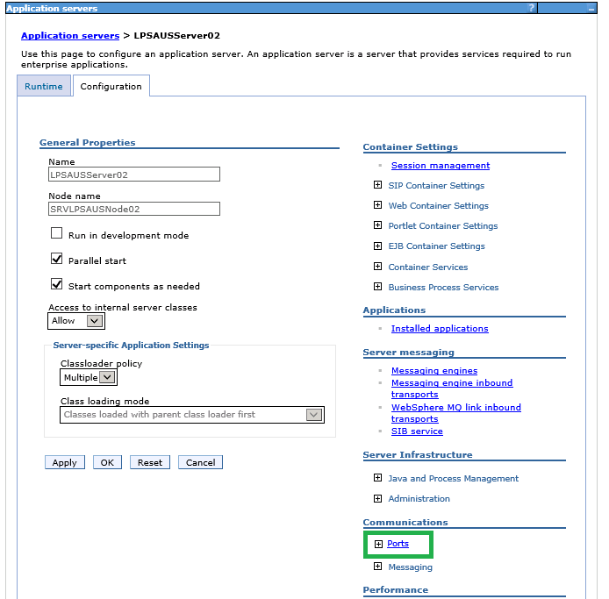

5. Record the **Port** for **WC_defaulthost** . This is the port number used for adding the default host.

### Add Virtual Host AUS Alias

6. Select **Environment** 🡪 **Virtual hosts** 🡪 **default_host**



7. Select **Host Aliases**



8. Select **New** to create a new host alias. ***Note: steps 4 – 7 will need to be done for Host Name * and the DNS name of the secondary server. Both will have the same Port.***

9. Enter * for Host Name and under Port enter the value from step 5 above.

10. Click **Apply** to apply the changes.

11. Click **Save** to save the changes.

12. Select **New** to create a new host alias.

13. Enter the AUS 01 server DNS name for Host Name and under Port enter the value from step 5 above.

14. Click **Apply** to apply the changes.

15. Click **Save** to save the changes.



16. Perform the same steps for AUS 02 server.

### Shared Libraries: WAS4 Server –AUS

1. Copy F:\Installs\WAS WEBSPHERE_SHARED_LIBRARIES to the root of F:\
2. Delete the PORTAL and LOS libraries
3. Verify Disruptor-3.3.0.jar, Log4j-api-2.1.jar and Log4j-core-2.1.jar are located within the AUS_Library
4. Verify xercesImpl.jar is removed from the AUS_Library
5. From the WebSphere admin console – Select: Environment 🡪 Shared libraries
6. Select the appropriate app, node and server from the dropdown list



1. Select New
2. Enter the following:
   1. Name = AUS_SHARED_LIBRARY_NODE02
   2. Classpath = F:\WEBSPHERE_SHARED_LIBRARIES\AUS_LIBRARY
3. Click Apply and Save
4. Select Severs 🡪 Server Types🡪WebSphere application servers
5. Select LPSAUSServer02🡪Server Infrastructure 🡪 Java and Process Management 🡪Class loader
6. New
7. Verify Class loader order has “Classes loaded with parent class loader first” and choose ok
8. Click on the actual Classloader
9. Select “shared library referenece”
10. Add
11. Select corresponding library name that matches the server in the drop down and choose ok

Apply and Save

### WebSphere Server Modification: WAS4 Server -JSQLXML

1. From the Administrative Console - (F:\Data\IBM\WebSphere\AppServer\profiles\cell01_dmgr\firststeps\firststeps.bat), use the account and password supplied during profile creation.
2. From Servers 🡪 Server Types 🡪 Websphere application servers and Select the second JSQLXML server “LPSJSQLXMLServer02”
3. Check Parallel Start option
4. Check Start components as needed option
5. Change the Class loader Policy as Multiple
6. Click Apply button and Save link to reflect the changes into the Master Configuration file.
7. Click the Application Server , Server Infrastructure 🡪 Java and Process Management 🡪 Process definition, Java Virtual Machine
8. Change the Classpath

* F:\Data\IBM\WebSphere\AppServer\profiles\SRVLPSJSQLXMLNode02

1. Change the Initial Heap size : 768
2. Change the Maximum Heap size: 1024
3. Generic JVM Arguments: -Dsun.io.useCanonCaches=false -XX:MaxPermSize=128m -XX:NewSize=32m -XX:PermSize=32m -XX:+UseConcMarkSweepGC
4. Click Apply button and Save link to reflect the changes into the Master Configuration file.

#### WebSphere Application Servers -LOG File Size/Retention

1. From within the application server profile navigate to: Server Infrastructure > Java and Process Management > Process Definition > Logging and Tracing (under Additional Properties) > JVM Logs, and adjust the settings on the Configuration tab as follows:
2. System.out

* Log File Rotation: File Size: 5MB Maximum size. Maximum # of historical log files: 30

1. System.err

* Log File Rotation: File Size: 5MB Maximum size. Maximum # of historical log files: 30

1. Click OK, then click Save (directly to the master configuration):
2. Select the Application Server, Server Infrastructure, Java and Process Management, Monitoring policy:
3. Change the node restart state to RUNNING
4. Click Apply button and Save link to reflect the changes into the Master Configuration file.

### Shared Libraries: WAS4 Server –JSQLXML

1. Copy F:\Installs\WAS WEBSPHERE_SHARED_LIBRARIES to the root of F:\
2. Delete the PORTAL and LOS libraries
3. Verify Disruptor-3.3.0.jar, Log4j-api-2.1.jar and Log4j-core-2.1.jar are located within the JSQLXML_Library
4. From the WebSphere admin console – Select: Environment 🡪 Shared libraries
5. Select the appropriate app, node and server from the dropdown list



1. Select New
2. Enter the following:
   1. Name = JSQLXML_SHARED_LIBRARY_NODE02
   2. Classpath = F:\WEBSPHERE_SHARED_LIBRARIES\JSQLXML_LIBRARY
3. Click Apply and Save
4. Select Severs 🡪 Server Types🡪WebSphere application servers
5. Select LPSJSQLXMLServer02🡪Server Infrastructure 🡪 Java and Process Management 🡪Class loader
6. New
7. Verify Class loader order has “Classes loaded with parent class loader first” and choose ok
8. Click on the actual Classloader
9. Select “shared library referenece”
10. Add
11. Select corresponding library name that matches the server in the drop down and choose ok

Apply and Save

### WebSphere Server Modification: WAS4 Server -LX

1. From the Administrative Console - (F:\Data\IBM\WebSphere\AppServer\profiles\cell01_dmgr\firststeps\firststeps.bat), use the account and password supplied during profile creation.
2. From Servers 🡪 Server Types 🡪 Websphere application servers and Select the second LX server “LPSLXServer02”
3. Check Parallel Start option
4. Check Start components as needed option
5. Change the Class loader Policy as Multiple
6. Click Apply button and Save link to reflect the changes into the Master Configuration file.
7. Click the Application Server , Server Infrastructure 🡪 Java and Process Management 🡪 Process definition, Java Virtual Machine
8. Change the Classpath

* F:\Data\IBM\WebSphere\AppServer\profiles\SRVLPSLXNode02

1. Change the Initial Heap size : 768
2. Change the Maximum Heap size: 1536
3. Generic JVM Arguments: -Dsun.io.useCanonCaches=false -XX:MaxPermSize=128m -XX:NewSize=32m -XX:PermSize=32m -XX:+UseConcMarkSweepGC
4. Click Apply button and Save link to reflect the changes into the Master Configuration file.

#### WebSphere Application Servers -LOG File Size/Retention

1. From within the application server profile navigate to: Server Infrastructure > Java and Process Management > Process Definition > Logging and Tracing (under Additional Properties) > JVM Logs, and adjust the settings on the Configuration tab as follows:
2. System.out

* Log File Rotation: File Size: 5MB Maximum size. Maximum # of historical log files: 30

1. System.err

* Log File Rotation: File Size: 5MB Maximum size. Maximum # of historical log files: 30

1. Click OK, then click Save (directly to the master configuration):
2. Select the Application Server, Server Infrastructure, Java and Process Management, Monitoring policy:
3. Change the node restart state to RUNNING
4. Click Apply button and Save link to reflect the changes into the Master Configuration file.

### Shared Libraries: WAS4 Server – LX

1. Copy F:\Installs\WAS WEBSPHERE_SHARED_LIBRARIES to the root of F:\
2. Delete the PORTAL and LOS libraries
3. Verify Disruptor-3.3.0.jar, Log4j-api-2.1.jar and Log4j-core-2.1.jar are located within the LX_Library
4. From the WebSphere admin console – Select: Environment 🡪 Shared libraries
5. Select the appropriate app, node and server from the dropdown list



1. Select New
2. Enter the following:
   1. Name = LX_SHARED_LIBRARY_NODE02
   2. Classpath = F:\WEBSPHERE_SHARED_LIBRARIES\LX_LIBRARY
3. Click Apply and Save
4. Select Severs 🡪 Server Types🡪WebSphere application servers
5. Select LPSLXServer02🡪Server Infrastructure 🡪 Java and Process Management 🡪Class loader
6. New
7. Verify Class loader order has “Classes loaded with parent class loader first” and choose ok
8. Click on the actual Classloader
9. Select “shared library referenece”
10. Add
11. Select corresponding library name that matches the server in the drop down and choose ok

### WebSphere Server Modification: WAS4 Server -UPLOAD

1. From the Administrative Console - (F:\Data\IBM\WebSphere\AppServer\profiles\cell01_dmgr\firststeps\firststeps.bat), use the account and password supplied during profile creation.
2. From Servers 🡪 Server Types 🡪 Websphere application servers and Select the second UPLOAD server “LPSUPLOADServer02”
3. Check Parallel Start option
4. Check Start components as needed option
5. Change the Class loader Policy as Multiple
6. Click Apply button and Save link to reflect the changes into the Master Configuration file.
7. Click the Application Server , Server Infrastructure 🡪 Java and Process Management 🡪 Process definition, Java Virtual Machine
8. Change the Classpath

* F:\Data\IBM\WebSphere\AppServer\profiles\SRVLPSUPLOADNode02

1. Change the Initial Heap size : 2048
2. Change the Maximum Heap size: 5120
3. Generic JVM Arguments: -Dsun.io.useCanonCaches=false -XX:MaxPermSize=128m -XX:NewSize=32m -XX:PermSize=32m -XX:+UseConcMarkSweepGC
4. Click Apply button and Save link to reflect the changes into the Master Configuration file.

#### WebSphere Application Servers -LOG File Size/Retention

1. From within the application server profile navigate to: Server Infrastructure > Java and Process Management > Process Definition > Logging and Tracing (under Additional Properties) > JVM Logs, and adjust the settings on the Configuration tab as follows:
2. System.out

* Log File Rotation: File Size: 5MB Maximum size. Maximum # of historical log files: 30

1. System.err

* Log File Rotation: File Size: 5MB Maximum size. Maximum # of historical log files: 30

1. Click OK, then click Save (directly to the master configuration):
2. Select the Application Server, Server Infrastructure, Java and Process Management, Monitoring policy:
3. Change the node restart state to RUNNING
4. Click Apply button and Save link to reflect the changes into the Master Configuration file.

### Shared Libraries: WAS4 Server – UPLOAD

1. Copy F:\Installs\WAS WEBSPHERE_SHARED_LIBRARIES to the root of F:\
2. Delete the PORTAL and LOS libraries
3. Verify Disruptor-3.3.0.jar, Log4j-api-2.1.jar and Log4j-core-2.1.jar are located within the UPLOAD_Library
4. From the WebSphere admin console – Select: Environment 🡪 Shared libraries
5. Select the appropriate app, node and server from the dropdown list



1. Select New
2. Enter the following:
   1. Name = UPLOAD_SHARED_LIBRARY_NODE02
   2. Classpath = F:\WEBSPHERE_SHARED_LIBRARIES\UPLOAD_LIBRARY
3. Click Apply and Save
4. Select New
5. Enter the following:
   1. Name = UPLOAD_PLATFORM_SERVICES_NODE02
   2. Classpath = F:\WEBSPHERE_SHARED_LIBRARIES\PLATFORM_SERVICES_LIBRARY
6. Click Apply and Save
7. Select Severs 🡪 Server Types🡪WebSphere application servers
8. New
9. Verify Class loader order has “Classes loaded with parent class loader first” and choose ok
10. Click on the actual Classloader
11. Select “shared library referenece”
12. Add
13. Select corresponding library name UPLOAD_SHARED_LIBRARY_NODE02
14. Apply and Save
15. Take note of the existing Class Loader(s) and click New
16. Click on the actual Classloader
17. Select “shared library referenece”
18. Add
19. Select corresponding library name UPLOAD_PLATFORM_SERVICES_NODE02

### Apply and SaveDeploy the application template WAR file – AUS (Decisioning)

1. From the Admin console of the WAS3: select Applications 🡪 Application Types 🡪 WebSphere enterprise applications. On the right frame, click Install button.
2. Select the sample WAR file for the application you are installing from - F:\Installs\WAS\WAR Files\SRVLPSAUS.war, click Next
3. Select the Fast Path option and click the Next button.
4. Step 1:installation options - provide the Application Name SRVLPSAUS, (remove the _war) Highlight all the 3 File Permissions as shown below are click “Next” button.

NOTE: When installing IN CELL2 with MULTIPLE applications - Ensure to select the correct CLUSTER AND SERVERS for the appropriate application is checked .

1. Step2: map modules to servers - select the associated cell\node\cluster and click Apply. The Server field will update with the new information,
2. Select the module, and Click “Next” button
3. Step 3: map virtual hosts for web modules - map the virtual host ar “default_host” for the selected Web Module and click the “Next” button
4. Step 4: map context roots for web modules - change the “Contect Root” as /SRVLPSAUS and click “Next”.
5. Step 5: summary - click “Finish” button to install the application onto all the nodes in the cluster.
6. The Screen would show the message “Application installed successfully”. Click the Save link to reflect the changes to the master configuration file.

### Deploy the application template WAR file – JSQLXML: LOS

1. From the Admin console of the WAS3: select Applications 🡪 Application Types 🡪 WebSphere enterprise applications. On the right frame, click Install button.
2. Select the sample WAR file for the application you are installing from - F:\Installs\WAS\WAR Files\SRVLPSJXMLLOS.war, click Next
3. Select the Fast Path option and click the Next button.
4. Step 1:installation options - provide the Application Name SRVLPSJXMLLOS, (remove the _war) Highlight all the 3 File Permissions as shown below are click “Next” button.
5. Step2: map modules to servers - select the associated cell\node\cluster and click Apply. The Server field will update with the new information,
6. Select the module, and Click “Next” button

NOTE: When installing IN CELL2 with MULTIPLE applications - Ensure to select the correct CLUSTER AND SERVERS for the appropriate application is checked .

1. Step 3: map virtual hosts for web modules - map the virtual host ar “default_host” for the selected Web Module and click the “Next” button
2. Step 4: map context roots for web modules - change the “Contect Root” as /SRVLPSJXMLLOS and click “Next”.
3. Step 5: summary - click “Finish” button to install the application onto all the nodes in the cluster.
4. The Screen would show the message “Application installed successfully”. Click the Save link to reflect the changes to the master configuration file.

### Deploy the application template WAR file – JSQLXML: PORTAL

1. From the Admin console of the WAS3: select Applications 🡪 Application Types 🡪 WebSphere enterprise applications. On the right frame, click Install button.
2. Select the sample WAR file for the application you are installing from - F:\Installs\WAS\WAR Files\SRVLPSJXMLPORTAL.war, click Next
3. Select the Fast Path option and click the Next button.
4. Step 1:installation options - provide the Application Name SRVLPSJXMLPORTAL, (remove the _war) Highlight all the 3 File Permissions as shown below are click “Next” button.
5. Step2: map modules to servers - select the associated cell\node\cluster and click Apply. The Server field will update with the new information,
6. Select the module, and Click “Next” button

NOTE: When installing IN CELL2 with MULTIPLE applications - Ensure to select the correct CLUSTER AND SERVERS for the appropriate application is checked .

1. Step 3: map virtual hosts for web modules - map the virtual host ar “default_host” for the selected Web Module and click the “Next” button
2. Step 4: map context roots for web modules - change the “Contect Root” as /SRVLPSJXMLPORTAL and click “Next”.
3. Step 5: summary - click “Finish” button to install the application onto all the nodes in the cluster.
4. The Screen would show the message “Application installed successfully”. Click the Save link to reflect the changes to the master configuration file.

### Deploy the application template WAR file – LX

1. From the Admin console of the WAS3: select Applications 🡪 Application Types 🡪 WebSphere enterprise applications. On the right frame, click Install button.
2. Select the sample WAR file for the application you are installing from - F:\Installs\WAS\WAR Files\SRVLPSLX.war, click Next
3. Select the Fast Path option and click the Next button.
4. Step 1:installation options - provide the Application Name SRVLPSLX, (remove the _war) Highlight all the 3 File Permissions as shown below are click “Next” button.

NOTE: When installing IN CELL2 with MULTIPLE applications - Ensure to select the correct CLUSTER AND SERVERS for the appropriate application is checked .

1. Step2: map modules to servers - select the associated cell\node\cluster and click Apply. The Server field will update with the new information,
2. Select the module, and Click “Next” button
3. Step 3: map virtual hosts for web modules - map the virtual host ar “default_host” for the selected Web Module and click the “Next” button
4. Step 4: map context roots for web modules - change the “Contect Root” as /SRVLPSLX and click “Next”.
5. Step 5: summary - click “Finish” button to install the application onto all the nodes in the cluster.
6. The Screen would show the message “Application installed successfully”. Click the Save link to reflect the changes to the master configuration file.

### Deploy the application template WAR file – UPLOAD

1. From the Admin console of the WAS3: select Applications 🡪 Application Types 🡪 WebSphere enterprise applications. On the right frame, click Install button.
2. Select the sample WAR file for the application you are installing from - F:\Installs\WAS\WAR Files\SRVLPSUPLOAD.war, click Next
3. Select the Fast Path option and click the Next button.
4. Step 1:installation options - provide the Application Name SRVLPSUPLOAD, (remove the _war) Highlight all the 3 File Permissions as shown below are click “Next” button.

NOTE: When installing IN CELL2 with MULTIPLE applications - Ensure to select the correct CLUSTER AND SERVERS for the appropriate application is checked .

1. Step2: map modules to servers - select the associated cell\node\cluster and click Apply. The Server field will update with the new information,
2. Select the module, and Click “Next” button
3. Step 3: map virtual hosts for web modules - map the virtual host ar “default_host” for the selected Web Module and click the “Next” button
4. Step 4: map context roots for web modules - change the “Contect Root” as /SRVLPSUPLOAD and click “Next”.
5. Step 5: summary - click “Finish” button to install the application onto all the nodes in the cluster.
6. The Screen would show the message “Application installed successfully”. Click the Save link to reflect the changes to the master configuration file.
7. Start ALL of the installed applications

### Copy “Magic” 5 files – WAS3 Server -AUS

1. Copy the files from “F:\Installs\WAS\Magic 5 files (.xml and .wsdd)\AUS\Deploy Mgr config-cells” directory To:

“F:\Data\IBM\WebSphere\AppServer\profiles\cell01_dmgr\config\cells\dmgrCell01\applications\SRVLPSAUS.ear\deployments\SRVLPSAUS\SRVLPSAUS.war\WEB-INF” directory and OVERWRITE any files that exist

1. Copy the files from “F:\Installs\WAS\Magic 5 files (.xml and .wsdd)\AUS\Node 01 config-cells” directory To:

“F:\Data\IBM\WebSphere\AppServer\profiles\SRVLPSAUSNode01\config\cells\dmgrCell01\applications\SRVLPSAUS.ear\deployments\SRVLPSAUS\SRVLPSAUS.war\WEB-INF” directory and OVERWRITE any files that exist

1. Copy the files from “F:\Installs\WAS\Magic 5 files (.xml and .wsdd)\AUS\Node 01 installed apps” directory To:

“F:\Data\IBM\WebSphere\AppServer\profiles\SRVLPSAUSNode01\installedApps\dmgrCell01\SRVLPSAUS.ear\SRVLPSAUS.war\WEB-INF” directory and OVERWRITE any files that exist

### Copy “Magic” 5 files – WAS4 Server -AUS

1. Copy the files from “F:\Installs\WAS\Magic 5 files (.xml and .wsdd)\AUS\Node 02 config-cells” directory To:

“F:\Data\IBM\WebSphere\AppServer\profiles\SRVLPSAUSNode02\config\cells\dmgrCell01\applications\SRVLPSAUS.ear\deployments\SRVLPSAUS\SRVLPSAUS.war\WEB-INF” directory and OVERWRITE any files that exist

1. Copy the files from “F:\Installs\WAS\Magic 5 files (.xml and .wsdd)\AUS\Node 02 installed apps” directory To:

“F:\Data\IBM\WebSphere\AppServer\profiles\SRVLPSAUSNode02\installedApps\dmgrCell01\SRVLPSAUS.ear\SRVLPSAUS.war\WEB-INF” directory and OVERWRITE any files that exist

### Copy “Magic” 5 files – WAS3 Server -JSQLXML-LOS

1. Copy the files from “F:\Installs\WAS\Magic 5 files (.xml and .wsdd)\JSQLXML-LOS\Deploy Mgr config-cells” directory To:

“F:\Data\IBM\WebSphere\AppServer\profiles\cell01_dmgr\config\cells\dmgrCell01\applications\SRVLPSJXMLLOS.ear\deployments\SRVLPSJXMLLOS\SRVLPSJXMLLOS.war\WEB-INF” directory and OVERWRITE any files that exist

1. Copy the files from “F:\Installs\WAS\Magic 5 files (.xml and .wsdd)\JSQLXML-LOS\Node 01 config-cells” directory To:

“F:\Data\IBM\WebSphere\AppServer\profiles\SRVLPSJSQLXMLNode01\config\cells\dmgrCell01\applications\SRVLPSJXMLLOS.ear\deployments\SRVLPSJXMLLOS\SRVLPSJXMLLOS.war\WEB-INF” directory and OVERWRITE any files that exist

1. Copy the files from “F:\Installs\WAS\Magic 5 files (.xml and .wsdd)\JSQLXML-LOS\Node 01 installed apps” directory To:

“F:\Data\IBM\WebSphere\AppServer\profiles\SRVLPSJSQLXMLNode01\installedApps\dmgrCell01\SRVLPSJXMLLOS.ear\SRVLPSJXMLLOS.war\WEB-INF” directory and OVERWRITE any files that exist

### Copy “Magic” 5 files – WAS4 Server -JSQLXML-LOS

1. Copy the files from “F:\Installs\WAS\Magic 5 files (.xml and .wsdd)\JSQLXML-LOS\Node 02 config-cells” directory To:

“F:\Data\IBM\WebSphere\AppServer\profiles\SRVLPSJSQLXMLNode02\config\cells\dmgrCell01\applications\SRVLPSJXMLLOS.ear\deployments\SRVLPSJXMLLOS\SRVLPSJXMLLOS.war\WEB-INF” directory and OVERWRITE any files that exist

1. Copy the files from “F:\Installs\WAS\Magic 5 files (.xml and .wsdd)\JSQLXML-LOS\Node 02 installed apps” directory To:

“F:\Data\IBM\WebSphere\AppServer\profiles\SRVLPSJSQLXMLNode02\installedApps\dmgrCell01\SRVLPSJXMLLOS.ear\SRVLPSJXMLLOS.war\WEB-INF” directory and OVERWRITE any files that exist

### Copy “Magic” 5 files – WAS3 Server -JSQLXML-PORTAL

1. Copy the files from “F:\Installs\WAS\Magic 5 files (.xml and .wsdd)\JSQLXML-PORTAL\Deploy Mgr config-cells” directory To:

“F:\Data\IBM\WebSphere\AppServer\profiles\cell01_dmgr\config\cells\dmgrCell01\applications\SRVLPSJXMLPORTAL.ear\deployments\SRVLPSJXMLPORTAL\SRVLPSJXMLPORTAL.war\WEB-INF” directory and OVERWRITE any files that exist

1. Copy the files from “F:\Installs\WAS\Magic 5 files (.xml and .wsdd)\JSQLXML-PORTAL\Node 01 config-cells” directory To:

“F:\Data\IBM\WebSphere\AppServer\profiles\SRVLPSJSQLXMLNode01\config\cells\dmgrCell01\applications\SRVLPSJXMLPORTAL.ear\deployments\SRVLPSJXMLPORTAL\SRVLPSJXMLPORTAL.war\WEB-INF” directory and OVERWRITE any files that exist

1. Copy the files from “F:\Installs\WAS\Magic 5 files (.xml and .wsdd)\JSQLXML-PORTAL\Node 01 installed apps” directory To:

“F:\Data\IBM\WebSphere\AppServer\profiles\SRVLPSJSQLXMLNode01\installedApps\dmgrCell01\SRVLPSJXMLPORTAL.ear\SRVLPSJXMLPORTAL.war\WEB-INF” directory and OVERWRITE any files that exist

### Copy “Magic” 5 files – WAS4 Server -JSQLXML-PORTAL

1. Copy the files from “F:\Installs\WAS\Magic 5 files (.xml and .wsdd)\JSQLXML-PORTAL\Node 02 config-cells” directory To:

“F:\Data\IBM\WebSphere\AppServer\profiles\SRVLPSJSQLXMLNode02\config\cells\dmgrCell01\applications\SRVLPSJXMLPORTAL.ear\deployments\SRVLPSJXMLPORTAL\SRVLPSJXMLPORTAL.war\WEB-INF” directory and OVERWRITE any files that exist

1. Copy the files from “F:\Installs\WAS\Magic 5 files (.xml and .wsdd)\JSQLXML-PORTAL\Node 02 installed apps” directory To:

“F:\Data\IBM\WebSphere\AppServer\profiles\SRVLPSJSQLXMLNode02\installedApps\dmgrCell01\SRVLPSJXMLPORTAL.ear\SRVLPSJXMLPORTAL.war\WEB-INF” directory and OVERWRITE any files that exist

### Copy “Magic” 5 files – WAS3 Server -LX

1. Copy the files from “F:\Data\IBM\WebSphere\AppServer\profiles\SRVLPSJSQLXMLNode02\installedApps\dmgrCell01\SRVLPSJXMLPORTAL.ear\SRVLPSJXMLPORTAL.war\WEB-INF” directory To:

“F:\Data\IBM\WebSphere\AppServer\profiles\cell01_dmgr\config\cells\dmgrCell01\applications\SRVLPSLX.ear\deployments\SRVLPSLX\SRVLPSLX.war\WEB-INF” directory and OVERWRITE any files that exist

1. Copy the files from “F:\Installs\WAS\Magic 5 files (.xml and .wsdd)\LX\Node 01 config-cells” directory To:

“F:\Data\IBM\WebSphere\AppServer\profiles\SRVLPSLXNode01\config\cells\dmgrCell01\applications\SRVLPSLX.ear\deployments\SRVLPSLX\SRVLPSLX.war\WEB-INF” directory and OVERWRITE any files that exist

1. Copy the files from “F:\Installs\WAS\Magic 5 files (.xml and .wsdd)\LX\Node 01 installed apps” directory To:

“F:\Data\IBM\WebSphere\AppServer\profiles\SRVLPSLXNode01\installedApps\dmgrCell01\SRVLPSLX.ear\SRVLPSLX.war\WEB-INF” directory and OVERWRITE any files that exist

### Copy “Magic” 5 files – WAS4 Server -LX

1. Copy the files from “F:\Installs\WAS\Magic 5 files (.xml and .wsdd)\LX\Node 02 config-cells” directory To:

“F:\Data\IBM\WebSphere\AppServer\profiles\SRVLPSLXNode02\config\cells\dmgrCell01\applications\SRVLPSLX.ear\deployments\SRVLPSLX\SRVLPSLX.war\WEB-INF” directory and OVERWRITE any files that exist

1. Copy the files from “F:\Installs\WAS\Magic 5 files (.xml and .wsdd)\LX\Node 02 installed apps” directory To:

“F:\Data\IBM\WebSphere\AppServer\profiles\SRVLPSLXNode02\installedApps\dmgrCell01\SRVLPSLX.ear\SRVLPSLX.war\WEB-INF” directory and OVERWRITE any files that exist

### Copy “Magic” 5 files – WAS3 Server -UPLOAD

1. Copy the files from “F:\Installs\WAS\Magic 5 files (.xml and .wsdd)\UPLOAD\Deploy Mgr config-cells” directory To:

“F:\Data\IBM\WebSphere\AppServer\profiles\cell01_dmgr\config\cells\dmgrCell01\applications\SRVLPSUPLOAD.ear\deployments\SRVLPSUPLOAD\SRVLPSUPLOAD.war\WEB-INF” directory and OVERWRITE any files that exist

1. Copy the files from “F:\Installs\WAS\Magic 5 files (.xml and .wsdd)\UPLOAD\Node 01 config-cells” directory To:

“F:\Data\IBM\WebSphere\AppServer\profiles\SRVLPSUPLOADNode01\config\cells\dmgrCell01\applications\SRVLPSUPLOAD.ear\deployments\SRVLPSUPLOAD\SRVLPSUPLOAD.war\WEB-INF” directory and OVERWRITE any files that exist

1. Copy the files from “F:\Installs\WAS\Magic 5 files (.xml and .wsdd)\UPLOAD\Node 01 installed apps” directory To:

“F:\Data\IBM\WebSphere\AppServer\profiles\SRVLPSUPLOADNode01\installedApps\dmgrCell01\SRVLPSUPLOAD.ear\SRVLPSUPLOAD.war\WEB-INF” directory and OVERWRITE any files that exist

### Copy “Magic” 5 files – WAS4 Server -UPLOAD

1. Copy the files from “F:\Installs\WAS\Magic 5 files (.xml and .wsdd)\UPLOAD\Node 02 config-cells” directory To:

“F:\Data\IBM\WebSphere\AppServer\profiles\SRVLPSUPLOADNode02\config\cells\dmgrCell01\applications\SRVLPSUPLOAD.ear\deployments\SRVLPSUPLOAD\SRVLPSUPLOAD.war\WEB-INF” directory and OVERWRITE any files that exist

1. Copy the files from “F:\Installs\WAS\Magic 5 files (.xml and .wsdd)\UPLOAD\Node 02 installed apps” directory To:

“F:\Data\IBM\WebSphere\AppServer\profiles\SRVLPSUPLOADNode02\installedApps\dmgrCell01\SRVLPSUPLOAD.ear\SRVLPSUPLOAD.war\WEB-INF” directory and OVERWRITE any files that exist

### WebSphere Web Server Creation: WAS3 Server

1. From the Admin console for each deployment manager, go to the Servers 🡪 Server Types 🡪 Web Servers link Click the New button.
2. In Step 1: Select the first Node and provide the web server name WEBSRVCLUSTER2. Select the Type as IBM HTTP Server and click the Next button.
3. In Step 2: Click Next button on the screen.
4. In Step 3: leave the port as 80. Change the web server installation location F:\Data\IBM\HTTPServer , leave the Service name as the default, and change the Plug-in installation location to F:\Data\IBM\HTTPServer\Plugins
5. In Step 4: confirmation screen click the Finish button. Click Save link in the next screen to save changes to master configuration.

### WebSphere Web Server Plug-in Generation WAS3 Server

After all application templates are installed within each cell

Note: Make a backup of the original plugin if one exists. Located:

F:\Data\IBM\HTTPServer\Plugins\config\WEBSRVCLUSTER2\plugin-cfg.xml

From the cell-manager Admin console on WAS3 Server:

Servers 🡪 Servertypes🡪 Web Servers, Select the Web server check block and click generate plug-in

Note the plug-in config file location (the path will be used during cell 2 configuration to over write) and copy that file location and paste it into notepad for propagation step:

F:\data\IBM\WebSphere\AppServer\profiles\cell01_dmgr\config\cells\dmgrCell01\nodes\SRVLPS<APP>Node01\servers\WEBSRVCLUSTERx

### Disabling Automatic Webserver Plugin Generation: WAS3 Server

1. Select the webserver (click the name) and from the Additional Properties section, click Plug –in properties.
2. Deselect Automatically generate the plug-in configuration file and Automatically propagate plug-in configuration file.
3. Click Apply and save to the master configuration.

If encountering an error in Cell 2, copy the plugin-key.kdb and plugin.key.sth from F:\Installs\Temp plugin to the path specified when originally generating the plugin-cfg. Once copied perfom the steps to disable the auto generation and propagation. Delete the temporary plugin files.

### WebSphere Web Server Plug-in Propagation: WAS3 Server

1. From the console main column tree – select Environment 🡪 Select “Update global Web server plug-in configuration.

The plugin is generated :

F:\Data\IBM\WebSphere\AppServer\profiles\cell01_dmgr\config\cells\plugin-cfg.xml

1. Copy that file into the location you recorded from previous step:

F:\data\IBM\WebSphere\AppServer\profiles\cell01_dmgr\config\cells\dmgrCell01\nodes\SRVLPS<APP>Node01\servers\WEBSRVCLUSTERx

1. Return to Web servers, select the web server and propagate plug-in

### HTTP-Plugin BIN folder copy for WAS3 Server

Copy F:\Installs\WAS\Bin folder for HTTP server plugins\bin directory to F:\Data\IBM\HTTPServer\Plugins on WAS Server 3

### HTTP-Plugin BIN folder copy for WAS4 Server

Copy F:\DATA\IBM\HTTPServer\Plugins directory from WAS Server 3 to F:\DATA\IBM\HTTPServer on the WAS Server 4

### HTTP server final configuration: WAS3 and WAS4

1. Copy the httpd.conf file from

“F:\Installs\WAS\HTTP Conf files\Cell 02” to F:\DATA\IBM\HTTPServer\conf

1. Edit the following areas in each HTTPD.conf
2. Listen and ServerName attributes

* IPv4 support, modify: Listen 0.0.0.0:80 – change 0.0.0.0 to the servername

1. Modify the Servername directive:
2. ServerName servername:80 – enter Servers FQDN ex. myserver.domain.com
3. Alias section

* Any location referring to <StorageServerFQDN> - change to the storage server fully qualified domain name (no ip addresses). Not all servers contain this alias..
* ServerSignature
* Ensure ServerSignature is set to off

1. WebSpherePlugConfig section

* Look for the line:

WebSpherePluginConfig "F:\Data\IBM\HTTPServer\Plugins\config\ WEBSRVCLUSTER2\plugin-cfg.xml – ensure the correct WEBSRVCLUSTER for the cell being configured

1. Change the Timeout value from 300 to 600
2. Restart HTTP services

### Transaction Timeout – WAS3 and WAS4 Servers

1. Login to the admin console

2. Navigate to the Application Servers via Servers… Server Types… WebSphere application servers

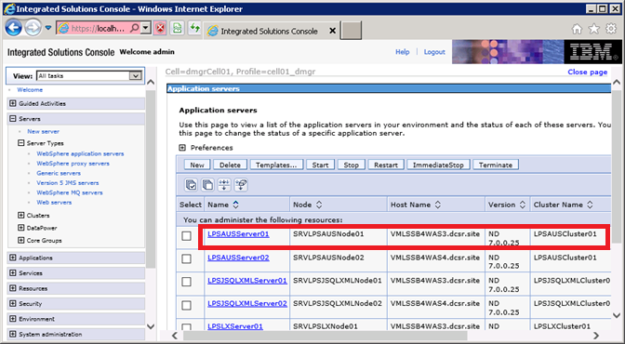

3. Click on the first AUS server in the cluster. **LPSAUSServer01** in the previous screen.

4. Click on **Container Services**.

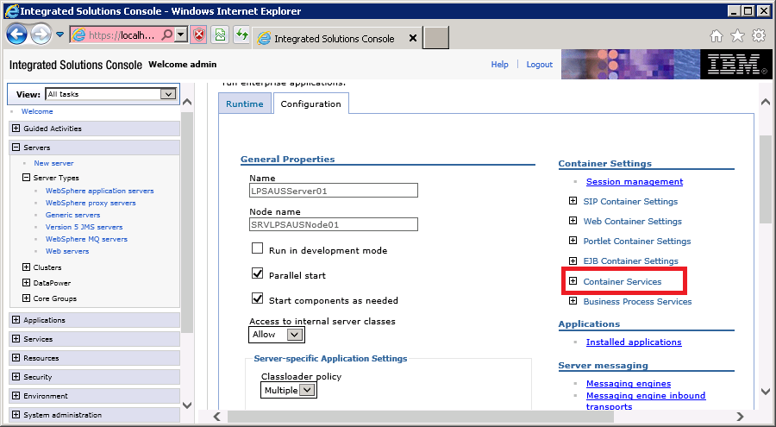

5. Click on **Transaction Service**.

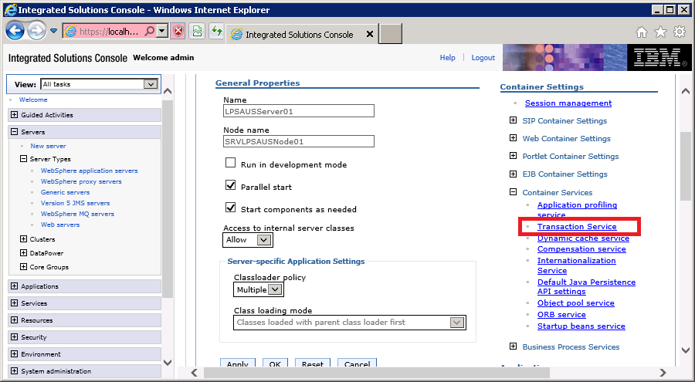

6. Change both the **Total transaction lifetime timeout** and **Maximum transaction timeout** values to **600**.

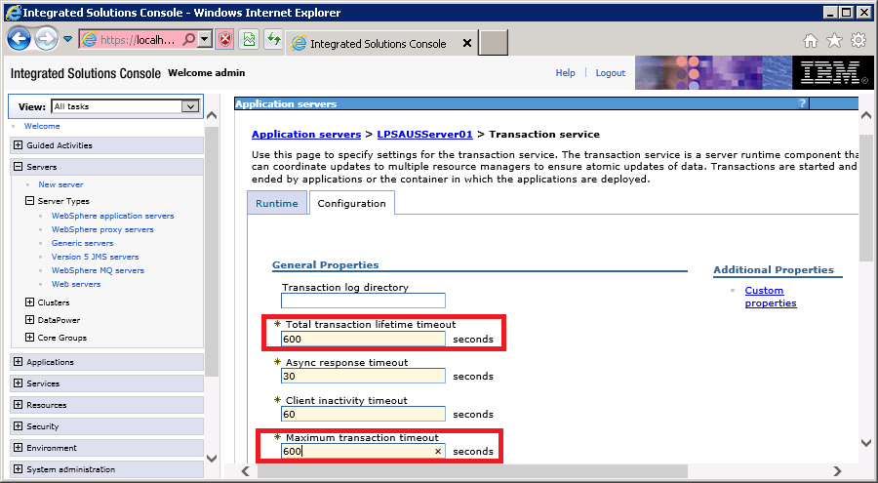

7. Select **OK** and then **Save** the changes.

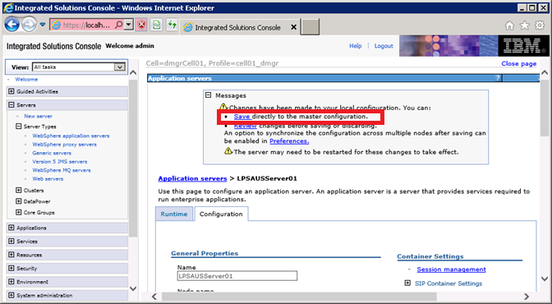

8. Click on the secondary server **LPSAUSServer02** in this example.

9. **Repeat steps 4 through 7** for the secondary server in the cluster.

### WebSphere Secure Cookies – WAS3 and WAS4 Servers (AUS, LX, JSQXML, UPLOAD)

**Set HTTP Only on cookes in WAS 7.0 (not Cache Servers)**

1.       Open the WebSphere Administration Console.

2.       Select Servers, Server Types, WebSphere application Servers

3.       Select "your server".

**4.       Select "Web Container Settings" -> “Web container “**

5.       Select "Custom properties"

6.       Press the "new" button.

**7.       Enter com.ibm.ws.webcontainer.httpOnlyCookies in the "Name" field.**

8.       Enter * in the Value field.

9.     Enter "Secure Cookies" in the "Description" field.

10.   Press the "Apply" button.

11.   Press the "OK button.

12.   You will be navigated back to the custom properties field.

**Set the Secure Flag on JSESSIONID Cookie.**

1. Select Web Container
2. Check "Enable Cookies" checkbox in the "General Properties" section.
3. The text "Enable Cookies" is a hyperlink. Click on it.
4. Under general properties, check that JSESSIONID is entered in the "Cookie name" field.
5. Check the check-box named "Restrict cookies to HTTPS sessions"
6. Press the "Apply" button.
7. Press the "OK" button.
8. Restart the previously selected "server name".

### WebSphere Windows Services Creation: WAS3 Server

1. Open an administrative command prompt and navigate to F:\Data\IBM\Websphere\AppServer\bin
2. Run the following commands:
3. "F:\Data\IBM\WebSphere\AppServer\bin\WASService -add CellManager01 -serverName dmgr -profilePath F:\Data\IBM\WebSphere\AppServer\profiles\cell01_dmgr -wasHome F:\Data\IBM\WebSphere\AppServer\ -logRoot F:\Data\IBM\WebSphere\AppServer\profiles\cell01_dmgr\logs\dmgr -logFile MS_Windows_service_ISC.log"
4. "WASService -add SRVLPSAUSNode01_nodeagent -serverName nodeagent -profilePath F:\Data\IBM\WebSphere\AppServer\profiles\SRVLPSAUSNode01 -wasHome F:\Data\IBM\WebSphere\AppServer -logRoot F:\Data\IBM\WebSphere\AppServer\profiles\SRVLPSAUSNode01\logs\nodeagent -logFile F:\Data\IBM\WebSphere\AppServer\profiles\SRVLPSAUSNode01\logs\nodeagent\startServer.log"
5. "WASService -add SRVLPSJSQLXMLNode01_nodeagent -serverName nodeagent -profilePath F:\Data\IBM\WebSphere\AppServer\profiles\SRVLPSJSQLXMLNode01 -wasHome F:\Data\IBM\WebSphere\AppServer -logRoot F:\Data\IBM\WebSphere\AppServer\profiles\SRVLPSJSQLXMLNode01\logs\nodeagent -logFile F:\Data\IBM\WebSphere\AppServer\profiles\SRVLPSJSQLXMLNode01\logs\nodeagent\startServer.log"
6. "WASService -add SRVLPSLXNode01_nodeagent -serverName nodeagent -profilePath F:\Data\IBM\WebSphere\AppServer\profiles\SRVLPSLXNode01 -wasHome F:\Data\IBM\WebSphere\AppServer -logRoot F:\Data\IBM\WebSphere\AppServer\profiles\SRVLPSLXNode01\logs\nodeagent -logFile F:\Data\IBM\WebSphere\AppServer\profiles\SRVLPSLXNode01\logs\nodeagent\startServer.log"
7. "WASService -add SRVLPSUPLOADNode01_nodeagent -serverName nodeagent -profilePath F:\Data\IBM\WebSphere\AppServer\profiles\SRVLPSUPLOADNode01 -wasHome F:\Data\IBM\WebSphere\AppServer -logRoot F:\Data\IBM\WebSphere\AppServer\profiles\SRVLPSUPLOADNode01\logs\nodeagent -logFile F:\Data\IBM\WebSphere\AppServer\profiles\SRVLPSUPLOADNode01\logs\nodeagent\startServer.log"
8. Open services from Administrative Tools, manually change the startup mode for the newly created services from manual to automatic.
9. Change the services credentials to the environment service account for the websphere services as well as the IBM HTTP Server 7.0 service.

### WebSphere Windows Services Creation: WAS4 Server

1. Open an administrative command prompt and navigate to F:\Data\IBM\Websphere\AppServer\bin
2. Run the following commands:
3. "WASService -add SRVLPSAUSNode02_nodeagent -serverName nodeagent -profilePath F:\Data\IBM\WebSphere\AppServer\profiles\SRVLPSAUSNode02 -wasHome F:\Data\IBM\WebSphere\AppServer -logRoot F:\Data\IBM\WebSphere\AppServer\profiles\SRVLPSAUSNode02\logs\nodeagent -logFile F:\Data\IBM\WebSphere\AppServer\profiles\SRVLPSAUSNode02\logs\nodeagent\startServer.log"
4. "WASService -add SRVLPSJSQLXMLNode02_nodeagent -serverName nodeagent -profilePath F:\Data\IBM\WebSphere\AppServer\profiles\SRVLPSJSQLXMLNode02 -wasHome F:\Data\IBM\WebSphere\AppServer -logRoot F:\Data\IBM\WebSphere\AppServer\profiles\SRVLPSJSQLXMLNode02\logs\nodeagent -logFile F:\Data\IBM\WebSphere\AppServer\profiles\SRVLPSJSQLXMLNode02\logs\nodeagent\startServer.log"
5. "WASService -add SRVLPSLXNode02_nodeagent -serverName nodeagent -profilePath F:\Data\IBM\WebSphere\AppServer\profiles\SRVLPSLXNode02 -wasHome F:\Data\IBM\WebSphere\AppServer -logRoot F:\Data\IBM\WebSphere\AppServer\profiles\SRVLPSLXNode02\logs\nodeagent -logFile F:\Data\IBM\WebSphere\AppServer\profiles\SRVLPSLXNode02\logs\nodeagent\startServer.log"
6. "WASService -add SRVLPSUPLOADNode02_nodeagent -serverName nodeagent -profilePath F:\Data\IBM\WebSphere\AppServer\profiles\SRVLPSUPLOADNode02 -wasHome F:\Data\IBM\WebSphere\AppServer -logRoot F:\Data\IBM\WebSphere\AppServer\profiles\SRVLPSUPLOADNode02\logs\nodeagent -logFile F:\Data\IBM\WebSphere\AppServer\profiles\SRVLPSUPLOADNode02\logs\nodeagent\startServer.log"
7. Open services from Administrative Tools, manually change the startup mode for the newly created services from manual to automatic.
8. Change the services credentials to the environment service account for the websphere services as well as the IBM HTTP Server 7.0 service.

## Keystore Copy

*Copy the keystore file from the F:* WEBSPHERE_SHARED_LIBRARIES directory on WebSphere Server 1 to the *F:* WEBSPHERE_SHARED_LIBRARIES directory on WebSphere Servers 3 and 4.

## WebSphere CELL-3 Configuration - PORTAL

### WebSphere Deployment Manager Creation WAS5 Server

1. Execute PMT.bat from “F:\Data\IBM\WebSphere\AppServer\bin\ProfileManagement”
2. Click the “Create” button to start the profile creation process.
3. In the “Environment Selection” window select the “Management” option and click the “Next” button.
4. In the Server Type Selection screen, select “Deployment manager” option and click “Next”.
5. In the “profile Creation Options” screen select the “Advanced profile creation” option and click “Next”.
6. In the “Optional Application Deployment” screen leave the “Deploy the administrative console” option “checked” and click “Next”. This option will enable web based administration for the created profile.
7. In the “Profile Name and Location” screen change the profile name and directory.
8. Profile Name: cell01_dmgr
9. Directory: F:\Data\IBM\WebSphere\AppServer\profiles\cell01_dmgr
10. Click “Next”
11. In the “Node, Host, and Cell Names” screen change the Node name, host name and cell name.
12. Node Name: Cellmanager01
13. Host Name: full DNS name for that server
14. Cell Name: dmgrCell01
15. Click “Next”
16. In the “Administrative Security Screen” make sure the “Enable administrative security” is checked and provide the username and password click “Next”.

(Make sure you document the credential values you use for your environment)

1. In the “Security Certificate (Part 1)” screen leave the default options as-is and click “Next”.
2. In the “Security Certificate (Part 2)” screen leave all of the default values and click “Next”.
3. In the “Port Values Assignment” screen leave the port values as-is and click “Next”.

Note: if you have more than one profile, make sure the port values are unique.

1. In the “Windows Service Definition” screen, make sure “Run the deployment manager process as a Windows service” is “Checked” and the “Log on as a local system account” is “selected”. Leave the “Startup type” as “automatic” and click “Next”.
2. In the “Profile Creation Summary” screen verify the summary details and click the “Create” button.
3. Once the profile is created successfully, in the “profile Creation Complete” screen “check” the “Launch the Frist step console” and Click the “Finish” button.
4. In the “First steps” window click the “Installation verification” look. This will verify the profile installation is done correctly and also start the Deployment Manager. Installation Verification is required to start the deployment manager prior to creating individual profiles.
5. Verify for the “The Installation verification is complete” in the First Steps Output screen.
6. Verify the service was created in the windows services listing (services.msc) (Looking for IBM WAS Server v7 –CellManager01)

### WebSphere Profile & Node Creation: WAS5 Server

1. Execute PMT.bat from “F:\Data\IBM\WebSphere\AppServer\bin\ProfileManagement” if the tool is not still running.
2. From the “Profile Management Tool” click the “Create” button
3. Select the “Custom Profile” option and click the “Next” button.
4. In the “profile Creation Options” screen select the “Advanced profile creation” option and click “Next”.
5. Profile Name: SRVLPSPORTALNode01
6. Profile Directory: F:\DATA\IBM\WebSphere\AppServer\profiles\SRVLPSPORTALNode01
7. Click “Next”
8. In the “node and host names” screen
9. Node name: SRVLPSPORTALNode01
10. Host name: <actual servername.domain.com>
11. Click “Next”
12. In the Federation Screen
13. Deployment manager host name: <actual servername.domain.com>
14. Deployment manager SOAP port number: 8879
15. Deployment manager authentication

* Enter a username and password – RECORD this information

1. Leave the Federate this Node Later option unchecked, and click “Next”
2. In the Security Certificate (Part 1) screen, just click Next button.
3. In the Security Certificate (Part 2) screen, just click the Next button.
4. In the Port Values Assignment screen, Normally, you can just click Next. If there is a port conflict, make sure to change the value based on the Recommended Port Values. Click Next button.
5. On the Profile Creation Summary screen, click “Create” button to create the profile.
6. After the successful creation, click Finish button to launch the First Steps Console. The profile(s) should be seen from the Profile Management Tool. Click Exit and also PORTAL the PMT.
7. Execute Firststeps.bat from F:\DATA\IBM\WebSphere\AppServer\profiles\cell01_dmgr\firststeps directory.
8. Click the “Administrative console” and login to WAS console with the userid and passwords created for the profile from steps above.

(If you have any browser issues running the console, select Tools from the Menu bar, Compatibility View Settings and add localhost(or run all in compatibility mode) , PORTAL and try to run the Admin Console)

1. From the Websphere Admin Console select System administration 🡪 Nodes look to verify the nodes. In the right frame, you should see Nodes listed along with the Deployment Cell Manager.

### WebSphere Profile & Node Creation: WAS6 Server

In development environments there is not always a second Cache Server. Skip past this section if applicable*

1. USE PMT (Profile Management tool) from F:\Data\IBM\WebSphere\AppServer\firststeps\firststeps.bat
2. From the “Profile Management Tool” click the “Create” button
3. Select the “Custom Profile” option and click the “Next” button.
4. In the “profile Creation Options” screen select the “Advanced profile creation” option and click “Next”.
5. Profile Name: SRVLPSPORTALNode02
6. Profile Directory: F:\DATA\IBM\WebSphere\AppServer\profiles\SRVLPSPORTALNode02
7. Click “Next”
8. In the “node and host names” screen
9. Node name: SRVLPSPORTALNode02
10. Host name: <actual servername.domain.com>
11. Click “Next”
12. In the Federation Screen
13. Deployment manager host name: < WAS5 SERVERNAME.domain.com> (in your environment)
14. Deployment manager SOAP port number: 8879
15. Deployment manager authentication

* Enter a username and password – RECORD this information

1. Leave the Federate this Node Later option unchecked, and click “Next”
2. In the Security Certificate (Part 1) screen, just click Next button.
3. In the Security Certificate (Part 2) screen, just click the Next button.
4. In the Port Values Assignment screen, Normally, you can just click Next. If there is a port conflict, make sure to change the value based on the Recommended Port Values. Click Next button.
5. On the Profile Creation Summary screen, click “Create” button to create the profile.
6. After the successful creation, click Finish button to launch the First Steps Console. The profile(s) should be seen from the Profile Management Tool. Click Exit and also PORTAL the PMT.

#### FROM Remote WAS5 Server:

1. Execute Firststeps.bat from F:\DATA\IBM\WebSphere\AppServer\profiles\cell01_dmgr\firststeps directory.
2. Click the “Administrative console” and login to WAS console.
3. From the Websphere Admin Console select System administration 🡪 Nodes look to verify the nodes. In the right frame, you should see Nodes listed along with the Deployment Cell Manager.

### WebSphere Server Creation: WAS 5 Server Portal

1. From the Administrative Console - (F:\Data\IBM\WebSphere\AppServer\profiles\cell01_dmgr\firststeps\firststeps.bat), use the account and password supplied during profile creation.
2. From Servers 🡪 Server Types 🡪 Websphere application servers and click New button in the right frame.
3. Select the first Node – “SRVLPSPORTALNode01” from the dropdown and add “LPSPORTALServer01”
4. In Server template screen– select the default option and click the Next button.
5. In the Server Specific Properties screen (shown above) – leave the “Generate Unique Ports” option checked and click Next button.
6. Click the Finish button in Confirm new server screen (shown above) to create the server.
7. The Application Server is now listed. Now click the Save link in the messages block for the changes to be reflected in the Master Configuration file.
8. Select the Application Server – “LPSPORTALServer01” link and in the Configuration screen change the following
9. Check Parallel Start option
10. Check Start components as needed option
11. Change the Class loader Policy as Multiple
12. Click Apply button and then subsequently Save link to reflect the changes in the Master Configuration file.
13. Click the Application Server , Server Infrastructure 🡪 Java and Process Management 🡪 Process definition, Java Virtual Machine
14. Change the Classpath

* F:\Data\IBM\WebSphere\AppServer\profiles\SRVLPSPORTALNode01

1. Check the Verbose Garbage Collection box
2. Change the Initial Heap size : 1024
3. Change the Maximum Heap size: 2048
4. Generic JVM Arguments: -Dsun.io.useCanonCaches=false -XX:MaxPermSize=128m -XX:NewSize=32m -XX:PermSize=32m -XX:+UseConcMarkSweepGC -XX:+UseParNewGC
5. Click Apply button and Save link to reflect the changes into the Master Configuration file.

### Shared Libraries: WAS5 Server – PORTAL

1. Copy F:\Installs\WAS WEBSPHERE_SHARED_LIBRARIES to the root of F:\
2. Delete all other libraries except PORTAL and was_generated_keystore.jks
3. Verify Disruptor-3.3.0.jar, Log4j-api-2.1.jar and Log4j-core-2.1.jar are located within the Portal_Library
4. Verify xercesImpl.jar is removed from the Portal_Library
5. From the WebSphere admin console – Select: Environment 🡪 Shared libraries
6. Select the appropriate app, node and server from the dropdown list

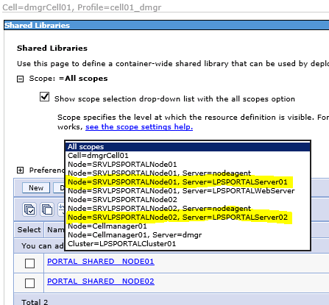

1. Select New
2. Enter the following:
   1. Name = PORTAL_SHARED_LIBRARY_NODE01
   2. Classpath = F:\WEBSPHERE_SHARED_LIBRARIES\PORTAL_LIBRARY
3. Click Apply and Save
4. Select New
5. Enter the following:
   1. Name = PORTAL_PLATFORM_SERVICES_NODE01
   2. Classpath = F:\WEBSPHERE_SHARED_LIBRARIES\PLATFORM_SERVICES_LIBRARY
6. Click Apply and Save
7. Select Severs 🡪 Server Types🡪WebSphere application servers
8. New
9. Verify Class loader order has “Classes loaded with parent class loader first” and choose ok
10. Click on the actual Classloader
11. Select “shared library referenece”
12. Add
13. Select corresponding library name PORTAL_SHARED_LIBRARY_NODE01
14. Apply and Save
15. Take note of the existing Class Loader(s) and click New
16. Click on the actual Classloader
17. Select “shared library referenece”
18. Add
19. Select corresponding library name PORTAL_PLATFORM_SERVICES_NODE01

Apply and Save

#### WebSphere Application Servers -LOG File Size/Retention

1. From within the application server profile, navigate to: Server Infrastructure > Java and Process Management > Process Definition > Logging and Tracing (under Additional Properties) > JVM Logs, and adjust the settings on the Configuration tab as follows:
2. System.out

* Log File Rotation: File Size: 5MB Maximum size. Maximum # of historical log files: 30

1. System.err

* Log File Rotation: File Size: 5MB Maximum size. Maximum # of historical log files: 30

1. Click OK, then click Save (directly to the master configuration):
2. Select the Application Server, Server Infrastructure, Java and Process Management, Monitoring policy:
3. Change the node restart state to RUNNING
4. Click Apply button and Save link to reflect the changes into the Master Configuration file.
5. From Servers 🡪 Server Types 🡪 Websphere application servers, select Web Server plug-in properties change the following
6. Use connection timeout to 0
7. Read/Write timeout to 0
8. Click Apply button and Save link to reflect the changes into the Master Configuration file.

NOTE: Do not create server for the second node, they are created when creating the clusters.

#### Profile/Node Verification

From the Websphere Admin Console select System administration 🡪 Nodes link to verify the nodes. In the right frame, you should see Nodes listed along with the Deployment Cell Manager.

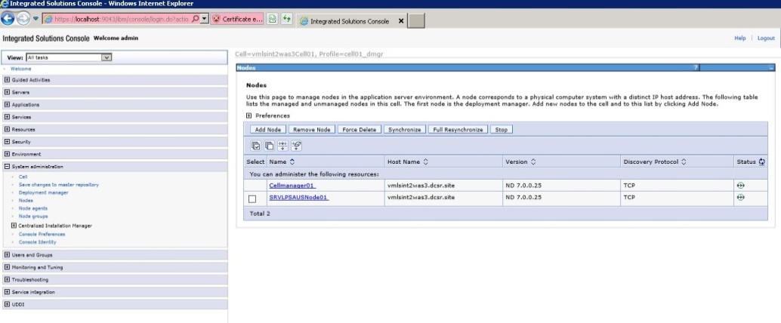

Ensure all profiles on both NODE 1 and NODE 2 are created before proceeding.

DO NOT ADD SECOND NODE TO WEBSPHERE APPLICATION SERVERS IN ADMIN CONSOLE, THIS WILL AUTOMATICALLY OCCUR WHEN CREATING THE CLUSTER.

#### **Hung Thread Issue Fix – Websphere Portal\LOS Server 1 Configuration**

This must be done for both nodes, and entails the creation of custom property in Websphere application server to avoid HUNG Thread issue:

1. Select Websphere Application Servers > Application Server > Click Administation and Custom Properties
2. 
3. Click New
4. Add the following properties (suggestion – copy below and paste into given fields)
5. Property1:

* Name: com.ibm.websphere.threadmonitor.interval
* Value: 360
* Description: The frequency (in seconds) at which managed threads in the selected application server will be interrogated.
  + Click Apply and click OK
  + Save the changes.

1. Property2:

* Name: com.ibm.websphere.threadmonitor.threshold
* Value: 2100
* Description: The length of time (in seconds) in which a thread can be active before it is considered hung. Any thread that is detected as active for longer than this length of time is reported as hung.
  + Click Apply and click OK
  + Save the changes.

1. Property3:

* Name: com.ibm.websphere.threadmonitor.false.alarm.threshold
* Value: 100
* Description: The number of times (T) that false alarms can occur before automatically increasing the threshold. It is possible that a thread that is reported as hung eventually completes its work, resulting in a false alarm. A large number of these events indicates that the threshhold value is too small. The hang detection facility can automatically respond to this situation: For every T false alarms, the threshold T is increased by a factor of 1.5. Set the value to zero (or less) to disable the automatic adjustment.
  + Click Apply and click OK
  + Save the changes.

1. Property4:

* Name: com.ibm.websphere.threadmonitor.dump.java
* Value: False
* Description: Set to true to cause a javacore to be created when a hung thread is detected and a WSVR0605W message is printed. The threads section of the javacore can be analyzed to determine what the reported thread and other related threads are doing.
  + Click Apply and click OK
  + Save the changes.

### WebSphere Cluster Creation: WAS5 -PORTAL

1. Go to Servers 🡪 Clusters 🡪 WebSphere application server clusters link in the console. Then click the “New” button in the right frame.
2. Enter the Cluster name “LPSPORTALCluster01” Leave the Prefer Local option checked and configure HTTP session memory-to-memory replication option unchecked. Click the Next button.
3. In the Create First Cluster Member screen , Select the third option – Create the member by converting an existing application server - LPSPORTALServer01 from the list, and take the default first node. Leave the Weight field value as 2. Click the Next button.
4. In the Create Additional Cluster Members screen, provide a Member Name

LPSLOSServer02

and Select Node 2 – SRVLPSPORTALNode02. Refer to the chart for naming conventions. Leave the Weight field value as 2 and Generate unique HTTP ports option checked. Now click the Add Member button. The member will get added to the list at the bottom (as shown above). Click the Next button.

1. Click the Finish button to create the cluster.
2. Click the Save link to reflect the changes to the Master Configuration.
3. Log into WAS Server 6
4. Start Node 2
5. From a command prompt Execute startNode.bat batch file from:
6. “F:\Data\IBM\WebSphere\AppServer\profiles\SRVLPSPORTALNode02\bin”
7. Watch the output on the window, and wait for the “open for e-business” entry.
8. Verfiy the nodes are started, and in a synchronized status with the deployment manager using System Administration 🡪 Nodes in the Admin Console.
9. Start the Cluster server using Servers 🡪 Clusters 🡪 Web application server clusters link. Select the newly created cluster and click the Start button. This will start the cluster and in turn will start the application servers.

### WebSphere Server Modification: WAS6 Server -PORTAL

1. From the Administrative Console - (F:\Data\IBM\WebSphere\AppServer\profiles\cell01_dmgr\firststeps\firststeps.bat)
2. Use the account and password supplied during profile creation.
3. From Servers 🡪 Server Types 🡪 Websphere application servers and Select the second PORTAL server “LPSPORTALServer02”
4. Check Parallel Start option
5. Check Start components as needed option
6. Change the Class loader Policy as Multiple
7. Click Apply button and Save link to reflect the changes into the Master Configuration file.
8. Click the Application Server , Server Infrastructure 🡪 Java and Process Management 🡪 Process definition, Java Virtual Machine
9. Change the Classpath

* F:\Data\IBM\WebSphere\AppServer\profiles\SRVLPSPORTALNode02

1. Check the Verbose Garbage Collection box
2. Change the Initial Heap size : 1024
3. Change the Maximum Heap size: 2048
4. Generic JVM Arguments: -Dsun.io.useCanonCaches=false -XX:MaxPermSize=128m -XX:NewSize=32m -XX:PermSize=32m -XX:+UseConcMarkSweepGC -XX:+UseParNewGC
5. Click Apply button and Save link to reflect the changes into the Master Configuration file.

#### WebSphere Application Servers -LOG File Size/Retention

1. From within the application server profile navigate to: Server Infrastructure > Java and Process Management > Process Definition > Logging and Tracing (under Additional Properties) > JVM Logs, and adjust the settings on the Configuration tab as follows:
2. System.out

* Log File Rotation: File Size: 5MB Maximum size. Maximum # of historical log files: 30

1. System.err

* Log File Rotation: File Size: 5MB Maximum size. Maximum # of historical log files: 30

1. Click OK, then click Save (directly to the master configuration):
2. Select the Application Server, Server Infrastructure, Java and Process Management, Monitoring policy:
3. Change the node restart state to RUNNING
4. Click Apply button and Save link to reflect the changes into the Master Configuration file.

#### **Hung Thread Issue Fix – Websphere Portal\LOS Server 2 Configuration**

This must be done for both nodes, and entails the creation of custom property in Websphere application server to avoid HUNG Thread issue:

1. Select Websphere Application Servers > Application Server > Click Administation and Custom Properties
2. 
3. Click New
4. Add the following properties (suggestion – copy below and paste into given fields)
5. Property1:

* Name: com.ibm.websphere.threadmonitor.interval
* Value: 360
* Description: The frequency (in seconds) at which managed threads in the selected application server will be interrogated.
  + Click Apply and click OK
  + Save the changes.

1. Property2:

* Name: com.ibm.websphere.threadmonitor.threshold
* Value: 2100
* Description: The length of time (in seconds) in which a thread can be active before it is considered hung. Any thread that is detected as active for longer than this length of time is reported as hung.
  + Click Apply and click OK
  + Save the changes.

1. Property3:

* Name: com.ibm.websphere.threadmonitor.false.alarm.threshold
* Value: 100
* Description: The number of times (T) that false alarms can occur before automatically increasing the threshold. It is possible that a thread that is reported as hung eventually completes its work, resulting in a false alarm. A large number of these events indicates that the threshhold value is too small. The hang detection facility can automatically respond to this situation: For every T false alarms, the threshold T is increased by a factor of 1.5. Set the value to zero (or less) to disable the automatic adjustment.
  + Click Apply and click OK
  + Save the changes.

1. Property4:

* Name: com.ibm.websphere.threadmonitor.dump.java
* Value: False
* Description: Set to true to cause a javacore to be created when a hung thread is detected and a WSVR0605W message is printed. The threads section of the javacore can be analyzed to determine what the reported thread and other related threads are doing.
  + Click Apply and click OK
  + Save the changes.

### Shared Libraries: WAS6 Server – PORTAL

1. Copy F:\Installs\WAS WEBSPHERE_SHARED_LIBRARIES to the root of F:\
2. Delete all other libraries except PORTAL and was_generated_keystore.jks
3. Verify Disruptor-3.3.0.jar, Log4j-api-2.1.jar and Log4j-core-2.1.jar are located within the Portal_Library
4. Verify xercesImpl.jar is removed from the Portal_Library
5. From the WebSphere admin console – Select: Environment 🡪 Shared libraries
6. Select the appropriate app, node and server from the dropdown list



1. Select New
2. Enter the following:
   1. Name = PORTAL_SHARED_LIBRARY_NODE02
   2. Classpath = F:\WEBSPHERE_SHARED_LIBRARIES\PORTAL_LIBRARY
3. Click Apply and Save
4. Select New
5. Enter the following:
   1. Name = PORTAL_PLATFORM_SERVICES_NODE02
   2. Classpath = F:\WEBSPHERE_SHARED_LIBRARIES\PLATFORM_SERVICES_LIBRARY
6. Click Apply and Save
7. Select Severs 🡪 Server Types🡪WebSphere application servers
8. Select LPSPORTALServer02🡪Server Infrastructure 🡪 Java and Process Management 🡪Class loader
9. New
10. Verify Class loader order has “Classes loaded with parent class loader first” and choose ok
11. Click on the actual Classloader
12. Select “shared library referenece”
13. Add
14. Select corresponding library name PORTAL_SHARED_LIBRARY_NODE01
15. Apply and Save
16. Take note of the existing Class Loader(s) and click New
17. Click on the actual Classloader
18. Select “shared library referenece”
19. Add
20. Select corresponding library name PORTAL_PLATFORM_SERVICES_NODE02
21. Apply and Save

### Deploy the application template WAR file – PORTAL

1. From the Admin console of the WAS3: select Applications 🡪 Application Types 🡪 WebSphere enterprise applications. On the right frame, click Install button.
2. Select the sample WAR file for the application you are installing from - F:\Installs\WAS\WAR Files\SRVLPSPORTAL.war, click Next
3. Select the Fast Path option and click the Next button.
4. Step 1:installation options - provide the Application Name SRVLPSPORTAL, (remove the _war) Highlight all the 3 File Permissions as shown below are click “Next” button.
5. Step2: map modules to servers - select the associated cell\node\cluster and click Apply. The Server field will update with the new information,
6. Select the module, and Click “Next” button
7. Step 3: map virtual hosts for web modules - map the virtual host ar “default_host” for the selected Web Module and click the “Next” button
8. Step 4: map context roots for web modules - change the “Contect Root” as /SRVLPSPORTAL and click “Next”.
9. Step 5: summary - click “Finish” button to install the application onto all the nodes in the cluster.
10. The Screen would show the message “Application installed successfully”. Click the Save link to reflect the changes to the master configuration file.
11. Start the installed application

### Copy “Magic” 5 files – WAS5 Server

1. Copy the files from “F:\Installs\WAS\Magic 5 files (.xml and .wsdd)\PORTAL\Deploy Mgr config-cells” directory To:

“F:\Data\IBM\WebSphere\AppServer\profiles\cell01_dmgr\config\cells\dmgrCell01\applications\SRVLPSPORTAL.ear\deployments\SRVLPSPORTAL\SRVLPSPORTAL.war\WEB-INF” directory and OVERWRITE any files that exist

1. Copy the files from “F:\Installs\WAS\Magic 5 files (.xml and .wsdd)\PORTAL\Node 01 config-cells” directory To:

“F:\Data\IBM\WebSphere\AppServer\profiles\SRVLPSPORTALNode01\config\cells\dmgrCell01\applications\SRVLPSPORTAL.ear\deployments\SRVLPSPORTAL\SRVLPSPORTAL.war\WEB-INF” directory and OVERWRITE any files that exist

1. Copy the files from “F:\Installs\WAS\Magic 5 files (.xml and .wsdd)\PORTAL\Node 01 installed apps” directory To:

“F:\Data\IBM\WebSphere\AppServer\profiles\SRVLPSPORTALNode01\installedApps\dmgrCell01\SRVLPSPORTAL.ear\SRVLPSPORTAL.war\WEB-INF” directory and OVERWRITE any files that exist

### Copy “Magic” 5 files – WAS6 Server

1. Copy the files from “F:\Installs\WAS\Magic 5 files (.xml and .wsdd)\PORTAL\Node 02 config-cells” directory To:

“F:\Data\IBM\WebSphere\AppServer\profiles\SRVLPSPORTALNode02\config\cells\dmgrCell01\applications\SRVLPSPORTAL.ear\deployments\SRVLPSPORTAL\SRVLPSPORTAL.war\WEB-INF” directory and OVERWRITE any files that exist

1. Copy the files from “F:\Installs\WAS\Magic 5 files (.xml and .wsdd)\PORTAL\Node 02 installed apps” directory To:

“F:\Data\IBM\WebSphere\AppServer\profiles\SRVLPSPORTALNode02\installedApps\dmgrCell01\SRVLPSPORTAL.ear\SRVLPSPORTAL.war\WEB-INF” directory and OVERWRITE any files that exist

### WebSphere Web Server Creation: WAS5 Server

1. From the Admin console for each deployment manager, go to the Servers 🡪 Server Types 🡪 Web Servers link Click the New button.
2. In Step 1: Select the first Node and provide the web server name WEBSRVCLUSTER3. Select the Type as IBM HTTP Server and click the Next button.
3. In Step 2: Click Next button on the screen.
4. In Step 3: leave the port as 80. Change the web server installation location F:\Data\IBM\HTTPServer , leave the Service name as the default, and change the Plug-in installation location to F:\Data\IBM\HTTPServer\Plugins
5. In Step 4: confirmation screen click the Finish button. Click Save link in the next screen to save changes to master configuration.

### WebSphere Web Server Plug-in Generation WAS5 Server

After all application templates are installed within each cell

Note: Make a backup of the original plugin if one exists. Located:

F:\Data\IBM\HTTPServer\Plugins\config\WEBSRVCLUSTER3\plugin-cfg.xml

From the cell-manager Admin console on WAS5 Server:

Servers 🡪 Servertypes🡪 Web Servers, Select the Web server check block and click generate plug-in

Note the plug-in config file location (the path will be used during cell 3 configuration to over write) and copy that file location and paste it into notepad for propagation step:

F:\data\IBM\WebSphere\AppServer\profiles\cell01_dmgr\config\cells\dmgrCell01\nodes\SRVLPS<APP>Node01\servers\WEBSRVCLUSTERx

### Disabling Automatic Webserver Plugin Generation: WAS5 Server

1. Select the webserver (click the name) and from the Additional Properties section, click Plug –in properties.
2. Deselect Automatically generate the plug-in configuration file and Automatically propagate plug-in configuration file.
3. Click Apply and save to the master configuration.

If encountering an error in Cell 3, copy the plugin-key.kdb and plugin.key.sth from F:\Installs\Temp plugin to the path specified when originally generating the plugin-cfg. Once copied perfom the steps to disable the auto generation and propagation. Delete the temporary plugin files.

### WebSphere Web Server Plug-in Propagation: WAS5 Server

1. From the console main column tree – select Environment 🡪 Select “Update global Web server plug-in configuration.

The plugin is generated :

F:\Data\IBM\WebSphere\AppServer\profiles\cell01_dmgr\config\cells\plugin-cfg.xml

1. Copy that file into the location you recorded from previous step:

F:\data\IBM\WebSphere\AppServer\profiles\cell01_dmgr\config\cells\dmgrCell01\nodes\SRVLPS<APP>Node01\servers\WEBSRVCLUSTERx

1. Return to Web servers, select the web server and propagate plug-in

### HTTP-Plugin BIN folder copy for WAS5

Copy F:\Installs\WAS\Bin folder for HTTP server plugins\bin directory to F:\Data\IBM\HTTPServer\Plugins on WAS Server 5.

### HTTP-Plugin BIN folder copy for WAS6

Copy F:\DATA\IBM\HTTPServer\Plugins directory from WAS Server 5 to F:\DATA\IBM\HTTPServer on the WAS Server 6

### HTTP server final configuration: WAS5 and WAS6

1. Copy the httpd.conf file from
2. “F:\Installs\WAS\HTTP Conf files\Cell 03” to F:\DATA\IBM\HTTPServer\conf
3. Edit the following areas in each HTTPD.conf
4. Listen and ServerName attributes

* IPv4 support, modify: Listen 0.0.0.0:80 – change 0.0.0.0 to the servername

Modify the Servername directive:

1. ServerName servername:80 – enter Servers FQDN ex. myserver.domain.com
2. Alias section
3. Any location referring to <StorageServerFQDN> - change to the storage server fully qualified domain name (no ip addresses). Not all servers contain this alias.

* ServerSignature
* Ensure ServerSignature is set to off

1. WebSpherePlugConfig section

* Look for the line:  
  WebSpherePluginConfig "F:\Data\IBM\HTTPServer\Plugins\config\ WEBSRVCLUSTER3\plugin-cfg.xml – ensure the correct WEBSRVCLUSTER for the cell being configured

1. Restart HTTP services

### WebSphere Secure Cookies – WAS5 and WAS6 Servers

**Set HTTP Only on cookes in WAS 7.0 (not Cache Servers)**

1.       Open the WebSphere Administration Console.

2.       Select Servers, Server Types, WebSphere application Servers

3.       Select "your server".

**4.       Select "Web Container Settings" -> “Web container “**

5.       Select "Custom properties"

6.       Press the "new" button.

**7.       Enter com.ibm.ws.webcontainer.httpOnlyCookies in the "Name" field.**

8.       Enter * in the Value field.

9.       Enter "Secure Cookies" in the "Description" field.

10.   Press the "Apply" button.

11.   Press the "OK button.

12.   You will be navigated back to the custom properties field.

**Set the Secure Flag on JSESSIONID Cookie.**

1. Select Web Container
2. Check "Enable Cookies" checkbox in the "General Properties" section.
3. The text "Enable Cookies" is a hyperlink. Click on it.
4. Under general properties, check that JSESSIONID is entered in the "Cookie name" field.
5. Check the check-box named "Restrict cookies to HTTPS sessions"
6. Press the "Apply" button.
7. Press the "OK" button.
8. Restart the previously selected "server name".

### WebSphere Windows Services Creation: WAS5 Server

1. Open an administrative command prompt and navigate to F:\Data\IBM\Websphere\AppServer\bin
2. Run the following commands:
   * "F:\Data\IBM\WebSphere\AppServer\bin\WASService -add CellManager01 -serverName dmgr -profilePath F:\Data\IBM\WebSphere\AppServer\profiles\cell01_dmgr -wasHome F:\Data\IBM\WebSphere\AppServer\ -logRoot F:\Data\IBM\WebSphere\AppServer\profiles\cell01_dmgr\logs\dmgr -logFile MS_Windows_service_ISC.log"
   * "WASService -add SRVLPSPORTALNode01_nodeagent -serverName nodeagent -profilePath F:\Data\IBM\WebSphere\AppServer\profiles\SRVLPSPORTALNode01 -wasHome F:\Data\IBM\WebSphere\AppServer -logRoot F:\Data\IBM\WebSphere\AppServer\profiles\SRVLPSPORTALNode01\logs\nodeagent -logFile F:\Data\IBM\WebSphere\AppServer\profiles\SRVLPSPORTALNode01\logs\nodeagent\startServer.log"
3. Open services from Administrative Tools, manually change the startup mode for the newly created service from manual to automatic.
4. Change the services credentials to the environment service account for the websphere services as well as the IBM HTTP Server 7.0 service.

### WebSphere Windows Services Creation: WAS6 Server

1. Open an administrative command prompt and navigate to F:\Data\IBM\Websphere\AppServer\bin
2. Run the following command:
3. "WASService -add SRVLPSPORTALNode02_nodeagent -serverName nodeagent -profilePath F:\Data\IBM\WebSphere\AppServer\profiles\SRVLPSPORTALNode02 -wasHome F:\Data\IBM\WebSphere\AppServer -logRoot F:\Data\IBM\WebSphere\AppServer\profiles\SRVLPSPORTALNode02\logs\nodeagent -logFile F:\Data\IBM\WebSphere\AppServer\profiles\SRVLPSPORTALNode02\logs\nodeagent\startServer.log"
4. Open services from Administrative Tools, manually change the startup mode for the newly created service from manual to automatic.
5. Change the services credentials to the environment service account for the websphere services as well as the IBM HTTP Server 7.0 service.

## Keystore Copy

*Copy the keystore file from the F:* WEBSPHERE_SHARED_LIBRARIES directory on WebSphere Server 1 to the *F:* WEBSPHERE_SHARED_LIBRARIES directory on WebSphere Servers 5 and 6.

## Work Engines

Prerequisite Information

* Log in to the servers as the service account

### IBM HTTP (IHS) Installation: Work Engine 1 and Work Engine 2

1. Execute Install.exe from F:\Installs\Workengine\WAS7.0-win64\IHS\IHS
2. Select Next to begin the installation
3. Accept License agreement and Click Next
4. Click Next from the System Prerequisites Check
5. If System Prerequisites Check produces a warning, still continue by selecting Next **
6. Select installation Directory as “F:\Data\IBM\HTTPServer” and Next
7. If you receive the a pop-up warning about symbolic links, select OK to continue
8. Use the default ports (80 for HTTP, 8080 for Admin) and select Next
9. Select both to run as Windows Services and local system account (will change later in the documentation), and click next.
10. Provide Authentication information for accessing the IBM HTTP admin server, Enter admin as user name and password.
11. UserID: admin
12. Password: admin

Examples only, make sure you document the values you use for your environment

1. Select Next to continue
2. Deselect Installation of the HTTP Server plugin for WAS, and click Next
3. Select Next from the Installation Summary window
4. Click Finish button to exit the wizard.

### IBM “Update Installer” Installation: Work Engine 1 and Work Engine 2

1. Execute Install.exe from F:\Installs\Workengine\WAS7.0-win64\WAS7.0\UpdateInstaller
2. Select Next to begin the installation
3. Accept the terms and conditions agreement and click next
4. In the following step fix pack checks the compatibility and requirements of the system. If the test is passed click next
5. If System Prerequisites Check produces a warning, still continue by selecting Next
6. Select installation Directory as “F:\Data\IBM\WebSphere\UpdateInstaller” and Next
7. Select OK if a warning is received about symbolic links
8. Click Next at the Installation Summary window
9. Deselect Launch IBM check box and click Finish
10. Open services and change the IBM HTTP Server 7.0 service to run as the service account

### Fix Pack Installation For IHS: Work Engine 1 and Work Engine 2

1. Copy the fix packs from F:\Installs\Workengine\FIX PACKS and paste to F:\DATA\IBM\WebSphere\UpdateInstaller\Maintenance
2. Open the Updater from the Windows Start menu
3. Select Next from the IBMUpdate Installer Window
4. Verify the directory path is “F:\Data\IBM\HTTPServer” and select Next
5. Select install maintenance package and click next.
6. Ensure the directory path is F:\DATA\IBM\WebSphere\UpdateInstaller\maintenance, select Next
7. Click next from the Installation Summary window
8. Finish to complete installation

### Modify HTTPD.conf: Work Engine 1 and Work Engine 2

1. Copy F:\Installs\WorkEngine\HTTP Conf files\Work Engine\httpd.conf to F:\Data\IBM\HTTPServer\conf\httpd.conf
2. Over write the existing file and edit the following locations.
3. Edit httpd.conf
4. IPv4 support: change to the local servername
5. Listen *servername*:80
6. ServerName: set server FQDN
7. ServerName LPSLPS.internaldomain.com:80
8. Modify the following to the httpd.conf and change to the FQDN of the the storage server (for example Alias /TempViewLX/ [\\\*Servername\\LSFiles\\SRVLPSLX\\JSP\*](http://www.myblackknight.com/Servername/LSFiles/SRVLPSLX/JSP))
9. Alias /icons/ "F:/Data/IBM/HTTPServer/icons/"
10. Alias /LOSTempView/ "\\\\Servername\\LSFiles\\SRVLPSLOS\\properties\\TempView\\"
11. Alias /LMS/LeadMgmtTemp/ "\\\\Servername\\LSFiles\\SRVLPSLM\\properties\\TempView\\"
12. Alias /PORTAL/TempView/ "\\\\Servername\\LSFiles\\SRVLPSPORTAL\\properties\\TempView\\"
13. Alias /TempViewLX/ "\\\\Servername\\LSFiles\\SRVLPSLX\\JSP\\"

### AdobeReader v.11: Work Engine 1 and Work Engine 2

1. Execute F:\Installs\WorkEngine\AdobeReader v11\AdbeRdr11009_en_US.exe
2. Change installation destination to F:\apps\adobe\reader 11.0\
3. Select Manually check for and install updates
4. Select Finish to complete installation

### Monitor Setups and Configuration: Work Engine 1 and Work Engine 2

1. Copy F:\Installs\WorkEngine\WRKENG_SHARED_LIBRARIES to Work Engines: F:\WRKENG_SHARED_LIBRARIES
2. Run the F:\Installs\WorkEngine\Workengine Monitor Scripts\WRKENG_Install.bat
3. Enter the username@domain and password when prompted of the service accout
4. Repeat all Steps WorkEngine all work engines

### Application Restart Scripts - Setup

Several pieces of information should be identified before continuing:

* The Environment – like DEV1, QA2, etc
* The ‘host’ machine – this is the server that will execute the task. Normal practice has been to use Work Engine 1 with Work Engine 2 also configured but disabled and available as stand-by.
* Confirm that all servers affected (Cache, WAS, Work Engine) have PowerShell 3.0 installed. To verify, run the following command in a PowerShell prompt:  
  $PSVersionTable  
  The value for the PSVersion attribute should be “3.0” or higher.

##### Configuring/Installing the Restart Task

The following sections describe the steps necessary to create new instance of the restart task.

##### Editing the Configuration XML file for the new application or environment

1. Edit F:\Installs\WorkEngine\ApplicationRestart Scripts\LendingSpace_RestartConfiguration.xml to include the environment and servernames.
2. Search and replace proper values for your environment:
3. <ENV>
4. “smtpServer” (value)
5. "taskFailureEmailRecipient" (email recipients for the restart notifications)
6. "emailSender" (the sender shown in the restart email notifications)
7. If you are in an HA environment, copy the <server name section for “RC” and add the second server
8. Copy the edited

F:\Installs\WorkEngine\ApplicationRestart Scripts\LendingSpace_RestartConfiguration.xml file into the F:\Data\Scripts\ApplicationRestart directory.

Note that the order of the applicationGroup elements in the configuration file determines the order in which the script perform startups.

##### PowerShell execution and Remote Administration

1. Test the PowerShell remoting capabilities
2. On the host server, run the following command in PowerShell (in some environments this should be run from and administrative session), once for each server other than the host:  
   Test-WSMan RemoteComputerName
3. Output should look something like this:  
   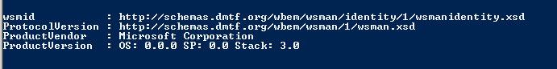
4. If an error message appears, the prerequisite PS configuration steps need to be revisited from the server build checklist.

*If you are in an environment that prohibits running unsigned powershell scripts, you must run the powershell scripts from an administrative command prompt like this:

powershell.exe -executionpolicy bypass -file Port_Test_Main.ps1

*Alternately, you can create a batch file that contains this line, and run the batch file from a command prompt.

##### Create the Windows Scheduled Task

The following steps would normally be done on the host server (Work Engine 1) and the backup server to run the task (Work Engine 2)

1. Import the LendingSpace Restart Task from the F:\Data\Scripts\ApplicationRestart directory.
2. General tab

* Security options – Choose the option “Run whether user is logged on or not”
* Change the task to run as the service account associated with the application

1. Triggers tab

* Set the time schedule as desired.
* In the Advanced Settings, select the checkbox “Stop task if it runs longer than:” and enter 4 hours.

1. Actions tab

* Edit Action, and choose “Start a program”
* Add arguments field, edit your environment variable into the command line Enter values like the following example for LendingSpace INT1:  
  -file F:\Data\Scripts\ApplicationRestart\ApplicationRestartMain.ps1 INT1 F:\Data\Scripts\ApplicationRestart\LendingSpace_RestartLog.txt LendingSpace_RestartConfiguration.xml

1. Click OK, OK, enter the password and ok, ok.
2. Create the task on Work Engine 2, but set it to Disabled, so it’s available for use if Work Engine 1 is not functioning properly.

### Temporary File Cleanup Utility - Setup

Setup Folder:

* The default path is F:\Data\Scripts\FileCleanup

Note: If you choose a different path, then you will need to make changes in both of the XML files to reflect the new path.

* Review all the values in the <appSettings> section of the FileCleanup.xml configuration file, and modify as appropriate for the target environment.

##### Create Scheduled Task:

1. Import the File Cleanup Task.xml into the Task Scheduler.
2. General tab

* Security options – Choose the option “Run whether user is logged on or not”
* Change the task to run as the service account associated with the application

1. Triggers tab

* Set the time schedule as desired.
* In the Advanced Settings, select the checkbox “Stop task if it runs longer than:” and enter 4 hours.

1. Actions tab

* Edit Action, and choose “Start a program”
* Add arguments field, edit your environment variable into the command line Enter values like the following example for LendingSpace INT1:  
  -file F:\Data\Scripts\ApplicationRestart\ApplicationRestartMain.ps1 INT1 F:\Data\Scripts\ApplicationRestart\LendingSpace_RestartLog.txt LendingSpace_RestartConfiguration.xml

1. Click OK, OK, enter the password and ok, ok.

### Temporary File Cleanup Utility – Add\Remove Clients

1. Edit the FileCleanup.ps1 to add or remove clients. Clients are located in the app, work engine and ftp sections.
2. To remove clients delete any lines containing the their org code such as LPSC.
3. To add a new client copy an existing client and change the org id:
   1. <file path="F$\DATA\LSFiles\SRVLPSLOS\properties\TempView\LPSC\" mask="*.xml" age="14"/>
4. In this example change LPSC to the new client

### Suspend Review TaskJob

1. Import the SuspenseReviewTaskJob.xml into the Task Schedule from F:\Data\Scripts.
2. General tab

* Security options – Choose the option “Run only when user is logged on”
* Change the task to run as the service account associated with the application

1. Triggers tab

* Set the time 3:00 AM every day

1. Click OK, OK, enter the password and ok, ok.

## SSRS/SQLXML

Prerequisites:

* Application databases and application schema files (full build) are required to configure SQLXML and SSRS (you can install, but not configure without)
* Prerequisite Service accounts:

1. Domain Based service account with local administrative privileges
2. SQL application account (database client lsapp)
3. SQL reporting account (database client lsreports)

* ALWAYS be logged in to the servers as the application service account

### IIS Installation

1. Open server manager and click Add Roles

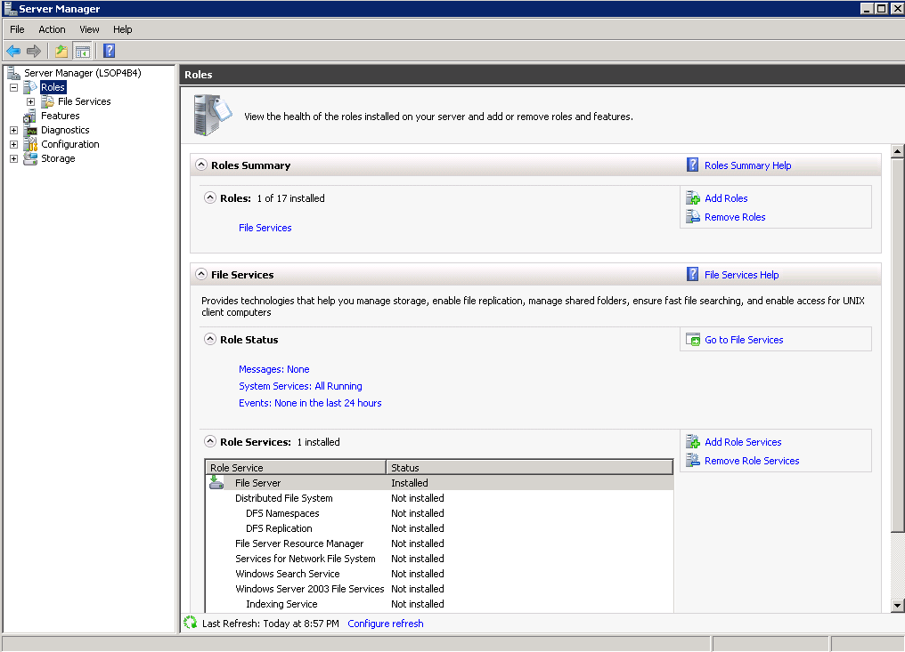

1. Click Next
2. Check Web Server(IIS) and click Next
3. Click Next
4. Check all Role services AND FTP Role services and click Next
5. Click Install
6. After “Installation succeeded” Click Close
7. From IIS Manager, rename the default web site to “<environment>server” (example INT2MQ1, or PRODMQ2, etc..)

### SQLXML

Prerequisites:

* SQL user “database client lsapp” must be created, and granted rights to SQL db’s prior to configuration
* Schema and Template files (located in F:\Data\Codebase\SQLXML)
* ALWAYS be logged in to the servers as the application service account

#### SQLXML Installation

1. Execute F:\Installs\SQL-and-RPT\SQLXML\sqlxml.msi
2. Select Next to continue the installation
3. Choose “I accept the terms in the License Agreement” then click Next
4. Enter User and Organization information and Next to continue
5. Choose setup type as Install Now

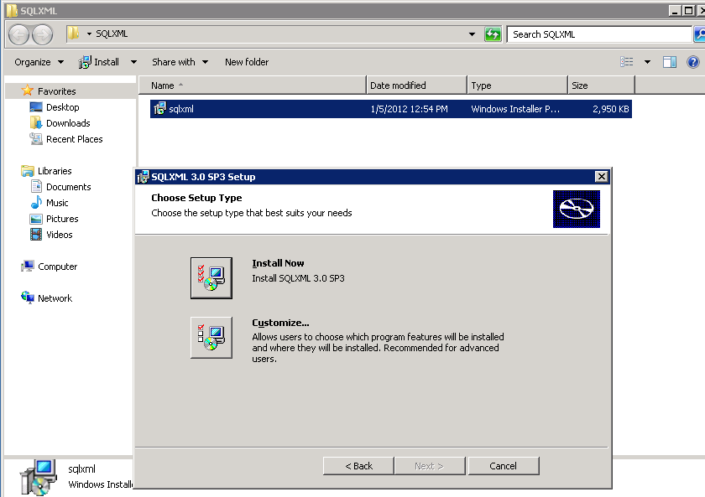

1. Finish to complete installation

SQLXML Virtual Directory Management

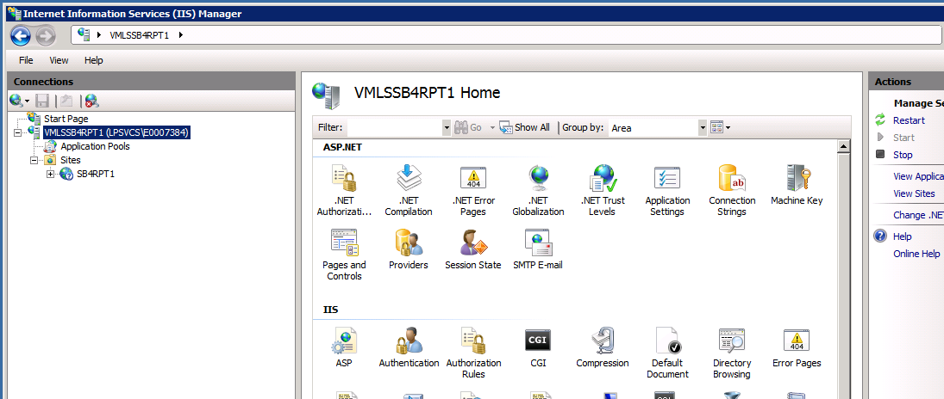

#### SQLXML Configuration

The following folders contain the necessary files for JSQLXML:

* LOS: F:\Data\Codebase\SQLXML\CORRLOSSQLXML\Schema & Template\<client>
* Portal: F:\Data\Codebase\SQLXML\CORRCPSQLXML\Schema & Template\<client>

This table is to assist creating the configurations (open, search and replace <ClientORG> with the client identifier ) (ex…. STRN)



##### Create SQLXML Virtual Directories

Start -> Programs -> SQLXML 3.0 - > Configure IIS Support

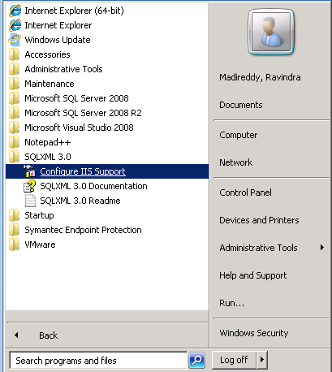

##### Create virtual directory for Client Instance Name:

1. Right click web site and New Virtual Directory(New🡪Virtual Directory) for new client:
2. Give the virtual directory name as <client>LSSCHEMA
3. Click Browse button to location the path of the schema & template (F:\Data\Codebase\SQLXML\CORRLOSSQLXML\Schema & Template\<client>\LP & DU)
4. Security Tab:

* User Name: username for targeted database
* Password: password for the above username

1. Data Source Tab:

* Select server name – ex: VMLSQA2SQL01\VMLSQA2SQL01
* Deselect Use default database for current login and from the pull down select <client>_Corrlos

1. Settings Tab:

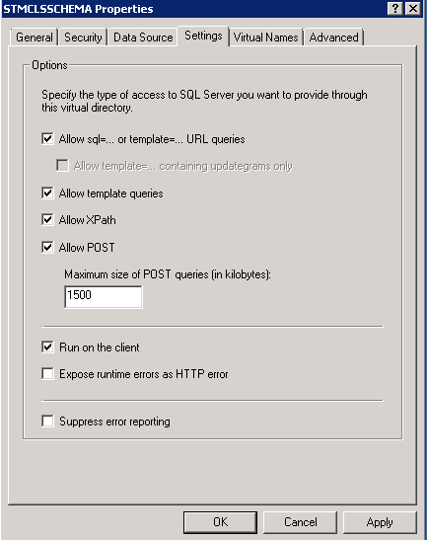

1. Virtaul Names Tab – Creation of schema:

* Name given as “schema”
* Type selected as “schema”
* Path: F:\Data\codebase\SQLXML\CORRLOSSQLXML\Schema & Template\<client>\LP & DU\Schema

1. Click Save
2. Virtaul Names Tab – Creation of template:

* Name given as “template”
* Type selected as “template”
* Path: F:\Data\codebase\SQLXML\CORRLOSSQLXML\Schema & Template\<client>\LP & DU\Template

1. Click Save and OK
2. Right click Default web site and New Virtual Directory(New🡪Virtual Directory) for new client:
3. Give the virtual directory name as <client>LSXMLSCHEMA
4. Click Browse button to location the path of the schema & template (F:\Data\Codebase\SQLXML\CORRLOSSQLXML\Schema & Template\<client>\LSXMLSchema)
5. Security Tab:
   * User Name: username for targeted database
   * Password: password for the above username
6. Data Source Tab:

* Select server name – ex: VMLSQA2SQL01\VMLSQA2SQL01
* Deselect Use default database for current login and from the pull down select <client>_Corrlos

1. Settings Tab:



1. Virtaul Names Tab – Creation of schema:

* Name given as “schema”
* Type selected as “schema”
* Path: F:\Data\Codebase\SQLXML\CORRLOSSQLXML\Schema & Template\<client>\LSXMLSchema\schema

1. Click Save
2. Virtaul Names Tab – Creation of template:

* Name given as “template”
* Type selected as “template”
* Path: F:\Data\Codebase\SQLXML\CORRLOSSQLXML\Schema & Template\<client>\LSXMLSchema\template

1. Click Save and OK
2. Right click Default web site and New Virtual Directory(New🡪Virtual Directory) for new client:
3. Give the virtual directory name as <client>CPSCHEMA
4. Click Browse button to location the path of the schema & template (F:\data\Codebase\SQLXML\CORRCPSQLXML\Schema&Template\<client>)
5. Security Tab:
   * User Name: username for targeted database
   * Password: password for the above username
6. Data Source Tab:

* Select server name – ex: VMLSQA2SQL01\VMLSQA2SQL01
* Deselect Use default database for current login and from the pull down select <client>_CORRPortal

1. Settings Tab:



1. Virtaul Names Tab – Creation of schema:

* Name given as “schema”
* Type selected as “schema”
* Path: F:\data\Codebase\SQLXML\CORRCPSQLXML\Schema&Template\<client>\schema

1. Click Save
2. Virtaul Names Tab – Creation of template:

* Name given as “template”
* Type selected as “template”
* Path:

1. Click Save and OK

##### IIS Configuration Settings for SQLXML:

1. Open IIS Administrator
2. Select the default web site, Bindings in the Right panel

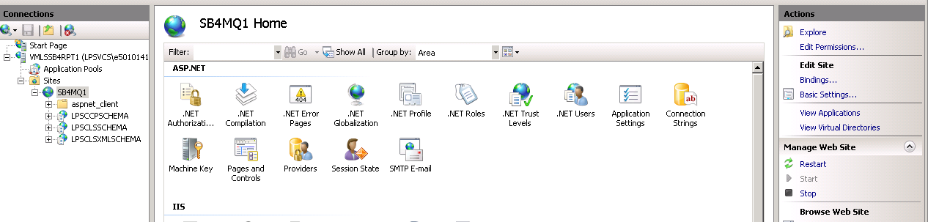

1. Hightlight the binding and select Edit.

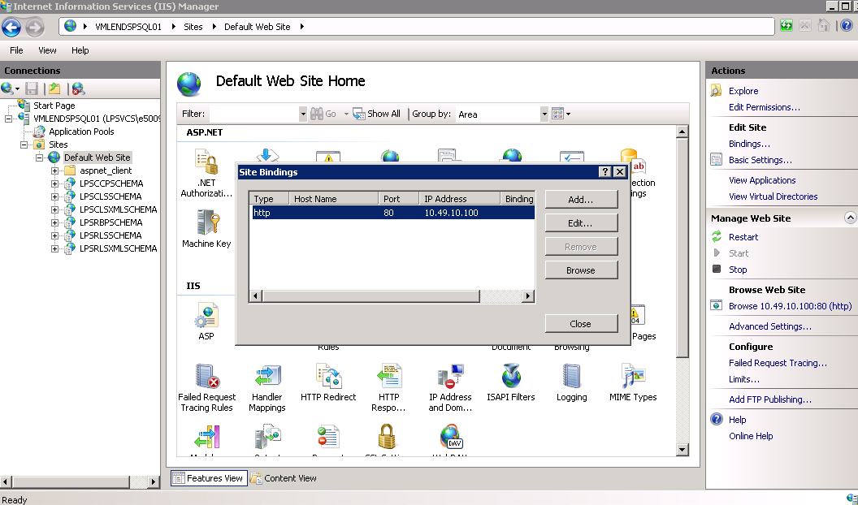

1. Add Ip address of the local server and Port 80 , select OK and Close
2. Click Basic Settings

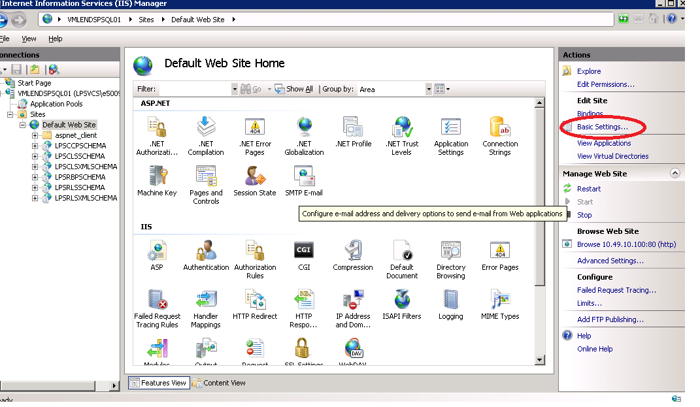

1. Click Connect as
2. 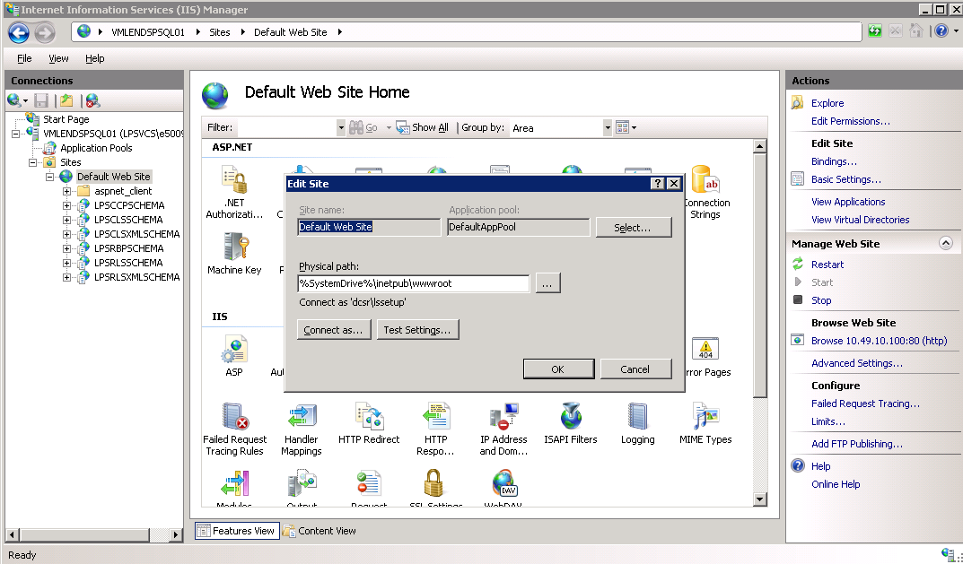
3. Select Specific User and Set

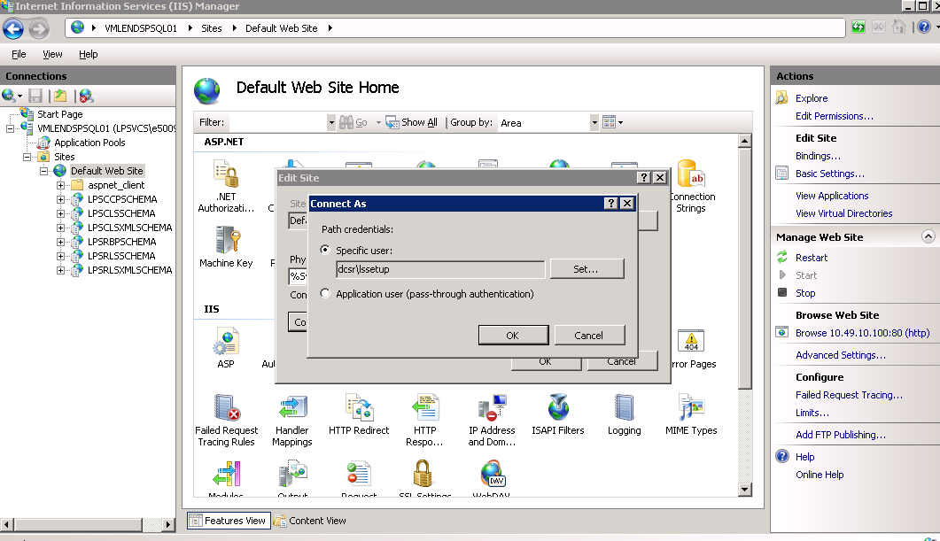

Use domain\service account for the environment

1. Provide the Username and password (username is service account, ex. Lssetup, lsint1setup) then click Ok

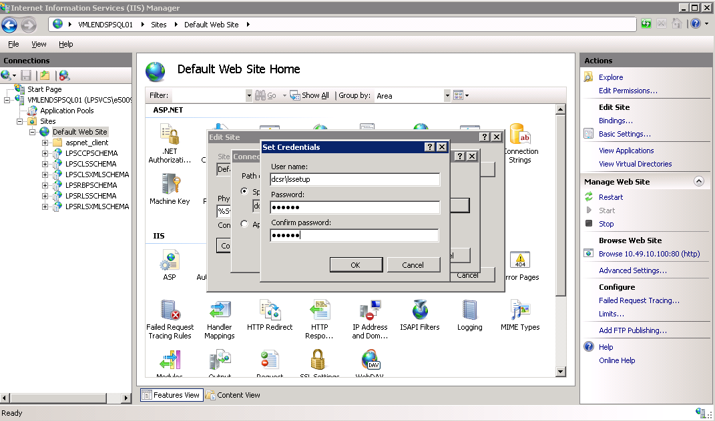

1. Now Click Test Settings

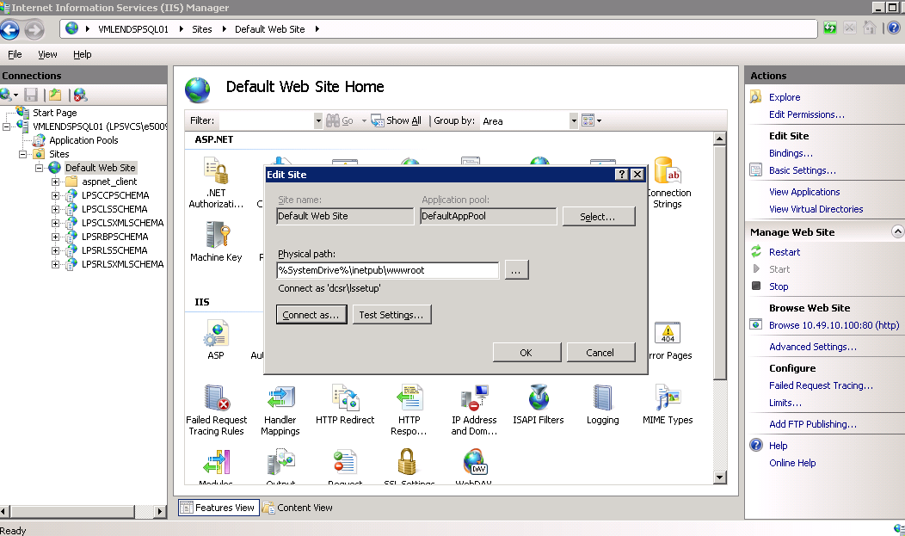

1. After successful test select Close and OK
2. Double click “Directory Browsing”

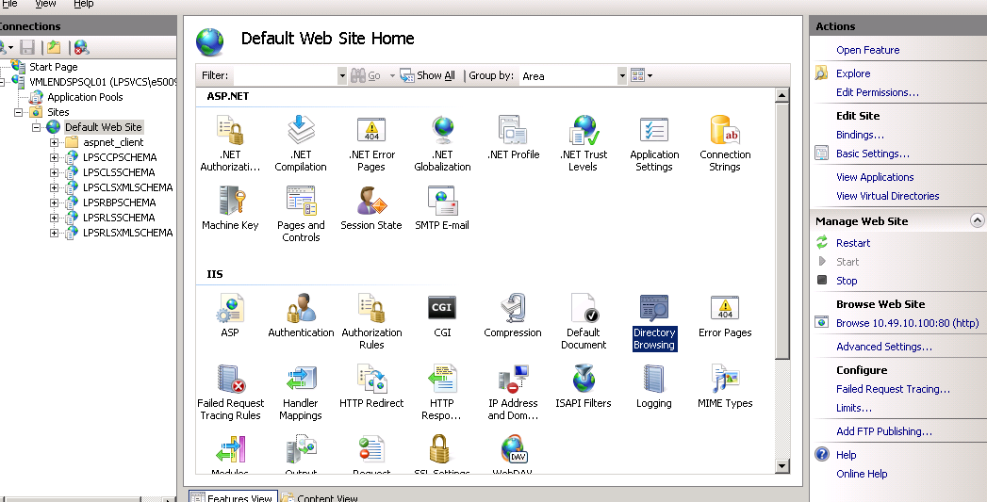

1. Click Enable on the right side of the screen under Actions
2. Select DefaultAppool under Application Pools and click Advanced Settings

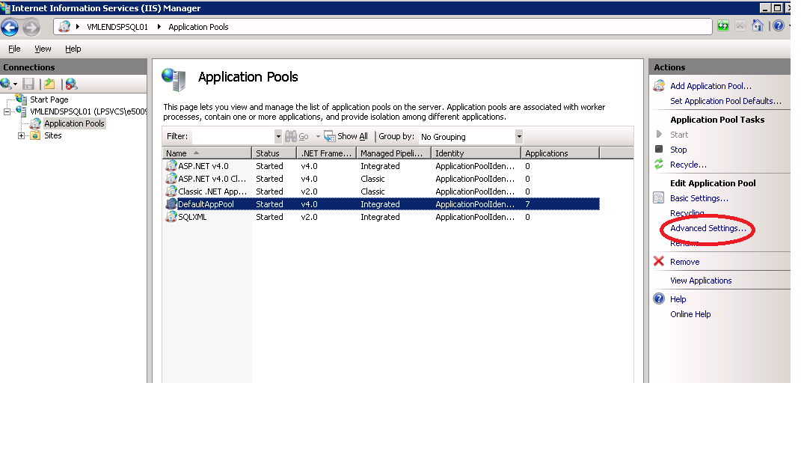

1. Set “Enable 32-bit Applications” as true
2. Click Ok

##### Verification:

1. Right click test.xml under <client>CPSCHEMA🡪template then click Browse from Content View

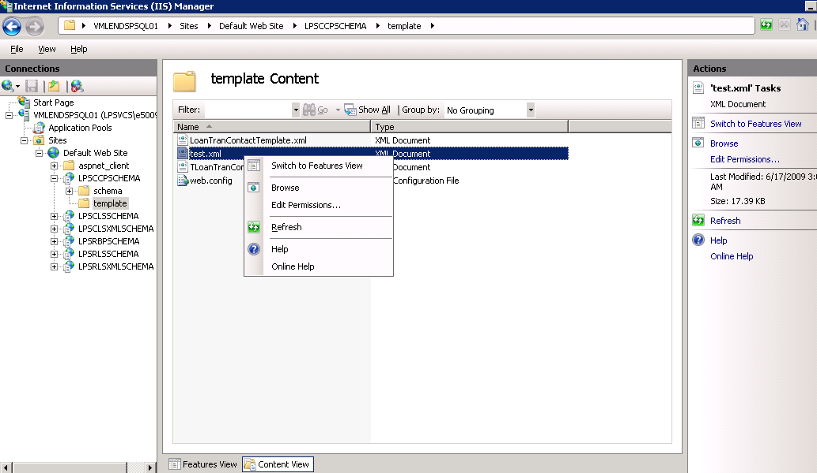

1. Look for the below screen after browsing test.xml

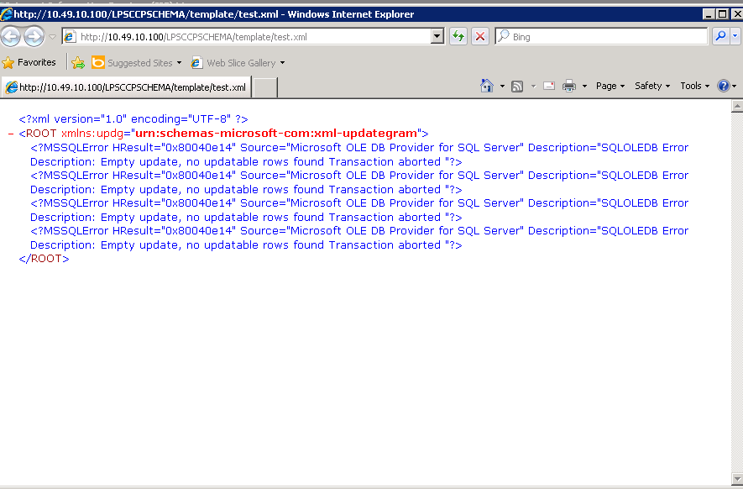SQL

### SSRS Installation

Prerequisites:

* Application databases and application schema files (full build) are required to configure SQLXML and SSRS (you can install, but not configure without)
* Prerequisite Service accounts:

1. Domain Based service account with local administrative privileges
2. SQL application account (lsapp)
3. SQL reporting account (lsreports)

* ALWAYS be logged in to the servers as the application service account

1. Have the SQL2008R2 CD/DVD image mounted, and run Setup.exe

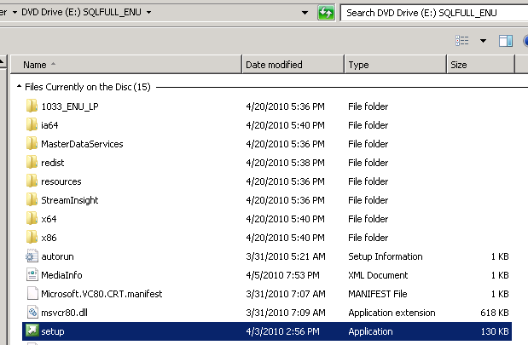

1. On the SQL Server Installation Center, click Installation on in the left column
2. Select New Installation or add features:
3. After the self-check runs, click OK (assuming no errors)
4. Supply the product key and select Next
5. Accept the License Terms and select Next
6. Click Install for the Setup Support Files
7. Click Next on the Setup Support Files (assuming no errors)
8. On the Setup Role, select SQL Server Feature Installation, and click Next
9. On the Feature Selection choose: Reporting Services, Management Tools – Complete,
10. Change the installation paths to:
11. F:\Apps\Microsoft SQL Server\
12. F:\Apps\Microsoft SQL Server\Shared\
13. Click Next on the Installation rules (assuming no errors)
14. On the Instance Configuration, change to the Named Instance. For the name, provide the environment abbreviation and SSRS (ex. INT2SSRS).
15. Change the Instance Root directory to F:\Apps\Microsoft SQL Server\ , click Next

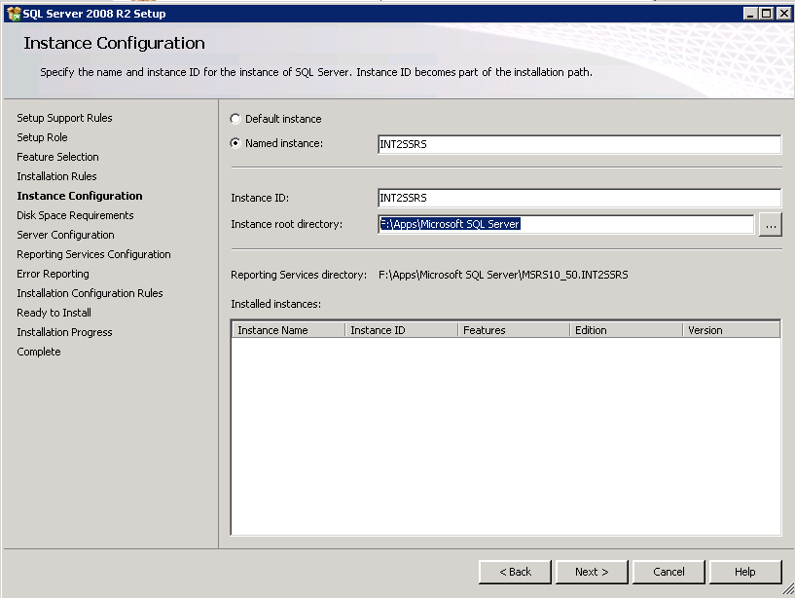

1. Click Next on the Disk Space Requirements
2. On the Server Configuration select the local NT authority\System account for the services to run, and click next
3. On the Reporting Services Configuration, take the default Install, but not configure, and click Next
4. On Error Reporting, do not select the “Send Windows….” box, and click Next
5. Click Next on Installation Configuration rules (assuming no errors)
6. Ready to Install , click Install
7. When Complete, Click Close
8. ApplySQL2008R2 SP2

##### Revert of Setting up Anonymous Access for Reporting Services in SQL Server 2008 R2

1. Find and replace the below tags in rsreportserver.config to located at:   
   F:\apps\Microsoft SQL Server\MSRS10_50.SB2SSRS\Reporting Services\ReportServer

Note: The above path may vary depends on the installation.

1. Use Find to locate this section:

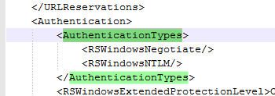

1. Replace the AuthenticationTypes section with the text below:

<AuthenticationTypes>

<RSWindowsBasic/>

</AuthenticationTypes>

1. Restart the reporting services, Anonymous Access should **not work.** It should ask for authentication when trying to access Reports website.

#### Configure SSRS (Refer to Scale-Out-Deployment section below for client facing environments)

1. Open Reporting Services Configuration Manager ( from configuration tools folder under SQL2008R2) and select the instance just created.
2. From Service account choose Network Service, apply

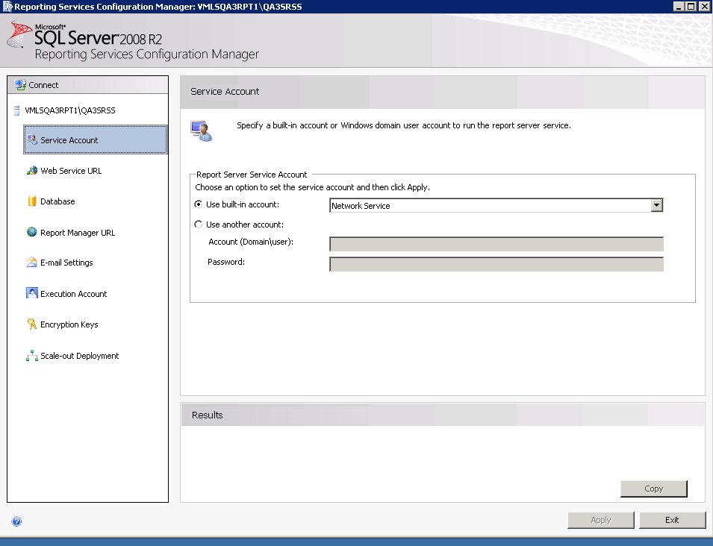

1. From Web Service URL and change:
2. Virtual directory should be ReportServer
3. Select the specific IP or DNS name for the server
4. Port 8080
5. Click apply
6. From Database select Change Database

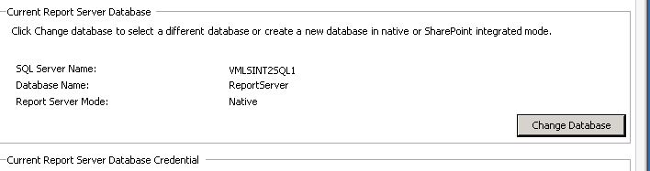

1. Select Choose an existing report server database
2. Select the instance containing the report server databases (may have to manually enter information) and authentication type should be Current User-Integrated Security. Test Connection, Next
3. Select the ReportServer database, Next

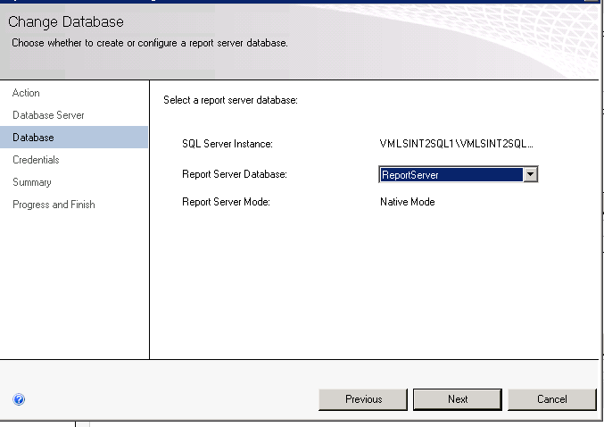

1. Select SQL Server Account and use the lsreports credentials, Next and Finish
2. Report Manager URL, change the virtual directory to Reports and click apply

#### Setup SSRS DataSources

1. Select the Report Manager URL and double click the url

If you receive an encryption error after restoring databases from a previous environment, the encryption needs to be reset.

1. From Encryption Keys select delete and choose Yes

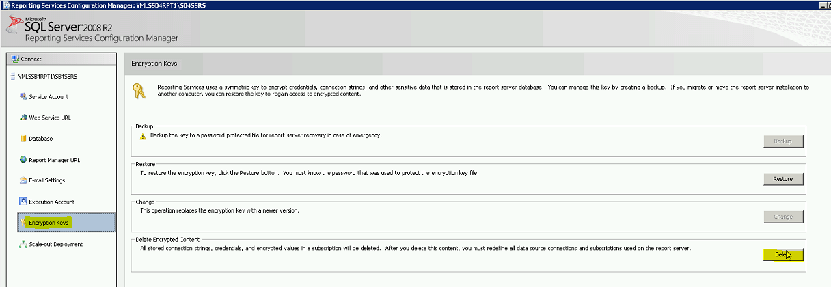

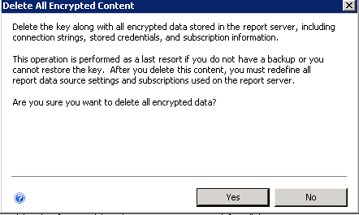

1. Select another option within SSRS – ex E-mail Settings and then back to Encryption Keys (forces configuration to be re-read)
2. Choose Backup and file location – ex: Selected the file location F:\Apps\Microsoft SQL Server\MSRS10_50.<env>SSRS\Reporting Services\<your env>ssrs.snk
3. Password – same as lsreports sql account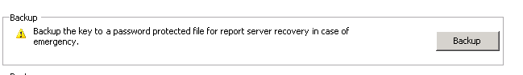

Attempt to hit the URL again

1. Enter your service account and password at the Windows Security prompt (pass thru credentials)

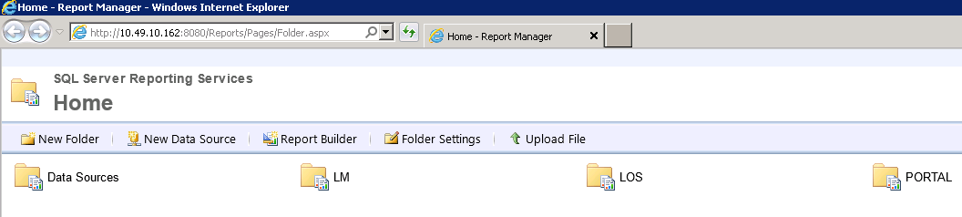

1. Select the Data Source folder
2. New Data Source
3. Name = Share_<client>_Reports
4. Description = Data Source=ip of sql server,port:Initial
5. Catalog=<client>_CorrLoss_Reports
6. Copy the description from the step above to Connecting String
7. Select Credentials stored securely in the report server
8. Username - lsreports
9. Password – password for lsreports
10. Test connection – if works select apply

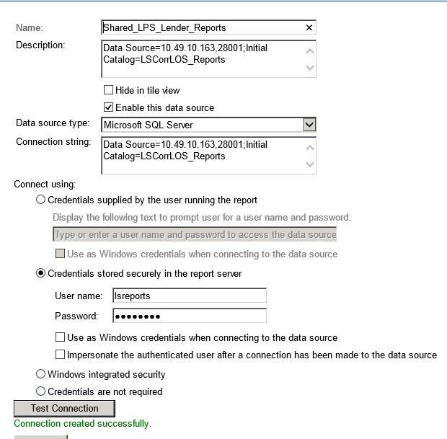

1. Test reports via the application
2. Once successful, select Apply to save settings

#### Scale-out-Deployments (Draft)

* 1. Configure the Service Account, Web Service URL, Database and Report Server Manager URL on the 1st SSRS as directed above. Do not configure the Data Sources or configure the 2nd server.
  2. Close the SSRS configuration tool and reopen.
  3. Click Scale-out-Deployment , you should see two entries. One will be lised as Joined while the other listes as Waiting to join.

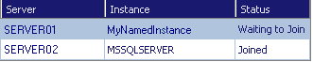

* 1. On the Scale-out Deployment page, select the report server instance that is waiting to join the deployment, and click Add Server.
  2. Configure the Data Sources on SSRS server 1.
  3. From the 2nd SSRS server configure the Service account and Database settings to use a separate service account than the 1st server.
  4. Verify the newly created Data Sources exist on the 2nd SSRS server.

## Storage Server MQ/FTP (Non-Clustered)

Prerequisite Information and CHECKLIST -

* ALWAYS be logged in to the servers via the domain-level service account when installing software
* The service account should belong to the local administrators group

### IIS Installation

1. Open Windows Server Manager and click Add Roles
2. Click Next
3. Check Web Server(IIS) and click Next
4. Click Next
5. Check all Role services and click Next
6. Click Install
7. Close when Installation succeded is displayed
8. From IIS Manager, rename the default web site to “environmentserver” (example INT2MQ1, or PRODMQ2, etc.)

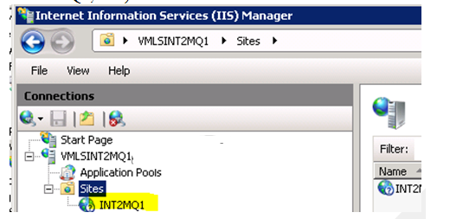

#### Create FTP User and Site

Create a local user on that machine:

1. From Server Manager, Expand Configuration, Local Users and Groups, Users

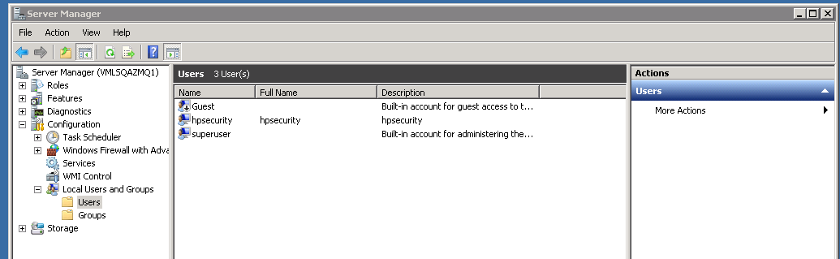

1. Right Click Users -> New User

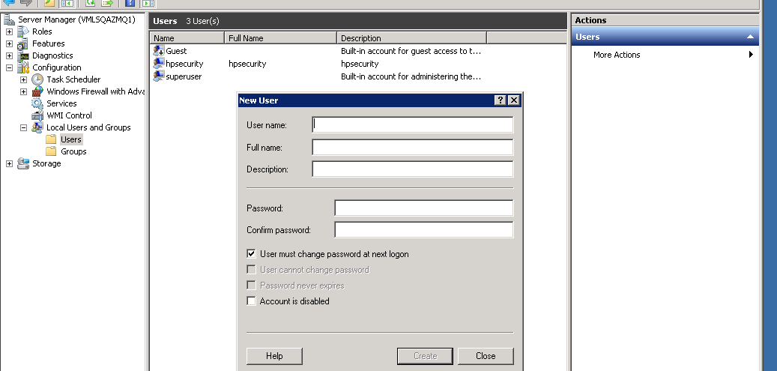

1. Enter the below information to create the user which is required for our FTP site (the following are examples only, make sure you document the values you use for your environment):
2. User Name: lsftp
3. Full Name: lsftp
4. Description: lsftp
5. Password: create a password and record for use later
6. Confirm Password: create a password and record for use later

PASSWORD RESTRICTIONS for FTP USER- You cannot have a password with the following special characters: “;” OR “/” OR “?” OR “:” OR “@” OR “&” OR “=” OR “+” OR “$” OR “,”

1. UnCheck “User must change password at next login”
2. Check “User cannot change password”
3. Check “Password never expires”
4. UnCheck “Account is disabled”

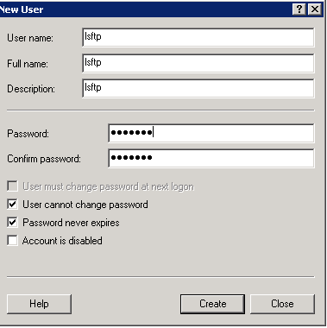

1. Click Create, and close

Add the ftp user to the local Administrators Group on the server:

1. Double click the new user, and click Member Of tab
2. Click Add, change Locations to the local Machine you are on, and type in administrators. Click Check names, and OK, and OK

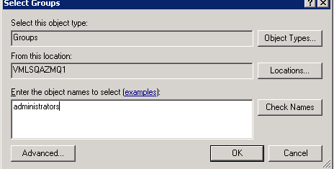

#### Create FTP site

1. Open IIS Manager

2. Right Click the Servername, select Add FTP Site

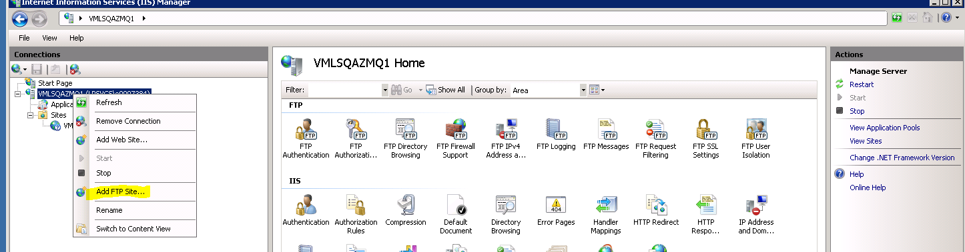

3. Enter a Site name, (example LSINT2FTP), and select the Content directory of F:\Data\Inetpub\FTPRoot and click next

4. Change the SSL Settings to No, and click next

5. Change the authentication to Basic, select to allow access to Specfied users, put lsftp in the field, and choose Read and Write, click Finish

6. Highlight the new FTP site, and on the Actions column, select Basic Settings:

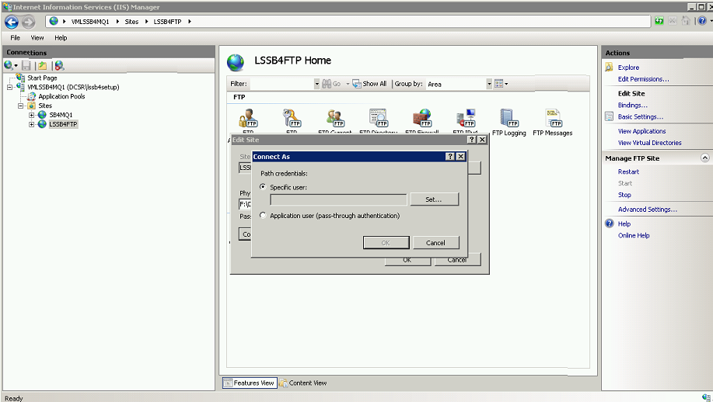

7. Click Connect as….

8. Change Path Credentials to Specific user, click Set, and enter the credential info:

9. Click Ok, then Ok, and Test Settings

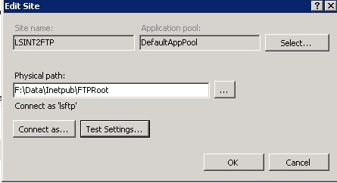

You should see valid results

10. Click Close, and OK.

#### Verify sub folders for docs and files

Once we are done with the creation of FTP site, verify folders inside the ROOT folder of FTP site.

The root folder is F:\Data\Inetpub\FTPRoot.

The following folders at the root of FTPRoot:

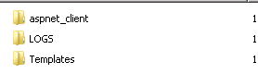

** FTPROOT also includes any *client folders*

F:\Data\inetpub\ftproot*client folders* and the following subfolders

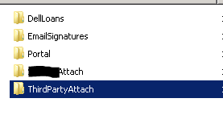

#### LSFILES permissions

F:\Data\LSFiles folder structure as follows:

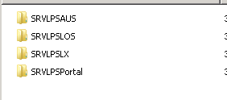

1. Share the folder to everyone with read/write permissions

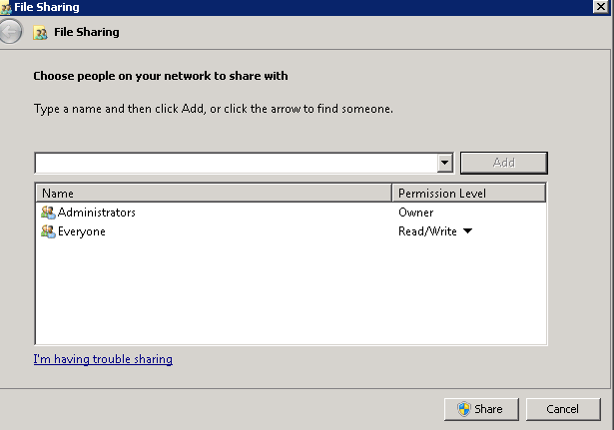

1. Share and Done
2. Close

### IBM WebSphere MQ 7 Installation

1. Execute F:\Installs\MQ-FTP\WMQ7\Server\Setup.exe
2. Select Software Requirements tab on the left side of the screen.

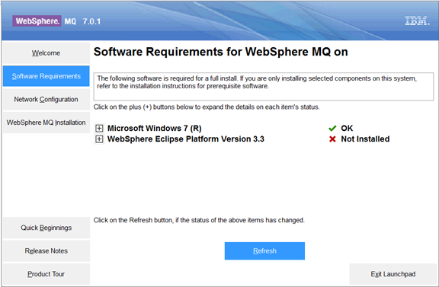

The figure above shows WebSphere Eclipse Platform Version 3.3 is not installed.

1. Click + symbol to expand the options available for us to install the missing software. We will see the below screen when we expand by clicking.

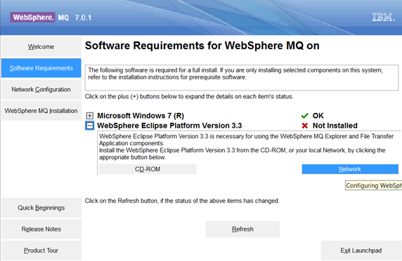

1. Select NETWORK to locate and install the missing software. From the Server folder navigate to Prereqs and then IES and choose setup.exe

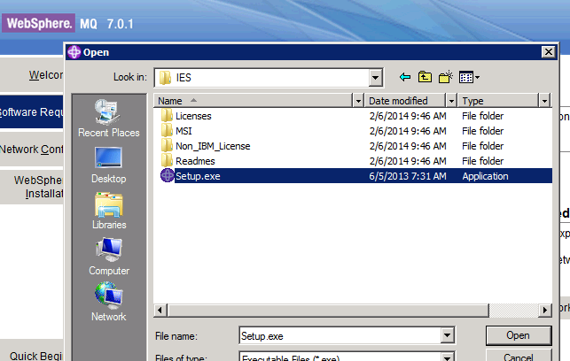

1. Choose English from the combo-box shown above and click ok.
2. Click next
3. Select I accept option and click Next button.
4. Select CHANGE to edit the destination folder path to:
   * F:\Data\IBM\WebSphere MQ\eclipseSDK33\
5. Select OK and Next to Continue then Install
6. Click Finish button to exit the wizard
7. Click REFRESH button which is located on the bottom of the wizard. 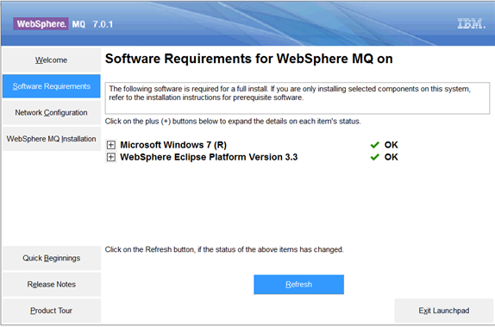
8. Click the Network Configuration
9. Choose NO
10. Select WebSphere MQ installation tab on the left side.
11. Select English as the installation language and Launch IBM WebSphere MQ Installer
12. Accept the license agreement and Next
13. Choose Custom installation
14. Select CHANGE to edit the default destination folder to –
15. F:\Data\IBM\WebSphere MQ\ and then OK
16. Next to continue

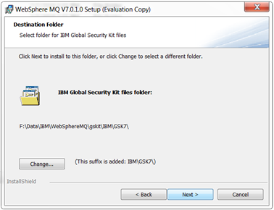

1. Click Next.
2. Choose to Install the Java and .Net Messaging and Web Services feature 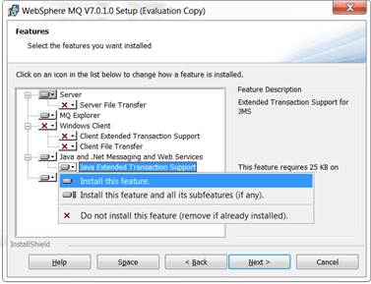
3. Click Next button

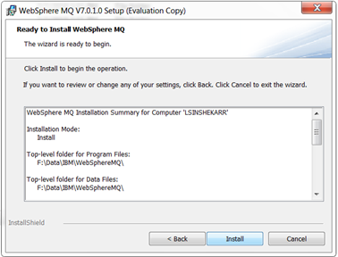

1. Install button to start the installation
2. Click Finish button to exit wizard

### MQ Configuration

Upon installation completion, the prepare Websphere MQ wizard opens

1. Click Next
2. Click Next in the network configuration screen
3. Configuration prompts for a username and password to provide access to network clients.
4. Enter Domain Service account name, username , password and then click Next

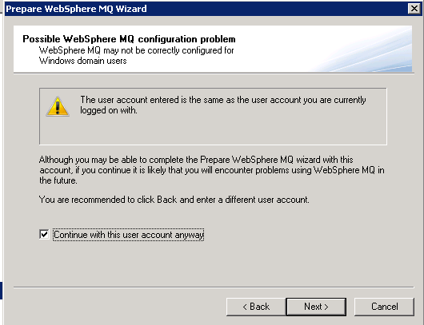

1. Check the box to continue with this user account anyway and choose Next

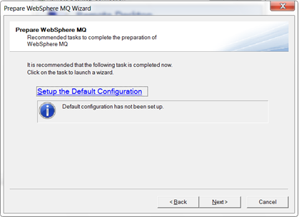

1. Click Next
2. Deselect Launch Notepad option and click Finish

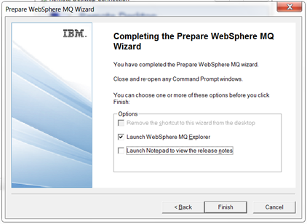

1. Click close(X) close the welcome Tab in the upper left corner of the window:

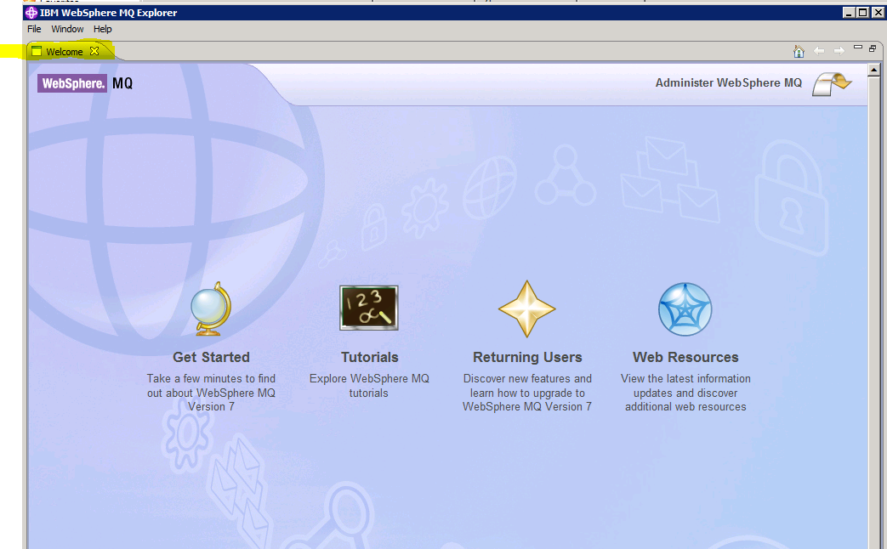

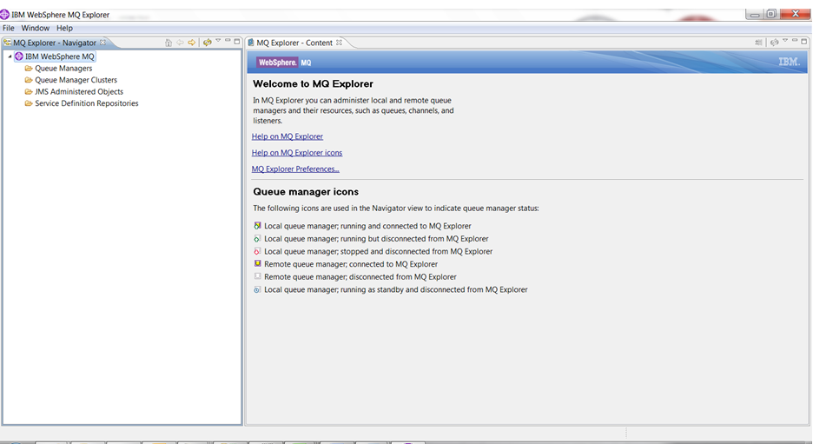

#### Create Queue Manager

Note that MQ is case sensitive when creating all items below

1. Right click Queue Managers, Select New -> Queue Manager..

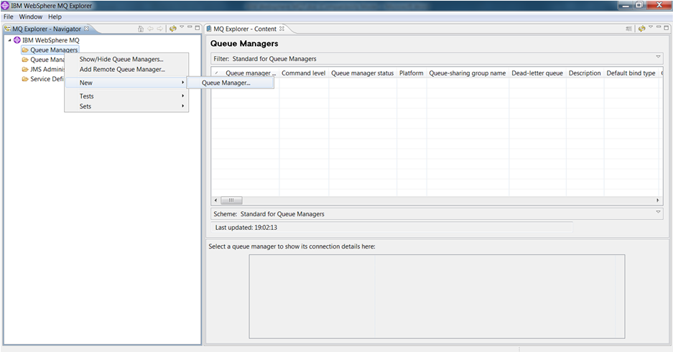

The Create Queue Manager wizard will be shown as below figure.

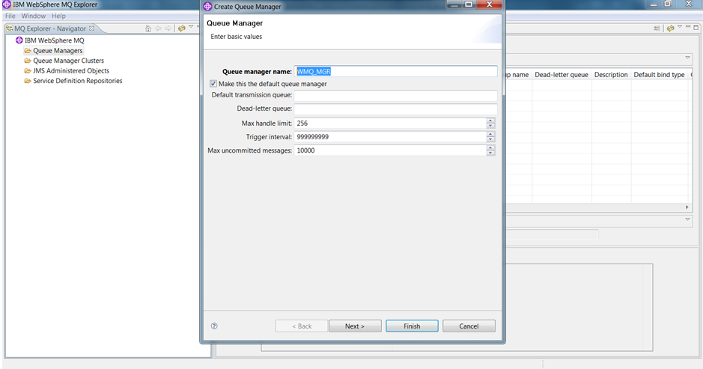

1. Enter the Queue Manager Name as WMQ_MGR.
2. Select the check box “Make this the default queue manager”
3. Click Next.

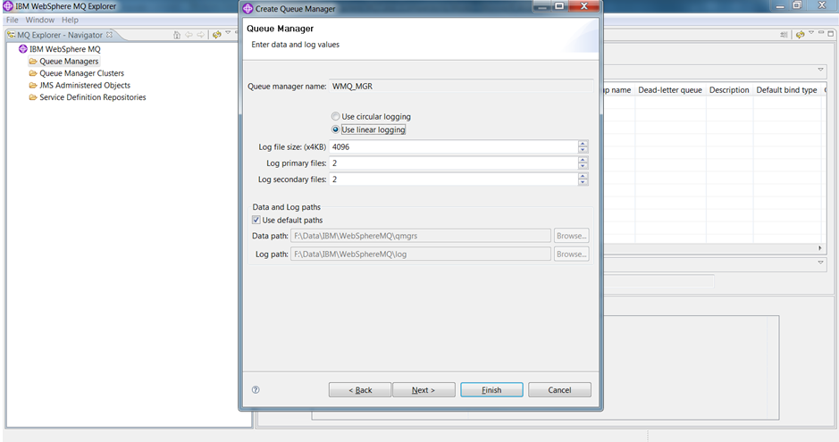

1. Select “use Linear logging”
2. Enter 2 in log primary files text box
3. Leave the remaining default values
4. Click Next.

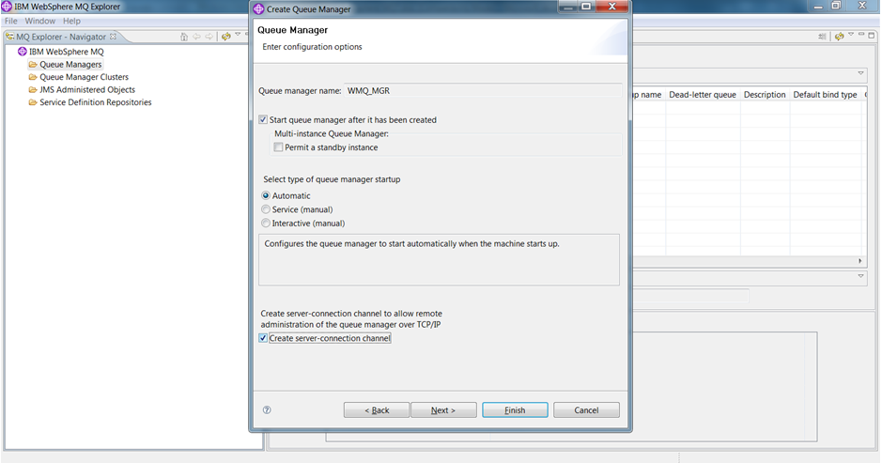

1. Select the checkbox against “Create server-connection channel” and click Next button.
2. Select Finish to complete the Queue Manager creation.

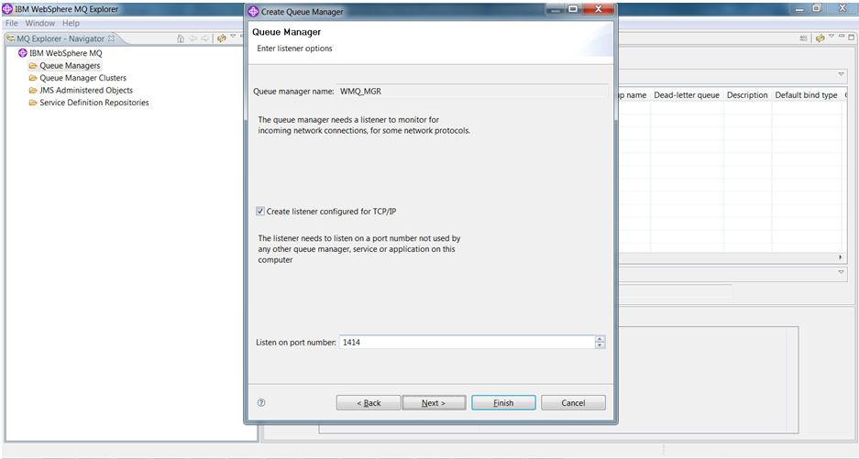

Queue Manager has been created

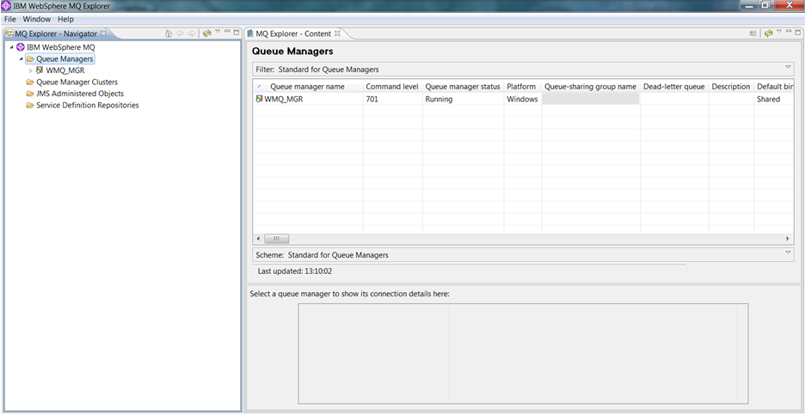

1. Open Queue Managers, WMQ_MGR, Advanced.

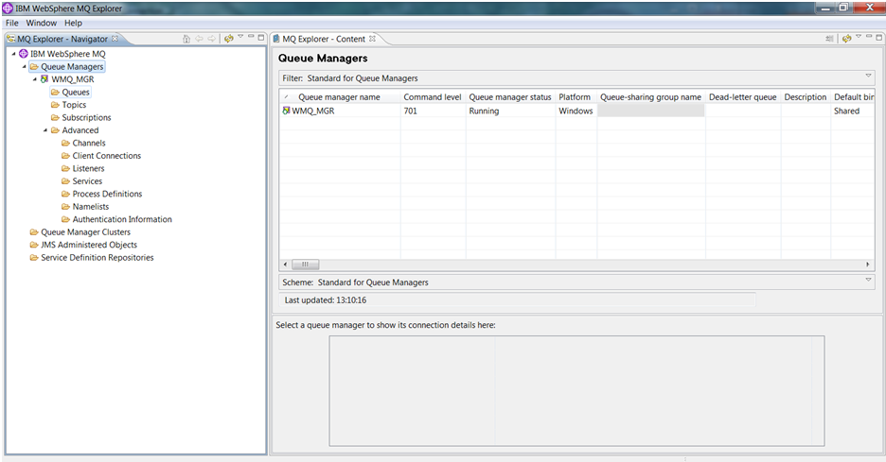

### Create Initial Contexts & Connection Factories

#### JMS Administered Objects

Create Initial Context

Create Connection Factories

Create Destinations

##### Create Initial Context

1. Right click JMS Administered Objects and click Add Initial Context

.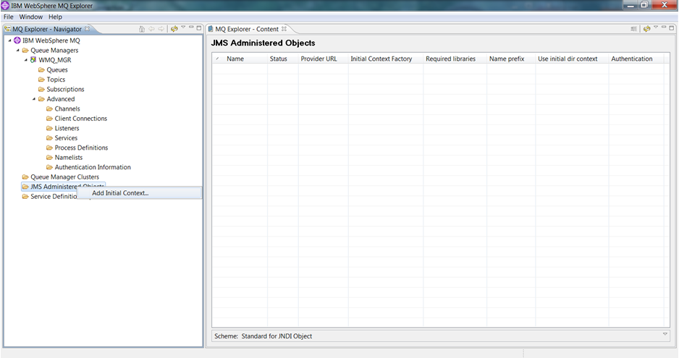

The Add Initial Context wizard will be started to guide us through the creation of the context.

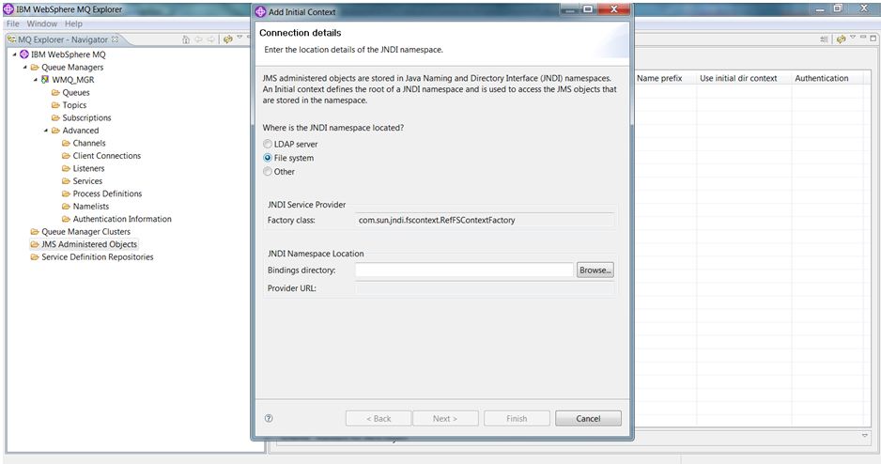

1. Select File System for JNDI namespace.
2. From Windows Explorer, navigate to the WebSphere MQ installation folder - F:\Data\IBM\WebSphere MQ
3. Create a folder named data and create 2 more subfolders (los & lx) inside the data folder.

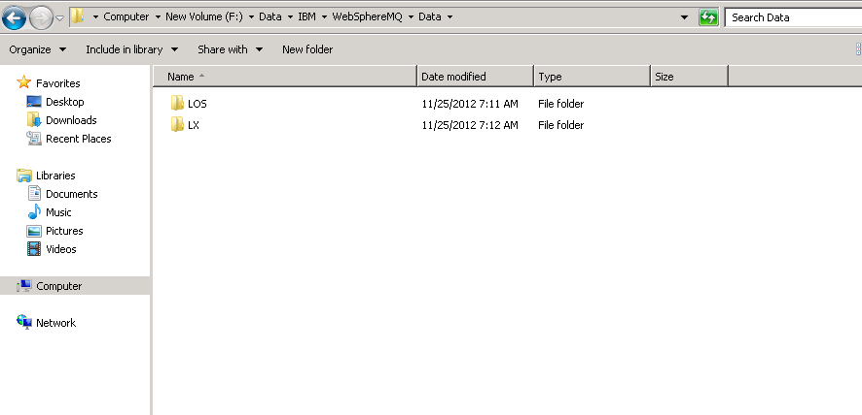

1. Coming back to our Add Initial context wizard, copy the los folder path which we created in the above step in Bindings directory text box as shown in below figure.

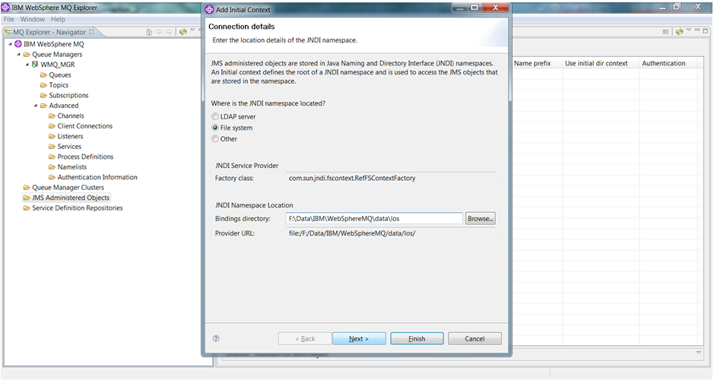

1. Click Next. In the next screen as shown below enter the context nickname as LOSCtx (as we are creating LOS initial context).

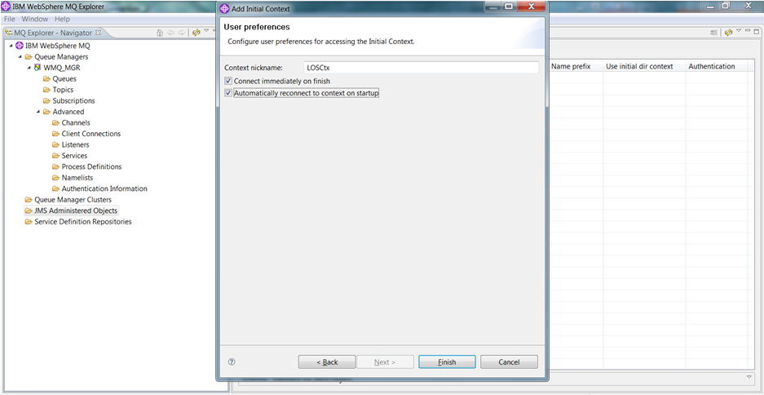

1. Select the “automatically reconnect to context on startup” checkbox and click Finish button.

The LOS initial context will be created and the MQ explorer shows the newly created context and sub-items available under it.

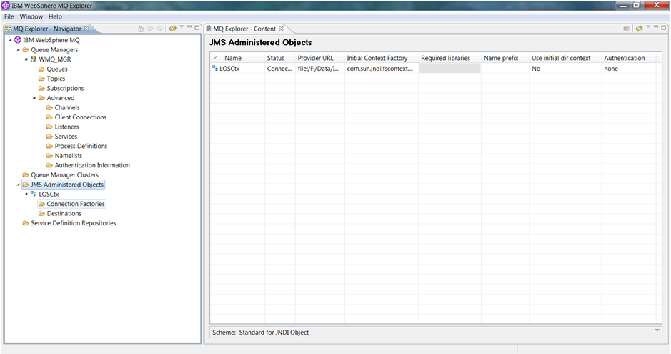

##### Creating Queue Connection Factory

1. Open the JMS Administered Objects, and Under LOSCtx right click Connection Factories -> New -> Connection Factory.

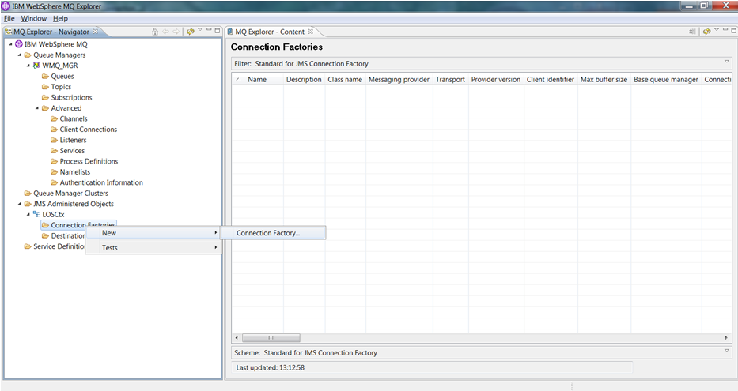

The Create connection factory dialog box is displayed as shown in figure below.

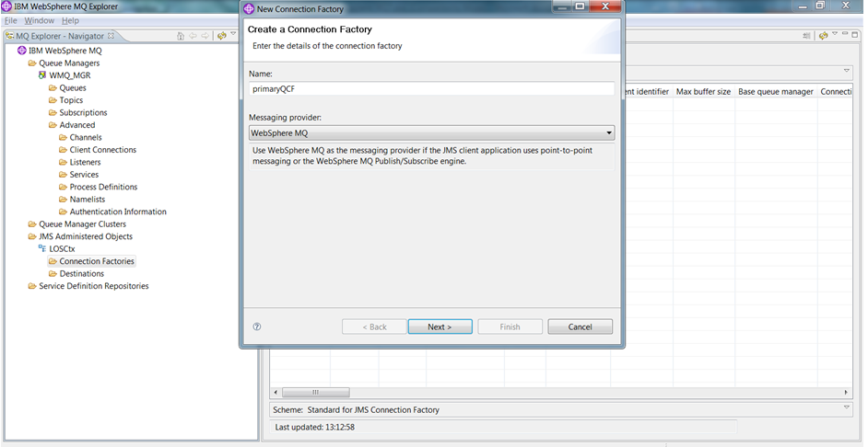

1. Enter Name: primaryQCF
2. Leave Messaging provider as WebSphere MQ
3. Click Next

The next screen displays creating connection factory.

1. Choose Queue Connection Factory from the pull down

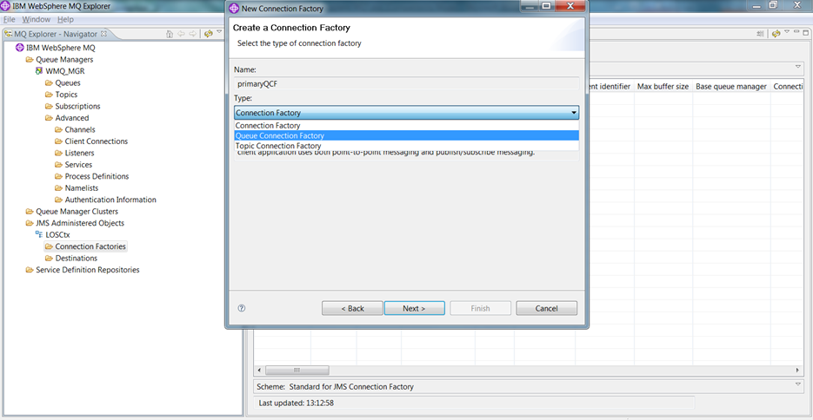

1. Select Next
2. Select Transport: MQ Client and click Next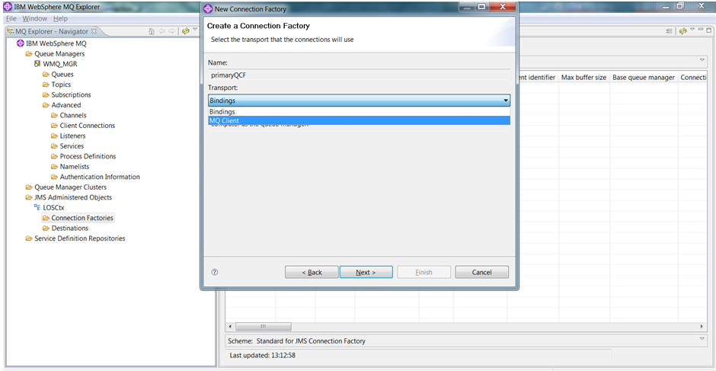
3. Select Finish to proceed. 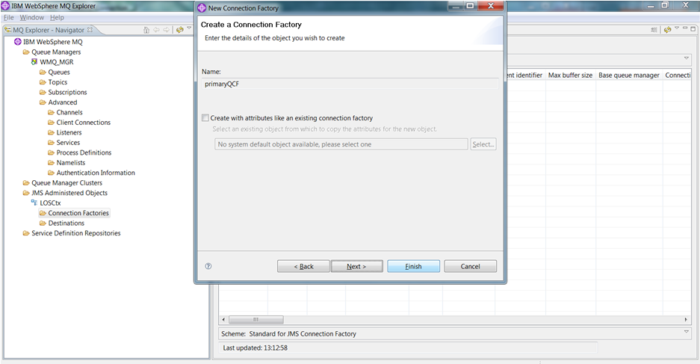

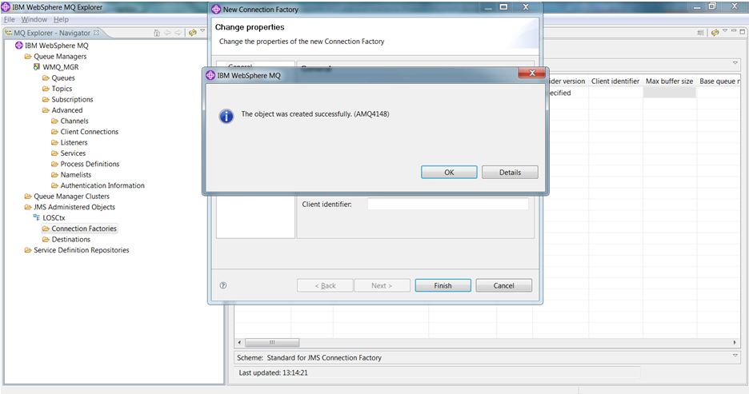

1. Click ok to continue
2. Right click JMS Administered objects and click Add Initial Context

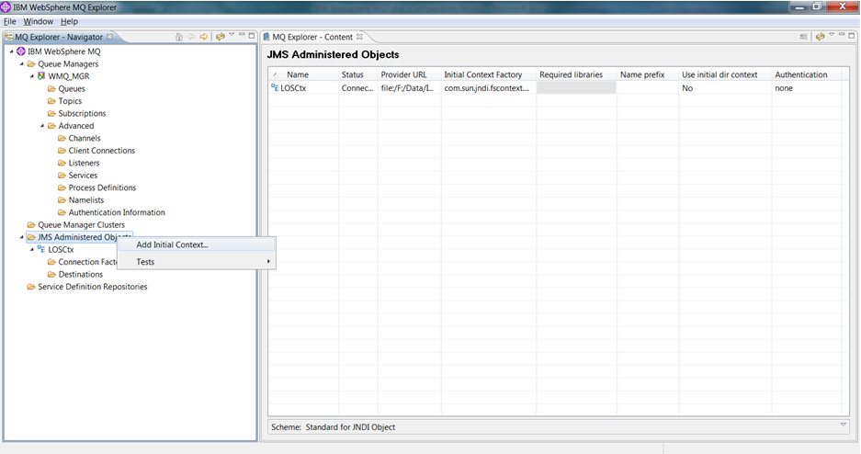

1. Select File System for JNDI namespace.
2. Enter LX folder path which we created in above steps (inside data folder) and click Next.

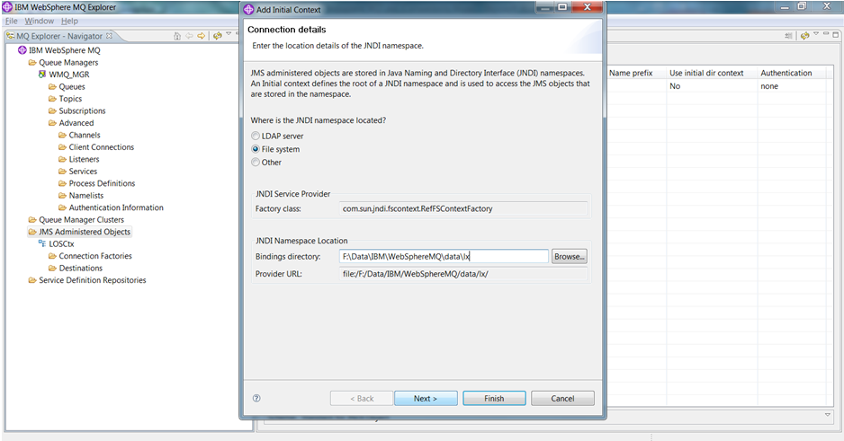

1. Enter the context nickname as LXCtx and check the automatically reconnect to context on startup check box and click Finish.

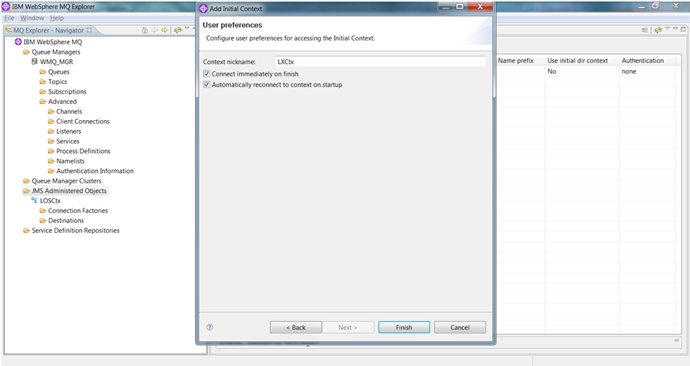

The LX Initial context has been created successfully

1. Create a queue connection factory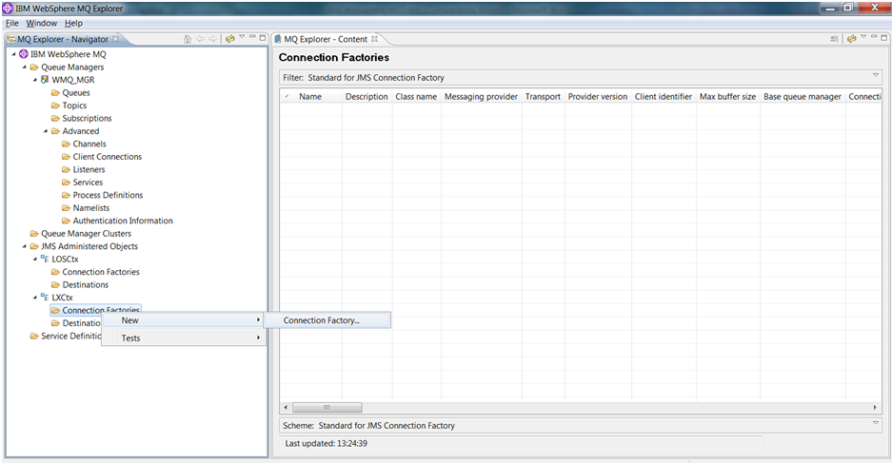
2. Right click Connection factories under LXCtx and click New -> Connection Factory - enter the Name primaryQCF (this used in the queueinfo.properties)

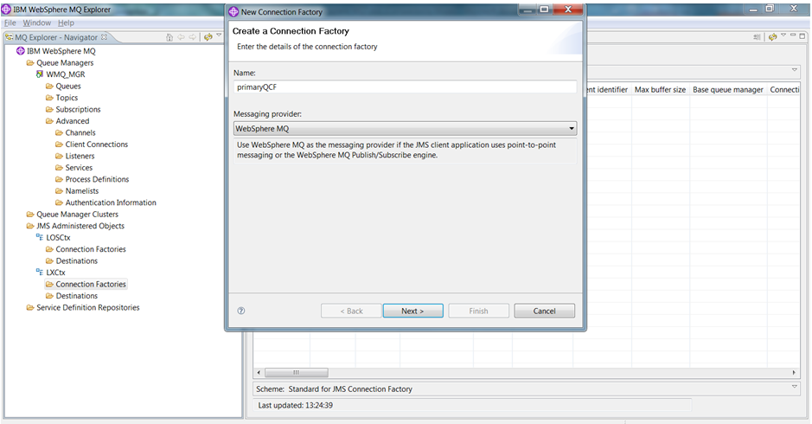

1. Select messaging provider: WebSphere MQ and click Next.
2. Select Type as Queue Connection Factory and click Next.

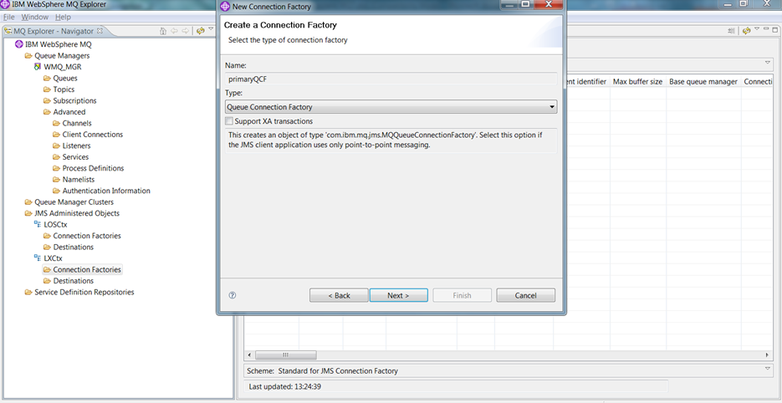

1. Select the transport as MQ Client and click next.

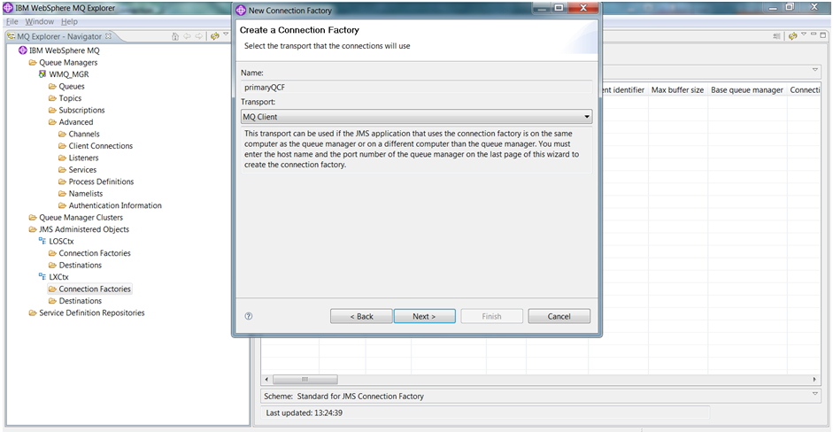

1. Select Finish to complete the creation of queue connection factory.

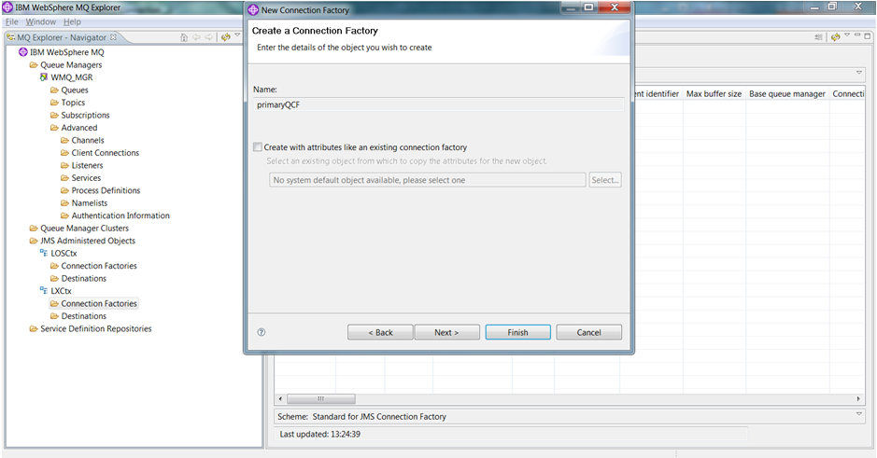

LX queue connection has also been created successfully.

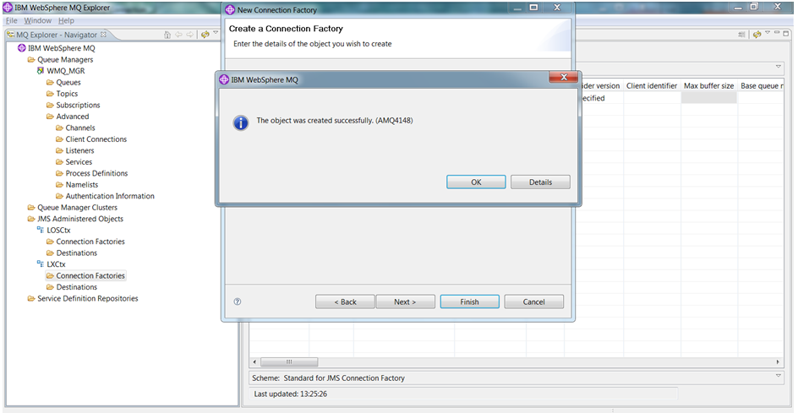

1. Navigate Windows explorer to the folders:
2. F:\Data\IBM\WebSphereMQ\data\los
3. F:\Data\IBM\WebSphereMQ\data\lx

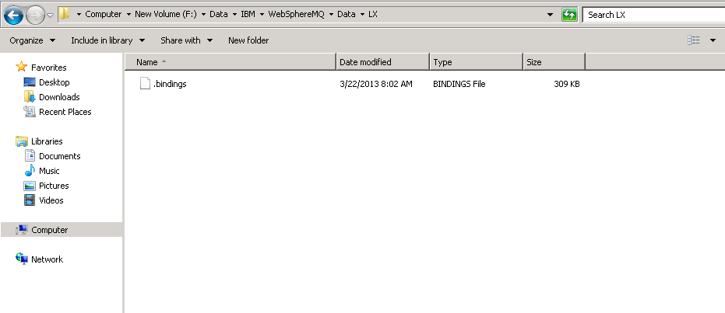

1. Edit “.bindings” to replace “localhost” with the IP address of the MQ server.

There are three occurrences of localhost to be replaced in each file.

1. Edit both bindings files - LOS (F:\Data\IBM\WebSphereMQ\data\los) and LX (F:\Data\IBM\WebSphereMQ\data\lx)

) 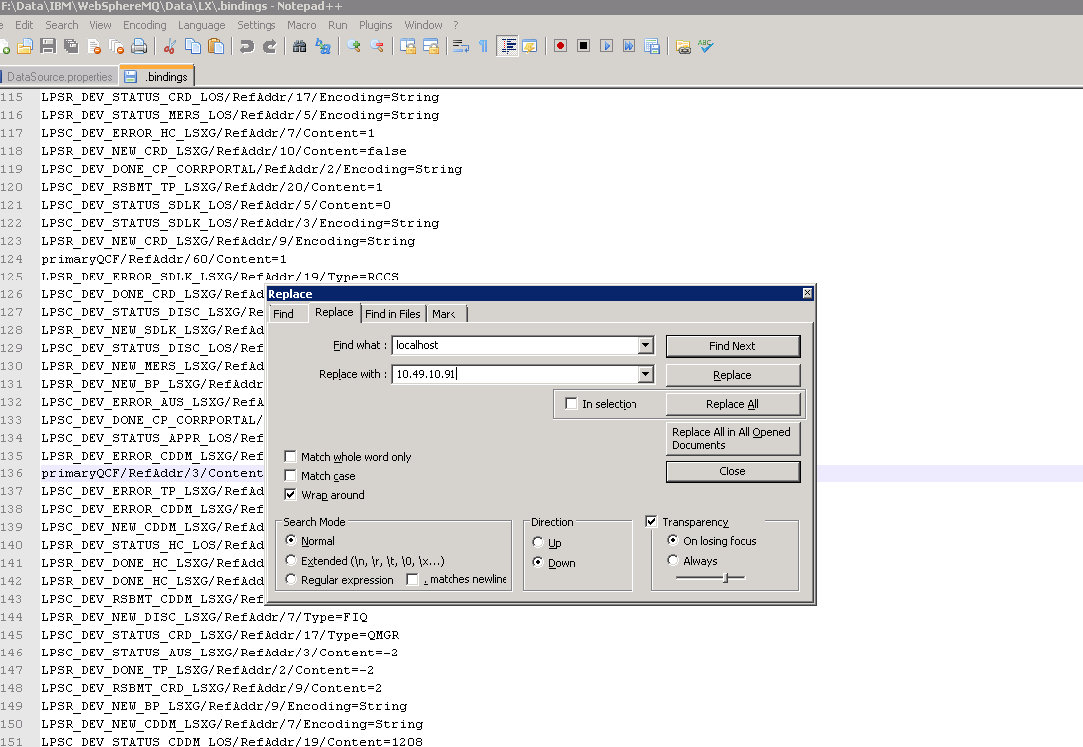

The folders should contain one and only one file, i.e. .bindings

#### Environment Variables for MQ

Add to existing or create the following system variables if they do not exist:

* CLASSPATH= F:\data\IBM\WebSphere MQ\Java\lib\com.ibm.mqjms.jar;F:\data\IBM\WebSphere MQ\Java\lib\com.ibm.mq.jar

THEN-- Add to end of existing PATH if not there:

* F:\data\IBM\WebSphere MQ\Java\lib;F:\data\IBM\WebSphere MQ\Java\lib64;F:\data\IBM\WebSphere MQ\bin64;F:\data\IBM\WebSphere MQ\bin;F:\data\IBM\WebSphere MQ\tools\c\samples\bin;F:\Data\jdk1.6.0_37\bin;.;F:\Data\jdk1.6.0_37\jre\bin;.;F:\Data\jre6\bin\

### Create Queues

Create queues in the queue manager and Initial contexts-

4 files are necessary to create the queues:

* CreatMQQueues.scp – (contains the queue creation script for creating Correspondant queues in Q Manager)
* CreateLOSQueues.scp – (contains the queue creation script for creating Correspondant queues in Initial Context)
* CreateLXQueues.scp – (contains the queue creation script for creating Correspondant queues in Initial Context)
* JMSAdmin.config – (to create the LOS/LX bindings)

Check to see if preconfigured scripts exist for the client prior to creating the queues

Copy the three files from F:\Installs\MQ-FTP\Queue Scripts (check for preconfigured) to F:\Data\IBM\WebSphere MQ\java\bin

### Creating Queues in Queue Manager

1. Open a command prompt, navigate to F:\Data\IBM\WebSphere MQ\bin

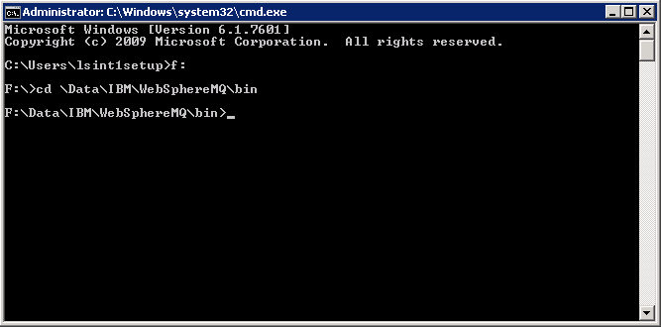

1. Enter the following command

runmqsc WMQ_MGR < ..\Java\bin\CreateMQQueues.scp

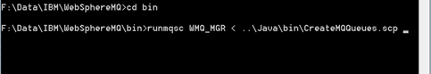

This command reads the script file (CreateMQQueues.scp) we passed as an argument and executes all the commands present inside the file.

The below screen shows the output of the command we executed in above step.

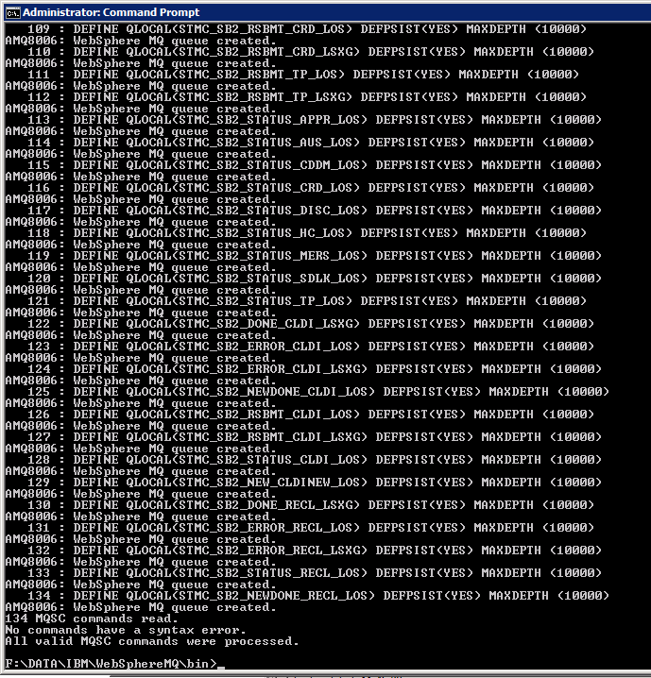

1. Open the WebSphere MQ Explorer to verify the new queues have been created.

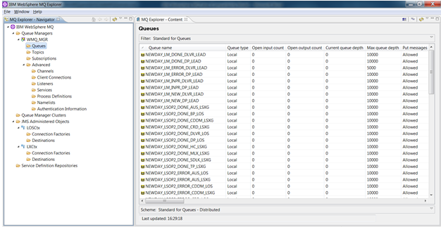

1. Select Queue Manager name(WMQ_MGR) -> Navigate to Queues
2. Verify the queues have been created using the script file in above steps.

### Creating Queues in Initial context – LOS

1. Edit the jmsadmin.config and ensure the trailing directory is “los”

PROVIDER_URL=file:/F:/Data/IBM/WebSphereMQ/data/los

1. Open a command prompt and navigate to F:\Data\IBM\WebSphere MQ\java\bin
2. Enter the following command:

JMSAdmin –t –v < CreateLOSQueues.scp

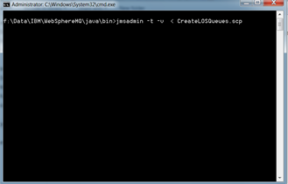

1. All the queues which we specified in the CretaeLOSQueues.scp file will be created in the respective initial context according to the information given in jmsadmin.config.

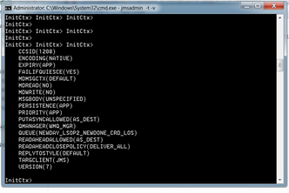

1. Ctrl + c to break
2. Open WebSphere MQ Explorer to verify the queues we have created just now.
3. If the queues are not shown, disconnect the LOSCtx and connect back to it.

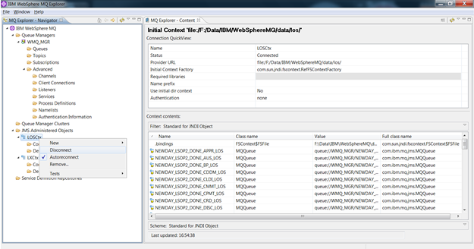

1. Right click the LOSCtx -> click Disconnect.

The below screen shows the disconnected view of LOSCtx.

1. Right click LOSCtx -> click Connect.

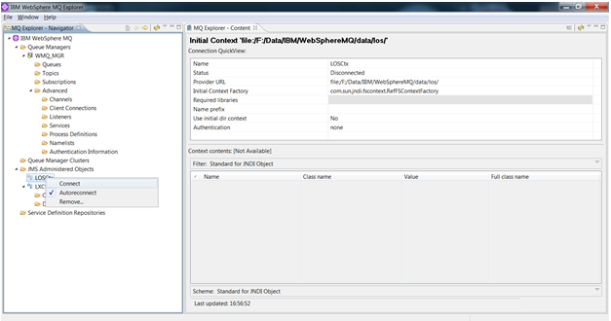

Once LOSCtx has been connected and if go to the Destinations, we can see the queues created in the above steps as shown in below figure.

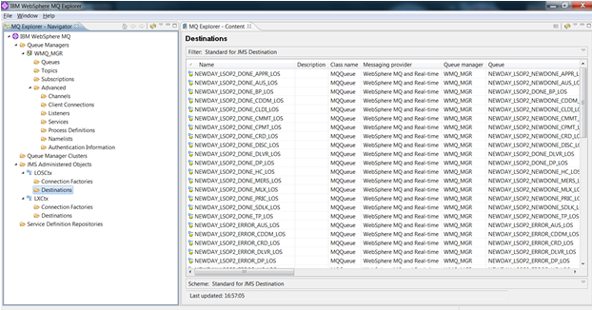

1. Edit the jmsadmin.bat and ensure the trailing directory is “lx”

PROVIDER_URL=file:/F:/Data/IBM/WebSphereMQ/data/lx

1. Open a command prompt and navigate to F:\Data\IBM\WebSphere MQ\java\bin
2. Enter the following command

JMSAdmin –t –v < CreateLXQueues.scp

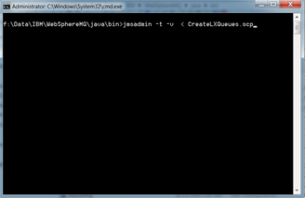

The queues have been created for LX also.

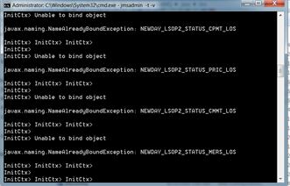

1. Open WebSphere MQ Explorer, disconnect and connect to LXCtx and navigate to destinations, then we will see the below screen.

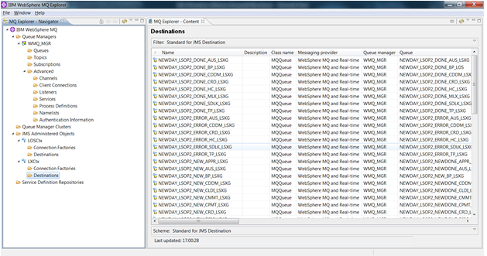

### Creating the Share for WebSphereMQ

1. Navigate to “F:\Data\IBM\ , right click and select properties on the WebSphere MQ” folder

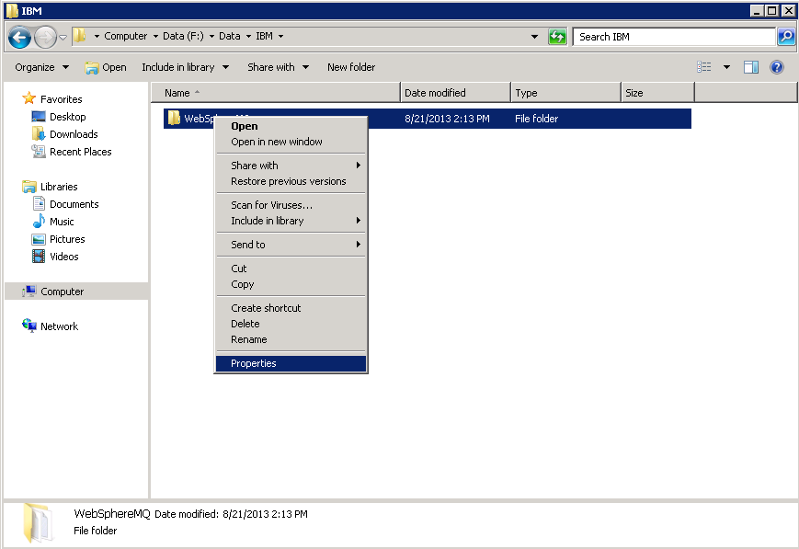

1. Select the “Sharing” tab and click “Share…”

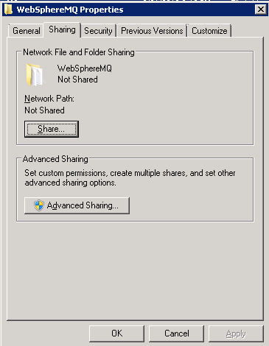

1. From File Sharing click the dropdown and select “Everyone”

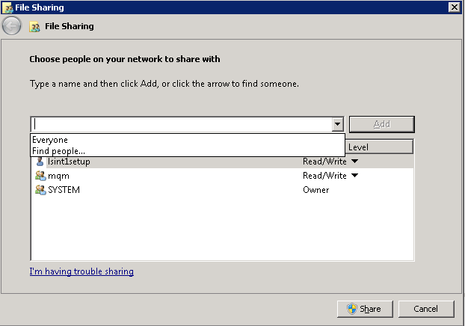

1. Select “Add”

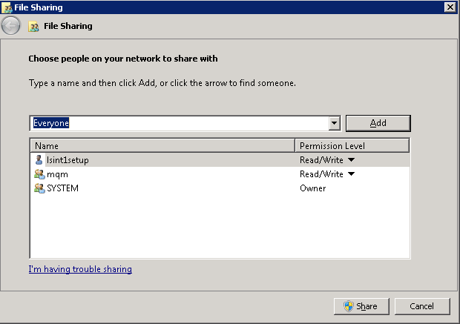

1. Change permissions for “Everyone” to “Read/Write”

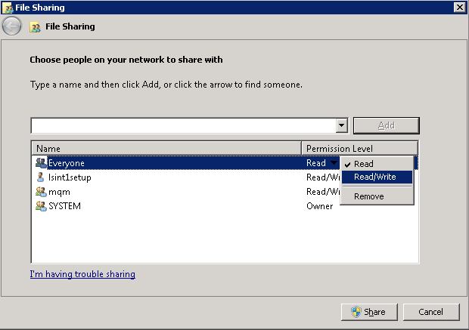

1. Select Share and when a popup window opens click Done.

## Storage Server MQ/FTP (Clustered)

Prerequisite Information and CHECKLIST -

* ALWAYS be logged in to the servers via the domain-level service account when installing software
* The service account should belong to the local administrators group
* 3 Cluster services:
  + Cluster service 1:
    - Name
    - VIP
    - Drive that will hold MQ content (50GB)
    - Shared folder: Websphere MQ share name, M:\Data, with full rights to everyone.
  + Cluster service 2:
    - Name
    - VIP
    - Drive that will hold IIS Shared content (1GB)
    - Shared folder: IIS Shared Content share name, I:\IIS Shared Config, full rights to everyone
  + Cluster service 3:
    - Name
    - VIP
    - Drive that will hold storage/FTP content (large (multiple TB), and expandable)
    - Shared folders: FTPRoot Share name, F:\Data\Inetpub\FTPRoot, full rights to everyone. LSFiles share name, F:\Data\LSFiles, full rights to everyone.

### IIS Installation

Complete steps 1 - on both nodes of the cluster

1. Open Windows Server Manager and click Add Roles

2. Click Next

3. Check Web Server(IIS) and click Next

4. Click Next

5. Check all Role services and click Next

6. Click Install

1. Close when Installation succeded is displayed
2. From IIS Manager, rename the default web site to “environmentserver” (example INT2MQ1, or PRODMQ2, etc.)



1. Create FTP User and Site
2. Create a local user on that machine:

11. From Server Manager, Expand Configuration, Local Users and Groups, Users



* 1. Right Click Users -> New User



12. Enter the below information to create the user which is required for our FTP site (the following are examples only, make sure you document the values you use for your environment):

* + User Name: lsftp
  + Full Name: lsftp
  + Description: lsftp
  + Password: create a password and record for use later
  + Confirm Password: create a password and record for use later

13. UnCheck “User must change password at next login”

14. Check “User cannot change password”

15. Check “Password never expires”

16. UnCheck “Account is disabled”



17. Click Create, and close

18. Add the ftp user to the local Administrators Group on the server:

19. Double click the new user, and click Member Of tab

20. Click Add, change Locations to the local Machine you are on, and type in administrators. Click Check names, and OK, and OK

#### Create FTP site

21Open IIS Manager

22.Right Click the Servername, select Add FTP Site



23. Enter a Site name, (example LSINT2FTP), and select the Content directory of F:\Data\Inetpub\FTPRoot and click next **NOTE** Content directory needs to be the drive letter for Cluster service 3 drive. If that drive is F:\, then F:\Data\Inetpub\FTPRoot is appropriate.

24. Change the SSL Settings to No, and click next

25. Change the authentication to Basic, select to allow access to Specfied users, put lsftp in the field, and choose Read and Write, click Finish

26. Highlight the new FTP site, and on the Actions column, select Basic Settings:



27. Click Connect as….

28. Change Path Credentials to Specific user, click Set, and enter the credential info:

29. Click Ok, then Ok, and Test Settings



You should see valid results

30. Click Close, and OK.

31. Click on the server name in IIS Manager

32. Select "Shared config"

33. Select "Export Configuration" and type the path to the IIS Shared config location in the Physical path box.

34. Click connect as, and provide a user account. This account will be used by both nodes to connect to the shared config and should be dedicated.

35. Select "Enable shared configuration"

36. Type in the path (UNC path to IIS Shared config share)

37. Type in the username previously used for IIS shared config 3 steps prior

38. Type in the password for the account

39. In the encryption password dialog use the encryption password that you set earlier.

40. On the second nod open IIS Manager

41. Click on server name

42. Select Shared Config

43. Select "Enable shared configuration"

44. Type the UNC path to the IIS shared config, username, and password

45. Type in the encryption key password

46. Click OK

47. Click OK

48. Save the following as "Clusftp7.vbs" and place in %systemroot%\System32\Inetsrv\ on both nodes.

***********************

'This script provides high availability for IIS FTP websites

'The script is applicable to:

' - Windows Server 2008: Microsoft FTP Service 7.5 for IIS 7.0 (available for download from microsoft.com)

' - Windows Server 2008 R2: FTP Service in the box

'More thorough and application-specific health monitoring logic can be added to the script if needed

Option Explicit

'Helper script functions

'Start the FTP service on this node

Function StartFTPSVC()

Dim objWmiProvider

Dim objService

Dim strServiceState

Dim response

'Check to see if the service is running

set objWmiProvider = GetObject("winmgmts:/root/cimv2")

set objService = objWmiProvider.get("win32_service='ftpsvc'")

strServiceState = objService.state

If ucase(strServiceState) = "RUNNING" Then

StartFTPSVC = True

Else

'If the service is not running, try to start it

response = objService.StartService()

'response = 0 or 10 indicates that the request to start was accepted

If ( response <> 0 ) and ( response <> 10 ) Then

StartFTPSVC = False

Else

StartFTPSVC = True

End If

End If

End Function

'Cluster resource entry points. More details here:

'http://msdn.microsoft.com/en-us/library/aa372846(VS.85).aspx

'Cluster resource Online entry point

'Make sure the FTP service is started

Function Online( )

Dim bOnline

'Make sure FTP service is started

bOnline = StartFTPSVC()

If bOnline <> True Then

Resource.LogInformation "The resource failed to come online because ftpsvc could not be started."

Online = False

Exit Function

End If

Online = true

End Function

'Cluster resource offline entry point

'On offline, do nothing.

Function Offline( )

Offline = true

End Function

'Cluster resource LooksAlive entry point

'Check for the state of the FTP service

Function LooksAlive( )

Dim objWmiProvider

Dim objService

Dim strServiceState

set objWmiProvider = GetObject("winmgmts:/root/cimv2")

set objService = objWmiProvider.get("win32_service='ftpsvc'")

strServiceState = objService.state

if ucase(strServiceState) = "RUNNING" Then

LooksAlive = True

Else

LooksAlive = False

End If

End Function

'Cluster resource IsAlive entry point

'Do the same health checks as LooksAlive

'If a more thorough than what we do in LooksAlive is required, this should be performed here

Function IsAlive()

IsAlive = LooksAlive

End Function

'Cluster resource Open entry point

Function Open()

Open = true

End Function

'Cluster resource Close entry point

Function Close()

Close = true

End Function

'Cluster resource Terminate entry point

Function Terminate()

Terminate = true

End Function

*******************************

49. Within Failover cluster Manager, select the Storage/FTP cluster service.

50. Select Add a resource

51. Select generic script

52. Resource name: Clusftp7 Script

53. Script filepath: %systemroot%\System32\Inetsrv\Clusftp7.vbs

54. Dependancies: Name and Drive

#### Verify sub folders for docs and files

Once we are done with the creation of FTP site, verify folders inside the ROOT folder of FTP site.

The root folder is F:\Data\Inetpub\FTPRoot (Clustered Disk F☺

The following folders at the root of FTPRoot:

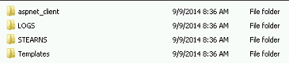

F:\Data\inetpub\ftproot\STEARNS and the following subfolders

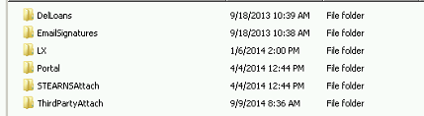

Within ThirdPartyAttach create the following folders:

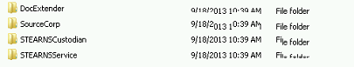

Correct subdirectory names if needed.

#### LSFILES permissions

F:\Data\LSFiles folder structure as follows:

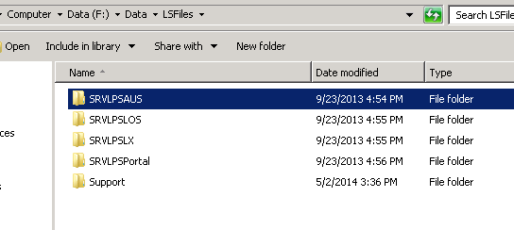

1. Share the folder to everyone with read/write permissions



1. Share and Done
2. Close

### Clustered MQ Prerequisites

Minimum two node Microsoft failover cluster

Minimum of one cluster shared drive (recommend M: drive letter if not already assigned)

This Local folders: D:\apps

An Active Directory service account to be used for user validation

Recommended: SVC-{app}MQUSER

Add service account to local Administrators group on each node of the cluster

IBM Websphere MQ installation CD (ISO)

### Installing MQ

1. Mount the IBM MQ installation disk and run setup to start the Launchpad
2. Select the Software Requirements tab on the left side of the Launchpad
   1. The Websphere Eclipse Platform should show as not installed, click the plus sign to expand
   2. Select the CD-ROM option to start the install

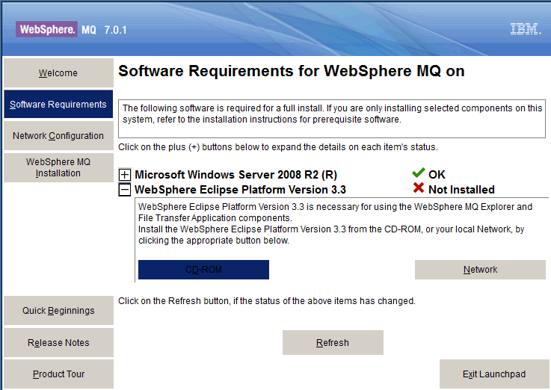

* 1. Click OK and Next to get to the License Agreement, accept and click Next
  2. Change the destination folder to D:\Apps\IBMMQ\eclipseSDK33
  3. Click Next and Install. When done, click Finished
  4. Click the Refresh button for Software Requirements. Verify everything is OK

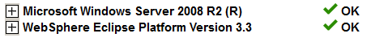

1. Select the Network Configuration tab on the left side of the Launchpad
   1. Select Yes
2. Select the Websphere MQ Installation tab on the left side of the Launchpad
   1. Click the Launch IBM WebSphere MQ Installer button at the bottom of the dialog box

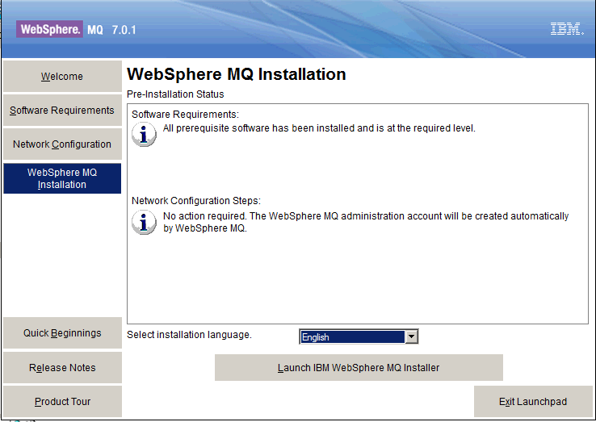

* 1. Accept the licensing agreement and click Next
  2. Select Custom and click Next to modify the file folders
     1. Change the Destination Folder to D:\apps\IBMMQ\MQ and click Next
     2. Click Next to accept the Data-Files, IBM Global Security Kit and Logs folders
  3. On the Features dialog box, use the dropdowns to select all options for install and click Next

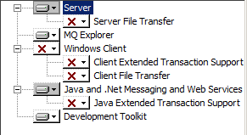

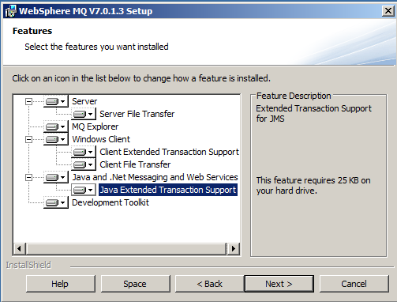

* 1. Click Install on the Ready to Install dialog box and Finish when the install is complete

1. The Prepare WebSphere MQ Wizard will run after install
   1. Click Next
   2. Click Next at the Network Configuration dialog box
      1. Setup the AD service account and click next (SVC-MQUSER is an example)

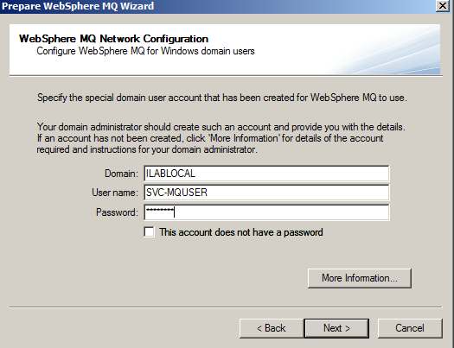

* + 1. The MQ service will start, click Next on the Default configuration dialog box
    2. Uncheck both boxes and click Finish

1. Repeat Steps 1-5 on each node of the cluster
2. From a command prompt, run *dspmqver* on all nodes and ensure the response is the same.

### Creating a Queue Manager

****The initial queue manager creation must be on local disk. Do not use a shared disk.****

1. On the first cluster node, start the WebSphere® MQ Explorer from the Start menu.
2. In the Navigator View, expand the tree nodes to find the Queue Managers folder

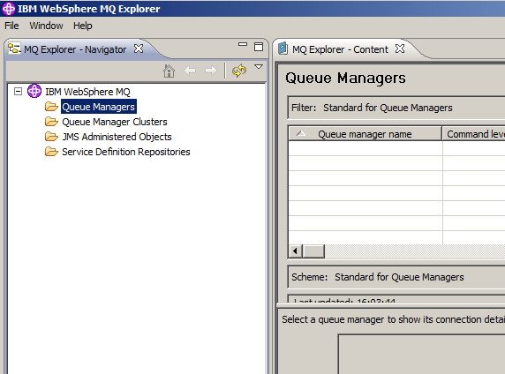

1. Right-click the Queue Managers folder and select New 🡪 Queue Manager.
2. Enter the Queue Manager Name as WMQ_MGR and ensure the “Make this the default queue manager” is unchecked, then click Next
3. Click Next for the Enter data and log values dialog
4. On the Enter Configuration options dialog
   1. Ensuring Start Queue Manager is unchecked
   2. For the queue manager startup, select Service (manual)
   3. Ensure Create Server Connection Channel is unchecked
   4. Click Next and then Finish
5. Using MQ Explorer, ensure the newly created queue manager is stopped

### Create MSCS Clustered Application

****The following steps are only to be performed on the first cluster node****

1. Create the new clustered application and configure dependencies
   1. Within Windows Cluster Manager, right click Services and Applications and select Configure a Service or Application
   2. Select Other Server and click Next
   3. Give the new Application a descriptive name, i.e., WMQ_MGR
   4. Assign an IP address for the resource and click Next
   5. Select the appropriate Cluster Disk and click Next
   6. Click Next on the Resource Type dialog box
   7. Click Next to create the new Application
2. Test the cluster failover by using the MSCS Cluster Administrator to move it from one cluster node to the other and back again.
3. Before proceeding, ensure all cluster resources are online and available on the first cluster node.

### Move Queue Manager to MSCS Shared Storage

****The following steps are only to be performed on the first cluster node****

1. Make sure that the shared disk is online on the first cluster node where the queue manager log and data files are stored locally.
2. From a command prompt, run the following command to move the queue manager to the shared disk. Directories will be created if they don’t exist and the queue manager data/log files moved.

hamvmqm /m {qmgrname} /dd "M:\MQData" /ld "M:\log"

1. Once complete, use Windows Explorer to verify the directories have been created and the files moved
2. Using MQ Explorer, test the queue manager to ensure it works
   1. Right-click the queue manager, then select Start as created. Verify the queue manager starts.
   2. Right-click the Queues folder, then select New->Local Queue, and give the queue a name.
   3. Click Finish.
   4. Right-click the queue, then select Put Test Message. The Put Test Message panel is displayed.
   5. Type some message text, then click Put Test Message, and close the panel.
   6. Right-click the queue, then select Browse Messages.
   7. Ensure your message is on the queue, and then click Close.
   8. Right-click the queue, then select Clear Messages
   9. Right-click the queue, then select Delete, click OK to delete the queue
   10. Right-click the queue manager tree node, then select Stop -> Controlled
   11. Click OK to stop the queue manager
   12. Right click the queue manager and select properties
       1. Ensure the startup is set to Service (manual)

### Putting MQ Under MSCS Control

1. Define a MSCS Resource Type for MQ
   1. From a command prompt on the all cluster nodes, run the following command to define the MQ MSCS resource type

haregtyp /r

* 1. Reboot second node.  When second node is back online, manually fail all cluster resources to the second node.  Once all cluster resources are online on the second node, reboot the first node.  Once the first node is back online, manually fail all cluster resources back to the first node.

1. Add the IBM MQ Resource to the MSCS cluster
   1. Using Failover Cluster Manager, expand Services and Applications
   2. Right click the MQ Cluster Application that was created previously
   3. Select Add a resource 🡪 More resources 🡪 Add IBM MQSeries MSCS

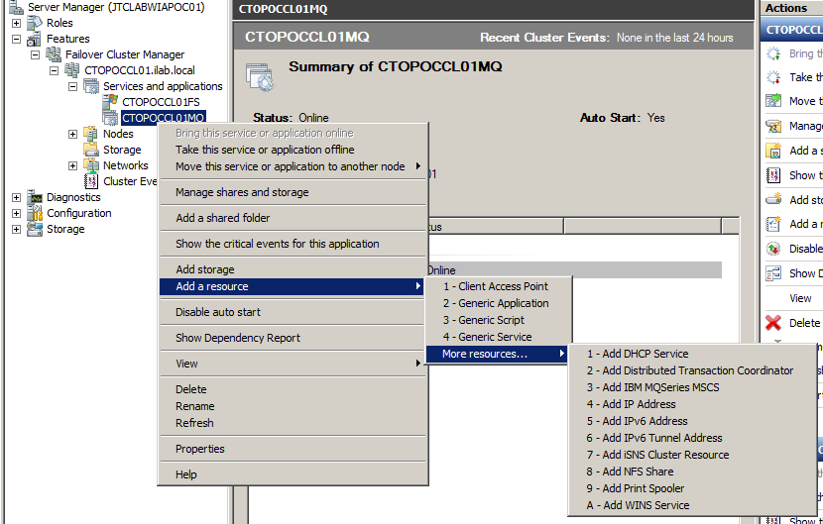

* 1. This creates a new IBM MQ resource for the application in an offline state
  2. Right click on the new MQ resource and select properties
     1. Provide a name for the new resource. Recommendation: {app}MQ

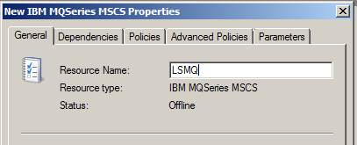

* + 1. Select the dependencies tab and add the assigned shared disk and IP address

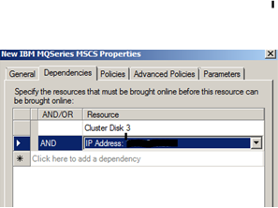

* + 1. Select the Advanced Policies tab
       1. Ensure at least two nodes are selected as possible owners
       2. Check the box for Run this resource in a separate Resource Monitor

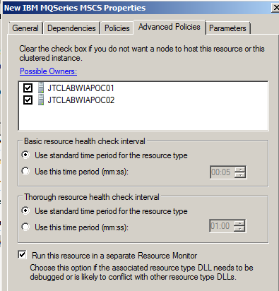

* + 1. Select the Parameters tab and enter the Queue Manager configured previously that will be clustered. This should be the Queue Manager moved to the shared disk.

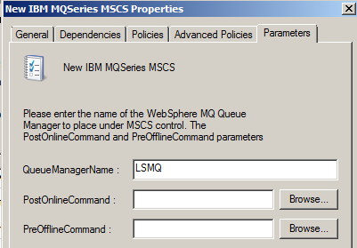

* + 1. Click Apply and then OK
  1. Right click on the new MQ resource and bring it online
  2. Move new application between nodes to ensure the resources remain online.
  3. Return the MQ application to the first cluster node

### Test the IBM MQ clustered application

1. On the first cluster node,
   1. Open MQ Explorer to test the queue manager
   2. Right-click the Queues folder, select New 🡪 Local Queue, and name the queue “Final”. Click Finish.
   3. Right click the Final queue and select Properties
      1. Set Default Persistence to “Persistent”, click Apply and OK
   4. Right-click the queue and select Put Test Message.
   5. Enter “This is a final test” for the message text, click Put Test Message, and close the panel.
   6. Right-click the queue, select Browse Messages and ensure your message is in the queue. Click Close
2. Failover the clustered MQ application to a second node
   1. Open MQ Explorer to test the queue manager
   2. Right-click the Queues folder, select New 🡪 Local Queue, and name the queue “Final2”. Click Finish.
   3. Right click the Final2 queue and select Properties
      1. Set Default Persistence to “Persistent”, click Apply and OK
   4. Right-click the queue and select Put Test Message.
   5. Enter “This is a second final test” for the message text
      1. Click the Put Message button and Close
   6. Right-click each queue, select Browse Messages and ensure your messages are in the queues. Click Close
   7. Move the MQ application back to the original cluster node
3. Remove the test queues and messages
   1. Open MQ Explorer and select the queue manager
   2. Select the Queues folder under the queue manager
   3. Right-click each queue and select Clear Messages
   4. Right-click each queue and select Delete to delete the queues

### Important Operational Notes

* Do not try to perform start and stop operations directly on any clustered queue managers using either the MQ Explorer or command line. Always use MSCS Cluster Manager to bring the MQ resource offline.
* MSCS Clustered applications can be configured to use preferred nodes but it is recommended that preferred nodes should not be set and to rely on a manual failback.
* Command line support utility programs
  + Register/Unregister IBM MQ Cluster Resource
    - Register: haregtyp /r
    - Unregister: haregtyp /u
  + Move a queue manager
    - hamvmqm /m {qmanager name} /dd {data path} /ld {log path}
  + Delete a queue manager
    - Hadltmgm /m {qmanager name}

### Create Initial Contexts & Connection Factories

#### JMS Administered Objects

Create Initial Context

Create Connection Factories

Create Destinations

##### Create Initial Context

1. Right click JMS Administered Objects and click Add Initial Context

.

The Add Initial Context wizard will be started to guide us through the creation of the context.



1. Select File System for JNDI namespace.
2. From Windows Explorer, navigate to the Data folder; - M:\Data\
3. Create subfolders (los & lx) inside the data folder.
4. Coming back to our Add Initial context wizard, copy the los folder path which we created in the above step in Bindings directory text box as shown in below figure.
5. Click Next. In the next screen as shown below enter the context nickname as LOSCtx (as we are creating LOS initial context).



1. Select the “automatically reconnect to context on startup” checkbox and click Finish button.

The LOS initial context will be created and the MQ explorer shows the newly created context and sub-items available under it.



##### Creating Queue Connection Factory

1. Open the JMS Administered Objects, and Under LOSCtx right click Connection Factories -> New -> Connection Factory.



The Create connection factory dialog box is displayed as shown in figure below.



1. Enter Name: primaryQCF
2. Leave Messaging provider as WebSphere MQ
3. Click Next

The next screen displays creating connection factory.

1. Choose Queue Connection Factory from the pull down



1. Select Next
2. Select Transport: MQ Client and click Next
3. Select Finish to proceed. 



1. Click ok to continue
2. Right click JMS Administered objects and click Add Initial Context



1. Select File System for JNDI namespace.
2. Enter LX folder path which we created in above steps (inside data folder) and click Next.
3. Enter the context nickname as LXCtx and check the automatically reconnect to context on startup check box and click Finish.



The LX Initial context has been created successfully

1. Create a queue connection factory
2. Right click Connection factories under LXCtx and click New -> Connection Factory - enter the Name primaryQCF (this used in the queueinfo.properties)



1. Select messaging provider: WebSphere MQ and click Next.
2. Select Type as Queue Connection Factory and click Next.



1. Select the transport as MQ Client and click next.



1. Select Finish to complete the creation of queue connection factory.



LX queue connection has also been created successfully.



1. Navigate Windows explorer to the folders:
2. M:\Data\los
3. M:\Data\lx



1. Edit “.bindings” to replace “localhost” with the IP address of the MQ server.

There are three occurrences of localhost to be replaced in each file.

1. Edit both bindings files - LOS (M:\Data\los) and LX (M:\Data\lx)

) 

The folders should contain one and only one file, i.e. .bindings

#### Environment Variables for MQ

Add to existing or create the following system variables if they do not exist:

* JAVA_HOME= F:\Data\jdk1.6.0_37

THEN-- Add to end of existing PATH:

* D:\data\IBM\WebSphere MQ\Java\lib;D:\data\IBM\WebSphere MQ\Java\lib64;D:\data\IBM\WebSphere MQ\bin64;D:\data\IBM\WebSphere MQ\bin;D:\data\IBM\WebSphere MQ\tools\c\samples\bin;D:\Data\jdk1.6.0_37\bin;.;D:\Data\jdk1.6.0_37\jre\bin;.;D:\Data\jre6\bin\

### Create Queues

Create queues in the queue manager and Initial contexts-

4 files are necessary to create the queues:

* CreatMQQueues.scp – (contains the queue creation script for creating Correspondant queues in Q Manager)
* CreateLOSQueues.scp – (contains the queue creation script for creating Correspondant queues in Initial Context)
* CreateLXQueues.scp – (contains the queue creation script for creating Correspondant queues in Initial Context)
* JMSAdmin.config – (to create the LOS/LX bindings)

Check to see if preconfigured scripts exist for the client prior to creating the queues

Copy the three files from F:\Installs\MQ-FTP\Queue Scripts (check for preconfigured) to F:\Data\IBM\WebSphere MQ\java\bin

### Creating Queues in Queue Manager

1. Open a command prompt, navigate to F:\Data\IBM\WebSphere MQ\bin



1. Enter the following command

runmqsc WMQ_MGR < ..\Java\bin\CreateMQQueues.scp



This command reads the script file (CreateMQQueues.scp) we passed as an argument and executes all the commands present inside the file.

The below screen shows the output of the command we executed in above step.



1. Open the WebSphere MQ Explorer to verify the new queues have been created.



1. Select Queue Manager name(WMQ_MGR) -> Navigate to Queues
2. Verify the queues have been created using the script file in above steps.

### Creating Queues in Initial context – LOS

1. Edit the jmsadmin.config and ensure the trailing directory is “los”

PROVIDER_URL=file:/F:/Data/IBM/WebSphereMQ/data/los

1. Open a command prompt and navigate to F:\Data\IBM\WebSphere MQ\java\bin
2. Enter the following command:

JMSAdmin –t –v < CreateLOSQueues.scp



1. All the queues which we specified in the CretaeLOSQueues.scp file will be created in the respective initial context according to the information given in jmsadmin.config.



1. Ctrl + c to break
2. Open WebSphere MQ Explorer to verify the queues we have created just now.
3. If the queues are not shown, disconnect the LOSCtx and connect back to it.



1. Right click the LOSCtx -> click Disconnect.

The below screen shows the disconnected view of LOSCtx.

1. Right click LOSCtx -> click Connect.



Once LOSCtx has been connected and if go to the Destinations, we can see the queues created in the above steps as shown in below figure.



1. Edit the jmsadmin.bat and ensure the trailing directory is “lx”

PROVIDER_URL=file:/F:/Data/IBM/WebSphereMQ/data/lx

1. Open a command prompt and navigate to F:\Data\IBM\WebSphere MQ\java\bin
2. Enter the following command

JMSAdmin –t –v < CreateLXQueues.scp



The queues have been created for LX also.



1. Open WebSphere MQ Explorer, disconnect and connect to LXCtx and navigate to destinations, then we will see the below screen.



### Creating the Share for WebSphereMQ

1. Navigate to “F:\Data\IBM\ , right click and select properties on the WebSphere MQ” folder



1. Select the “Sharing” tab and click “Share…”



1. From File Sharing click the dropdown and select “Everyone”



1. Select “Add”



1. Change permissions for “Everyone” to “Read/Write”



1. Select Share and when a popup window opens click Done.

## Proxy Server Installation

Pre-Requisites:

* Prerequisite Service accounts:

1. Domain Based service account

* Log in to the servers as the application service account

NOTE: Always log into the servers as the service account when installing software.

### IBM Installation Manager - Installation

1. Navigate to the IBM Installation media and execute ***install.exe***   
   E.g*.* ***\\yourservername\IBMHTTPv8.5\IBM Installation Manager\install.exe***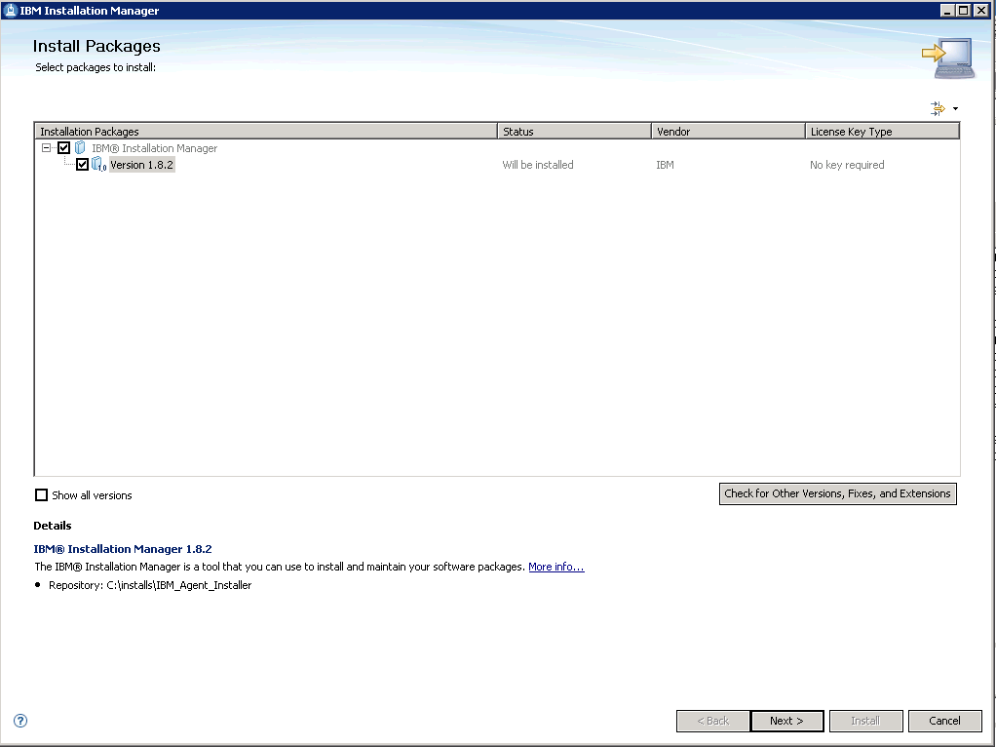
2. Click Next > and accept the license agreement.
3. Set the Installation manager directory to: ***C:\Data\IBM\Installation Manager\eclipse*** and click Next >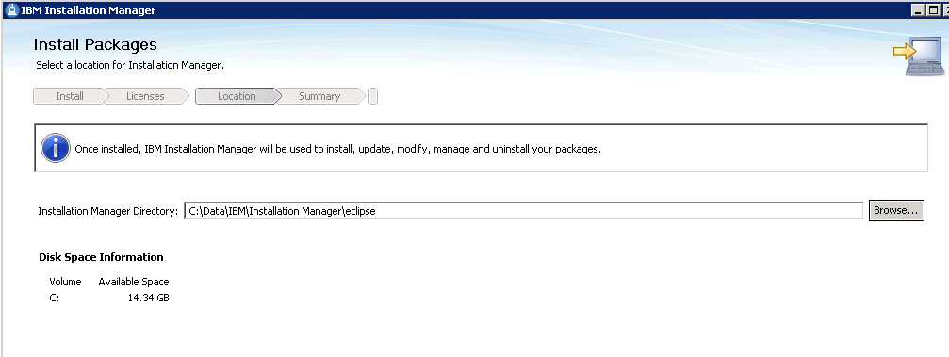
4. Install  
   
5. Once completed – select Restart Installation Manager

### IBM HTTP Server v8.5 and Fixpack 5 - Installation

1. Open the IBM Installation Manager and add the repositories
   1. File > Preferences > Add Repository
   2. Add the following repositories (*make sure you add both*):
      1. ***\\LendingSpace-BYserverTYPE\Proxy\IHS_8.5 Install\repository.config***
      2. ***\\LendingSpace-BYserverTYPE\Proxy\IHS_8.5 Fixpack 5\repository.config***
   3. Select OK

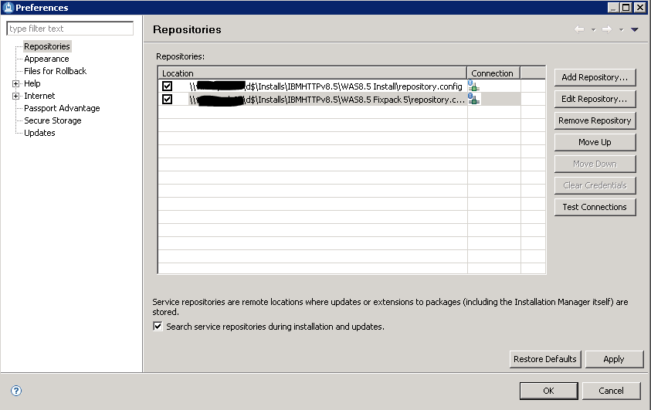

1. Select Install on the Installation Manager main menu

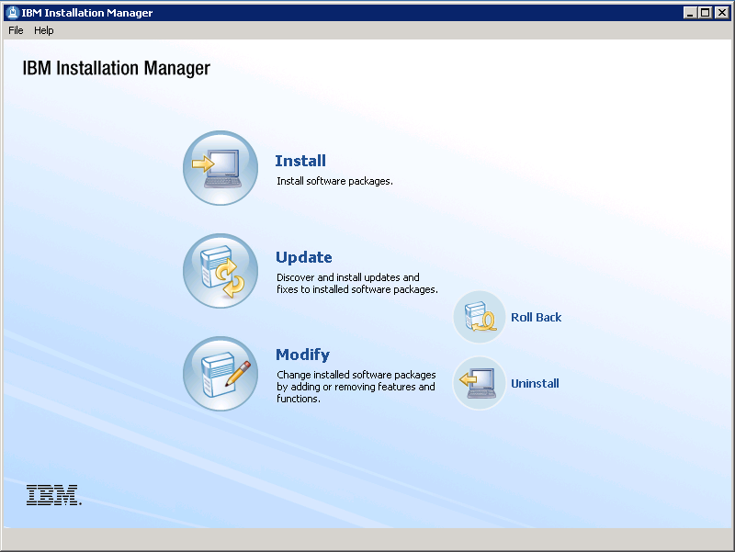

1. Select ***IBM HTTP Server for WebSphere Application Server*** > Next

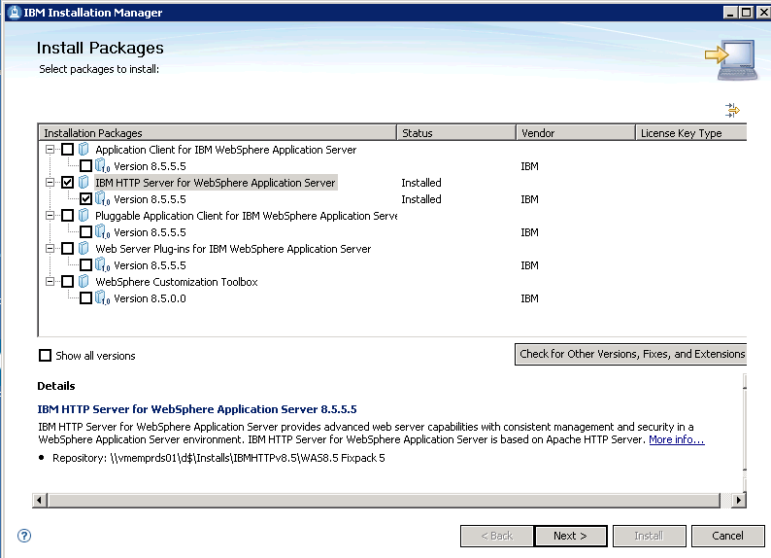

1. Accept license agreement > Next
2. Change Shared Resources Directory to : ***C:\Data\IBM\IMShared*** > Next

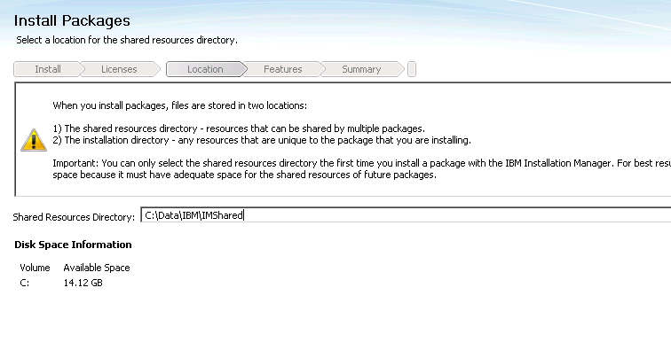

1. Change installation directory to ***C:\Data\IBM\HTTPServer*** > Next

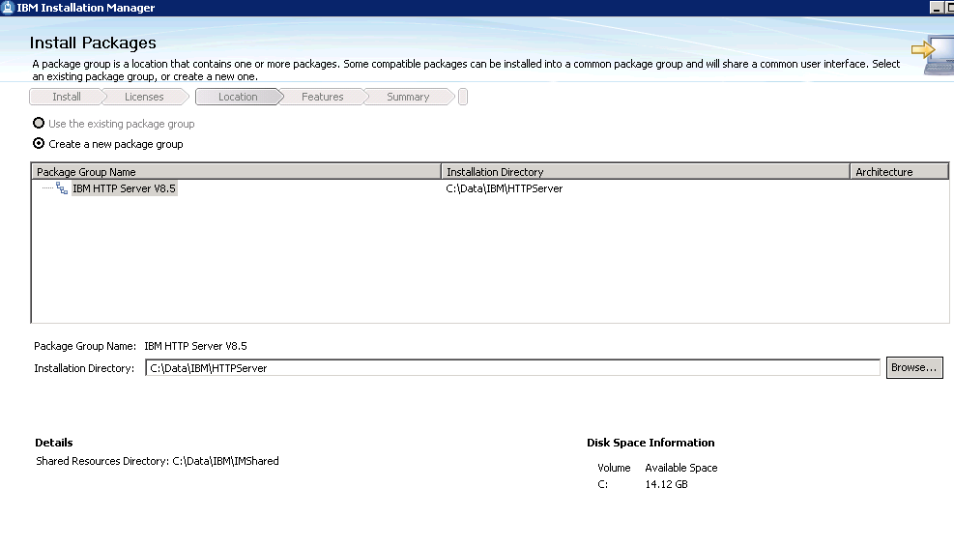

1. Click next
2. Use default settings (*we will change the service account later*)

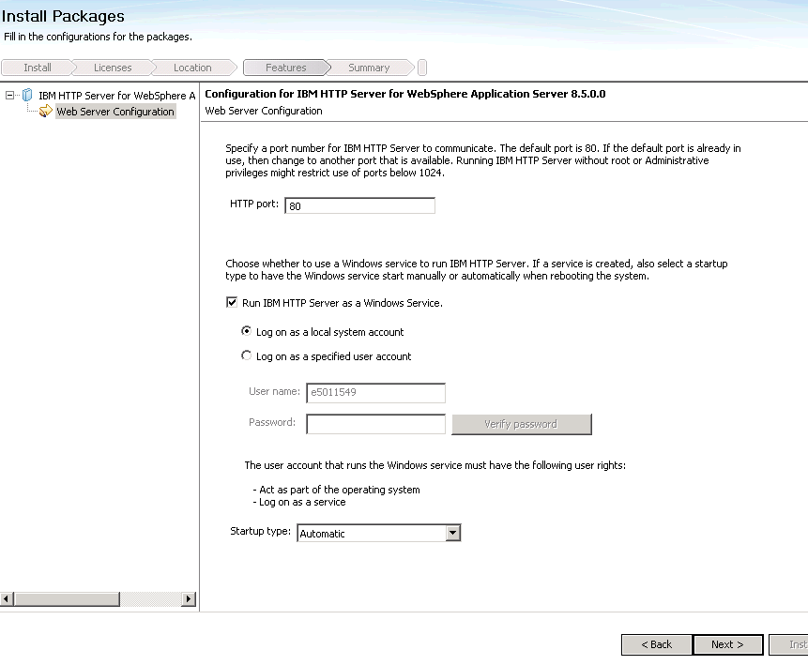

1. Next > Install
2. Once complete – close/finish the installer

### Post Installation Steps

1. Verify IBM HTTP Server version
   1. Open ***C:\Data\IBM\HTTPServer\version.signature*** in a text editor to verify that v8.5.5.5 was installed

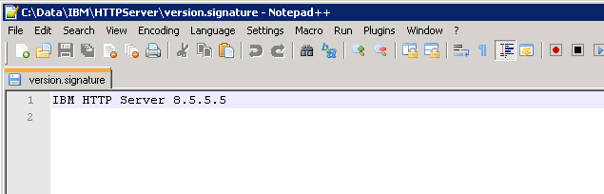

1. Set **IBM HTTP Server V8.5** service to run as the necessary service account

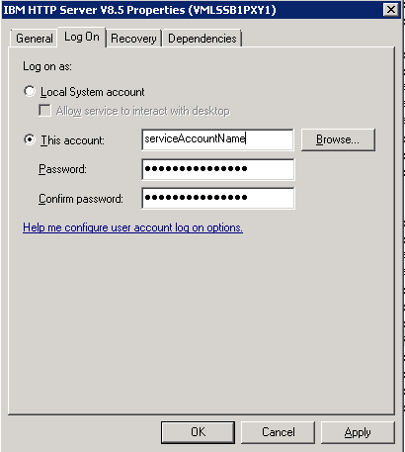

### Create Keystore (KDB) file

The IBM KDB file is required to enable SSL(HTTPS) on IBM HTTP server and IBM WebSphere Application server.

1. Create a subdirectory called SSLCert under the IBM directory - C:\Data\IBM\HTTPServer\SSLCert
2. Start the key management utility by clicking Start > Programs > IBM HTTP Server > Start Key Management Utility.

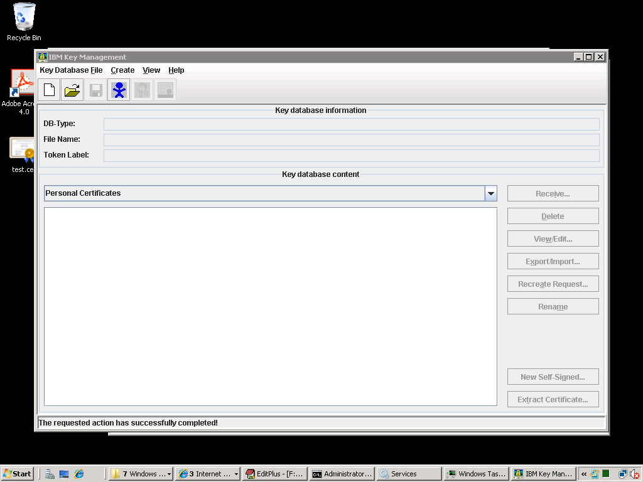

1. Create a key database and click Key Database File > New.

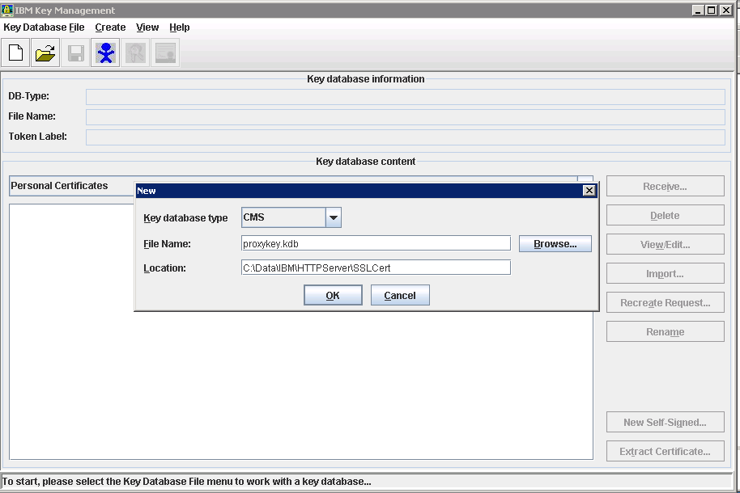

1. Select CMS as key database type.
2. Filename- proxykey.kdb
3. Location - C:\Data\IBM\HTTPServer\SSLCert
4. Select OK
5. Prompt for password
6. Type any password (Document what you use as a key store Password .!)
7. And select the check box against “Stash password to a file”.
8. Click ok.
9. Then the key management tool will create a new key store database file at the location we specified and open it for use.

### Create the SSL Certificate Request

1. From the IBM Key Mangement utility, Click Create, New Certificate Request
2. (The below screens are an example of what BKFS uses)

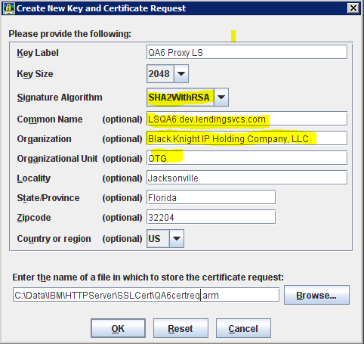

1. (BKFS) Items in Yellow are required to be there as they are shown. Self-Hosted follow their naming conventions
2. Submit your key request to the Certificate provider you use.
   * Notify your CA processor that it is preferred to receive Base-64 encoded X.509 (.cer) files.
3. Import (BKFS) a Service Catalog request for this servers’ certificate, and attach the certreq.arm file. You will ask them to send you back the certificate in .CER format.
4. When you receive a certificate back from your provider, make sure you have the intermediate and trusted root certificates (separated from the SSL Server certificate). (Copy both files to the server install directory.)
5. (BKFS only: If downloading from Venafi – choose the .DER format)
6. From the IMB Key Management Utility (can be located via the Windows Start menu):
7. Open your key store file.
8. Change the Key Database Content to Signer Certificates – click Add
9. Browse to where you stored the CA certificate
10. For the Trusted CA certificate, change the Key Database Content to “Signer Certificates” and click Add

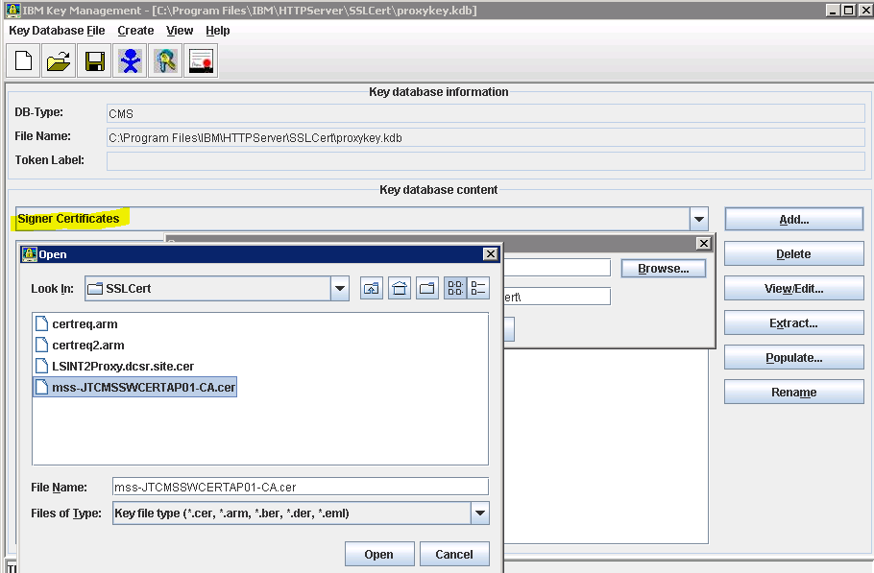

1. And click open. And OK.
2. Click View/Edit the file you imported, and verify or set the check mark to set it as a trusted root:

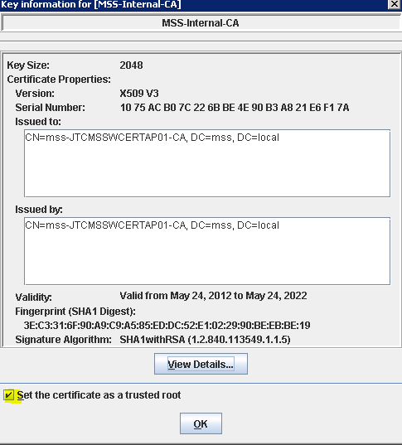

1. Click OK, and exit out.
2. Click Receive, point to the certificate file received, and click Ok.

### Configuring IBM HTTP Server for Secure Sockets Layer



1. Copy the embedded HTTPD.conf template file (standard, or Portal_Only dependant upon location) and begin to edit it with the environmental information. You need to search/replace the variables listed in the template and replace with the proper IP address. Info Needed prior to configuration:
2. PROXY-REAL-IP, SSRS-FQDN Serername, WAS-CELL1-Name, WAS-CELL2-Name, WAS-CELL3-Name, and Server Name

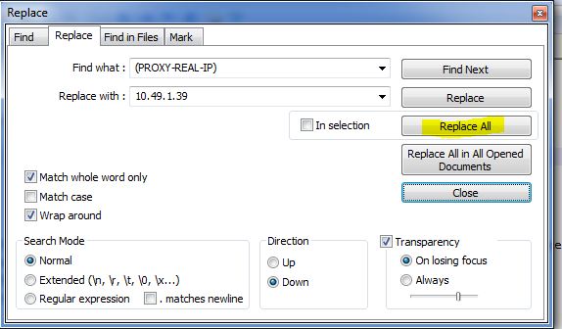

1. Verify the keyfile directive is set to the right directory and filename.

Example -- KeyFile C:/DATA/IBM/HTTPServer/SSLCert/proxykey.kdb

1. Save this file as <path to install>\IBM\HTTPServer\conf\httpd.conf and you can stop/Start the IBM HTTP server service. Verfify proper operation and log files.
2. PUT A HOST FILE ENTRY on the Proxy Server that contains the proxy FQDN, and LOCAL IP *if your environment does not do resolution of the external name to local IP.*

Ex. \windows\system32\drivers\etc\hosts:

10.49.XX.XX proxydnsname.externaldomain.com

1. Change anything after the “SSLProtocolDisable SSLv2 SSLv3” statement

Change:

SSLEnable

SSLProxyEngine On

SSLProtocolDisable SSLv2 SSLv3

SSLCipherSpec 27

SSLCipherSpec 23

SSLCipherSpec 3A

To:

#Listen [::]:443

<VirtualHost *:443>

SSLEnable

SSLProxyEngine On

SSLProtocolDisable SSLv2 SSLv3

SSLCipherSpec SSL_RSA_WITH_RC4_128_SHA

SSLCipherSpec SSL_RSA_WITH_RC4_128_MD5

SSLCipherSpec TLS_RSA_WITH_AES_128_GCM_SHA256

SSLCipherSpec TLS_RSA_WITH_AES_256_GCM_SHA384

SSLCipherSpec TLS_RSA_WITH_AES_128_CBC_SHA256

SSLCipherSpec TLS_RSA_WITH_AES_256_CBC_SHA256

SSLCipherSpec TLS_RSA_WITH_AES_128_CBC_SHA

SSLCipherSpec TLS_RSA_WITH_AES_256_CBC_SHA

SSLCipherSpec SSL_RSA_WITH_3DES_EDE_CBC_SHA

SSLCipherSpec TLS_ECDHE_ECDSA_WITH_AES_128_CBC_SHA256

SSLCipherSpec TLS_ECDHE_ECDSA_WITH_AES_256_CBC_SHA384

SSLCipherSpec TLS_ECDHE_RSA_WITH_AES_128_CBC_SHA256

SSLCipherSpec TLS_ECDHE_RSA_WITH_AES_256_CBC_SHA384

SSLCipherSpec TLS_ECDHE_ECDSA_WITH_AES_128_GCM_SHA256

SSLCipherSpec TLS_ECDHE_ECDSA_WITH_AES_256_GCM_SHA384

SSLCipherSpec TLS_ECDHE_RSA_WITH_AES_128_GCM_SHA256

SSLCipherSpec TLS_ECDHE_RSA_WITH_AES_256_GCM_SHA384

1. Verify SSL and name resolution by bringing it up in a browser window on the server

### Configuring IBM HTTP Server for Redundant Servers

After you have configured the first Proxy server:

1. Configure the HTTP server on the second node as above but do not do the certificate, but skip the “Create the SSL Certificate Request” section
2. On the first node, shut down the “IBM HTTP Server V8.5”service.
3. IF the “IBM HTTP Server V8.5” service is running, shut it down
4. Copy the the entire directory \data\IBM\HTTPServer\SSLCert over to the redundant node(s)
5. Bring up the “IBM HTTP Server V8.5” on the first node, and then on the redundant node(s).
6. Ensure you have the proper host entry for the redundant node(s), and test an SSL connection to the redundant node(s) HTTP server.

### SSL certificate renewal process

* Follow the instructions in the sections:
  + Creating the SSL Certificate Request (using the same server information, but use a DIFFERENT label name).
  + Configuring IBM HTTP Server for Redundant Servers
* After the new certificate has been installed, you can delete the expired certificate after all proxy servers have been updated.

NOTE: IF there is a problem receiving (importing) the new SSL Certificate (i.e. “The certificate request created for the certificate is not in the key database.”), you will need to create a new keystore database. BKFS has seen this after in-place upgrades.

* + Create a new keystore database file in a new subdirectory (ex. \DATA\IBM\HTTPServer\SSLCert-NEW) using the same filename – proxykey.kdb
  + Be sure to check the box for "Stash password to a file"
  + Add(import) your Signer CA Certificate(s)
  + Create a new Certificate Request, and submit to your CA provider
  + When you have the new certificate and are ready to install it, Click “Receive” to import your new certificate
  + Stop the IBM HTTP Server service
  + Rename the existing \SSLCert subdirectory to something different (ex. \ DATA\IBM\HTTPServer\SSLCert-old)
  + Rename the new keystore directory (ex.. \SSLCert-NEW) to \SSLCert
  + Start the HTTP Server service and validate with a connection to the application.

### SSL Certificate Authority Root and Intermediate certificate additions

Note that these instructions are for BKFS utilized Thawte root certificates, specifically for when new SHA-2 based servers certificates are used, but the process is the same for any CA certificates to be added or changed.

* Open the IBM HTTP Server v7.0 Key Management Utility

Click on: Start-Programs-IBMHTTP Server v7.0-Start Key Managment Utility

* Open the Key Database file

Click on: Key Database File-Open, and Browse to the C:\Data\IBM\HTTPServer\SSL Cert directory and select the proxykey.kdb file and click ok.

Enter the password for your key store, and click ok

* Import the SHA-2 root certificates (Root and Intermediate CA certificates)

From the key database content drop-down, select "Signer Certificates"

Click on Add, then Browse. Navigate to where the files are copied to the server and select the Intermediate certificate labeled thawte SHA256 SSL CA.cer file

Click Open on the file, and OK. Enter a label like "thawte-256 intermediate"

Click on Add, then Browse. Navigate to where the files are copied to the server and select the Root Certificate labeled thawte Primary Root CA - G3.cer

Click Open on the file, and OK. Enter a label like "thawte-256 root"

* Exit the Key Management utility

Click on Key Database File, and Exit

Transaction Timeout (enable on each proxy)  
  
1. Navigate to the configuration folder of HIS. In the example below this is C:\Data\IBM\HTTPServer\Conf

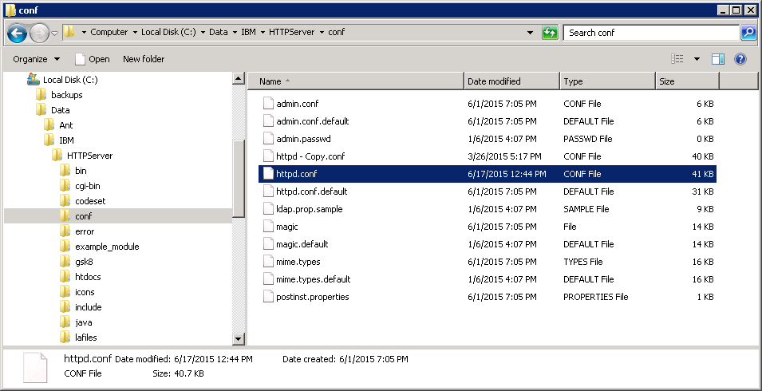

2. Open for edit the configuration file, **httpd.conf**, and search for **Timeout**.

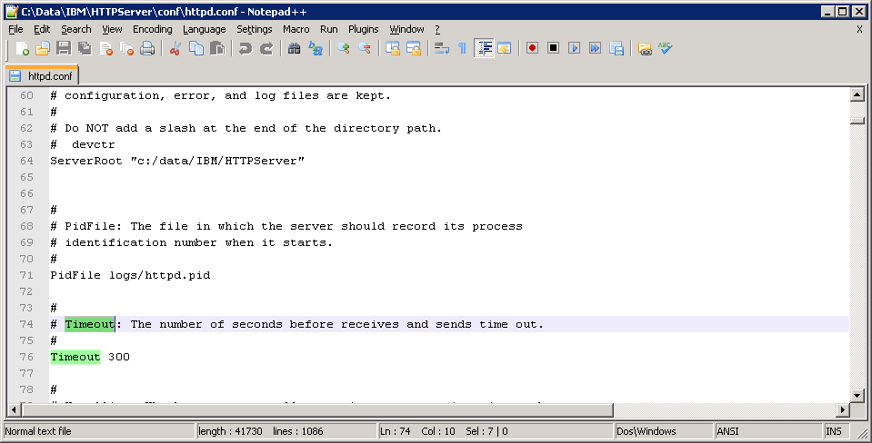

3. Modify the existing value; the current value is the default value of 300 (seconds). We are increasing to **600** (seconds).

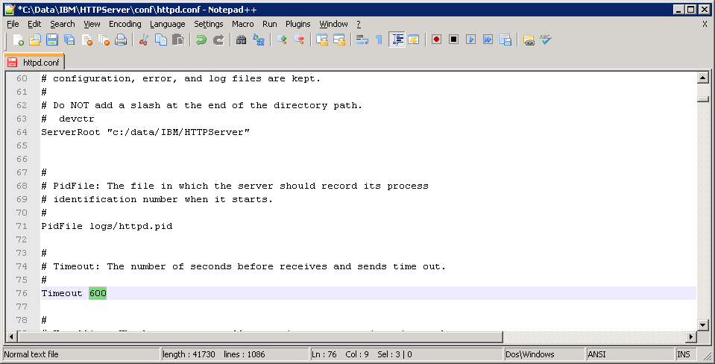

4. Save changes and restart the Proxy IHS instance.

## Proxy Upgrade (7.0 to 8.5.5)

### Uninstalling IHS v7.x

1. Stop the following IHS Services
   1. IBM HTTP Administration 7.0
   2. IBM HTTP Server 7.0
2. Locate existing HTTP Server installation directory - E.g. “*C:\Data\IBM\HTTPServer\”*
   1. Create backup of ***C:\Data\IBM\HTTPServer\conf\httpd.conf*** to your backup directory
   2. Create backup of ***C:\Data\IBM\HTTPServer\SSLCert\*** to your backup directory
3. Uninstall IBM HTTP Server v7.x
   1. Navigate to ***C:\Data\IBM\HTTPServer\uninstall*** and execute ***uninstall.exe***
   2. Click-thru uninstall prompts and complete the uninstall

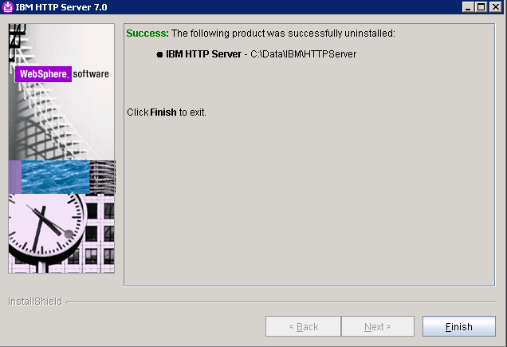

* 1. After the uninstall completes – ***RENAME*** the ***C:\data\IBM\HTTPServer*** directory to ***C:\data\IBM\HTTPServer_bak***

### IBM Installation Manager - Installation

1. Navigate to the IBM Installation media and execute ***install.exe***   
   E.g*.****\\yourservername\IBMHTTPv8.5\IBM Installation Manager\install.exe***
2. Click Next > and accept the license agreement.
3. Set the Installation manager directory to: ***C:\Data\IBM\Installation Manager\eclipse*** and click Next >
4. Install  
   
5. Once completed – select Restart Installation Manager

### IBM HTTP Server v8.5 and Fixpack 5 - Installations

1.Open the IBM Installation Manager and add the repositories

* 1. File > Preferences > Add Repository
  2. Add the following repositories (*make sure you add both*):
     1. ***\\yourservername\Installs\IBMHTTPv8.5\WAS8.5 Install\repository.config***
     2. ***\\yourservername\Installs\IBMHTTPv8.5\WAS8.5 Fixpack 5\repository.config***
  3. Select OK



1. Select Install on the Installation Manager main menu
   1. 
2. Select ***IBM HTTP Server for WebSphere Application Server*** > Next



1. Accept license agreement > Next
2. Change Shared Resources Directory to : ***C:\Data\IBM\IMShared*** > Next



1. Change installation directory to ***C:\Data\IBM\HTTPServer*** > Next



1. Click next
2. Use default settings (*we will change the service account later*)



1. Next > Install
2. Once complete – close/finish the installer.

### Post Installation Steps

1. Verify IBM HTTP Server version
   1. Open ***C:\Data\IBM\HTTPServer\version.signature*** in a text editor to verify that v8.5.5.5 was installed



1. Restore files that were backed up
   1. Restore the backed up **SSLCert** directory to ***C:\Data\IBM\HTTPServer\SSLCert\***
   2. Restore the backed up **httpd.conf** file to ***C:\Data\IBM\HTTPServer\conf\httpd.conf*** (overwrite if prompted)
2. Set **IBM HTTP Server V8.5** service to run as the necessary service account



1. Modify the http.conf file you just restored. Change anything after the “SSLProtocolDisable SSLv2 SSLv3” statement

Change:

SSLEnable

SSLProxyEngine On

SSLProtocolDisable SSLv2 SSLv3

SSLCipherSpec 27

SSLCipherSpec 23

SSLCipherSpec 3A

To:

#Listen [::]:443

<VirtualHost *:443>

SSLEnable

SSLProxyEngine On

SSLProtocolDisable SSLv2 SSLv3

SSLCipherSpec SSL_RSA_WITH_RC4_128_SHA

SSLCipherSpec SSL_RSA_WITH_RC4_128_MD5

SSLCipherSpec TLS_RSA_WITH_AES_128_GCM_SHA256

SSLCipherSpec TLS_RSA_WITH_AES_256_GCM_SHA384

SSLCipherSpec TLS_RSA_WITH_AES_128_CBC_SHA256

SSLCipherSpec TLS_RSA_WITH_AES_256_CBC_SHA256

SSLCipherSpec TLS_RSA_WITH_AES_128_CBC_SHA

SSLCipherSpec TLS_RSA_WITH_AES_256_CBC_SHA

SSLCipherSpec SSL_RSA_WITH_3DES_EDE_CBC_SHA

SSLCipherSpec TLS_ECDHE_ECDSA_WITH_AES_128_CBC_SHA256

SSLCipherSpec TLS_ECDHE_ECDSA_WITH_AES_256_CBC_SHA384

SSLCipherSpec TLS_ECDHE_RSA_WITH_AES_128_CBC_SHA256

SSLCipherSpec TLS_ECDHE_RSA_WITH_AES_256_CBC_SHA384

SSLCipherSpec TLS_ECDHE_ECDSA_WITH_AES_128_GCM_SHA256

SSLCipherSpec TLS_ECDHE_ECDSA_WITH_AES_256_GCM_SHA384

SSLCipherSpec TLS_ECDHE_RSA_WITH_AES_128_GCM_SHA256

SSLCipherSpec TLS_ECDHE_RSA_WITH_AES_256_GCM_SHA384

1. Save the changes, and start the **IBM HTTP Server V8.5** service and verify connectivity to the proxy

If there are errors starting the service – please review the httpd.conf and verify that the paths set in the config match up with the new install directory. Also, refer to the access and error logs located: *\*Data\IBM\HTTPServer\logs

1. After successful installation and verification of proxy connectivity you can now delete ***data\IBM\HTTPServer_bak***

## Connectivity Test

Test each connectivity point between the servers that the application requires. A diagram of the environment will show each connectivity point and the ports needed to test. (ex. Telnet to listening port(s) required for the application)

## Symantec Protection Engine Installation

There needs to be at least one SymScan server per site.

Pre-Requisites:

* Java JRE 1.7 or above
* Valid license file
* Firefox browser (only for initial configuration, can be removed after installation of the license file)

Execute the installer symantecprotectionengine.exe from Symantec_Protection_Engine\Win32

Take defaults (including deployment scenario-other)

Take default install directory, unless your site requires another

administrator: document and create the password.

Ports: admin port 8004, ssl port 8005

Choose no URL filtering

Choose no insight

Click Install

Import the Certificates into trusted root store of the Firefox browser: file (ca-bundle.crt) located in the installed application directory (default is C:\Program Files (x86)\Symantec\Scan Engine), and the new server certificate also into the trusted root store. (machine store)

Open management interface of Symantec https://127.0.0.1:8004/ or https://<servername>:8004/

Click I understand the risks, and Add Exception, then Activate the JRE-plugin. If you get errors about trust, you may have to turn off security in the java control panel applet.

Using credentials above, under Tasks- click Install license, and browse to your license file and install.

Save the configuration by clicking the upper left icon at the top of the browser interface screen.

## Update and Execute Environmental Scripts

*Note: To be Provided by RM&D

<Standup>

## LS Initial Database Stand Up Procedures

### Prepare Sql Server

* Ensure you have the most recent scripts - 01. ServerConfig.sql and 02.DBConfig.sql
* Run both scripts in OLTP and ODS

#### Aquire Current Source Backups

* Copy backups to local folder on the <Drive letter>:\ drive of the target server
  + Example <Drive Letter>:\DatabaseBackups
* Ensure backups are separated by instance
  + <Drive Letter>:\DatabaseBackups\OLTP
  + <Drive Letter>:\DatabaseBackups\ODS
* Ensure that all LendingSpace databases are included in the backups
* This includes the following
  + OLTP
    - MasterAuthentication
    - DBAWork
    - <OrgCode>_CorrAus
    - <OrgCode>_CorrAus_Adt
    - <OrgCode>_CorrAusAuth
    - <OrgCode>_CorrLos
    - <OrgCode>_CorrLos_adt
    - <OrgCode>_CorrLosAuth
    - <OrgCode>_CorrLosAuth_adt
    - <OrgCode>_CorrLx
    - <OrgCode>_CorrLxAuth
    - <OrgCode>_CorrPortal
    - <OrgCode>_CorrPortalAuth
  + ODS
    - MasterAuthentication
    - DBAWork
    - ReportServer
    - ReportServerTempDB
    - <OrgCode>_CorrLos_Reports

### Restore Scripts

* Pull the latest scripts AutomatedDatabaseRestore(DBA_Local).bat and AutomatedDatabaseRestore.sql from TFS: $/LendingSpace/Database/_HelperScript/TeamTools/AutomatedDatabaseRestore
* Copy the scripts to the root of the folder containing the database backups
  + <Drive Letter>:\DatabaseBackups\AutomatedDatabaseRestore(DBA_Local).bat
  + <Drive Letter>:\DatabaseBackups\AutomatedDatabaseRestore.sql
* Edit the the AutomatedDatabaseRestore(DBA_Local).bat ensure the following entries have correct values for proper execution, the batch file does create an output text file for post restore validation and troubleshooting.

Notes provided below like (e.g. xxxxx) are not present in batch file. Update only the items in Yellow and Red.

* set ScriptLocation=<Drive Letter>:\DatabaseBackups
* set Environment=TargetEnvironmentName (e.g. UAT1)
* set OLTPInstance=ServerName\InstanceName (e.g. UAT1\OLTP)
* set OLTPBackupLocation="<Drive Letter>:\DatabaseBackups\OLTP\"
* set OLTPRecoveryMode=Simple (e.g. Simple or Full – dictated by client prescribed recovery method)
* set ODSInstance=ServerName\InstanceName (e.g. UAT1\ODS)
* set ODSBackupLocation="<Drive Letter>:\DatabaseBackups\ODS\"
* set ODSRecoveryMode=Simple (e.g. Simple or Full – dictated by client prescribed recovery method)

### Restore Databases

* Execute AutomatedDatabaseRestore(DBA_Local).bat
* Validate restore has been successfully executed
  + The batch file creates output files of the restore

### Unique User Setup

* Pull latest sql files from TFS locally: $/LendingSpace/Database/_HelperScript/TeamTools/ClientLoginUserSetup
* Modify client login and user batch files for specific target environment
  + Edit batch files located within the “ZZ_” folders
  + Example:
    - set InstanceOLTP=VMLSQA6SQL1\VMLSQA6SQL101
    - set InstanceODS=VMLSQA6SQL1\VMLSQA6SQL102
    - set RootPath=F:\ClientLoginUserSetup
    - set OrgCode=SSRS
    - set Environment=QA6
* Copy ClientLoginUsersetup to F:\ on sql server
* Copy specific client OLTP trigger (example: LPSC_OLTP_Triggers) and 00a.DisableOldLSSQLLogins.sql
* from F:\ClientLoginUsersetup to F:\Deployment Code(LS)\LS(OLTP)
* Edit PowerShell ScriptJob.cmd file located in “F:\Deployment Code(LS)\PowerShell(OLTP)\ ScriptJob.cmd
* Change the following in the script
  + Set Instance=Servnamer\Instance
  + set Path = "F:\Deployment Code(LS)\LS(OLTP)\ LPSC_OLTP_Triggers"
  + set JobName = " **NewLoginTriggers**”
* Execute the PowerShell script “ScriptJob.cmd “ to create deployment job named “**NewLoginTriggers**”
* Run OLTP deployment SQL job “**NewLoginTriggers**” –newly created sql job within SSMS
* **Execute Batch files in order** (items in red are dependent upon local clients installed) within F:\ClientLoginUserSetup:
  + LS_Client_User_Setup.bat
  + BYVW_Client_User_Setup(DBA_Local).bat
  + LPSC_Client_User_Setup(DBA_Local).bat
  + STMC_Client_User_Setup(DBA_Local).bat
  + STRN_Client_User_Setup(DBA_Local).bat
  + SSRS_Client_User_Setup(DBA_Local).bat
  + BYVW_Client_IntraDay_User_Setup(DBA_Local).bat (as required where/when intraday is installed)
  + LPSC_Client_IntraDay_User_Setup(DBA_Local).bat (as required where/when intraday is installed)
  + STMC_Client_IntraDay_User_Setup(DBA_Local).bat (as required where/when intraday is installed)
  + STRN_Client_IntraDay_User_Setup(DBA_Local).bat (as required where/when intraday is installed)
* **Open each password output file and** 
  + Ensure that all users can login to SQL Server
  + Ensure that all users can access their respective databases
    - Refer to table below for databases and userid’s
  + Ensure that all users can access the MasterAuthentication database
    - Exception is the SSRS_LS_Reports user, this user will not have access to the MasterAuthentication database

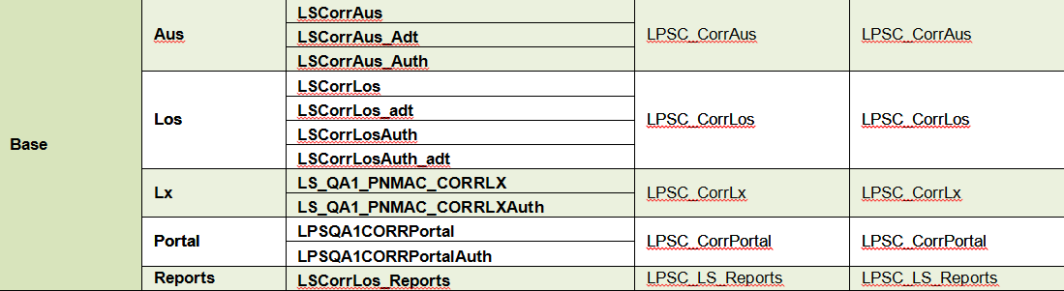



* Save off Password output files to Secret Server
* Update ODS LS_App user password
  + open the output file “LS_OLTP_UserPasswordOutput.txt” copy the password for LS_App
  + Open SSMS logging into ODS instance
  + open server login LS_App change password for login to OLTP LS_App password
* Update the ODS output file “LS_ODS_UserPasswordOutput.txt” paste OLTP password over the original ODS password save file

### Post Deploy Scripts

* Pull the latest postdeploy scripts from TFS: $/LendingSpace/Base/Main/DbScript/*release version(i.e – 4.3)*/Release-PostDeploy
  + Should contain three folders
    - 01_ODS_and_OLTP
    - 02_ODS
    - 03_OLTP
* Create the following folders on sql server:
  + <Drive Letter>:\Deployment Code(LS)
  + <Drive Letter>:\Deployment Code(LS)\LS(ODS)\Release –x.x.x.x\
  + <Drive Letter>:\Deployment Code(LS)\LS(OLTP)\ Release –x.x.x.x\
* Copy files to <Drive Letter>:\Deployment Code(LS)\LS(ODS)\ Release –x.x.x.x\
  + Example - F:\Deployment Code(LS)\LS(ODS)\Release-4.3.2.9\01_ODS_and_OLTP
    - “F:\Deployment Code(LS)\LS(ODS)\Release-4.3.2.9\03_ODS”
* Copy files to <Drive Letter>:\Deploymen tCode(LS)\LS(OLTP)\Release-PostDeploy
  + Example- F:\Deployment Code(LS)\LS(OLTP)\Release-4.3.2.9\01_ODS_and_OLTP
    - “F:\Deployment Code(LS)\LS(OLTP)\Release-4.3.2.9\03_OLTP”
* **Login to OLTP**
* Edit PowerShell ScriptJob.cmd file located in “F:\Deployment Code(LS)\PowerShell(OLTP)\ ScriptJob.cmd
* Change the following in the script
  + Set Instance=Servnamer\Instance
  + set Path = "F:\Deployment Code(LS)\LS(OLTP)\Release-x.x.x.x" – set to release number
  + set JobName = "LS_Release-x.x.x.x” – set to release number
* Execute the PowerShell script “ScriptJob.cmd “ to create deployment job named “LS_Release- x.x.x.x”
* Run OLTP deployment SQL job “LS_Release-x.x.x.x” –newly created sql job
* **Login to ODS**
* Edit PowerShell ScriptJob.cmd file located in “F:\Deployment Code(LS)\PowerShell(ODS)\ ScriptJob.cmd
* Change the following in the script
  + set Path = "F:\Deploymen tCode(LS)\LS(ODS)\Release-x.x.x.x" – set to release number
  + set JobName = "LS_Release-x.x.x.x” – set to release number
* Execute the PowerShell script “ScriptJob.cmd “ to create deployment job named “LS_Release- x.x.x.x”
* Run OLTP deployment SQL job “LS_Release-x.x.x.x” –newly created sql job

### Client Purge Scripts (Only necessary to remove transaction data and setup default admin users)

* Pull the latest clientpurgescripts from TFS: $/LendingSpace/Database/_HelperScript/TeamTools/ClientPurgeScripts
* Copy the entire folder to <Drive Letter>:\ClientPurgeScripts
* Edit the batch files for the clients being restored the following entries need to be updated for proper execution. Output text files are created for validation and troubleshooting
  + Example - LPSC_Client_Purge(DBA_Local)

Notes provided below like (e.g. xxxxx) are not present in batch file. Update only the items in Yellow and Red.

* set InstanceOLTP=ServerName\InstanceName (e.g. UAT1\OLTP)
* set InstanceODS=ServerName\InstanceName (e.g. UAT1\ODS)
* set RootPath=<Drive Letter>:\ClientPurgeScripts
* set OrgCode=<ClientORGCode>
* set Environment=TargetEnvironmentName (e.g. UAT1)

### Purge Data

* Execute <client>_Client_Purge(DBA_local).bat

### SSIS Packages

* Include SSIS Packages to match the Release on the source system
* Pull latest SSISPackage for release from TFS: $/LendingSpace/Base/Main/DbScript/*ReleaseVersion/Release-Number*
  + Example: $/LendingSpace/Base/Main/DbScript/4.3/Release-4.3.2.09/SSISPackages
* Copy SSIS packages from the following Folders: and deploy using table below
  + •          \Extract”
  + •         “\MasterAuthentication”
  + •         “\ODSXfer”

___________________

* Contents of Extract Folder  to F:\SSISPackages
* Contents of MasterAuthentication folder to F:\MA_SSISPackages
* Contents of “\ODSXfer” folder to F:\LPSC_SSISPackages, F:\STMC_SSISPackages, F:\STRN_SSISPackages, F:\BYVW_SSISPackages( As Applicable)

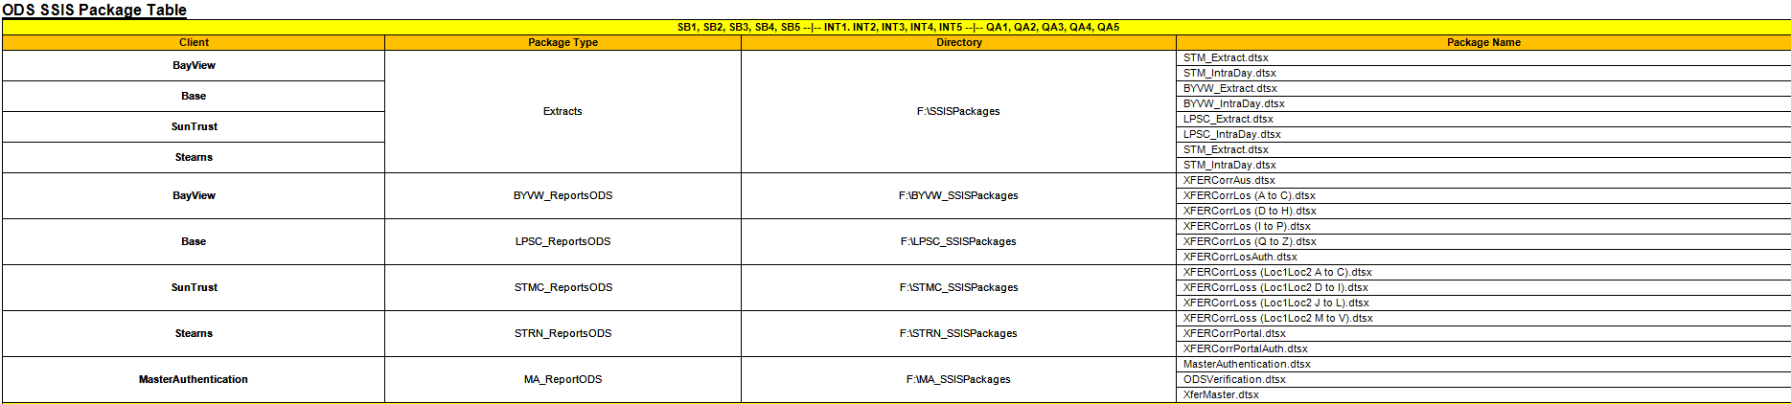

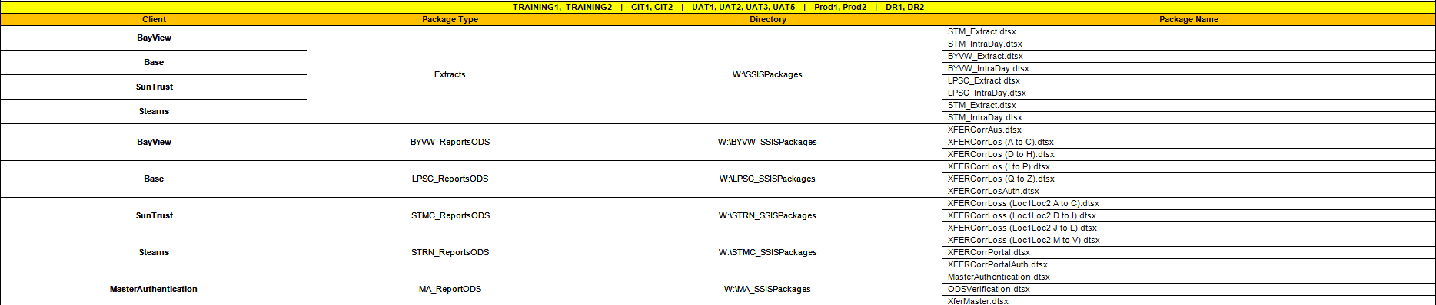

### EnvironmentSpecificDBScript (OLTP)

* Execute Environment Specific script to change correct database values for targeted environment.

### Grant Minimal Access\Read-Only Database Permissions

Execute !GrantMinimalAccessToUser_JobCreation.sql from installs folder on both OLTP\ODS

### Maintenance Plan

* Login to the OLTP SQL Server Instance
* Under Management Select Maintenance Plans
* Right Click to Create a New Maintenance plan
* Input Maintenance plan name - !!LS All Client DB Deployment Backup
* 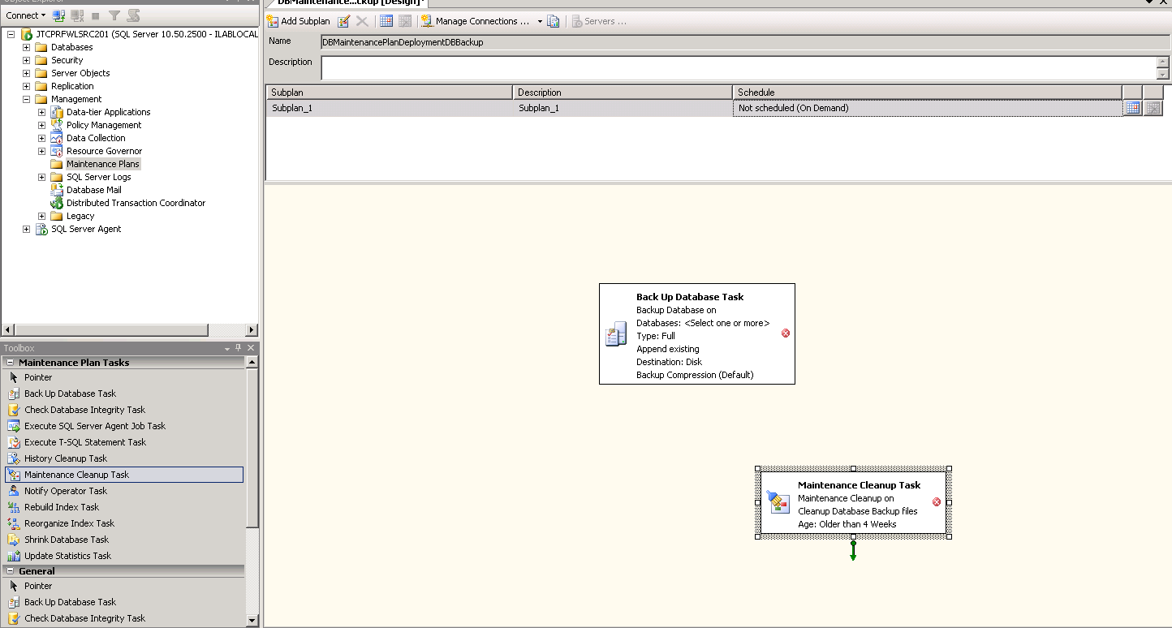
* Drag - Backup To Database Task and Maintenance Cleanup Task as shown above
* Double click Backup To Database Task box to view Properties
* From the Database(s) drop down select These databases: and choose:
  + DBAWork
  + LPSQA1CORRPortal
  + LPSQA1CORRPortalAuth
  + LS_QA1_PNMAC_CORRLX
  + LS_QA1_PNMAC_CORRLXAuth
  + LSCorrAus
  + LSCorrAus_Adt
  + LSCorrAus_Auth
  + LSCorrLos
  + LSCorrLos_adt
  + LSCorrLosAuth
  + LSCorrLosAuth_adt
  + MasterAuthentication
* Ok
* Change the backup file for every database to: S:\DeploymentBackups\LS_All_Clients_Backup_OLTP
* Ok
* Double click the Maintenance Cleanup Task box
* Select Backup files to delete
* Select the folder S:\DeploymentBackups\LS_All_Clients_Backup_OLTP
* Set File extension to bak
* Change the file age to 5 days

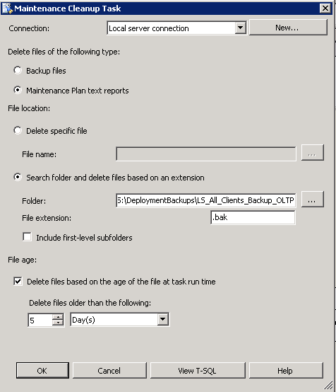

* Select Ok
* Link the Backup Up Database Task to the Maintenance Cleanup Task
* From the File menu select Save All
* After Job is created..Navigate to the Job Created >>>Properties and Change the Owner to: sa 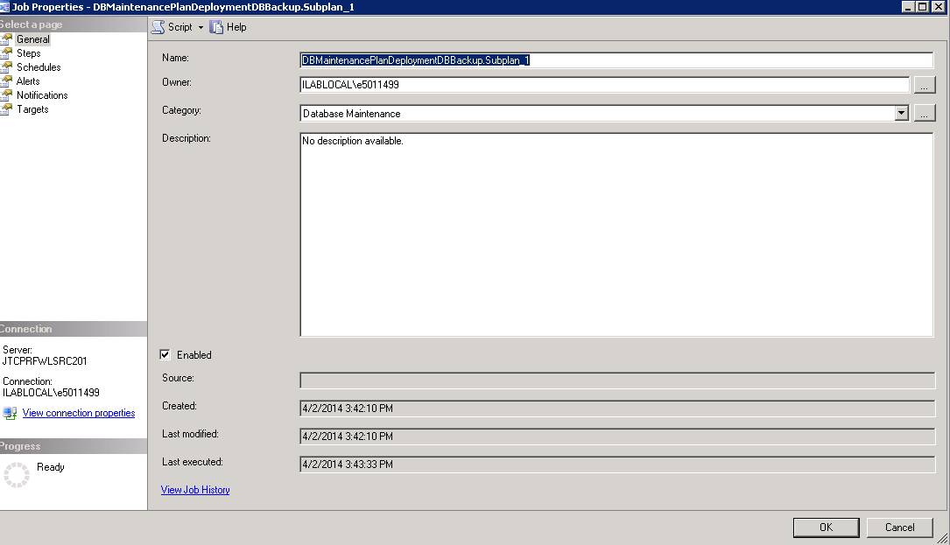
* Login to the ODS SQL Server Instance
* Under Management Select Maintenance Plans
* Right Click to Create a New Maintenance plan
* Input Maintenance plan name - !!LS All Client DB Deployment Backup
* 
* Drag - Backup To Database Task and Maintenance Cleanup Task as shown above
* Double click Backup To Database Task box to view Properties
* From the Database(s) drop down select These databases: and choose:
  + DBAWork
  + LSCorrLOS_Reports
  + MasterAuthentication
  + ReportServer
  + ReportServerTempDB
* Ok
* Change the backup file for every database to: S:\DeploymentBackups\LS_All_Clients_Backup_ODS
* Ok
* Double click the Maintenance Cleanup Task box
* Select Backup files to delete
* Select the folder S:\DeploymentBackups\LS_All_Clients_Backup_ODS
* Set File extension to bak
* Change the file age to 5 days
* Select Ok
* Link the Backup Up Database Task to the Maintenance Cleanup Task
* From the File menu select Save All
* After Job is created..Navigate to the Job Created >>>Properties and Change the Owner to: sa 

<Standup>

**Creating LS User Accounts and Correspondents**

**LOS**

1. Login as default user
2. If default user is not known, run the following database script:

use LSCorrAus_Auth

select * from LoginInfo

1. Select System Admin
2. Admin Center from menu
3. Security Management
4. User Information
5. ADD NEW
6. First Name – lsdeploy, patchtester or whatever account name you are setting up
7. Last Name – lsdeploy, patchtester or whatever account name you are setting up
8. Zip code – 32259
9. Job description – RM&D
10. Email address – [lsdeploy@lpsvcs.com](mailto:lsdeploy@lpsvcs.com) or name listed in step 8/9
11. Phone Number – 9048545100
12. Role – select all except ViewOnly
13. Node – Others
14. Login Name – lsdeploy or whatever account name you are setting up
15. Password – P@ssword1 (this is just a temporary password, will receive a prompt to change upon first login)
16. Save
17. OK to the Please select Branch Assignment for this user using Assignment Admin
18. Sign out and back in as the newly created account
19. Change password
20. update secret server

**Correspondent**

1. Login to LOS with account created above
2. System Admin
3. Select Party Management
4. Change Party Type to “Doing Business at Company Level”
5. Add New Party
6. Company Name – LSDEPLOY CORR
7. DBA – LSDEPLOY CORR
8. Party Code – 888 or Generate Party Code
9. Time Zone (under address) – EST
10. E-Mail address for daily pricing guide – [lsdeploy@bkfs.com](mailto:lsdeploy@bkfs.com) or email created with los account
11. Address Line 1 – 601 Riverside Ave
12. Zip Code – 32259
13. Select Same as above for Billing Address Line 1
14. Check Company can accept first payments
15. MI Delegated – Yes
16. Verify LendingXchange is selected
17. LQA DocUpload Flag – No
18. Auto QI – No
19. Service E-Mail – [lsdeploy@bkfs.com](mailto:lsdeploy@bkfs.com) or email created with los account
20. Confirm Service E-Mail – [lsdeploy@bkfs.com](mailto:lsdeploy@bkfs.com) or email created with los account
21. Delivery Methods – Best Efforts
22. Approved Products – Conventional, FHA, Jumbo and VA
23. Check AUS Method
24. FHA Tier – FHA Tier 1
25. Approval Effective Date – enter N and tab
26. Save
27. From Menu on right side select – Checklist
28. Select all and approved date should be the current day
29. Save
30. Select Company Information from the menu on the right
31. From Menu on right side select – Assignments
32. From the Select One dropdown on bottom choose Account Executive
33. New Assignment
34. Leave Assignment Option Manual and choose Select
35. Choose Login Name – LSDEPLOY or LOS account created above
36. Effective Date – enter N then tab
37. Save
38. Select Company Information from the menu on the right
39. From Menu on right side select – Licenses
40. Check first three boxes for Florida and New York or any other state required
41. Save
42. Change the status from Open to Approved
43. Save

Portal

1. Login as default user
2. If default user is not known, run the following database script:

use LPSQA1CORRPortalAuth

select * from LoginInfo

1. Correspondent Admin
2. Admin Center
3. Security Management
4. Users Information
5. Add New
6. First Name – lsdeploy, patchtester or whatever account name you are setting up
7. Last Name – lsdeploy, patchtester or whatever account name you are setting up
8. Zip code – 32259
9. Job description – RM&D
10. Email address – [lsdeployteam@lpsvcs.com](mailto:lsdeployteam@lpsvcs.com) or designated email for account
11. Phone number – 9048545100
12. Time zone – Eastern Standard
13. Role – select all except AE View Only and View Only
14. Save - No to Do you want to select any Notification Preferences
15. Select the account you just created
16. Assign password – enter P@ssword1 (this is just a temporary password, will receive a prompt to change upon first login)
17. Save
18. Sign out and back in as the newly created account
19. Change password
20. update secret server

AUS

1. Login as default user
2. If default user is not known, run the following database script:

use LSCorrAus_Auth

select * from LoginInfo Select System Admin

1. System Admin
2. Security Management
3. User Information
4. Add New
5. First Name – lsdeploy, patchtester or whatever account name you are setting up
6. Last Name – lsdeploy, patchtester or whatever account name you are setting up
7. Zip code – 32259
8. Job description – RM&D
9. Email address – **MUST USE A VALID EMAIL ADDRESS**
10. Phone number – 9048545100
11. Time zone – Eastern Standard
12. Role – select all except View Only
13. Login Name – lsdeploy, patchtester or whatever account name you are setting up
14. Password – enter P@ssword1 (this is just a temporary password, will receive a prompt to change upon first login)
15. Save
16. Sign out and back in as the newly created account
17. Change password
18. update secret server

## Code Deployment to Self-Hosted Environment

Synopsis

This portion of the document provides Lending Space step by step semi-auto deployment instructions for the output of the automated build package in the LSConfigFileTool format. The intended audiences are Self-Hosted Deployment teams.

### Package Location and Description

The build/deployment package will be provided in a ZIP file and will contain a FULL release zip file for each build (i.e. LS-<ReleaseNumber> <CLIENT> <ENV>.zip). The contents of the FULL release zip include:

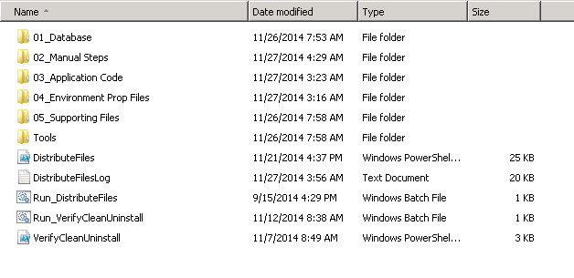

Inside the “01_Database/DbScript” Folder we have all the DB scripts for all the new releases and instructions document. Follow the document “<Client>_DB Instructions – <Cleint>”

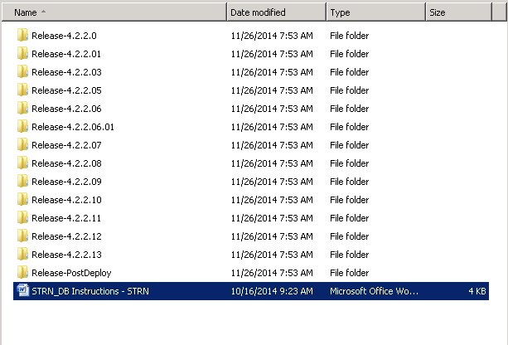

Inside the “02_Manual Steps” we can find all the manual steps that needs to be followed

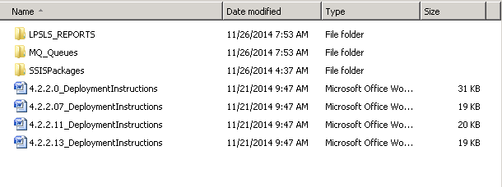

Inside “03_Application Code” we can find all the codebase, profiles, workEngine_Compiled_Code and EAR files.

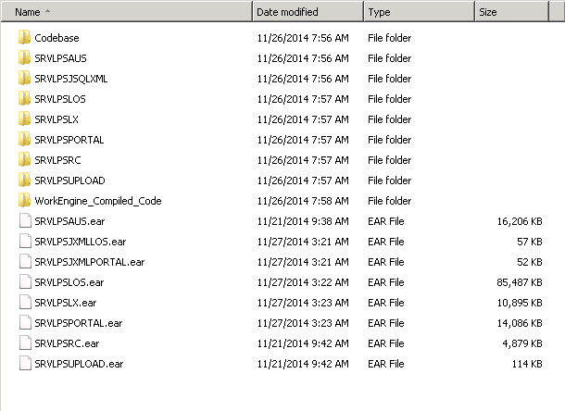

Inside the “04_Environment Prop Files” we can find all the properties files templates that are specific for an environment

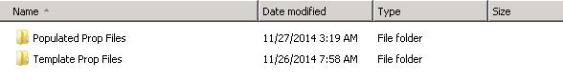

Inside the “05_Supporting” Files we can find all the “DocTemplates” and “Schema_and_Templates”

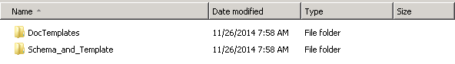

Inside the “Tools” folder we can find the tools that are required for the deployment.

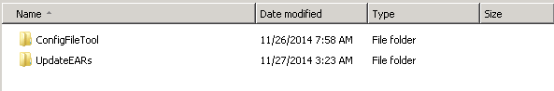

Other than the above there are some power shell and batch files that are needed for the auto deployment.

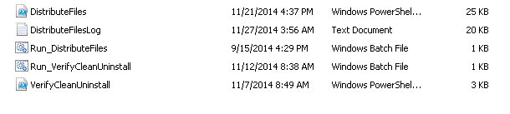

### Pre-deployment Tasks

**Preparation**

1. Copy the release zip file to the workengine1 server of that deployment environment under  F:\Deployment Code.
2. Unzip the release zip file to F:\Deployment Code.
3. Create and Copy the “Values by Client <ENV>”  Tab from your  previous Self Hosted Env Specific Catalogs (Profiles and Codebase). Copy to New Catalog Templates the corresponding “Values by Client <ENV>”  Tab that can be found on the catalogs that are under “**<PKG>\Tools\ConfigFileTool\Config Catalog\Codebase”** and **“<PKG>\Tools\ConfigFileTool\Config Catalog\Profiles**”.

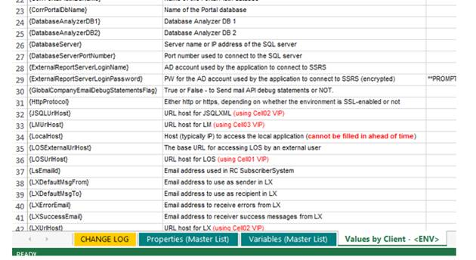

**Steps for  Updating Catalog File :**

1. Open New Template using Excel. Add the new Tab e.g  (Values by Client UAT) next to the Values by Client –ENV
2. After Adding the New Tab Compare the 2 tabs (i.e Values by Client - <ENV> and Values by Client – UAT)
3. Make sure the number of rows in template tab “<values by Client - <ENV>”  matches to the number of rows in the tabs that you created and copied.  Also check for any differences.
4. If there are differences, please update your values by Client  (i.e  UAT) with corresponding values that can be found in the package’s manual instructions.

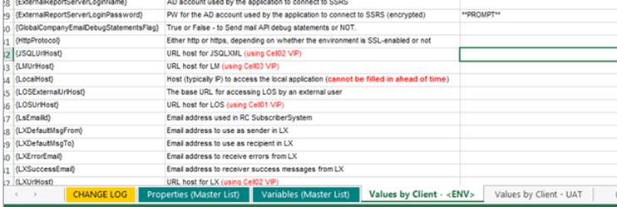

1. If the deployment is happening for the first time in the environment  modify the “EnviornmentDefinitions.xml” that is under <Release>\Tools\DeployTool - Self-Hosted to add new environment server names and copy the “DeployTool” folder to all the new env. servers under F:\Tools

Note: easiest way is to copy the existing environment. tab and replace the server names in “<server name=" “ for the respective environment.

1. Maintain the Environments and release numbers for code and config for all the Self hosted environments.

### Deploy

#### Stop Servers

1. Open the “FirstSteps.bat” from “F:\Data\IBM\WebSphere\AppServer\profiles\cell01_dmgr\firststeps”

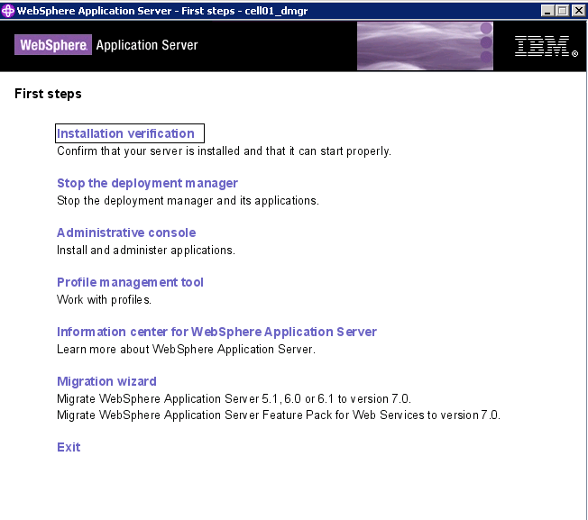

1. Click the “Administrative Console”

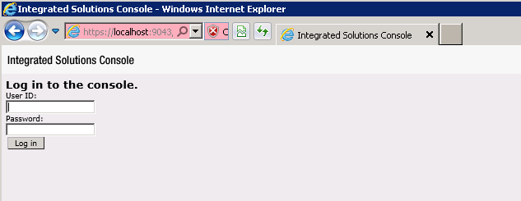

1. Login to Websphere admin console as administrator to all the DMGR servers(RC1, Web1, Web3, Web5) and login to the Websphere admin console, go to servers 🡪 Server Types 🡪 websphere application servers 🡪 and stop the application servers

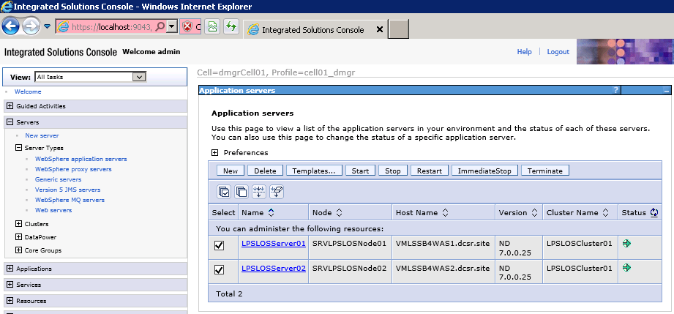

1. Login to workengines and open services.msc and stop all the services that start with “LPS_XXX”.

#### DB Execution

*Note: In the event a roll back is necessary for deployment:*

* 1. *Backup all DB’s before new code drop.*
  2. *Confirm pre-deployment version of code package is available.*

Once the DB backup is done go to the <PKG>\01_Database\DbScript and follow the DB Instructions document called “<Client Name>-DB Instructions - <client Name>”(if there is one) if not Check the old release number that the environment is on and From **\<PKG>\01_Database\DbScript \** run all the scripts that are after that release number and at the env run the Release-PostDeploy in both OLTP and ODS

Ex. If the env is at 4.X.X.2 before the Deployment and the currect deployment is 4.X.X.8 run all the scripts(OLTP and ODS) from 4.X.X.3 to 4.X.X.8.

run all the scripts from each folder .



From **\<PKG>\01_Database\DbScript\<latest Releas Folder>\SSISPackages\**

|  |  |
| --- | --- |
| Souce | Target |
| \ SSISPackage\STMExtract | F:\SSISPackage |
| \ SSISPackage\MasterAutentication | F:\ MA_SSISPackages |
| \ SSISPackage\ODSXfer | F:\<Client_ORGCD>_SSISPackages |

#### Run the DistributeFiles batch file

From WorkEngine1\F:\Deployment Code\<PKG>\ double click on “Run_DistributeFiles.bat”. It perform the below

|  |
| --- |
| a. Prompts to enter the environment for deployment Ex. UAT1, UAT2 etc… |
| a. Prompts to verify that the environment specified in the package is the intended one. **Verify that the environment is right and enter “y” for yes.** |
| b. Runs the Config File Tool with the Profiles config catalog. ***When the tool opens, review the values for accuracy, and then click Build Files. Enter the required values and click "ok". Review the output in the Status and Error Summary windows. If there are no issues, close the tool, but do not close the command window.*** |
| c. Runs the Config File Tool with the Codebase config catalog. ***When the tool opens, review the values for accuracy, and then click Build Files. Enter the required values and click "ok". Review the output in the Status and Error Summary windows. If there are no issues, close the tool, but do not close the command window.*** |
| d. Updates the EAR files – This applies to any application that has a WEB-INF folder; environment-specific properties files are placed inside the EAR file. |
| e. Copies EAR files to the appropriate servers (first server of every cell, into F:\Deployment Code\LS-X.X.X.X). This includes a step of deleting any existing folders inside F:\Deployment Code that start with “LS-” before copying. |

**At this point the RunDistributeFiles.bat will continue unattended until complete. To save time, you can skip to the below “Uninstall and Install of Web Sphere applications” Once Ear Files Copying is Completed.**

**Note: in the above command window, Check For EAR Files Complete Msg before Moving to below step**

#### Uninstallation and Installation of WebSphere applications

1. Uninstall the Application
2. Log on to the Primary Servers where DMGR(RC1, Web1, Web3, Web5) and open WebSphere admin console
3. <http://LocalHost:9060/ibm/console>
4. Select "Continue to this website (not recommended)"
5. Logon as administrator
6. On the left menu bar, select Applications
7. Select Application Types
8. Select WebSphere enterprise applications
9. Select the checkbox next to the application you are uninstalling

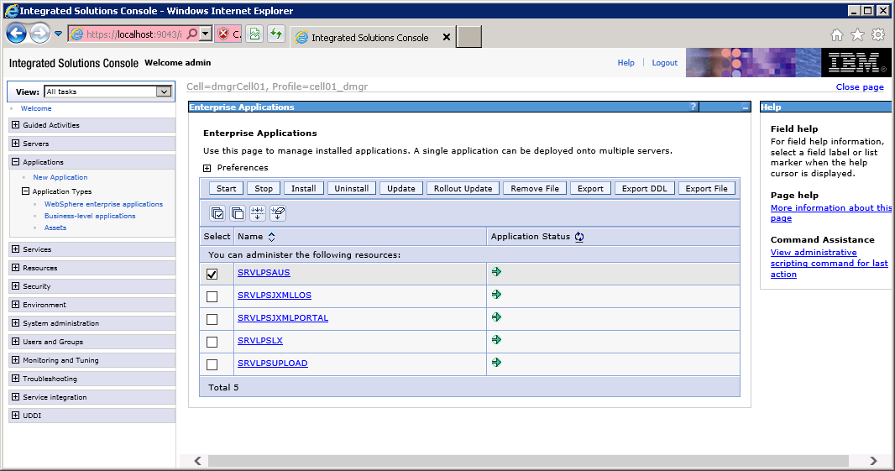

1. Press the Uninstall Button
2. On the confirmation screen, press OK
3. On the next screen, press "Save directly to master configuration link."

1. Check for the clean uninstall by browsing to “F:\Data\IBM\WebSphere\AppServer\profiles\<APP NODE>\installedApps\<Cell>” the EAR and WAR file should be gone.

Note: it might take few min to refresh the above folder.

1. Install the new Applications
2. In WebSphere, from the Enterprise Applications screen, Press the Install button
3. Browse to the appropriate Ear file

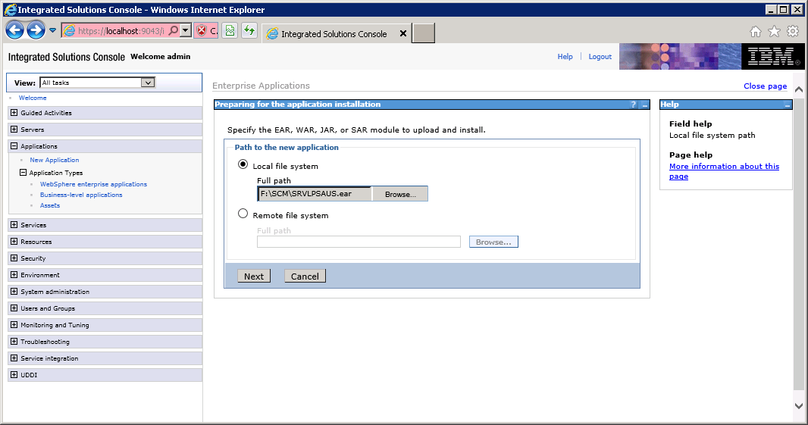

1. Select Next
2. Select Next on the following “Preparing for the application installation” screen

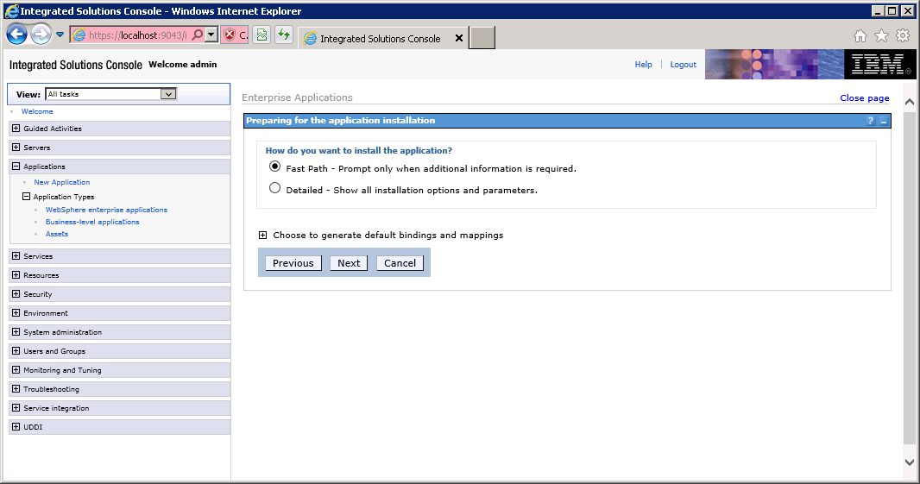

1. Select Next on the following “Select Installation options” screen

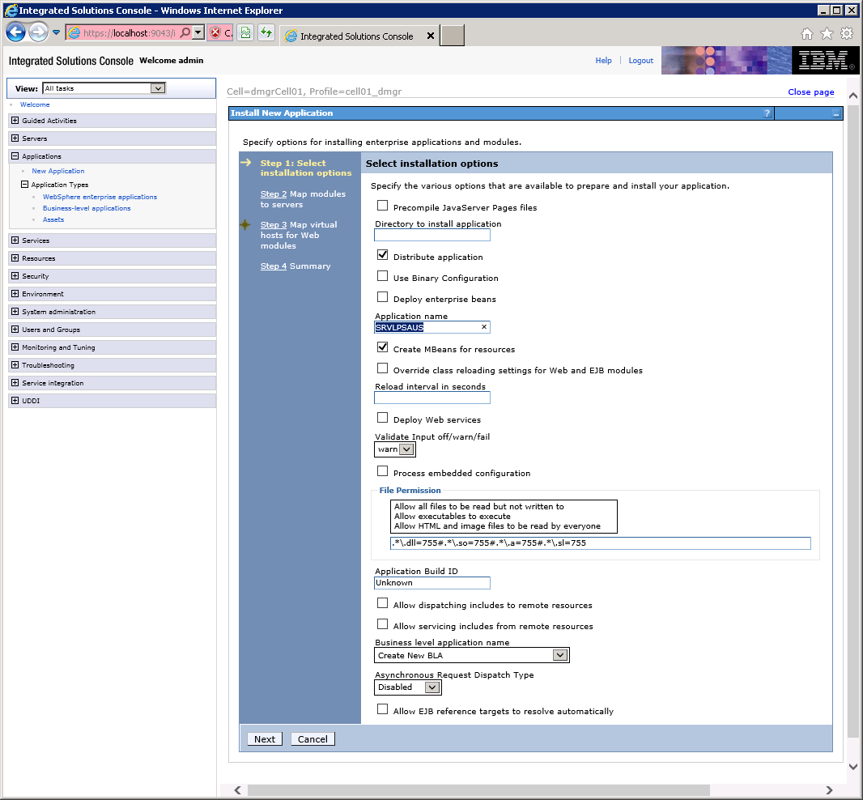

1. In the “Map modules to servers” screen, select the appropriate cluster (highlighted), and check the box next to the Module:

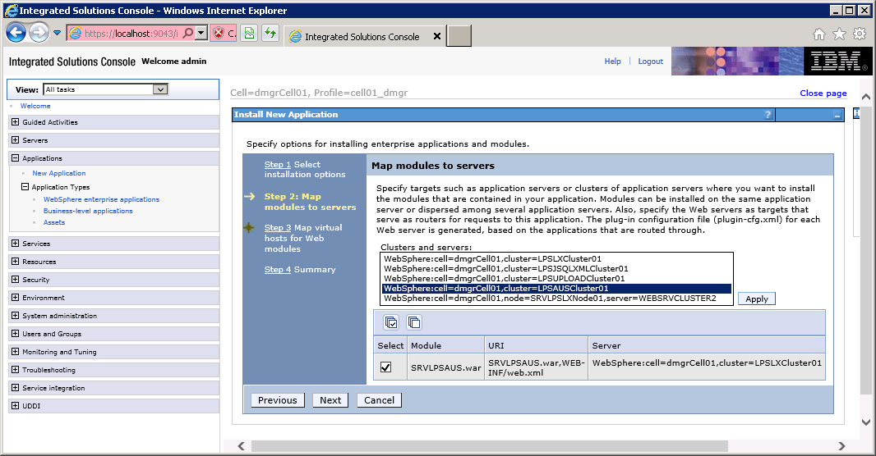

1. In the “Map virtual hosts for Web modules” window, select the checkbox next to the module

Verify correct Cluster is mapped above.

Like example above should map to AUSCluster01

1. Select Next

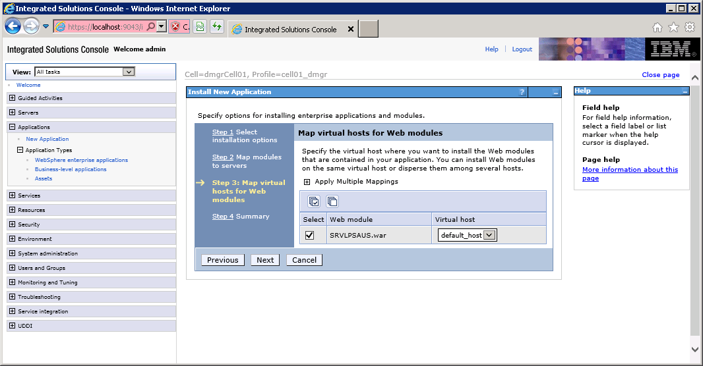

1. Select Next
2. Review the Summary – there should be no needed changes

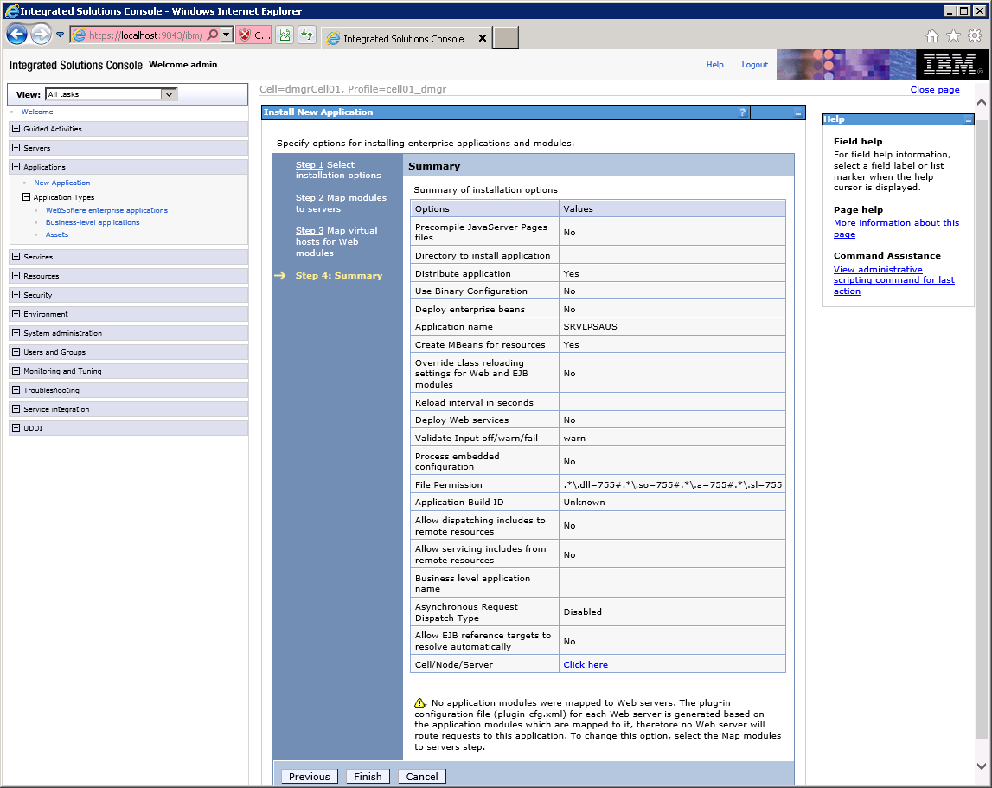

1. Select Finish

IMPORTANT: Depending on the size of the application, this could take several seconds to several minutes

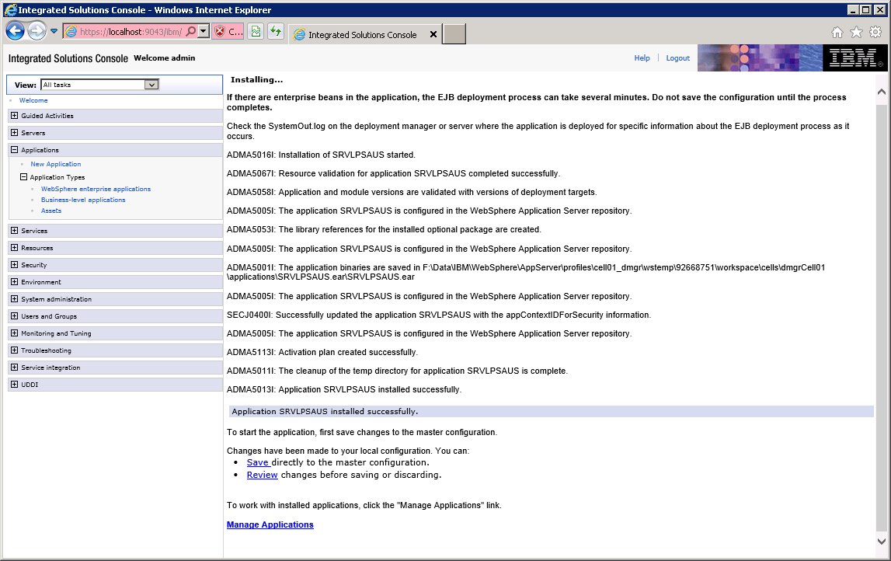

When the installation finishes you should see something like the screen above.

1. Select Save link to save the configuration for this application.
2. If the Enterprise applications screen show this application as started, select it and press Stop as shown below (You are not finished yet!!!)—Application show be in Red Not Green as below :
3. If red proceed to the next application
4. If green stop the application
5. If unknown – Reinstall application , check services to make sure they are running before install

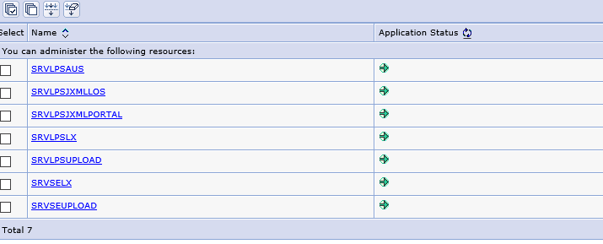

#### Manual Steps:

#### Queues

From the workengine1 : “F:\Deployment Code\<PKG>\02_Manaul Steps\MQ Queues” follow the   
“How to Create MQ queues” document.

#### LPSLS_REPORTS

##### *** Using the Deploy Tool for a New Environment***

Before using the tool in a new environment for the first time, the EnvironmentDefinitions.xml must be updated to have the required details for the new environment. The simplest approach is to review the existing environments in the file to get an understanding of the format, then copy one of the environments and modify its values to match the new environment.

Note that server names must be all lowercase in order for the tool to work properly.

On Work Engine 01, use the Deploy tool to upload the Reports (.rdl files). Go to the “Reports Import/Export” tab in deploy tool and enter the below. The Reporting Service URL should be entered as:

Reporting Services URL: **http://<SSRS-IP>:8080/ReportServer/ReportService2010.asmx (this value can be found in DBConnection.properties file from :F:\Data\Codebase\SRVLPSLOS\Properties\<ClientName>)**

**\*\*NOTE - If the shared reports folder is not on the SSRS server, please create Shared_<client>_Lender_Reports**

RDL files should be uploaded from **F:\Deployment Code\<PKG>\02_Manual Steps\LPSLS_REPORTS.** Click on “…” in the Upload Objects section and navigate to that folder. Then click Start and wait for the process to complete.

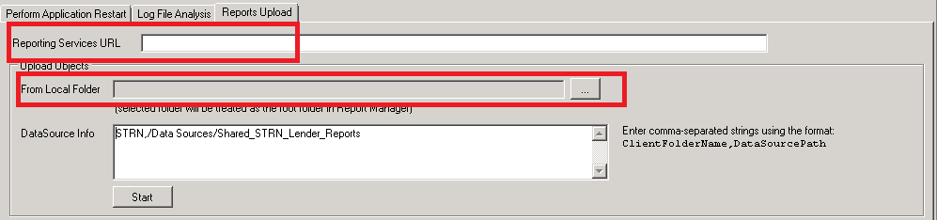  
Click on the “Start” Wait till the description says “Upload Complete” then close the tool.

#### Execute any Manual documents

Check the old release number that the environment is on and From **<PKG>\02_Manual Steps\** follow the deployment instructions documents that are after that release number.

Ex. If the env is at 4.X.X.2 before the Deployment and the currect deployment is 4.X.X.8 follow all the manual instructions documents(if any) from 4.X.X.3 to 4.X.X.8.

Note: if the Deployment instructions say anything about the properties files, cross check the catalog file to see if that is in place.

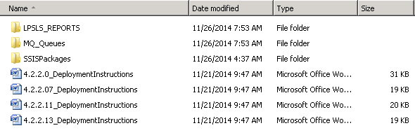

#### Check the status of DistributeFiles batch file

From Work Engine1 check the status of “Run_DistributeFiles.bat” that was running in the background from previous step. Wait till “**File Distribution complete**” message is displayed, then Close the command prompt and proceed with the next step.

#### Start the Application(s)

* Login to workengine 1 and from the schedule task start the LS nightly restart.
* Once that job ran, login to all applications servers and check the logs for errors.

#### Smoketest

See Appendix for basic deployment smokestest.

#### Aspose License Installation

* After the deployment, copy the Aspose license file (Aspose.Pdf.Kit.lic) into F:\WEBSPHERE_SHARED_LIBRARIES\LOS_LIBRARY on App servers 1 and 2 (cell 1).

# Restoring Client Database Instructions(Rollback)

### Restoring Same Environment (i.e., rollback)

When restoring the Database, i.e. in-case of a rollback

#### Step 1 Current Source Backups

* Copy backups to local folder on the <Drive letter>:\ drive of the target server
  + Example <Drive Letter>:\DatabaseBackups
* Ensure backups are separated by instance
  + <Drive Letter>:\DatabaseBackups\OLTP
  + <Drive Letter>:\DatabaseBackups\ODS
* Ensure that all LendingSpace databases are included in the backups
* This includes the following
  + OLTP
    - MasterAuthentication
    - DBAWork
    - <OrgCode>_CorrAus
    - <OrgCode>_CorrAus_Adt
    - <OrgCode>_CorrAusAuth
    - <OrgCode>_CorrLos
    - <OrgCode>_CorrLos_adt
    - <OrgCode>_CorrLosAuth
    - <OrgCode>_CorrLosAuth_adt
    - <OrgCode>_CorrLx
    - <OrgCode>_CorrLxAuth
    - <OrgCode>_CorrPortal
    - <OrgCode>_CorrPortalAuth
  + ODS
    - MasterAuthentication
    - DBAWork
    - ReportServer
    - ReportServerTempDB
    - <OrgCode>_CorrLos_Reports

#### Step 2 Setup Restore Scripts

When restoring the databases utilize the provided restore scripts from BKFS.

* Copy the following scripts to the root of the folder containing the database backups
  + <Drive Letter>:\DatabaseBackups\AutomatedDatabaseRestore(DBA_Local).bat
  + <Drive Letter>:\DatabaseBackups\AutomatedDatabaseRestore.sql
* Edit the the AutomatedDatabaseRestore(DBA_Local).bat ensure the following entries have correct values for proper execution, the batch file does create an output text file for post restore validation and troubleshooting.

Notes provided below like (e.g. xxxxx) are not present in batch file. Update only the items in Yellow and Red.

* + set ScriptLocation=<Drive Letter>:\DatabaseBackups
  + set Environment=TargetEnvironmentName (e.g. UAT1)
  + set OLTPInstance=ServerName\InstanceName (e.g. UAT1\OLTP)
  + set OLTPBackupLocation="<Drive Letter>:\DatabaseBackups\OLTP\"
  + set OLTPRecoveryMode=Simple (e.g. Simple or Full – dictated by client prescribed recovery method)
  + set ODSInstance=ServerName\InstanceName (e.g. UAT1\ODS)
  + set ODSBackupLocation="<Drive Letter>:\DatabaseBackups\ODS\"
  + set ODSRecoveryMode=Simple (e.g. Simple or Full – dictated by client prescribed recovery method)

#### Step 3 Restore Execution

1. Send notifications to appropriate teams
2. Stop application servers from WebSphere console
3. Stop work engine services
4. Restore Databases
   1. Execute AutomatedDatabaseRestore(DBA_Local).bat
   2. Validate restore has been successfully executed
      1. The batch file creates output files of the restore
5. Run All SQL Agent Jobs in order, ensure that all jobs succeed.
   1. If any fail log the issues with the appropriate team to open bugs for resolution.
6. Restart application servers from WebSphere console
7. Restart work engine services.
8. Smoke test application

# Reseeding Database To Existing Instances(Reseed)

Reseeding databases is used for upgrading existing environments with databases from another environment. When reseeding clients must match source version to  target version (ex 4.3.1.22 to 4.3.1.22). Also note, that both instances must be reseeded together; that is OLTP and ODS. Reseeding is accomplished in several steps they are outlined below.

#### Step 1 Aquire Current Source Backups

* Copy backups to local folder on the <Drive letter>:\ drive of the target server
  + Example <Drive Letter>:\DatabaseBackups
* Ensure backups are separated by instance
  + <Drive Letter>:\DatabaseBackups\OLTP
  + <Drive Letter>:\DatabaseBackups\ODS
* Ensure that all LendingSpace databases are included in the backups
* This includes the following
  + OLTP
    - MasterAuthentication
    - DBAWork
    - <OrgCode>_CorrAus
    - <OrgCode>_CorrAus_Adt
    - <OrgCode>_CorrAusAuth
    - <OrgCode>_CorrLos
    - <OrgCode>_CorrLos_adt
    - <OrgCode>_CorrLosAuth
    - <OrgCode>_CorrLosAuth_adt
    - <OrgCode>_CorrLx
    - <OrgCode>_CorrLxAuth
    - <OrgCode>_CorrPortal
    - <OrgCode>_CorrPortalAuth
  + ODS
    - MasterAuthentication
    - DBAWork
    - ReportServer
    - ReportServerTempDB
    - <OrgCode>_CorrLos_Reports

#### Step 2 Prepare System for Restore

When restoring the databases utilize the provided restore scripts from BKFS.

### Restore Scripts

* Copy the following scripts to the root of the folder containing the database backups
  + <Drive Letter>:\DatabaseBackups\AutomatedDatabaseRestore(DBA_Local).bat
  + <Drive Letter>:\DatabaseBackups\AutomatedDatabaseRestore.sql
* Edit the the AutomatedDatabaseRestore(DBA_Local).bat ensure the following entries have correct values for proper execution, the batch file does create an output text file for post restore validation and troubleshooting.

Notes provided below like (e.g. xxxxx) are not present in batch file. Update only the items in Yellow and Red.

* set ScriptLocation=<Drive Letter>:\DatabaseBackups
* set Environment=TargetEnvironmentName (e.g. UAT1)
* set OLTPInstance=ServerName\InstanceName (e.g. UAT1\OLTP)
* set OLTPBackupLocation="<Drive Letter>:\DatabaseBackups\OLTP\"
* set OLTPRecoveryMode=Simple (e.g. Simple or Full – dictated by client prescribed recovery method)
* set ODSInstance=ServerName\InstanceName (e.g. UAT1\ODS)
* set ODSBackupLocation="<Drive Letter>:\DatabaseBackups\ODS\"
* set ODSRecoveryMode=Simple (e.g. Simple or Full – dictated by client prescribed recovery method)

### Client Purge Scripts (Only necessary to remove transaction data and setup default admin users)

When purging the databases utilize the provided purge scripts from BKFS

* Copy the entire folder to <Drive Letter>:\ClientPurgeScripts
* Edit the batch files for the clients being restored the following entries need to be updated for proper execution. Output text files are created for validation and troubleshooting

Notes provided below like (e.g. xxxxx) are not present in batch file. Update only the items in Yellow and Red.

* set InstanceOLTP=ServerName\InstanceName (e.g. UAT1\OLTP)
* set InstanceODS=ServerName\InstanceName (e.g. UAT1\ODS)
* set RootPath=<Drive Letter>:\ClientPurgeScripts
* set OrgCode=<ClientORGCode>
* set Environment=TargetEnvironmentName (e.g. UAT1)

### Post Deploy Scripts

Post deploy scripts need to be from the latest build package provide by BKFS. This example would be for code drop 4.3.1.22

(put path here for actual code location)

* Copy files to <Drive Letter>:\DeploymentCode(LS)\LS(ODS)\Release-PostDeploy
  + If exists Delete OLTP folder
* Copy files to <Drive Letter>:\DeploymentCode(LS)\LS(OLTP)\Release-PostDeploy
  + If exists Delete ODS folder
* Create SQL Agent Deployment job for post deploy as prescribed in BKFS database deployment instructions
  + Create ODS job
  + Create OLTP job

### SSIS Packages

Include SSIS Packages to match the Release on the source system

Copy all SSIS packages need to be from the latest build package provide by BKFS. This example would be for code drop 4.3.1.22. Refer to that releases Database deployment guide for instructions.

### Unique Client User Setup (Only required if SQL logins do not exist on target)

Run the following queries below to verify that the correct LendingSpace SQL logins currently exist on the target system. If the do then this step can be by-passed.

OLTP Server Query

USE master;

SELECT *

FROM sys.server_principals

WHERE name LIKE '%CorrAus'

OR name LIKE '%CorrLos'

OR name LIKE '%CorrLx'

OR name LIKE '%CorrPortal'

OR name LIKE 'LS_App'

If the results of the query returns logins similar to below the OLTP Server has correct SQL logins

* <ClientOrgCode>_CorrAus
* <ClientOrgCode>_CorrLos
* <ClientOrgCode>_CorrLx
* <ClientOrgCode>_CorrPortal
* LS_App

ODS Server Query

USE master;

SELECT *

FROM sys.server_principals

WHERE name LIKE '%LS_Reports'

OR name LIKE 'LS_App'

If the results of the query returns logins similar to below the ODS Server has correct SQL logins

* SSRS_LS_Reports
* LS_App
* <ClientOrgCode>_LS_Reports

If the Target system does not already have Unique Client users set up, this will need to be a part of the reseeding effort. If the SQL logins do not exist on the target system then use the Client user Setup scripts provided by BKFS.

* Copy the entire folder to <Drive Letter>:\ClientLoginUserSetup
* Edit the batch files and ensure that the following are set up correctly for the target environment

Notes provided below like (e.g. xxxxx) are not present in batch file. Update only the items in Yellow and Red.

* + set InstanceOLTP=ServerName\InstanceName (e.g. UAT1\OLTP)
  + set InstanceODS=ServerName\InstanceName (e.g. UAT1\ODS)
  + set RootPath=<Drive Letter>:\ClientLoginUserSetup
  + set OrgCode=<ORGCODE>
  + set Environment=TargetEnvironmentName (e.g. UAT1)

If it was determined that the unique client user setup needs to be run; insert the steps below as Step 3 item 8a below

* 1. Run the Unique Client User as required
  2. Execute batch files
  3. Verify that the user setup was successful
  4. The batch file creates output files of the new user passwords
     1. Use passwords as per instructions provided by BKFS

### EnvironmentSpecificDBScript (OLTP)

Environment script are created at standup that has specific meta data for the system. It must be located prior to executing the reseed. It will be required during the process.

#### Step 3 Restore Client Databases

1. Send notifications to appropriate teams
2. Stop application servers from WebSphere console
3. Stop work engine services
4. Take current backups of target system to use for rollback purposes
5. Restore Databases
   1. Execute AutomatedDatabaseRestore(DBA_Local).bat
   2. Validate restore has been successfully executed
      1. The batch file creates output files of the restore
6. Run Post Deploy Scripts.
   1. Execute the PostDeploy SQL Agent Jobs
7. (optional) Run Loan Purge Scripts for both OLTP and ODS only if required
   1. Execute Loan Purge batch files
   2. Verify that the purge was successful
      1. The batch file creates output files of the purge
8. Run the EnvironmentSpecificDBScript (OLTP) NOTE: this should be saved on server when environment was stood up
9. Copy SSIS Packages as required.
10. Due to the Restore of ODS SSRS needs to be reconfigured for Reports. Please Refer to SSRS Configuration Document as provided by BKFS in the
    * Lending Space Installation and Deployment Guide
    * SSRS/SQLXML Section
    * Configure SSRS on page 100
11. Run All SQL Agent Jobs in order (as outlined in the database deployment guide from latest release version), ensure that all jobs succeed.
    1. If any fail log the issues with the appropriate team to open bugs for resolution.
12. Restart application servers from WebSphere console
13. Restart work engine services.
14. Smoke test application

# Maintenance and Restart Activities

### Restart

Note: The setup and configuration of the application restart script are contained within the “Install Work Engines” section (subsection Configuring/Installing the Restart Task)

### Log File Maintenance

Note: Log file maintenance is accomplished via 2 mechanisms within the LendingSpace components. Log files from web servers have the maintenance and cleanup set in the configuration files. Log files from the application servers are configured to be saved and rotated via the Application Restart utility.

### DB Maintenance

Note: To be added

### Environmental Monitoring

See: Provided in the Lending Space Requirements Document_vX

# Appendices

## Appendix A Configuration File Tool (Property File Management)

#### Configuration File Tool

The tool mentioned in this document should be provided with the versioned deployment package for a release, in the directory …\Tools\LS-Deployment-Tools\Tools\LSConfigFileTool. The latest version of the tool will be kept in this location.

#### When receiveing a Lending Space Deployment Package

1. Review the Release Notes and package provided by BKFS, looking for any changes that would require updates in the configuration catalog spreadsheet. To ensure that all new properties or changes are identified, any updated properties files can be compared to the existing versions on the servers. NOTE: The deployment package should not contain any folders called TENANTS or node01/node02. Search for any occurrences of these prior to running the tool.
2. Make any required changes to the appropriate version of the configuration catalog in Sharepoint (currently located in [http://www.mylpsonline.com/sites/ot/OTG/Environments/Shared%20Documents/Forms/AllItems.aspx?RootFolder=%2Fsites%2Fot%2FOTG%2FEnvironments%2FShared%20Documents%2FLendingSpace%2FApplication%20Deployment%20Documentation](http://www.myblackknight.com/sites/ot/OTG/Environments/Shared%20Documents/Forms/AllItems.aspx?RootFolder=/sites/ot/OTG/Environments/Shared%20Documents/LendingSpace/Application%20Deployment%20Documentation)). If changes are required, update the CHANGE LOG tab with details on the changes made.
3. Save a new copy of the appropriate (4.X) configuration catalog into XML 2003 format, even if the spreadsheet hasn’t been recently modified. This ensures that we’re always using a fresh copy of the spreadsheet.
4. Copy the XML format spreadsheet to the folder where the Config File Tool executable is located.
5. Run the Config File Tool
6. Choose the XML file that was created in step 3:  
   
7. Leave the Application value as All, pick the desired target environment in the “Use data from worksheet dropdown”, choose the Deployment Pkg option, then click Build Files:  
   
8. In the dialog, choose the directory that contains the various application deployment code folders (like LPSLS_LOS); these will be used as the source files. The tool will produce copies of these files that have the proper data values inserted.
9. As the tool is running, you may be prompted to enter certain sensitive values such as passwords:  
   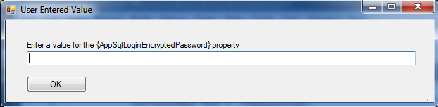
10. Review the tool’s output. If any lines appear in the Error Summary text box, search for those lines in the full Status text to see the context and meaning of the errors.
11. The Config File Tool will produce folder names that match the destination servers. Within those server folders, the subfolder names match the folder names used within deployment packages. Merge these folders into the F:\Deployment Code folder on each appropriate server. This should overwrite any environment-specific properties files that were provided in the deployment package.
12. Deploy the applications as normal with the Deploy Tool.

#### When standing up a new environment

1. Identify what the source environment will be (UAT1 or SB2 for example). Use the Config File Tool to gather copies of existing properties/configuration files from that environment’s Codebase directories.
2. Verify that the configuration catalog spreadsheet is up to date on Sharepoint (link shown above). If changes are required, update the CHANGE LOG tab with details on the changes made.
3. Save a new copy of the appropriate (4.X) configuration catalog into XML 2003 format, even if the spreadsheet hasn’t been recently modified. This ensures that we’re always using a fresh copy of the spreadsheet.
4. Choose the XML file that was created in step 3:  
   
5. Choose an application, adjust the Codebase Folder if necessary (this folder should be the parent of the Codebase folders like SRVLPSLOS, SRVLPSAUS), then click Gather Files:  
   
6. In the dialog, select a folder where the gathered files will be saved. The will place the selected Codebase folder (like SRVLPSAUS) inside the selected folder.
7. Repeat steps d – e for each application.
8. The end result of step 1 should be a single folder with subfolders for each application (i.e. SRVLPSAUS, SRVLPSLOS, etc). This could be located on a single server that is regularly used for this purpose, or an individual’s workstation.
9. On the machine where the gathered files are located, run the Config File Tool again and re-select the configuration catalog spreadsheet.
10. Leave the Application value as All, pick the desired target environment in the “Use data from worksheet dropdown”, choose the Full Codebase option, then click Build Files:  
    
11. Choose the directory that contains the various application codebase folders (like SRVLPSLOS); these will be used as the source files. The tool will produce copies of these files that have the proper data values inserted.
12. As the tool is running, you may be prompted to enter certain sensitive values such as passwords:  
    
13. Review the tool’s output. If any lines appear in the Error Summary text box, search for those lines in the full Status text to see the context and meaning of the errors, making changes to the configuration spreadsheet or source files as needed.
14. Once the process runs error-free (only known errors/situations), copy the generated files to the F:\Deployment Code directory on the appropriate servers. The Config File Tool will produce output files in folder names that match the destination servers.
15. NOTE on Work Engine servers. The Config File tool does not currently generate separate output folders for the work engine servers. Instead, the properties files from the WebSphere servers are re-used on the work engine servers, in a 1:1 fashion, meaning WebSphereNode01:Work Engine 01, WebSphereNode02:Work Engine 02. For example, the LOS, LX, and PORTAL properties files for Work Engine 01 would come from App01, 03, and 05, respectively, while the properties files for Work Engine 02 would come from App02, App04, and App06.
16. Use the LendingSpace Deploy Tool to do a build for each application (on each server…the tool will generate files for every node).

## Appendix B Deploy Tool

##### LendingSpace Application Overview

* LendingSpace is a collection of various applications.
* Remote Cache (RC)
* AUS (aka Decisioning)
* Correspondent Portal (CP, aka Portal)
* LOS
* JSQLXML
* LX
* UPLOAD

##### Typical installation

The Lending Space applications are typically installed for High Availability (redundancy), as follows:

1. WebSphere Remote Cache server 01
2. WebSphere Deployment Manager for RC
3. RC Node 01
4. WebSphere Remote Cache server 02
5. RC Node 02
6. WebSphere App server 01
7. WebSphere Deployment Manager for LOS
8. LOS Node 01
9. WebSphere App server 02
10. LOS Node02
11. WebSphere App server 03
12. WebSphere Deployment Manager for AUS, JSQLXML, LX, UPLOAD
13. AUS Node 01
14. JSQLXML Node 01
15. LX Node 01
16. UPLOAD Node 01
17. WebSphere App server 04
18. AUS Node 02
19. JSQLXML Node 02
20. LX Node 02
21. UPLOAD Node 02
22. WebSphere App server 05
23. WebSphere Deployment Manager for CP
24. CP Node 01
25. WebSphere App server 06
26. CP Node 02
27. Work Engine server 01
28. All Monitors (CP, LOS, LX)
29. Work Engine server 02
30. All Monitors (CP, LOS, LX)

##### Restart Sequence

Whenever the LendingSpace applications are restarted, the following sequence should be followed. Note that a particular restart request may not require restarts of all the applications.

1. Remote Cache (RC)
2. AUS (aka Decisioning)
3. Remaining applications
4. Portal (CP for Correspondent Portal)
5. LOS
6. JSQLXML
7. LX
8. UPLOAD
9. Monitors (applicable to CP, LOS, and LX, hosted on the Work Engine servers). Monitors use the same code files as the WebSphere applications.

Note that after AUS is completed, the remaining applications and Monitors can be started in any order. However, the typical order is to start Portal and LOS before the others since they take longer to start.

##### When is a LendingSpace application back up and running?

For the WebSphere applications server logs , the message “open for e-business” is an indicator that the application is back up and running, provided there are no exceptions in the log files.

For Monitors, availability is determined by the fact that the windows services remain started. Log files generally are not reviewed unless specific problems are happening within the LendingSpace application.

##### Restarting the WebSphere Deployment Manager

The Deployment Manager is a WebSphere component that manages WebSphere application nodes. For example, a typical deployment for LendingSpace is to have a pair of servers hosting one or more of the LendingSpace applications. The first server will host the Deployment Manager and a Node of a LendingSpace application (like LOS). The second server will host only a Node of the LendingSpace application.

The role of the Deployment Manager is basically to keep track of the health and status of whatever Nodes it has been associated with. It has no LPS code; it’s purely an IBM component.

When one or more of the LendingSpace applications (running as WebSphere Nodes) is restarted, there is typically no need to restart the Deployment Manager. It will detect when the nodes are stopped, and will automatically recognize when they are back up.

However, in cases where the Deployment Manager should be restarted (for example, to cause fresh log files to be generated), it should be started first and allowed to come “open for e-business” before starting any of the LendingSpace application nodes.

##### The LendingSpace Deploy Tool

The LendingSpace Deploy Tools is mainly used for restarting the DMGR/Application servers or checking the server status for application(s) and to upload Reports RDLS to SSRS.

The tool has 3 tabs:

1. Perform Application Restart – used to restart application server/check status of server
2. Application Drop down – list the allications that are in that server
3. Restart Deployment Manager Check box – used to restart DMGR
4. Restart button – used to restart the application from the drop down
5. Check Status button – used to check the status if the application server that is listed in the drop down
6. Copy Content to Clipboard – copies the output
7. Open Log Files folder – opens the log folder for both DMGR and application server.
8. Analyze Log Files – Searches the logfiles for any errors and it takes to the next tab “Log File Analysis”
9. Windows Services – Opens windows Services
10. Event Viewer -Opens Event Viewer log
11. WebShere profiles folder – Open the Websphere application profiles location
12. Codebase folder – opens Codebase folder
13. Log file Analysis – checks the server logs for any errors
14. Reports Upload – it upload the Reports RDLs in SSRS

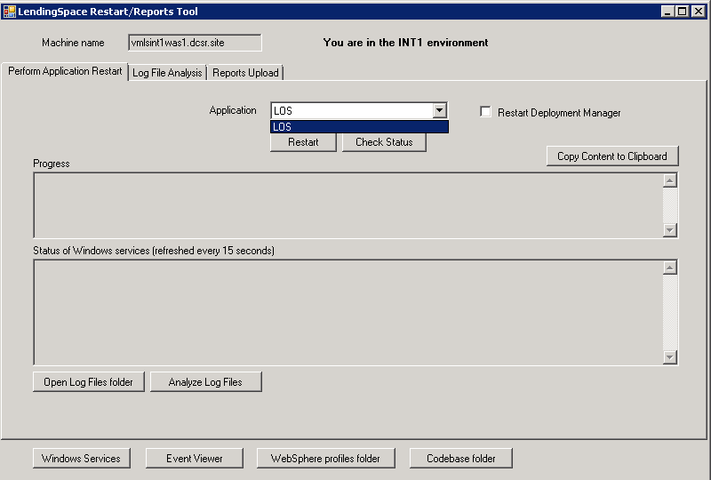

When used to do a restart of one of the WebSphere applications, the tool will do the following for the selected application

1. Stop the WebSphere service and java.exe processes (and optionally the Deployment Manager if one exists on the server)
2. Delete Log files and Temp files for all stopped services
3. Start all services that were stopped. If the option to restart the Deployment Manager was selected, it will start the Deployment Manager first, wait until the “open for e-business” message appears in the log file, then prompt the user to start any remaining nodes on that same server.
4. Provide periodic feedback on whether the “open for e-business message” has appeared in the log file.
5. Provide the user the option (via button click) to check the log files for exceptions and known error messages.

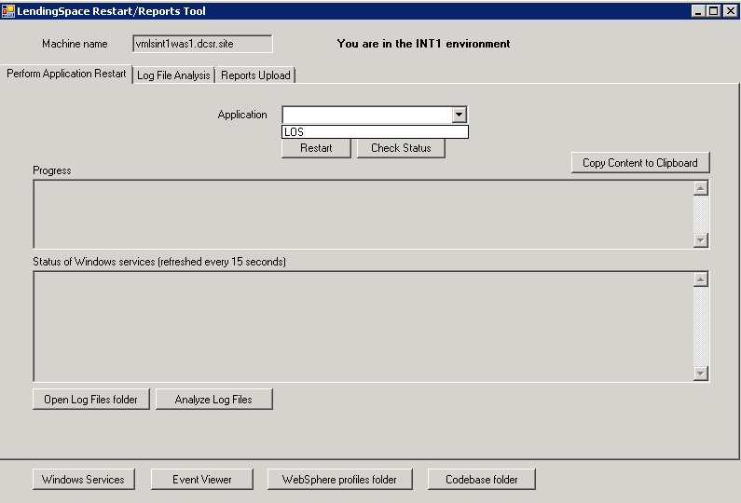

When used to do a Check server logs for one of the WebSphere applications, the tool will do the following for the selected application:

1. Checks the DMGR and Server log files for exceptions and known error messages.

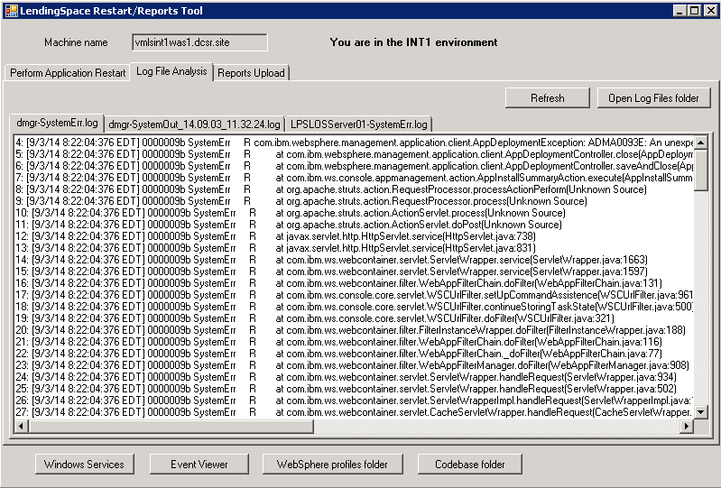

When used to do a restart of one of the Monitors (on the Work Engine servers), the tool will do the following:

1. Stop all Monitor Windows services.
2. Prompt the user to start all Monitor Windows services.

##### Reports Upload (RDL files for SSRS)

This tab is used to deploy RDL files for SQL Server Reporting Services (SSRS). SSRS is used by LendingSpace for reporting functionality within the application.

RDL files to import will typically be provided in a deployment package, inside a folder called LPSLS_REPORTS.

Note that the folder structure within LPSLS_REPORTS (or any folder containing RDL files to be imported) is expected to mirror the folder structure within the SSRS Report Manager, starting at the root level:

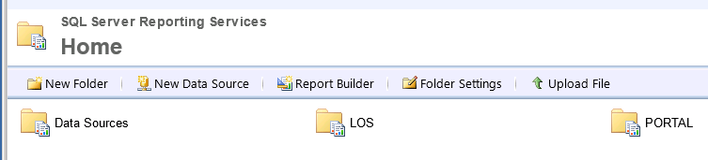

For example, based on the screen shot above, the LPSLS_REPORTS folder should contain directories LOS and PORTAL.

To upload RDL files,

1. Enter the Reporting Services web service URL (This value exist in DBConnectio.properties file and looks like ReportServicesWSDL=http://10.49.10.22:8080/ReportServer/ReportService2010.asmx?WSDL)
2. for “From Local Folder” browse to the “LPSLS_REPORTS” folder that was provided in the package.
3. Enter the Data Source information for the reports to be uploaded. The DataSource Info text box is designed to accept multiple lines of text, one for each Data Source that will be assigned to reports within the local folder containing the RDLs.

Each line should be a comma separated string containing two values:

1. Client-specific folder name that is contained in the path to the local RDL files
2. The path (starting with root) to the Data Source that exists in SSRS and is applicable for the reports within the specific client-specific folder.

Example: STRN,/Data Sources/Shared_STRN_Lender_Reports

Note that the Data Sources listed in this field must already exist in SSRS (the tool will not create them).

1. Click the Start button. You’ll be prompted to log in. Enter the credentials of a domain user

Note that the tool will overwrite existing reports in SSRS that have the same names as any of the local RDL files.

1. After clicking OK, the tool will begin uploading RDL files to SSRS and show the result of each operation in the text box.

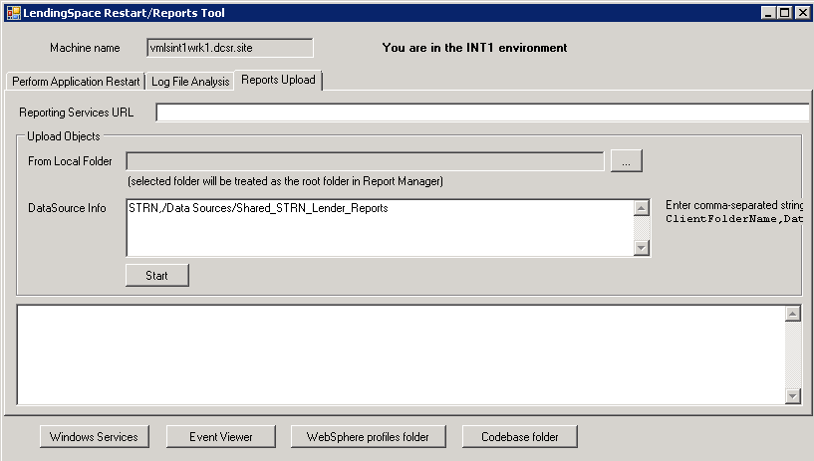

If the tool does not find a matching DataSource string while uploading the RDL file, the file will still be uploaded. However, the Data Source must either be manually assigned inside the SSRS Reports Manager website, or the correct DataSource Info values entered into the tool and the file re-uploaded.

A normal (successful) upload looks like this:

Item "/PORTAL/LPSC/Allocated Not Delivered" created.

WARNINGS:

The dataset ‘Shared_LPS_Lender_Reports’ refers to the shared data source ‘Shared_LPS_Lender_Reports’, which is not published on the report server. The shared data source ‘Shared_LPS_Lender_Reports’ must be published before this report can run.

------------------------------------------

DataSource set to Shared_LPS_Lender_Reports

The WARNING message in the output above is resolved by the tool in the line that says “DataSource set to Shared_LPS_Lender_Reports”.

If no DataSource Info string is found for the report, the output will look like this:

Item "/PORTAL/LPSC/Allocated Not Delivered" created.

WARNINGS:

------------------------------------------

The dataset ‘Shared_LPS_Lender_Reports’ refers to the shared data source ‘Shared_LPS_Lender_Reports’, which is not published on the report server. The shared data source ‘Shared_LPS_Lender_Reports’ must be published before this report can run.

------------------------------------------

No matching data source found for Allocated Not Delivered; Data Source NOT SET.

If an error occurs, it will look something like this:

Item "/PORTAL/STMC/Funding Advice Report - With EPP" created.

WARNINGS:

------------------------------------------

The dataset ‘Shared_LPS_Reports_Corr’ refers to the shared data source ‘Shared_LPS_Reports_Corr’, which is not published on the report server. The shared data source ‘Shared_LPS_Reports_Corr’ must be published before this report can run.

------------------------------------------

ERROR: <ErrorCode xmlns="http://www.microsoft.com/sql/reportingservices">rsDataSourceNotFound</ErrorCode><HttpStatus xmlns="http://www.microsoft.com/sql/reportingservices">400</HttpStatus><Message xmlns="http://www.microsoft.com/sql/reportingservices">The data source 'Shared_STMC_Reports' cannot be found.</Message><HelpLink xmlns="http://www.microsoft.com/sql/reportingservices">http://go.microsoft.com/fwlink/?LinkId=20476&amp;EvtSrc=Microsoft.ReportingServices.Diagnostics.Utilities.ErrorStrings&amp;EvtID=rsDataSourceNotFound&amp;ProdName=Microsoft%20SQL%20Server%20Reporting%20Services&amp;ProdVer=10.50.2500.0</HelpLink><ProductName xmlns="http://www.microsoft.com/sql/reportingservices">Microsoft SQL Server Reporting Services</ProductName><ProductVersion xmlns="http://www.microsoft.com/sql/reportingservices">10.50.2500.0</ProductVersion><ProductLocaleId xmlns="http://www.microsoft.com/sql/reportingservices">127</ProductLocaleId><OperatingSystem xmlns="http://www.microsoft.com/sql/reportingservices">OsIndependent</OperatingSystem><CountryLocaleId xmlns="http://www.microsoft.com/sql/reportingservices">1033</CountryLocaleId><MoreInformation xmlns="http://www.microsoft.com/sql/reportingservices"><Source>Microsoft.ReportingServices.ProcessingCore</Source><Message msrs:ErrorCode="rsDataSourceNotFound" msrs:HelpLink="http://go.microsoft.com/fwlink/?LinkId=20476&amp;EvtSrc=Microsoft.ReportingServices.Diagnostics.Utilities.ErrorStrings&amp;EvtID=rsDataSourceNotFound&amp;ProdName=Microsoft%20SQL%20Server%20Reporting%20Services&amp;ProdVer=10.50.2500.0" xmlns:msrs="http://www.microsoft.com/sql/reportingservices">The data source 'Shared_STMC_Reports' cannot be found.</Message></MoreInformation><Warnings xmlns="http://www.microsoft.com/sql/reportingservices" />

------------------------------------------

Note that some reports (sub-reports) for LendingSpace are intended to have the Hide in tile view setting selected. When RDL files are imported using the Deploy Tool, the Hide in tile view setting defaults to UN-selected. Therefore, the setting needs to be manually selected in the SSRS Report Manager website for those reports needing it.

##### Activities That Can Be Done in Parallel

After the Remote Cache and AUS WebSphere services have been deployed and/or restarted (i.e. open for e-business), the remaining applications can be started concurrently and in any order, including the Monitors on the Work Engine servers.

Also, the Nodes within a specific application can be started in parallel, provided the Deployment Manager is up and running.

For example, an abbreviated sequence of steps for executed the sample deployment request shown earlier could be:

1. Begin Restart of RC Node 01.
2. Immediately begin Restart of RC Node 02 (since the Deployment Manager for RC was not touched).
3. Watch for both RC nodes to become fully functional (i.e. open for e-business).
4. Begin Deployment of AUS Node 01, including Restart of Deployment Manager.
5. Immediately begin Deployment of AUS Node 02. When the build process is complete, wait to proceed with starting the services until the Deployment Manager on AUS server 01 is fully operational (i.e. open for e-business).
6. When the build process is complete on AUS Node 01, start the Deployment Manager and AUS Node 01.
7. Start Deployment of LOS Node 01, including restart of Deployment Manager.
8. Immediately start Deployment of LOS Node 02.
9. Immediately start Deployment of CP Node 01, including restart of Deployment Manager.
10. Immediately start Deployment of CP Node 02.
11. Immediately begin Restart of JSQLXML Node 01 (no restart of Deployment Manager).
12. Immediately begin Restart of JSQLXML Node02.
13. Immediately begin Deploy of CP on Work Engine 01. When the Deploy is complete, immediately start Deploy of LOS on Work Engine 01.
14. Immediately begin Deploy of CP on Work Engine 02. When the Deploy is complete, immediately start Deploy of LOS on Work Engine 02.
15. When the build processes complete on LOS Node 01 and CP Node 01, start the Deployment Manager and the Node 01 WebSphere services for both.
16. When the build process complete on LOS Node 02 and CP Node 02, and the Deployment Managers on LOS Node 01 and CP Node 01 are fully functional (open for e-business), start the Node 02 WebSphere services for both.
17. When Restart of JSQLXML Node 01 is complete, immediately begin Restart of LX Node 01.
18. When Restart of JSQLXML Node 02 is complete, immediately begin Restart of LX Node 02.
19. When Restart of LX Node 01 is complete, immediately begin Restart of UPLOAD Node 01.
20. When Restart of LX Node 02 is complete, immediately begin Restart of UPLOAD Node 02.
21. When the Restarts of the UPLOAD nodes are complete, the overall deployment is complete.

##### Using the Deploy Tool for a New Environment

Before using the tool in a new environment for the first time, the EnvironmentDefinitions.xml must be updated to have the required details for the new environment. The simplest approach is to review the existing environments in the file to get an understanding of the format, then copy one of the environments and modify its values to match the new environment.

Note that server names must be all lowercase in order for the tool to work properly.

Changes to EnvironmentDefinitions.xml should also be checked into source control for the tool.

## Appendix C Smoketest

Before starting the smoke test we need the below:

* URL’s and login credentials for all the 3 apps( PORTAL, LOS and AUS)
* Smoke test supporting docs(FNM File, 2 PDF’s, AUS test case Scenario)

1. Login to Portal:
2. Open the PORTAL URL in IE and enter the “E-mail Address”, “Password” and “Org. Id” on the login page and click “Ok”.

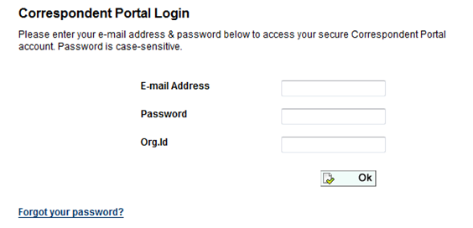

1. Select the “Secondary Marketing” and click “Ok”.

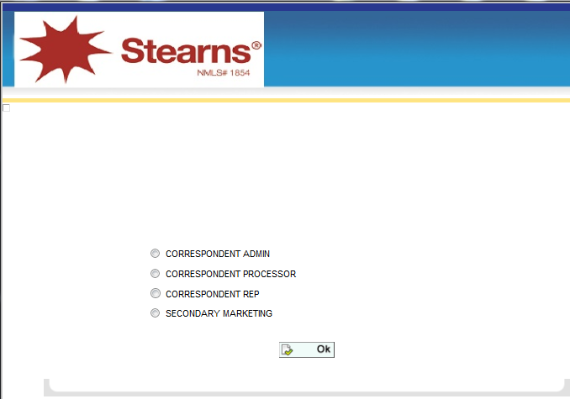

1. Upload FNM File
2. Once you are in the home page click the “Create Loan” from the left navigation

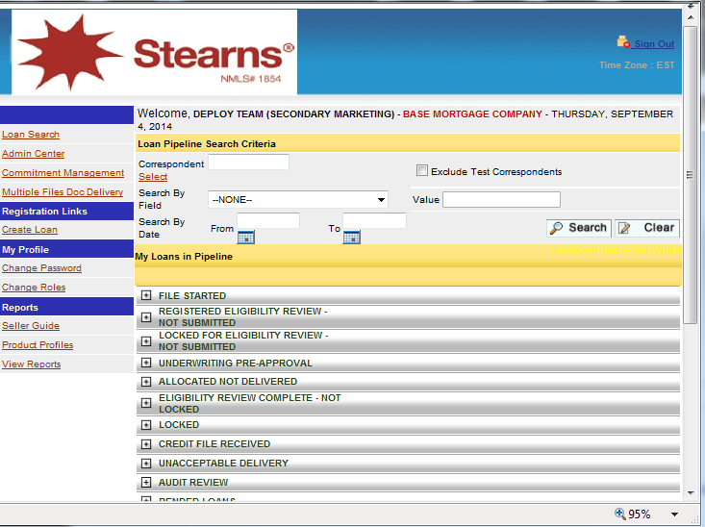

1. In the “Create Loan” screen click the “1003 Upload” button.

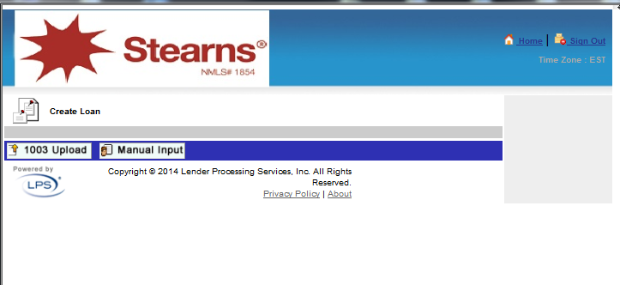

1. In the Loan Import screen, select “<CORRESPONDENT>” for the Correspondent type by clicking the “Select” link

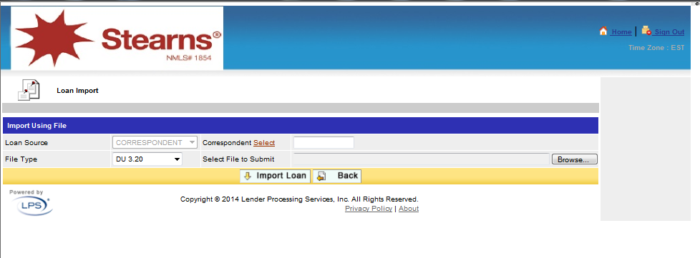

1. Choose the <CORRESPONDENT> from the dialog and click “Select”.

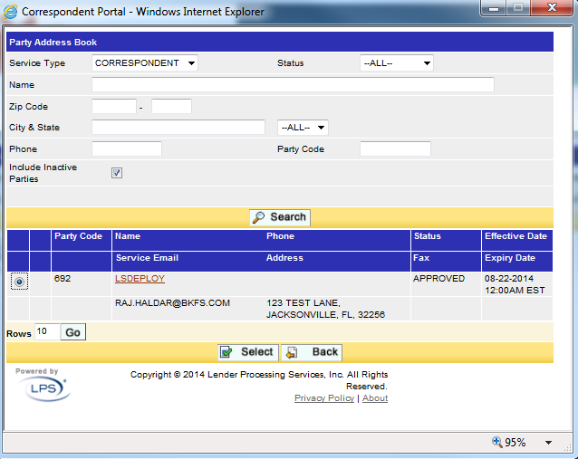

1. Browse to the FNM file that you saved in step 1 and click “Import Loan.”



1. Once the FNM file is imported the screen below appears. Click “Ok”.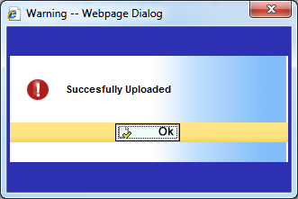

Note: After this step make sure that the “File Delivery” option is enabled on the right. If not, repeat the Correspondent selection above.

1. Edit loan and Price loan:
2. Expand the Borrowers Info section with the small (+) button on the left and change below
   * First Name
   * Last Name
   * SSN
   * Home Address 1
3. Click “Save”, and once saved click “Continue”

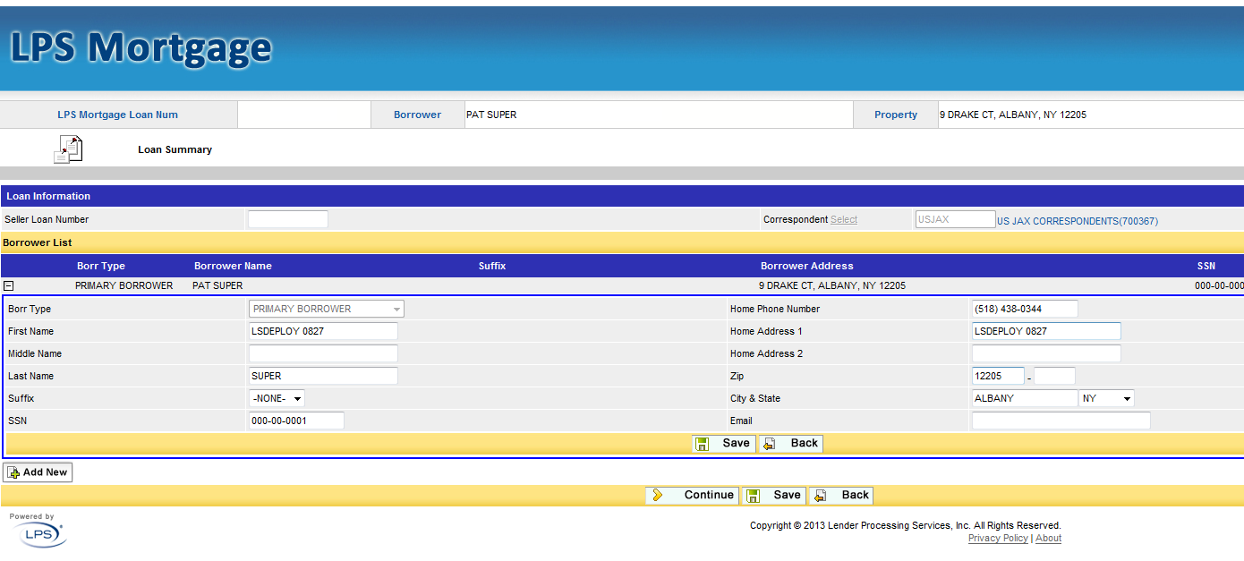

1. In the next screen change the following fields:
   * Address 1 (to match to the one that we used in the previous screen)
   * Product Name
   * Qualifying FICO (has to be 600 and above)
   * Documentation Level = Full Doc
   * Original sales price(has to be higher than loan amount)
   * Property Appraised Value(has to be higher than loan amount)
   * Debt ratio(should be less than 43)
   * AUS Type = DU
   * Recommendation = Approve – Eligible
   * Third Party Origination Loan(TPO Loan) = No
   * Clear the Rate field
   * Lock days = 30
2. Click the Save button, then Continue to return to the details screen
3. Click Get Price

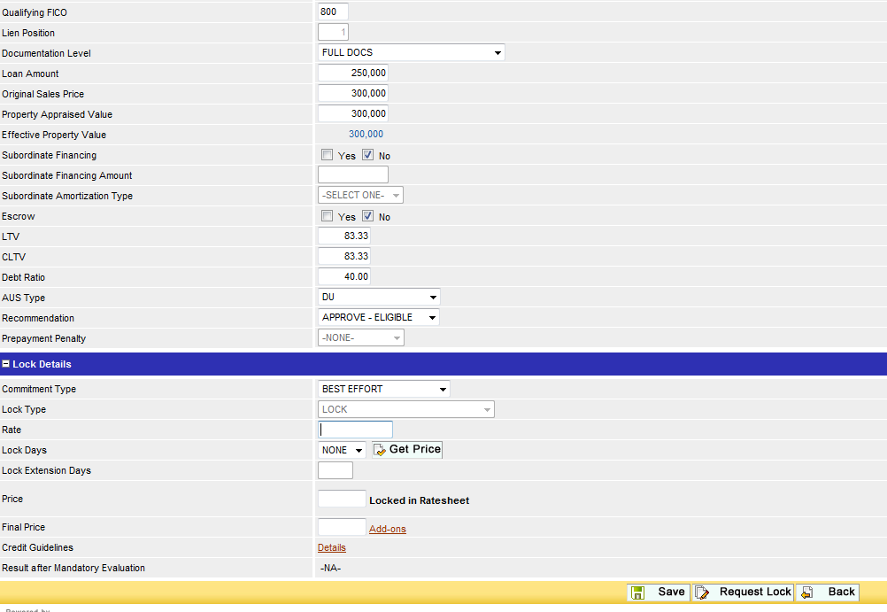

1. In the Product List window select the first rate and click “OK”.

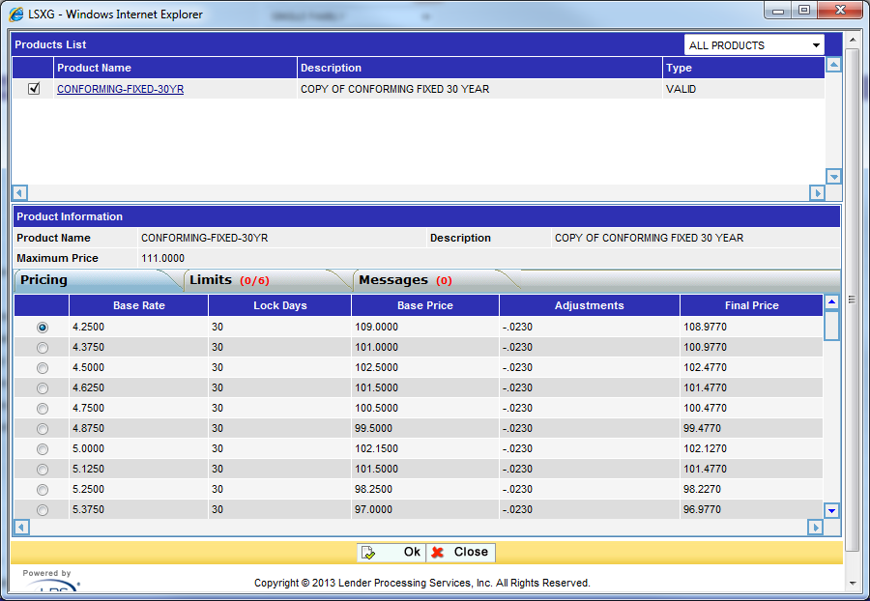

Note: if a popup window appears click “ok”

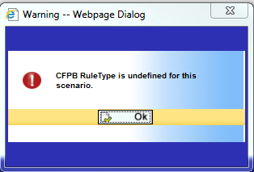

1. Now click “Request Lock”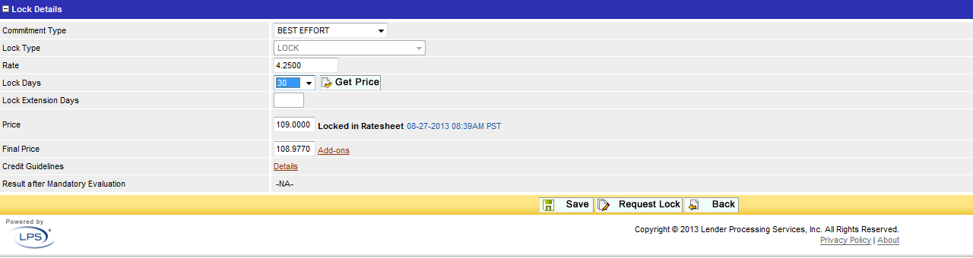  
   If a message saying “Please re price the loan” appears, click the Get Price again, then click Request Lock.
2. In the lock confirmation screen click “Yes” to look at the lock summary page.

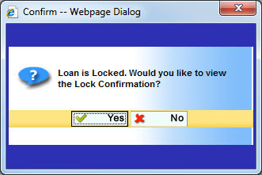

1. Once the lock confirmation screen opens close the window.

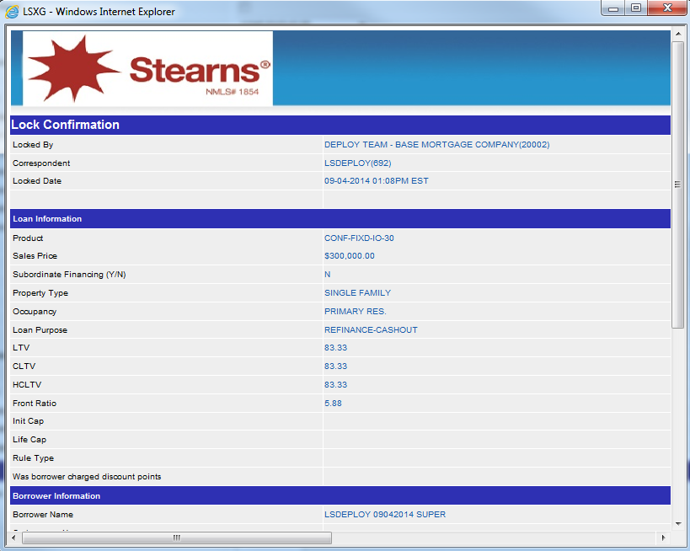

1. Upload documents and view uploaded documents:
2. Click Doc Center in the right nav.

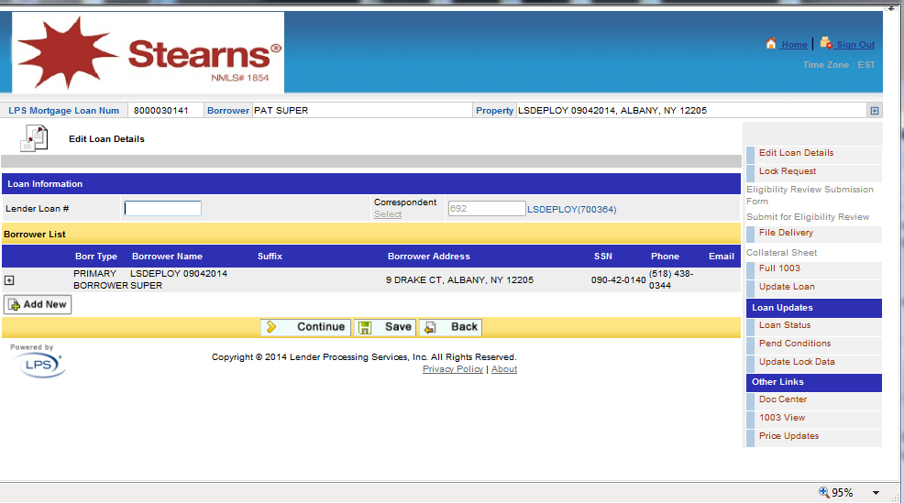

1. Click “Upload New Doc”.

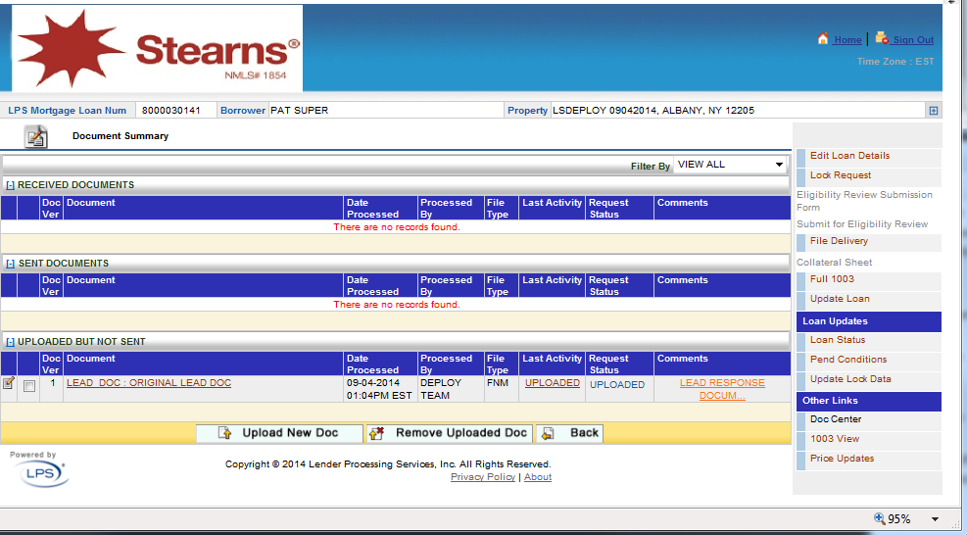

1. Select any of the doc types and browse to the “10 page PDF” file, then click the green up arrow to upload the document.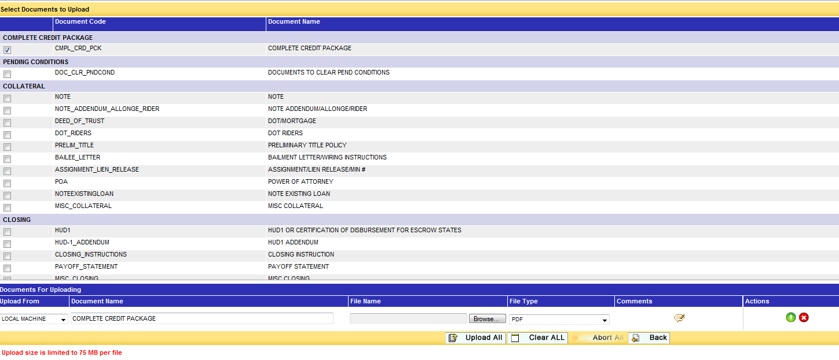
2. Once the doc is uploaded the status should say “Done” as below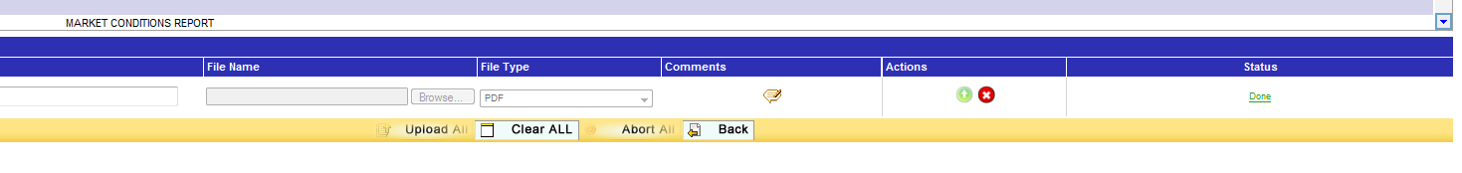
3. Click “Back” and click the document and once the document opens verify all the 10 pages are there. Then close the window.

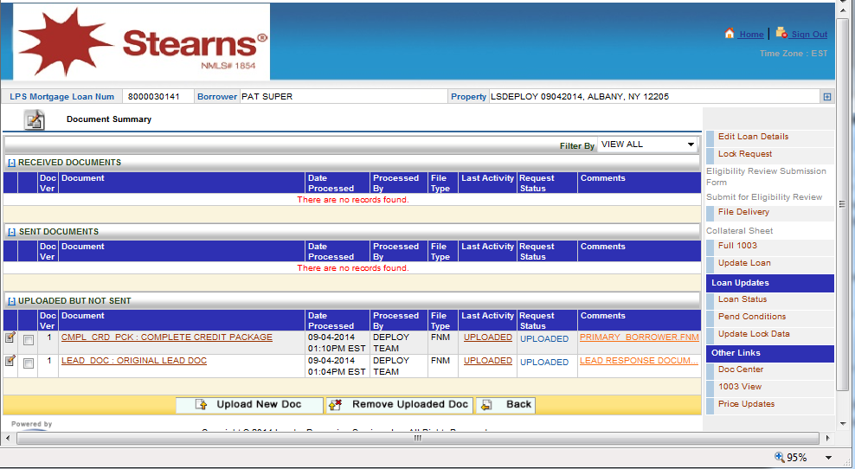

1. Send loan to LOS
2. In the right nav click “File Delivery”

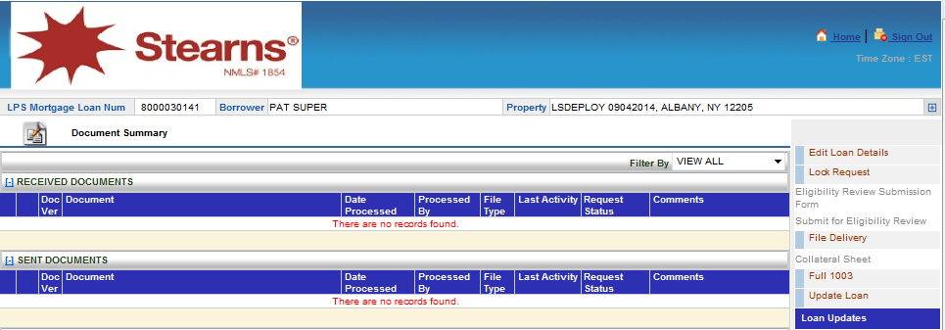

1. In the File Delivery confirmation screen click “Yes”.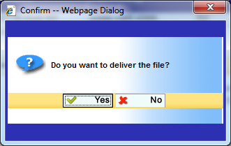
2. Once the loan is submitted click “OK” on the confirmation screen.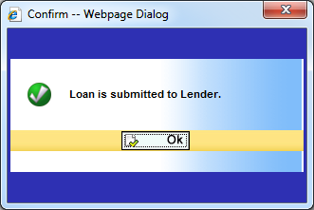
3. Copy the loan Number.
4. View reports
5. Click “Home” in the upper right-hand corner to return to the Portal Home screen. Click the View Reports from left Nav. and click the first report on the left and see if it opens up successfully, with Parameter fields and a View Report button at the top. Click View Report and make sure it runs. It’s not necessary for it to have any data. Now log out of Portal.

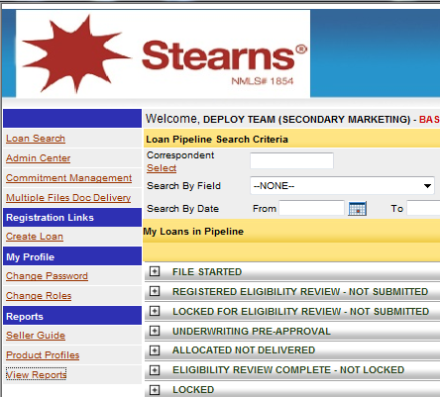

1. Click the first report on the left and see if it opens up successfully, with Parameter fields and a View Report button at the top. Click View Report and make sure it runs. It’s not necessary for it to have any data. Now log out of Portal.

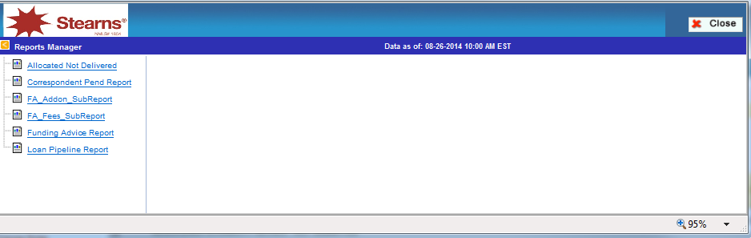

1. Login to LOS
2. Sign onto Secret Server again. Click the “LOS” entry and follow the steps in step 2 to login to LOS as “Doc Indexing Rep”. Click “Ok”.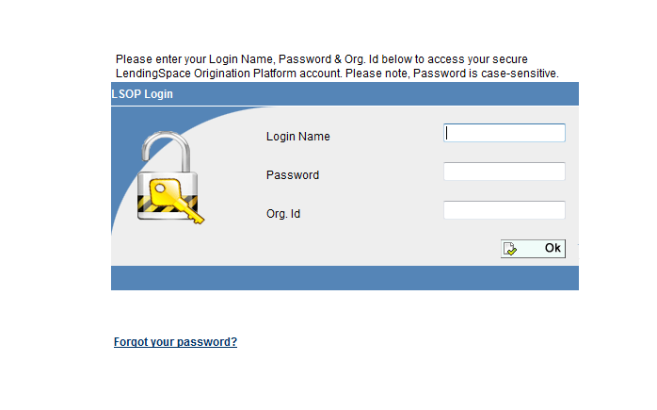

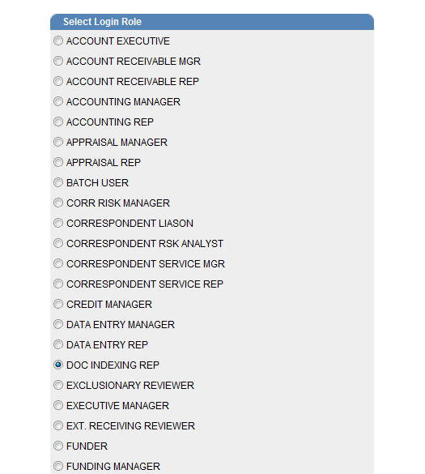

1. View submitted loans
2. Enter the new loan number that was just created in PORTAL and click “Go”.

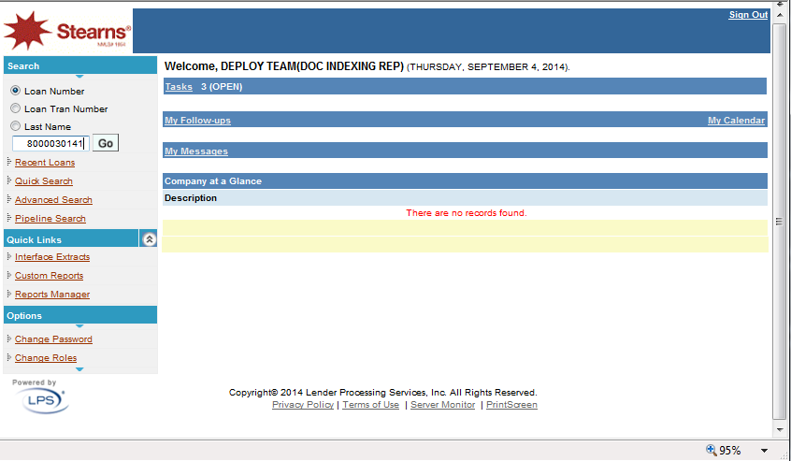

1. Click the Loan Status link in the right nav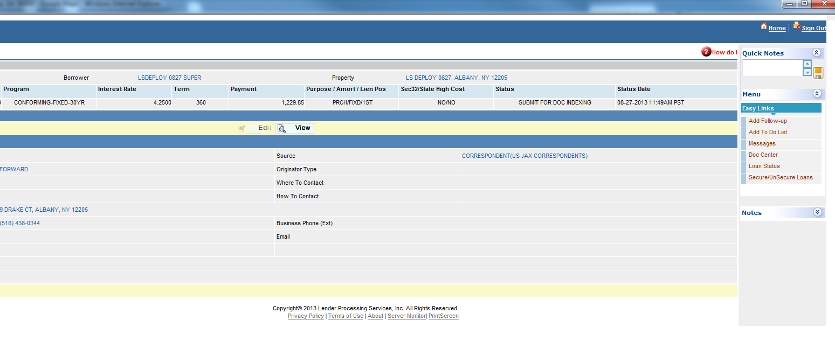
2. Update Loan Status to: “DOC Indexing Completed” OR “ND Doc Indexing Completed” Use CLOSED LOAN DOC INDEXING COMPLETED option if it’s a delegated loan or you receive a pop-up error message stating please insure proper status is selected.
3. Click Home. When you get a pop-up box saying “Do you want to COMMIT ALL the changes?” click “Yes”. Re-enter the loan number and click “Ok” to go back to the loan, and then click “Doc Center” on the right.
4. Click the “Upload New Doc”

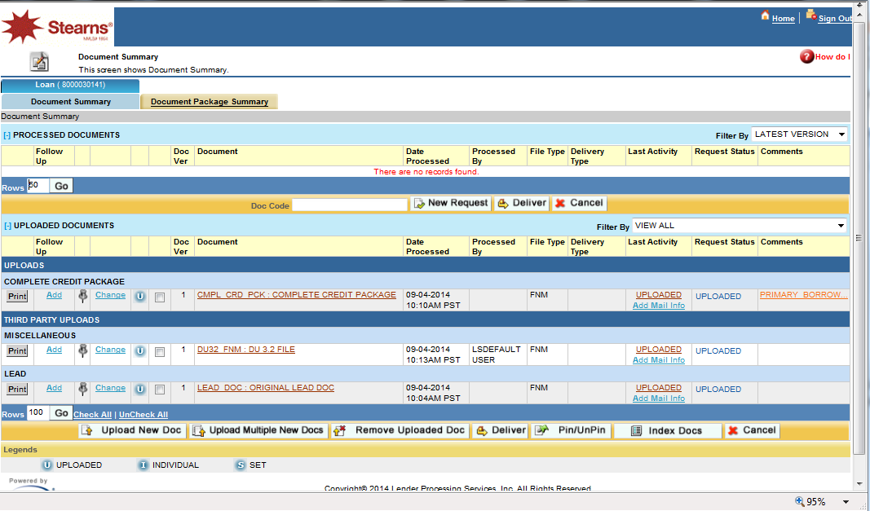

1. Click any doc type (radio button) and browse to the Outback PDF doc that is in your local machine and click “Ok”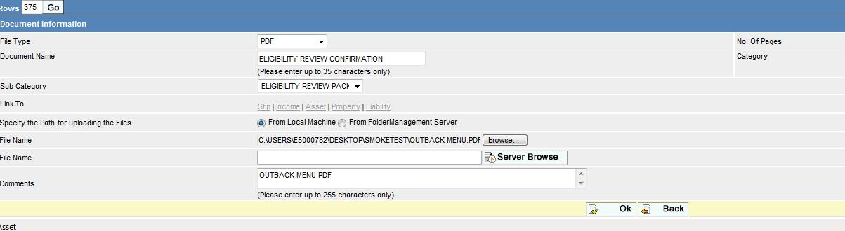
2. Once done click “Back”
3. Click the newly uploaded document to see if it opens
4. Transfer docs to portal
5. Check the box next to the new doc that is uploaded and click “Deliver”

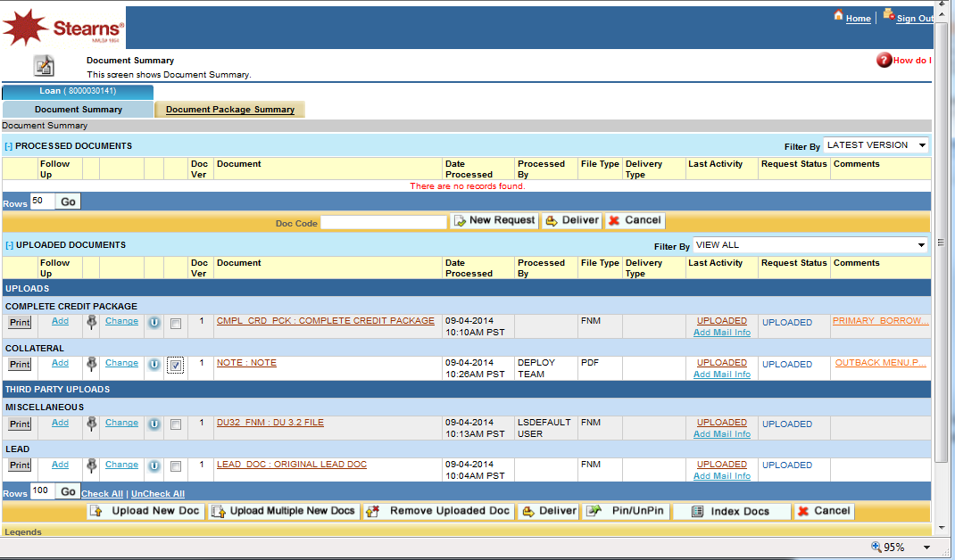

1. Select the Delivery Type dropdown and select “Send to Loan Portal” and click “Send”

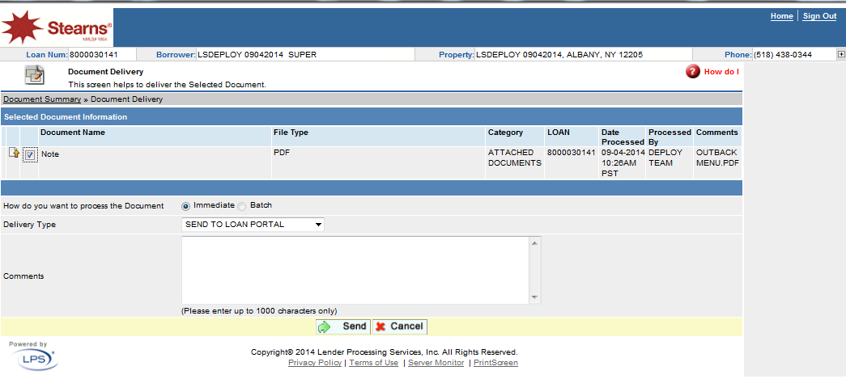

1. Log off LOS.
2. Repeat steps 1 and 2 to log back in to Portal as “Secondary Marketing”
3. Set “Search by” to “<Client> LPS MORTGAGE LOAN NUMBER” and put the loan number in the Value field.
4. Click Search
5. Expand the item that shows the (1) indicating a match
6. Hover over the blue/white arrow button and choose Doc Center
7. Verify that the transferred document appears in the list
8. Third Party Orders
9. Log off Portal.
10. Log back in to LOS as “SR. UNDERWRITER” or “SYSTEM ADMIN ” and then click “Ok”. 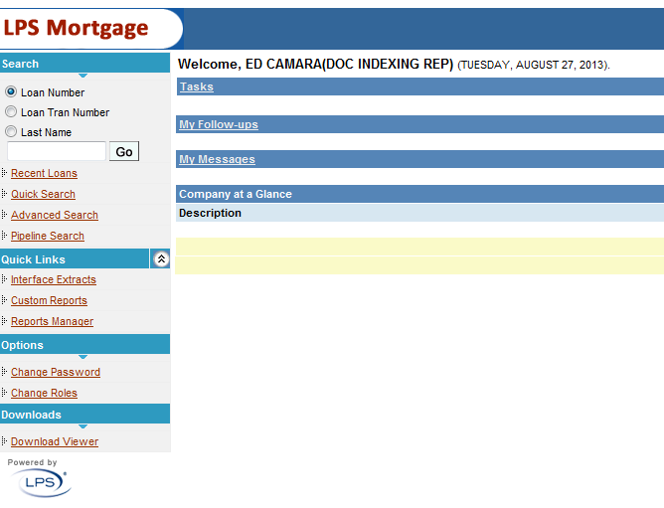

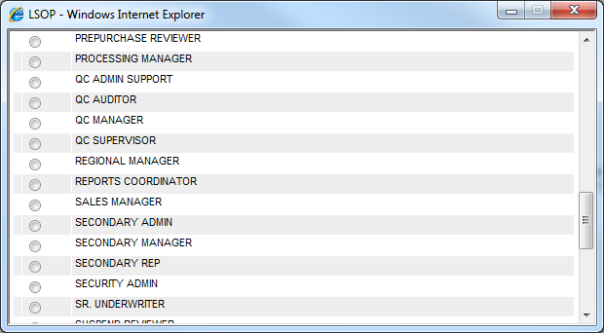

1. In the home page enter the loan number and click go.
2. Click “Edit”
3. In the right nav click “Third Party Orders”.

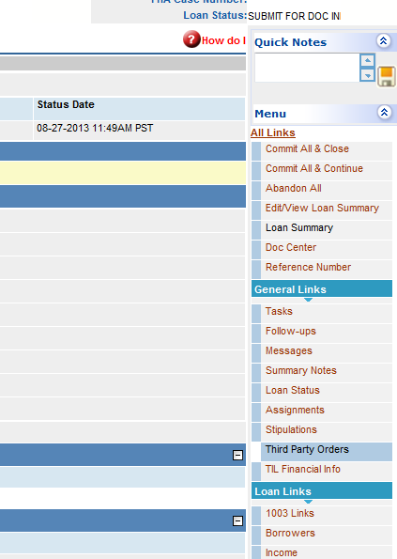

1. In the Third Party screen click “Add New” and change the “Service Type” and “Order Type” to the values in the illustration and click “Continue”

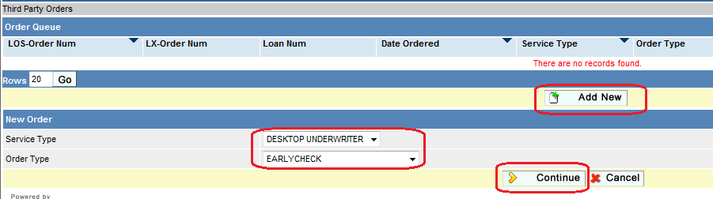

1. In the next screen, click “Save & Send” Now at the bottom of the screen.
2. After the application returns to the Third Party Order listing, click the Go button to see updates in the Current Status column. If it changes to something other than “NEW ORDER”, the test is successful (even if it shows an error in the Current Status column).
3. View reports
4. Click “Home”, click Yes on the Commit All Changes popup window, then click “Change Roles”.
5. Select “SYSTEM ADMIN”.
6. In the left nav click the Reports Manager and browse through reports and see if they open. It’s not necessary for them to have any data. Then close the Reports Manager and log out of LOS.

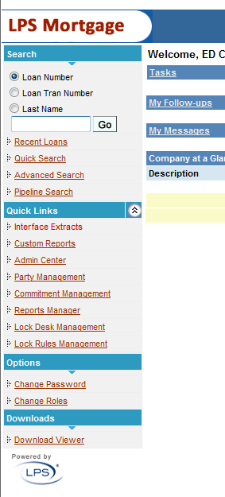

1. AUS Scenario test case
2. Login to AUS, select “System Admin” for base or “Credit Admin” for STM, and click “OK”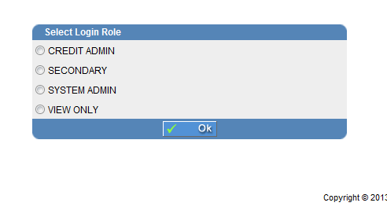
3. Click “Continue” if the following screen shows up.

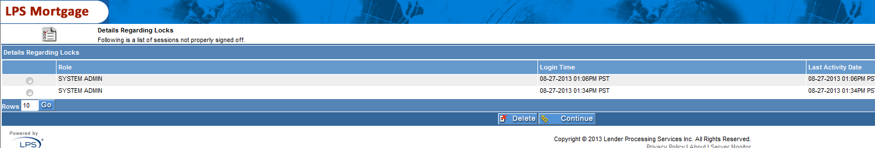

1. Click the “Scenario Test Case” in the left nav, browse to the file that was provided in this package “Scenario_Testcases-<Client>” and click “Upload and Run Test Cases”.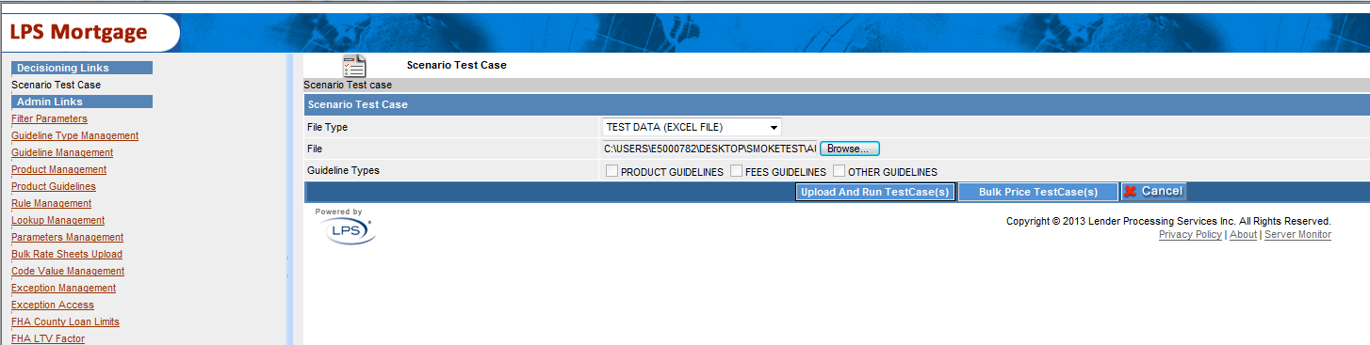

Below is the screen when it is still processing.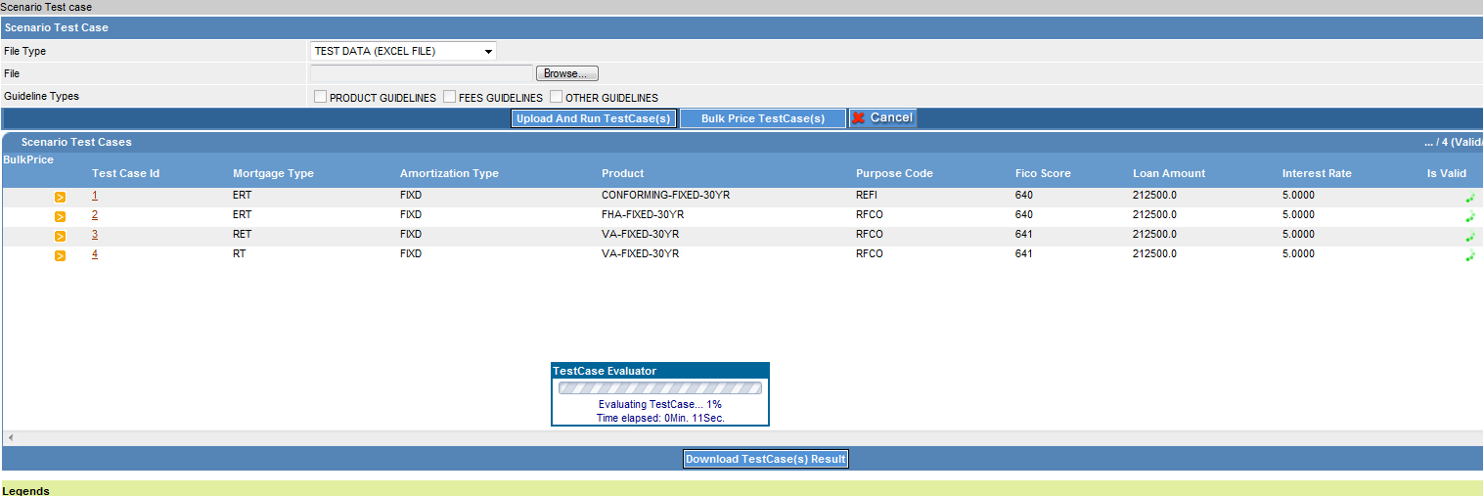

1. Once done click Download Test Cases Result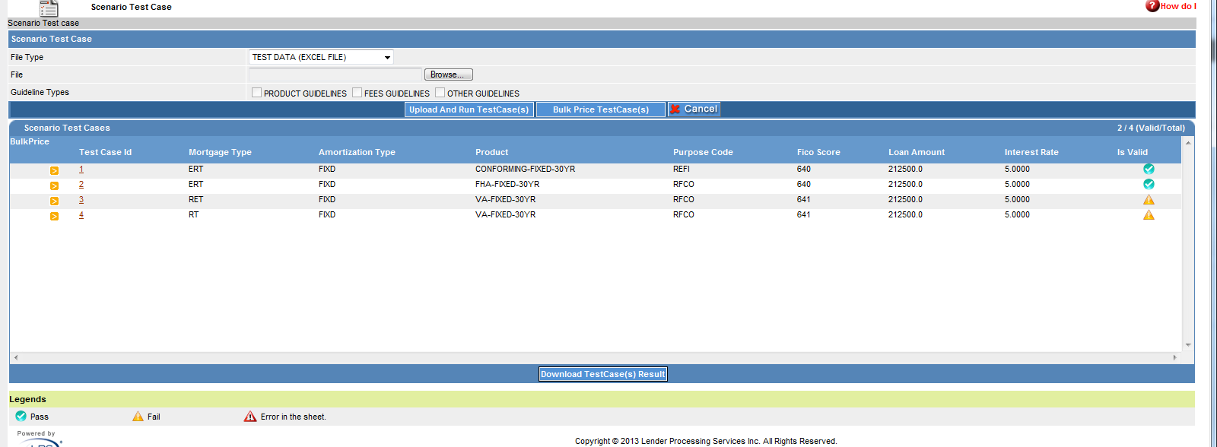
2. In the popup window click “Open” and see if any info is there. If you see the info then it’s a pass.

## Appendix D Websphere Topology Screenshots

#### Deployment Manager for each CELL



#### Remote Cache Nodes

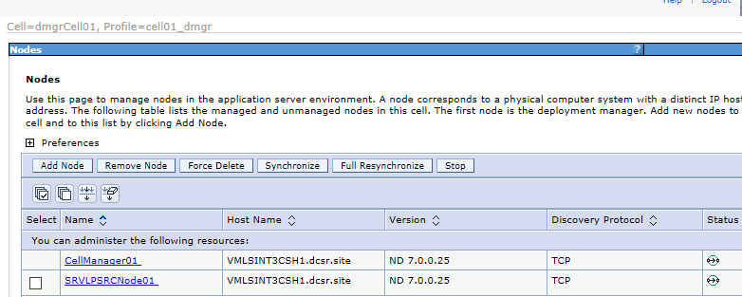

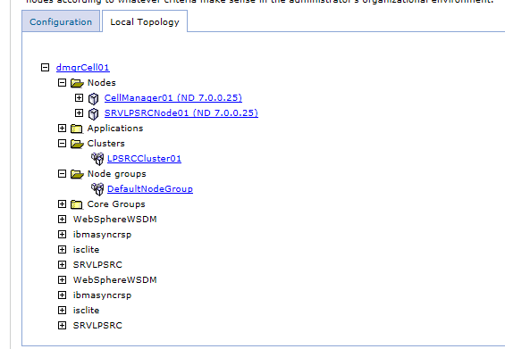

Remote Cache Servers

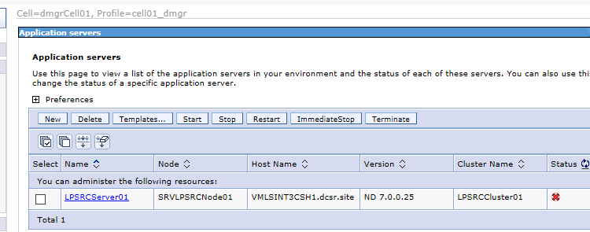

Remote Cache Clusters

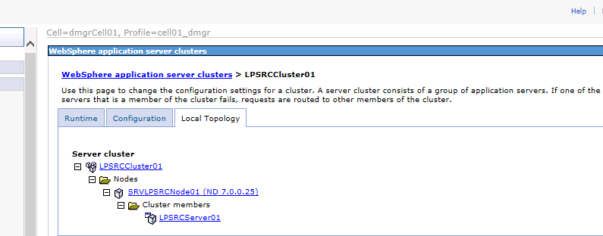

#### WebSphere CELL1 (WAS Server 1 & 2)

Cell1 Nodes

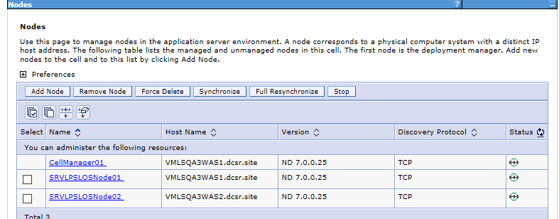

Cell1 Servers

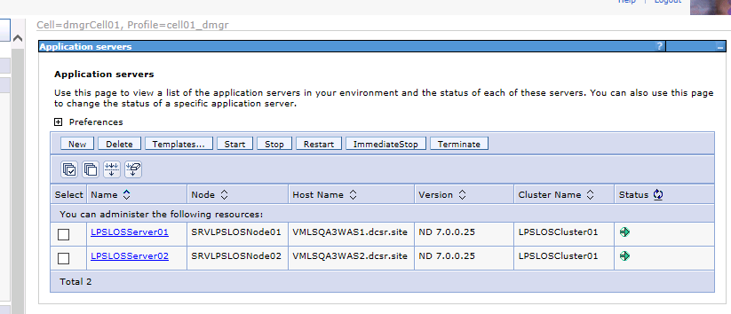

Cell1 Clusters

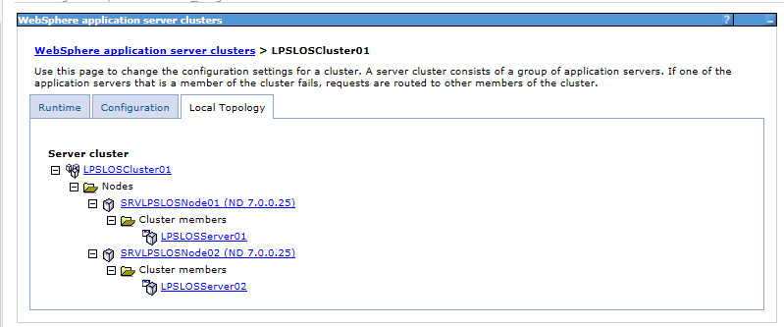

#### WebSphere CELL2 (WAS Server 3 &4)

Cell2 Nodes

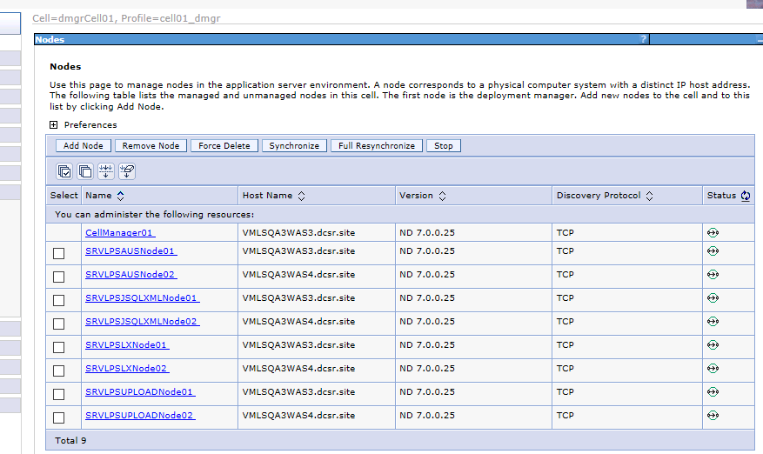

Cell2 Servers

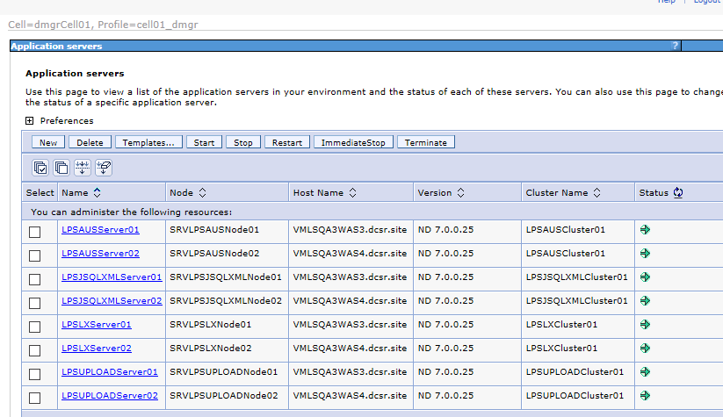

Cell2 Clusters

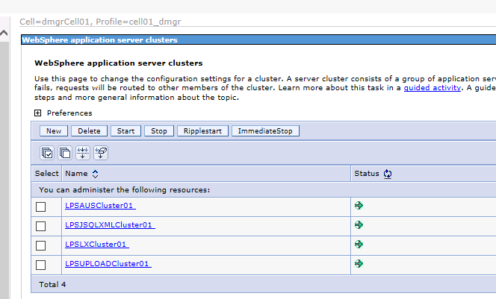

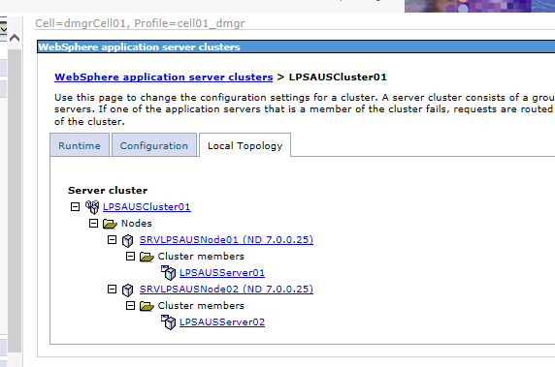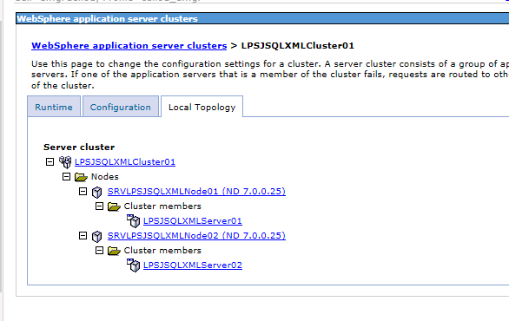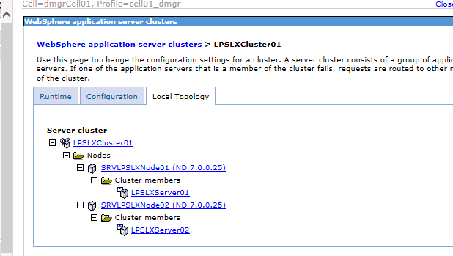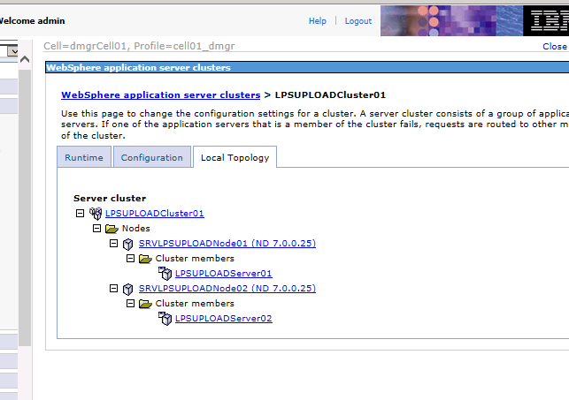

#### WebSphere CELL3 (WAS Servers 5&6)

Cell 3 Nodes

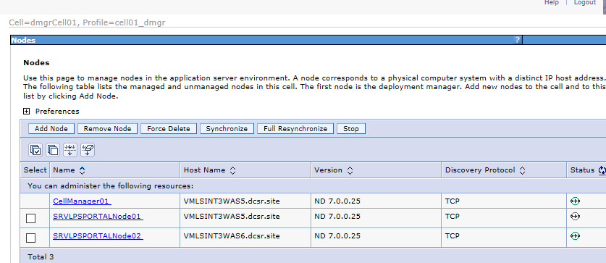

Cell 3 Servers

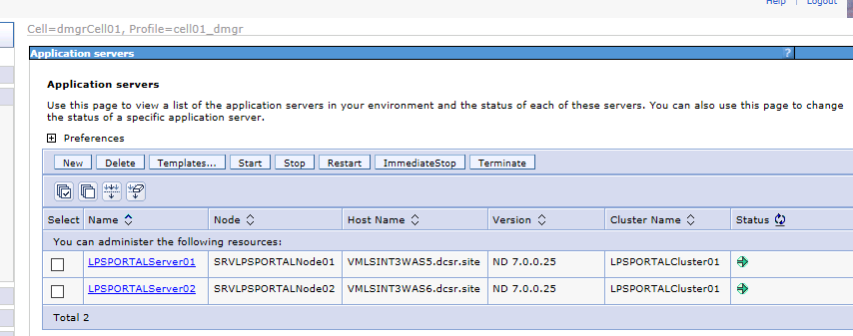

Cell 3 Clusters

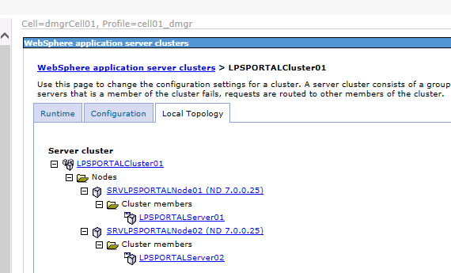

## Appendix E Exporting IBMKeystore Private Keys

To Export private keys from the IBM Keystore:

Start the IBM Key Management Utility

Open your keystore database file

Select the Certificate you want to export, and click on Export/Import

Choose Action Type: Export Key

Key file type: PKCS12

File Name: <you name your file>

Location: <your location you want to export>

Click OK

Password to protect key: <your password to use for import elsewhere>

Confirm: <your password to use for import elsewhere>

#### Disclaimer

Statement of confidentiality

The information contained in or supplied with this document is submitted solely for the purpose of evaluating the products and services of Black Knight Holdings, Inc. its affiliates and/or subsidiaries (collectively, “Black Knight”). The information contained in or supplied with this document, in its entirety, is the confidential and proprietary information of Black Knight, and it may not be copied by or disclosed to any person or entity (other than to the intended recipient), without the prior written consent of Black Knight. With or without Black Knight’s prior written consent, Black Knight accepts no liability whatsoever for any consequences arising from the reproduction of the information contained in or supplied with this document, or from its disclosure to any person or entity, including to the intended recipient. Black Knight additionally accepts no liability for the use of the information contained in, or supplied with this document, by the intended recipient, or by any other person or entity, with or without Black Knight’s express prior consent. The intended recipient shall not use any part of the information contained in, or supplied with this document, in any way to the competitive disadvantage of Black Knight, and will take all steps designed to assure its compliance with this provision.

This proposal is neither an offer nor intended by Black Knight, upon acceptance by the intended recipient, or otherwise, to create a binding agreement with Black Knight. Such an agreement shall be reflected only by a definitive contract, executed by both parties.

Trademarks

All trademarks are the property of their respective owners. Company, product and service names used within or supplied with this document may be trademarks or service marks of other persons or entities.

Copyright

Copyright © 2014

Black Knight Holdings, Inc., its affiliates and/or subsidiaries.  
601 Riverside Avenue  
Jacksonville, Florida 32204, USA

All rights reserved.